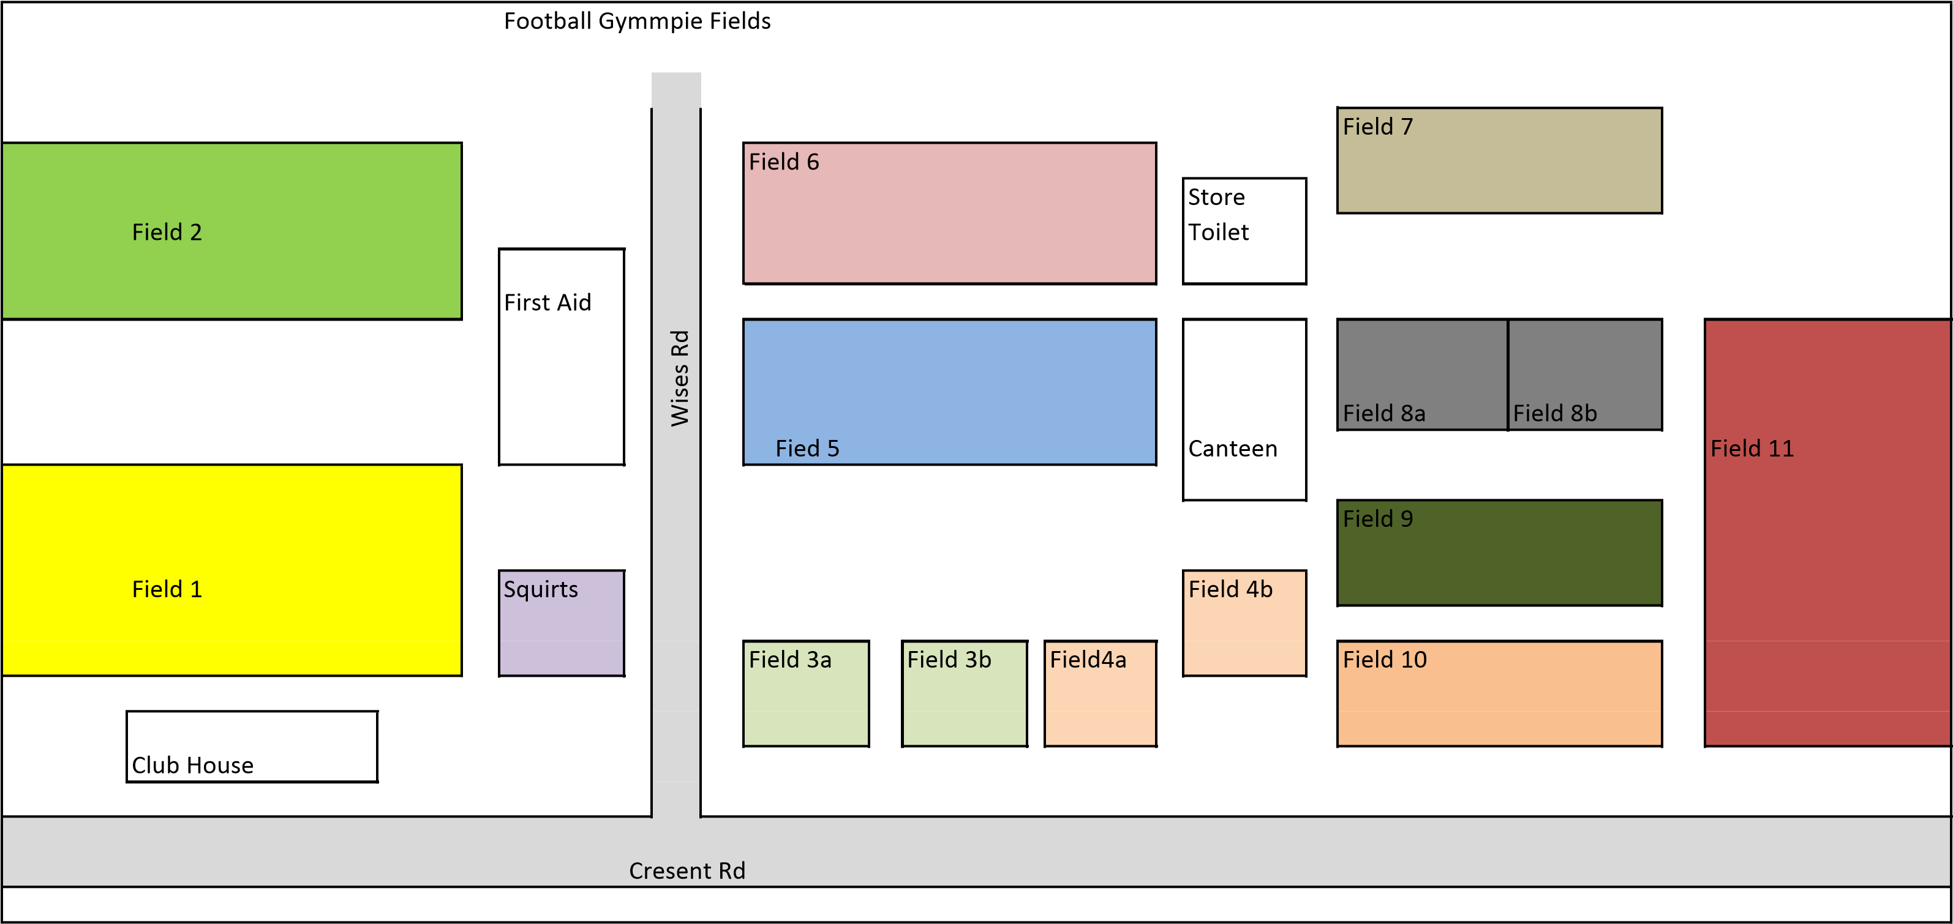

Under 4

Youth 3, Youth 2, Youth 1, Senior Girls, Ladies & Men’s

Youth 3, Youth 2, Youth 1, Senior Girls, Ladies & Men’s

Youth 3 & Senior Girls

Youth 3 & Senior Girls

Under 10, 11 & Junior Girls

Under 10, 11 & Junior Girls

Under 9

Under 8

Under 8

Under 5, 6 & 7

Under 5, 6 & 7

Under 5, 6 & 7

Under 5, 6 & 7