WOODVILLE DISTRICT BASKETBALL CLUB - TEAM APP
INSTRUCTIONS OF USE

- General Information

  - Administrator Rights Levels in Team App

In team app there are three different levels of administrator rights. Below is an explanation of how the administrator rights levels work and who they are generally associated to:

Full Administrator Rights – (Club Administrator)
Gives access to all areas and is generally provided to someone responsible for club administration.

The club admin will be responsible for the following:
- Setting up and editing Team App (Team App features and the way it looks, club settings, security levels, links to social media etc)
- Re-setting and setting up access groups each season
- Setting up a team selection area for each team in the club each season
- Setting up links to fixtures and results for each team in the club each season
- Setting up the Live Score Links for the Premier League teams in the club each season
- Approving member sign-up and access group requests
- Completing a bulk import (if applicable)
- Distribution of club wide news to all access groups or to the coach & team manager groups where required

Restricted Administrator Rights – (Team Managers, Coaches, Team Contact)
A restricted administrator has the ability to send push notifications, create news and events, moderate chat rooms and photos from within the app and only for access groups they are a part of.

Team Managers & Coaches (generally the Restricted Administrators) will be responsible for the following:
- Entering in team selections and conveying any notes/messages in team selection area (these can be sent to the coaches & managers in the age group and the players/parents in the team you are coaching or managing) – which are the access groups you will be a part of
- Creating News items and events and distributing them for the access groups you are a part of (generally your team and the other age group’s coaches and managers)
- Starting a chat room (and moderating) for the access groups you are a part of (generally your team and the other age group’s coaches and managers)
- As well as everything members with no administrative rights can do

No Administrator Rights – (Team Players and Parents)
All members that are not club administrators, coaches or managers generally will be members of the TeamApp with no administrator rights, generally players and parents with in teams.

Parents and Players will be able to:
- Sign up to team app and request to be part of an access group related to their team(s)
- View Team Selection area, fixture, results and messages/news related to your access group (Team)
- Message in the chat room related to your access group (Team)

  - Access Groups

Access Groups are the most important function of Team App to ensure that relevant information is only sent to respective members, rather than all information being sent to all members (access groups limit the amount of push notifications and emails you receive that are not directly related to you).

Each season the club administrator will reset access groups and set-up access groups based on the teams the club has as per the following:

- An access group for each age group for Coaches and Team Managers
(eg: U10 Boys Coaches and TMs)

- An access group for each team in the club (for players and parents)
(eg: U10 Boys Div3 Players/Parents)

When each member signs-up to TeamApp, they will need to select all the access groups that relate to them.

For example: A Coach of the U10 Boys div 3 team will select the access group for U10 Boys Coaches and TMs as well as U10 Boys Div 3 Players/Parents). The Team manager of that team would request the same. The Coach and the team manager will also be granted restricted administrator rights by the club admin. If a coach or team manager is involved in multiple teams, they will be able to request access to each related access group.

For example: A Parent or player in the U10 Boys div 3 team will select the access group of U10 Boys Div 3 Player/Parents. If a parent has more than one child at the club then they will be able to request multiple access groups relating to the teams that each child is in.

  - Team App platforms

Team App can be accessed on any Smartphone (iPhone and Android), Tablet and on the internet. Team App generally looks similar across and functions the same way across all platforms.

- Use of the TeamApp – Restricted Admin (Team Managers, Coaches, Team Contact)

  - Signing up to the app and finding WDBC Warriors

To sign up to Team App:
- Download and install the App from the iTunes or Play store or visit the Team App website
- Click on Sign up and fill in your details
- Follow the instructions to verify your sign up (Verification link sent to your email)
- Go back into TeamApp, find WDBC Warriors and click to join
- Request your relevant access group(s)
- Give a reason for requesting access
- Click Send
- Approval will be granted by club admin

(d) (e) (f & g) (h)
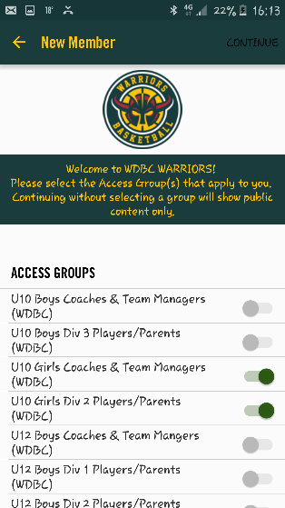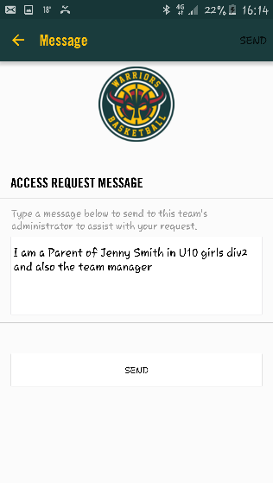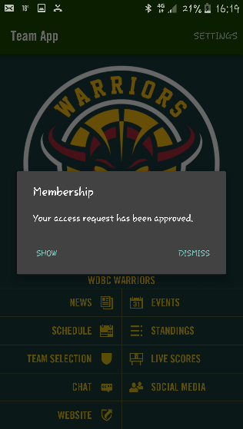

  - Editing Team Selection section and sending notes

To Edit team selection (Notes and Player) and send notes:
- In TeamApp click on “Team Selection”
- Select your team
- Select edit
- Then type your notes in the notes section and/or team selections in player section
- Select the Access groups applicable to you
- Click Save

- (b) (c) (d) (e&f)
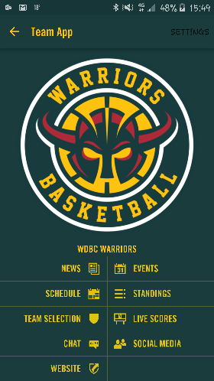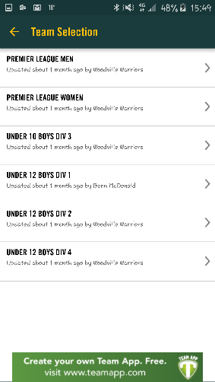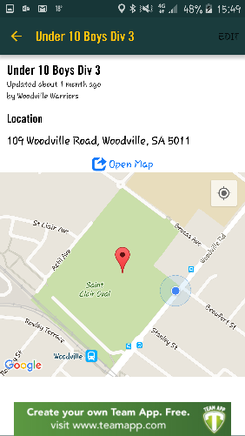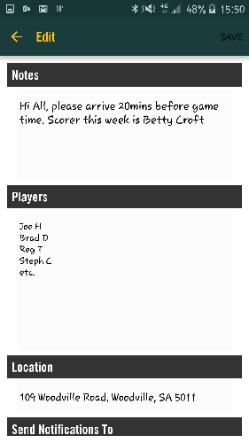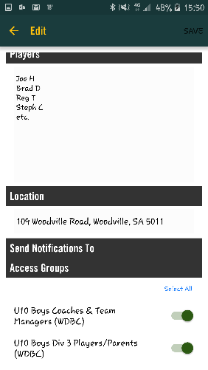

  - Creating News Items and Events for your access group

To create a News Item:
- In the Team App, click on News
- Click on “new”
- Complete the form with all the relevant details
- Ensure “Send Notifications” is set to on (green)
- Under Access Groups click on “Please select” and select the relevant access groups
- Click Create

To Create an Event Item:
- In the Team App, click on Events
- Click on “new”
- Complete the event form ensuring the date, time and location of the event is correct
- Ensure “Send Notifications” is set to on (green)
- Under Access Groups click on “Please select” and select the relevant access groups
- Click Create

  - Creating a New Chat room for your access group

To Create a chat room:
- In the Team App click on Chat
- Click on “new”
- Click on the relevant access group(s) you want involved in the chat room
- Type a message in the section that says “Type a message” and you can attach a photo by clicking on the paperclip
- Click send

- Use of the TeamApp – Players and Parents

  - Signing up to the app and finding WDBC Warriors

To sign up to Team App:
- Download and install the App from the iTunes or Play store or visit the Team App website
- Click on Sign up and fill in your details
- Follow the instructions to verify your sign up (Verification link sent to your email)
- Go back into TeamApp, find WDBC Warriors and click to join
- Request your relevant access group(s)
- Give a reason for requesting access
- Click Send
- Approval will be granted by club admin

(d) (e) (f & g) (h)
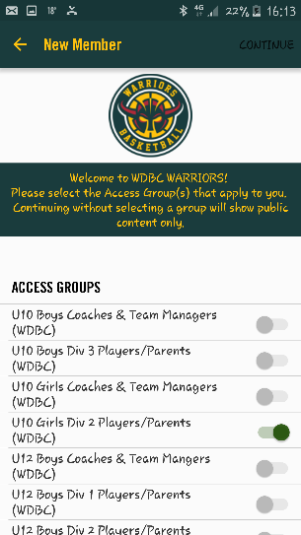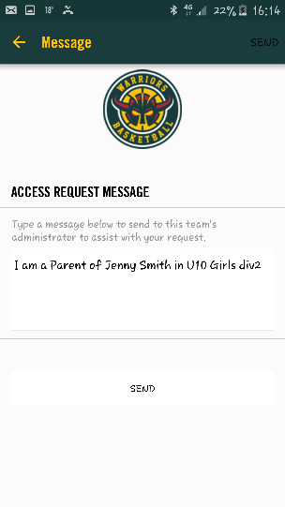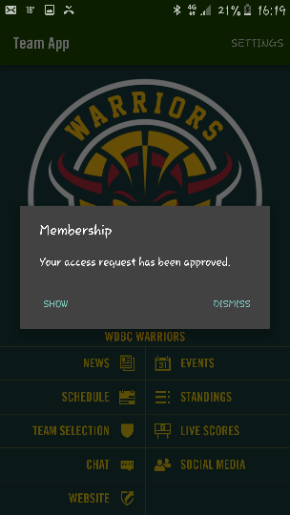

  - View News, Events, Team Selection Area, Schedules and Standings

To view News and Events: from the Team App home screen you can click on News and Events and you will be able to see News and Events that is linked to the access groups you are a part of.

To view Team Selection and Notes, Schedules and Standings: From the Team App home screen you can click on Team Selection, Schedules and Standings. You will then select your team and then you can see all information in each section relating to your team.

  - Messaging in Chat Room relating to your Access Group (Team)

From the Team App homescreen you can click on “Chat” and you will be able to see any chat rooms created for the access group(s) you are a part of. Click on the relevant chat room and you will be able to message similar to Facebook messenger and similar to a Smartphone (Android or iPhone) SMS function.

