Teaching Craft Booklet

Key Fundamentals in the Game of AFL
- Kicking
- Handballing
- Marking
- Ground Balls
- Tackling and physical presence
Need to ensure that we develop these fundamentals in a fun and engaging manner where players are being challenged and are able to compete! We must also ensure the practice is game based and transferrable.

Kicking exercises and activities

No Step Kicking/Footy Golf/Dribble Kicks –
- Encourage players to experiment with different kicks.
- No step kicking to increase their balance and fundamental technique/impact with the ball.
- Footy golf to go through different types of kicks: a driver (flat and hard kick), 5 iron (more weighted kick) and Pitching Wedge (Chipped kick high into space to teammates advantage).
- Then Dribble kicks allow players to get used to kicking the ball end over end, dribbling it off the outside of the boot to curl it etc.
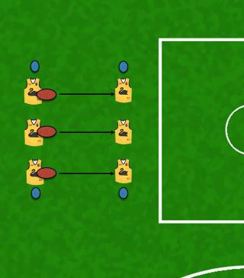

Kicking in three’s –
- Simple warm up activity where players are kicking to advantage of their teammate.
- Can start off static and then move to kicking on the run.
- Can progress by challenging them to see how many kicks they can complete without hitting the ground. L & R feet.
- Let the players experiment with different kicks.
- Scope to put in defender/s to add pressure make it more game like.
- Ensure players are pushing back from the mark at times and going quick at other times.

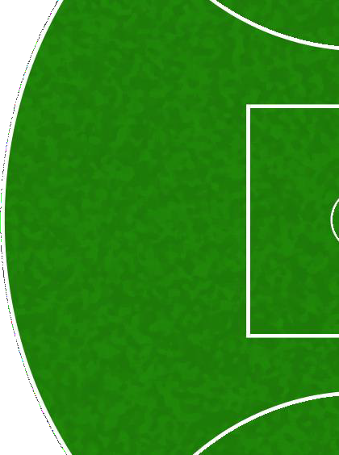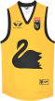

Initiative square –
- Focus on decision making and kicking on the run.
- Players must adapt their kicking to the option’s presented and execute a
range of different kicks to the advantage side of their teammates.
- Defensive Pressure can be added and increased as the players progress.

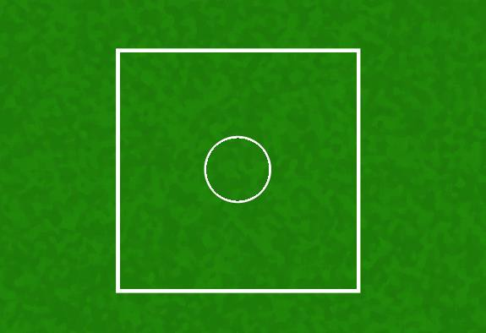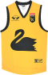

Handballing exercises and activities

Quick fire/Hot Pepper handballing –
- In groups of three with two balls players work the ball through the player who starts without a footy.
- They must work on handballing with both hands, along the ground, half volleys etc.
- Change up the distances apart as well.

4 vs 1 or 4 vs 2 handball grids –
- Decision making component added.
- Players need to move the ball quickly with their left or right hand and adapt the handball to the situation presented by the defenders.
- Quick release and clean hands are important.
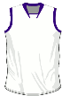

Golden Jacket handball game –
- Handball only with a plus one player who works offensively both ways.
- Teams must work the ball through the opposition to score a point at their end.
- Work on a 4 vs 5 or 5 vs 6 set up so players are involved and regularly executing the skills under pressure.

Marking exercises and activities

Kick Tennis/Footy Volleyball –
- Can be 1 vs 1 or 2 vs 2 or progress to two teams competing with multiple balls.
- Players are aiming to mark the opposition’s kicks and must adjust to the ball coming in and execute the mark required ie Chest, Out in front, Overhead etc.
- Key focus on their positioning, watching the ball closely and soft hands.
- Can add the competitive element by scoring everytime a team lands a kick the oppositions grid.

1 on 1 Contested Marking –
- Players break off into pairs and compete in one on one contests. Key teaching points around body positioning, reading the flight of the ball, protecting the ball drop etc.
- Encourage players to use different kicks and rotate which player is attacking and who is defending.
- Roll through some different options on the lead and then one on one physical contests.
- Have the players keep score of how many marks they take as opposed to their partner.

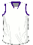

Ground Ball exercises and activities

One up, One down –
- Players work together in small groups of 5 - 6 on ground balls.
- Once the player picks up the ball a team mate should be getting in position to receive and then give one handball to another teammate who will then roll the next ball out in front of another team mate.
- Focus on body position behind the football, watching the ball closely and clean hands.
- Ensure balls are being rolled at different angles to create unpredictability.

4 vs 2 contest square –
- Four players on the cones feeding the ball into the middle player who will be battling against two defenders with bump bags and putting pressure on.
- Go for around 30 seconds and keep feeding the balls in from the different angles either along the ground, half volleys, out in front etc.

Tackling and physical presence exercises and activities

Protect the ball in 3’s –
- One player is attempting to pressure and tackle the ball carrier while the third player is shepherding and blocking the defender.
- Let players experiment with their body positions and different techniques from both a defender and blocker perspective.
- Rotate roles after around 30 seconds.

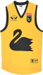
Pressure
Block
Pressure
Block

Tackling Grid –
- Players work through in pairs and run on the 45 where the ball carrier is tackled and then switch over and repeat for the next grid.
- Progress through to tacklers taking the ball carrier to ground and focus on the player with the ball falling safely and protecting themselves.

Tackle

Superman drill –
- 1 vs 1 or 2 vs 2 tackle drill where the opponents go head to head in a small grid.
- Defender attempts to tackle the ball carrier who is trying to get past the end line.
- Focus on quick feet and front on tackling technique (ie Head position, initial contact, finishing the tackle).

