Instructions for applying for a “Working with vulnerable people” card – it will only take 10 mins and is free
- Click on link below
http://www.ors.act.gov.au/community/working_with_vulnerable_people_wwvp/forms_and_fees
- Click on “Working With Vulnerable People Online Application For Registration”
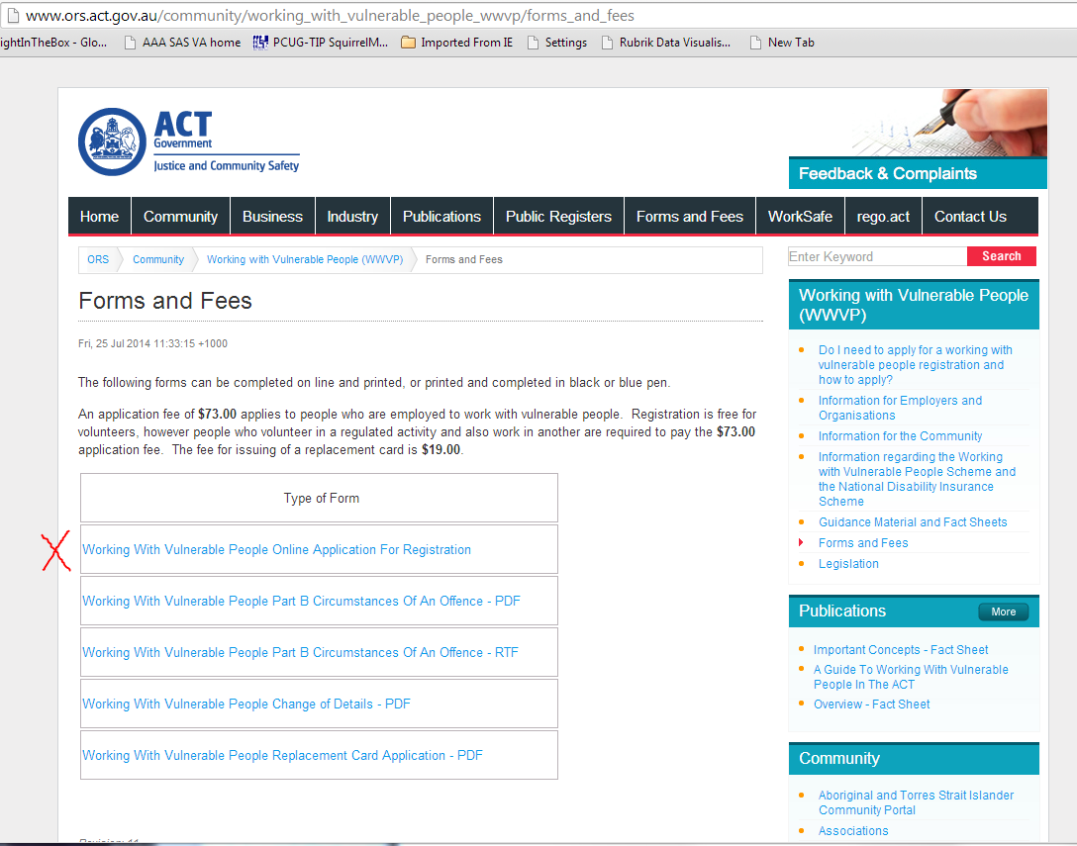

- Do it the easy way and select Option 1 - Complete the Online Application.
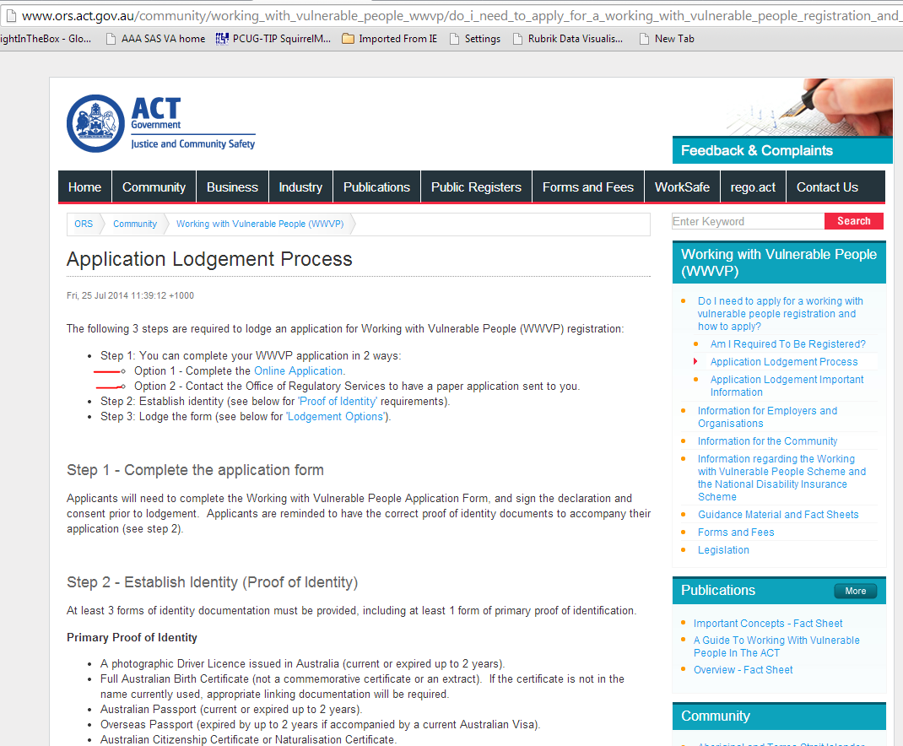

- Select “CONTINUE TO APPLICATION”
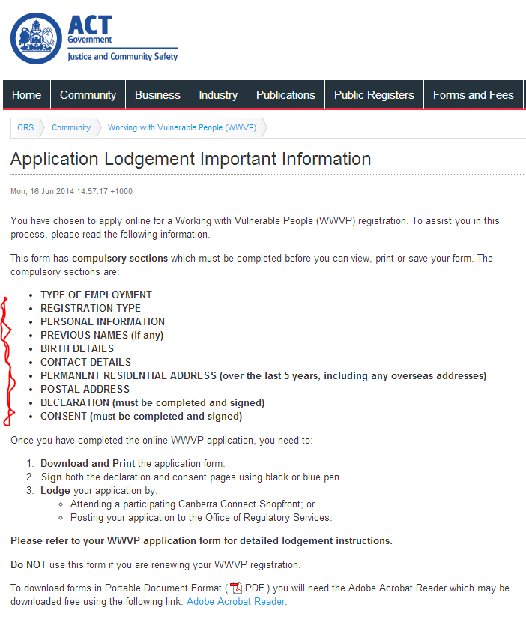
- Click on check boxes “volunteer” and “general” and fill out the details and click on submit
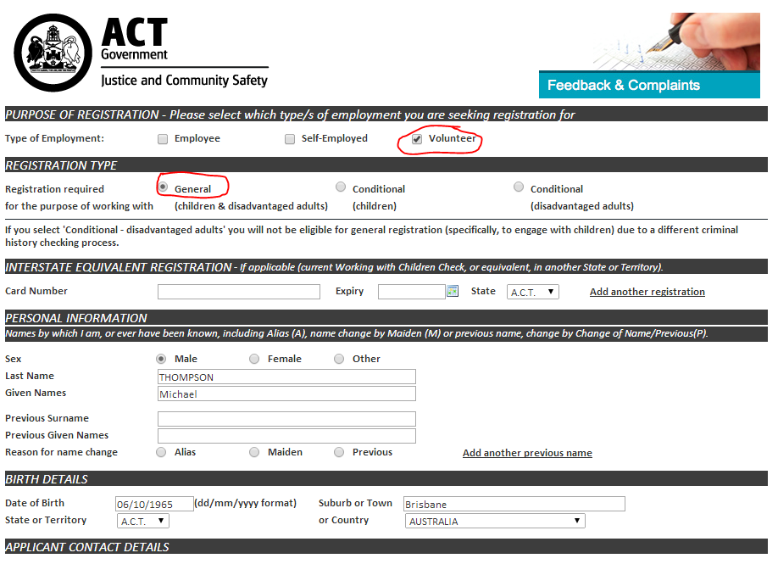

- Take note of the application reference number and print off a hard copy of the application form. Please note occasionally the printing fails – in this case call (02) 6207 3000 and request the .PDF to be emailed to you. Please email WMFC_MPO@iinet.net.au with the application reference number and the position you hold in which team.
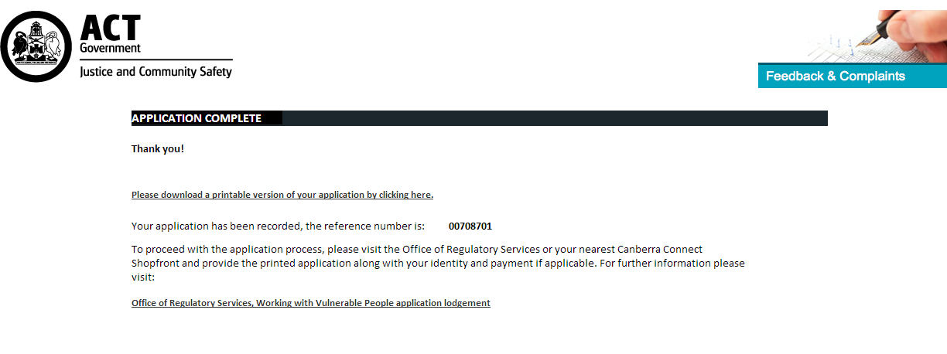
- Now take the form to an ACT government shopfront to submit. Please take identification with you – Drivers licence/Passport and a credit card is usually enough – Check on the form you printed out.
- Your card should arrive in about 3 weeks.
- When your card arrives please email WMFC_MPO@iinet.net.au with the card number and the position you hold in which team. If possible please include a photo/scan of the card. (include a scan/photo of the card if you can)
Any Q.s contact me at WMFC_MPO@iinet.net.au or (m) 0410692909
Michael Thompson – Member protection officer - WMFC

