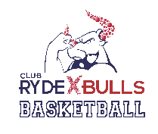
RYDE BULLS BASKETBALL Ltd.
CONDITIONS OF ENTRY

BY ENTERING THE CLUB RYDE X SPORTS STADIUM, RYDE AQUATIC OR ANY VENUE UNDER THE CONTROL OR DIRECTION OF RYDE BULLS BASKETBALL Ltd YOU ARE AGREEING:

1. To abide by Ryde Bulls Basketball Ltd. Codes of Conduct, Zero Tolerance Policy and
Competition By-Laws.

2. To adequately supervise any minors under your care.

3. To obey any reasonable direction from a Ryde Bulls Basketball official or staff member.

4. To the use of your photograph for promotional purposes. (Photographs will not contain
information to identify individuals.)

5. To refrain from bringing animals, glass, weapons, bicycles, skateboards or any other item
likely to cause inconvenience to other patrons into the stadium.

6. To refrain from consuming alcohol or drugs on the premises, or being intoxicated whilst on
the premises.

7. To refrain from smoking on the premises.

These guidelines have been developed in order to maintain patron and staff safety. While staff are expected to enforce the Conditions of Entry at all times, discretion may be required in certain circumstances.

