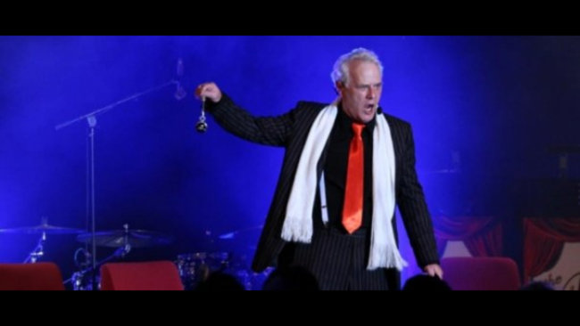

SHANE HILL HYPNOTIST
Back by popular demand appearing at
LAKE MULWALA SPORTS CLUB
Saturday 20th of February 7pm
Tickets $45.00 per head
Contact Kerrie McNamara
0428432063
Includes Nibbles. Drinks at bar prices
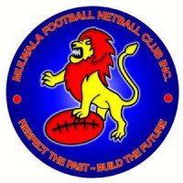
Get your tables together
Fabulous night guaranteed

