PIVOT CITY BASKETBALL – NEWSLETTER
SEPTEMBER 2013
A few words from the President:
Dear club members and supporters,
We approach the end of the 2013 Championship season in good health as a basketball club and community contributor. While we have enjoyed sustained success over the last 10 years bringing much joy to people associated with our great club, it is the friendships formed in the club and the culture we have built in our 63 year history that I get the most enjoyment from. I love seeing our committee, coaches, players and families at club events and games mingling and supporting one another and in many cases forming lifelong friendships. On this national day for mental health and asking Are You OK I think I can genuinely say that collectively our club is AOK.
It would be great to see that support for our teams in the Grand Finals this week and get a big crowd to the Division 1 Men’s game Tuesday 17 September at 8.30pm. We play our arch rival YMCA and have a chance to win four in a row to equal the record held by YMCA.
We have had a busy couple of months with another very well supported Junior Presentation Day, Bunnings Sausage Sizzle fundraiser and don’t forget the Senior Presentation Day Sunday 22 September 3pm at the Barking Dog, where we can reflect on another great year for Pivot.
Good luck to all the teams in Grand Finals this week.
Go Pivot
Craig Porte
President

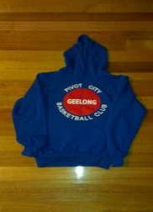
Reminder: Pivot City Hoodies must be ordered by Friday 20 September – see Pivot City Basketball website, Merchandise Menu
2013 JUNIOR PRESENTATION DAY
On Sunday 25 August we held our Junior Presentation Day at The Arena with special guest speaker Chris Scott (Geelong Cats Coach).
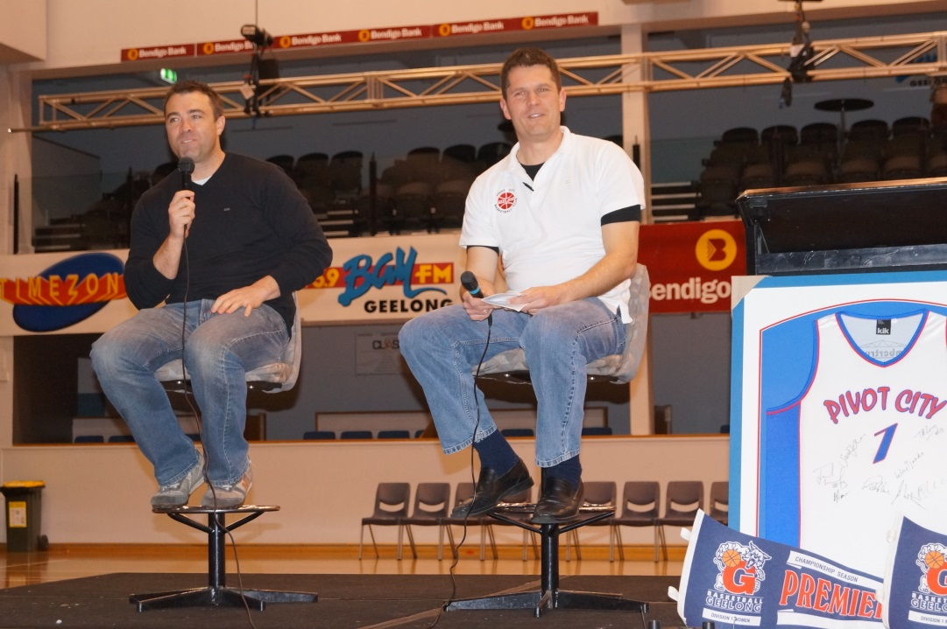
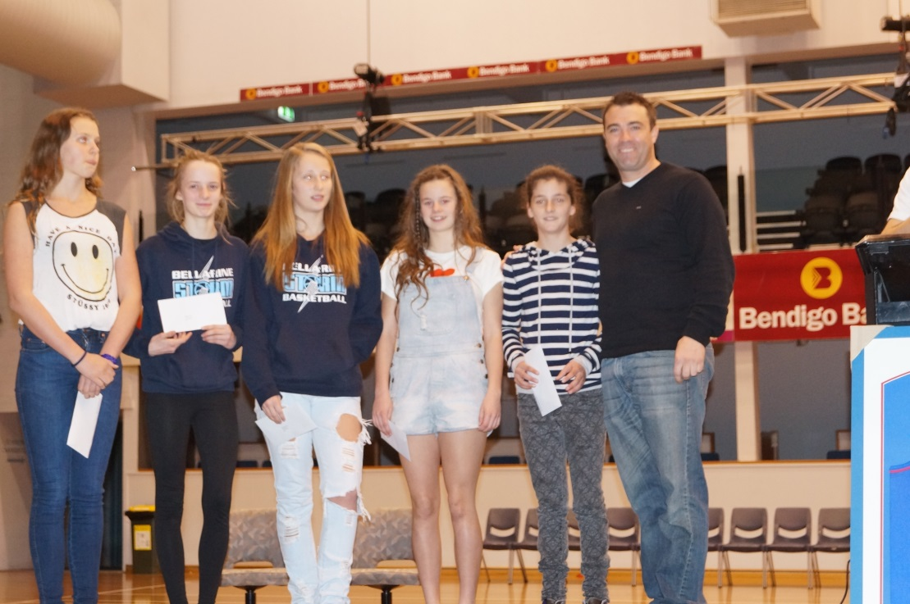
Chris Scott congratulates Pivot girls
Junior players enjoyed a clinic with Supercats Women players Bianca Cheever, Courtney Williamson, Abby Schrader and Sara Blicavs. Thanks girls.
Congratulations to all the award winners. See attached list of MVP’s and Coaches award winners.
The Michelle Chandler - OUTSTANDING Junior for 2013 was Carly Sanders. Congratulations Carly on a great basketball year.
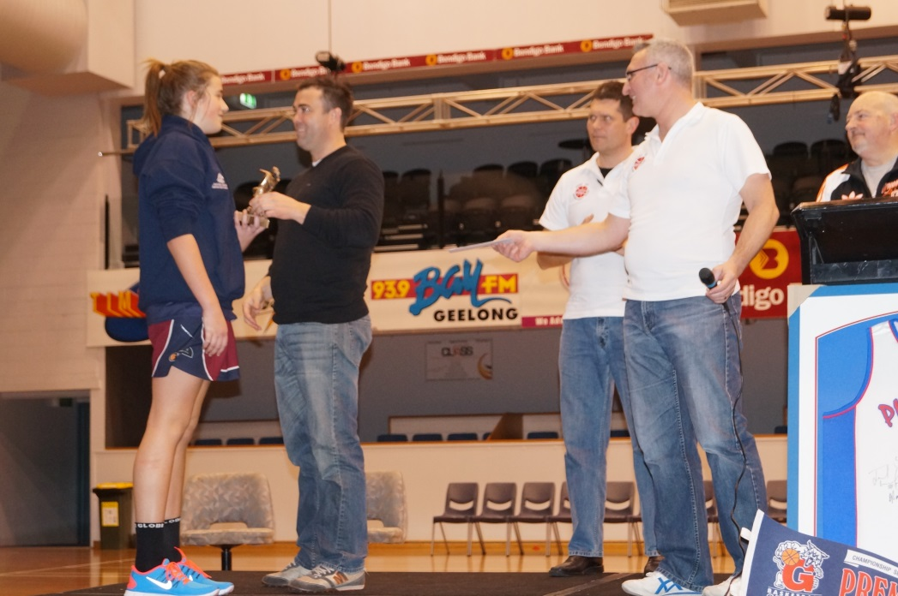
The Lesley Dandy award was awarded to Catherine Gillespie. Congratulations Cath and thanks very much for your efforts as a player, coach and secretary for Pivot City over a number of years.
Thanks to everyone for supporting our giant raffle and hope you all enjoyed the day.
Photos are available on the website – Select More Menus, Photo Gallery

SENIOR PRESENTATION DAY
SUNDAY 22 SEPTEMBER 2013 - 3pm
The Kennel - BARKING DOG WINE BAR & CAFÉ
126 Pakington Street, Geelong West
Finger Food & Drinks Provided
Men & Women DIV 1 MVP Awards
Pivot City Club Progress Update
Raffle & Door Prizes
All players, coaches & committee members welcome

BUNNINGS SAUSAGE SIZZLE
THANKS TO OUR VOLUNTEERS, BUNNINGS & COLES
Thanks to our volunteers, the support from Bunnings and to Coles for providing vouchers towards the cost of sausages, we made a total of $2,217.40.
Thanks very much to our volunteers – Craig Porte, Ross Gubbels, Linda Turner, Shane Minahan, Sue Goodhand, Carly & Kerrie Sanders & friend Indi, Justin Wigg, Matt Kennett, Kate Kennett, Cath Gillespie, Lauren Moloney, Michael Dacres-Manning, Steve Richmond, Tony Withers, Kate Schlicht, Raylene & Phobe Potter and Di Forsyth. Your help on the day was greatly appreciated.
Special thanks to our Treasurer Mick Pullen who did all the organising and also volunteered for the full day. Great job Mick.

GRAND FINALISTS – WINTER 2013
Tuesday night (17th September) at 8.30pm sees our Div 1 Men go for four premierships in a row. It would be great to have a big Pivot crowd with lots of support for the boys.
Good Luck to all teams in Grand Finals this week and it would be great to see lots of support for all teams this week.
Monday 16th
- U14BC Pivot City (Angus Kramer)
- D2M Pivot City (Michael Pullen)
Tuesday 17th
- U14GB Pivot City (Stephen North) v Pivot Raiders (Will Meyers)
- U20GA Pivot Raiders (Kevin McBain)
- ARes Men Pivot City (Gordon Treble)
- Div 1 Men Pivot City (Adam Clapinski)
Wednesday 18th
- U12BA Pivot City (Darren Hall)
- U14BA Pivot City (Murray Lovell)
- U16BA Pivot City (Tim O’Leary)
- U18BA Pivot City (Tim O’Leary)
Thursday 19th
- U12GA (Joe Andonovski)
- U16GA Pivot City (Tim O’Leary) v Pivot Raiders (Brendan Matthews)
SUMMER SEASON BEGINS MONDAY 7TH OCTOBER
Teams are currently being finalised and coaches will be contacting players in the next couple of weeks. If you have any queries re summer season please email pivotcitybasketball@hotmail.com

Rebel Support Your Sport Program
Our club has been selected to participate in the Rebel Support Your Sport Program. Under this program, the club can earn 5% of your purchases at Rebel Sport as instore credit to spend on our sports program.
All you need to do is join Rebel Season Pass, select our club from the list of participating groups and swipe your loyalty card every time you make a purchase at Rebel Sport. You'll receive access to great member prices and other initiatives and the club will receive a 5% credit.

CLUB CHAMPIONSHIPS
Good Luck to all players and coaches representing Pivot City at the Club Championships in Bendigo on 5th & 6th October.
Pivot teams and coaches are:
Boys:
- U12 (Darren Hall)
- U14 (Murray Lovell)
- U16 (Tim O’Leary/Ross Gubbels)
- U18 (Tim O’Leary)
Girls:
- U12 (Joe Andonovski)
- U14 (Craig Porte)
- U16 (Tim O’Leary)
- U18 (Jason Reardon)

REGISTRATION – Reminder that all players must pay Pivot City club registration (as well as Basketball Geelong registration). If you have not paid Pivot club registration you are ineligible to play for Pivot. If you have any registration queries please email pivotcitybasketball@hotmail.com

PLEASE SUPPORT OUR SPONSORS:

Harcourts North Geelong Real Estate
northgeelong.harcourts.com.au
Please contact Helena Fantela and Joe Grgic at the below contact details for all your real estate needs.
Harcourts North Geelong
North Geelong Real Estate Pty Ltd
127 Seperation Street, North Geelong
Phone: 03 5278 7011
email: northgeelong@harcourts.com.au

Aussie Farmers Direct
Shop with Aussie Farmers Direct, nominate Pivot City Basketball as your fundraiser and 2% of your total annual spend will be donated to Pivot City Basketball Inc.
click here Aussie Farmers.com.au
Aussie Farmers Direct is a free home delivery service providing fresh products that are 100% Australian owned and produced.

Email: pivotcitybasketball@hotmail.com
Website: www.pivotcity.geelong.basketball.net.au

