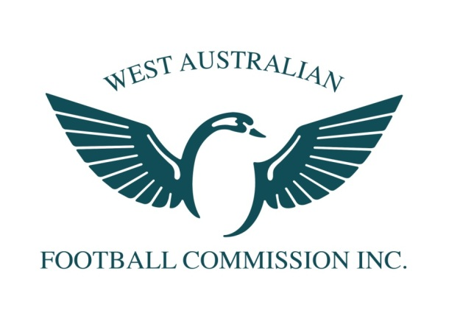
WAFC Female Football Development Squad
Strength and Conditioning Coach

POSITION TITLE: Female Football Development Squad: Strength and Conditioning Coach (16-18yrs)

DATE ASSUMED POSITION: December 2014

REQUIREMENTS: 2 x 2 hour Saturday morning session per month + 2 representative games

EXPECTED DATE TO CEASE POSITION: December 2016

KEY FOCUS OF THE ORGANISATION

To enhance and promote Australian Football throughout the community, encourage greater levels of participation for young females, enjoyment and commitment by individuals, community groups, business and government

KEY FOCUS OF THIS POSITION

- To create an elite developmental environment that is conducive to both learning and enjoyment for young female football players
- Contribute to the development of skills, physical attributes, football knowledge, personal growth and self-esteem of all players
- Establish, implement and coordinate appropriate rehabilitation programs that maximises the recovery of all players
- Lead and influence all players and staff in a positive manner.
- Minimise the number of injuries players receive while training
- Conduct training sessions to maintain optimum strength and conditioning of all players
- Develop and implement a training program that will assist players in their physical preparation for football matches. Copy supplied to Head Coach.
- Ensure work cooperatively with all coaches in training sessions.
- Report all injury concerns to the Sports Trainer/ Physiotherapist.
- Ensure that safety of training is paramount.

STRENGTH AND CONDITIONING COACH REQUIREMENTS

Planning and Implementing Training Sessions

- Attend training sessions
- Influence the program to cater for individual differences, rehab, and varying player workloads
- Support the planning and execution of all allocated training sessions and practice matches by the Head Coach
- Manage cool down sessions
- Maintain accurate player profiles, contact details, training programs
- Keep accurate record of training programs of individual players
- Develop close rapport with playing group and act as a liaison between players and coaches as needed
- Effectively liaise with Assistant Coach, State Coaches and WAFC Female High Performance Manager re: player welfare and injury status
- Ability to report and contribute to the planning review process at the conclusion of the program in conjunction with all coaches

Human Resources

- Encouragement and support of players individual development
- Provide feedback to all players where relevant
- Report to the Head Coach and WAFC Female High Performance Manager on all matters pertaining to the program and player welfare
- Assist in the mentoring of the playing group
- Demonstrate leadership and feedback to all players and coaches
- Work cohesively with other Assistant Coaches
- Possess sound conflict resolution skills

Information, Communication and Management

- Provision of accurate and timely feedback (verbal, written, visual) to all players/staff (including medical and support staff)
- Appropriate instructions to players at training sessions
- Liaise effectively with all coaching and support staff
- Contribute to reviews with the support of all staff

Talent ID and Selection

- Liaise with selectors and Assistant Coaches on matters of team/ squad selection & talent identification
- Liaise with the Female High Performance Manager re: the new Development Squad
- Assist the coaching staff by supplying accurate player information re: injuries and rehabilitation programs

Football Knowledge
- Demonstrate some knowledge of football coaching techniques
- Demonstrate some knowledge of WAFC Talent Pathways and programs
- Commitment to ongoing personal development in the area of strength and conditioning

Public Relations

- Attend all functions as requested by the WAFC relating to the WA female Talent Program
- Communicate with the Female High Performance Manager when required
- The Team Strength and Conditioning Coach shall wear approved WAFC talent apparel for all training sessions, team or representative functions and matches.
- Attend the Lap of Honour to represent the team at the WAFL Grand Final in September

Personal Traits
- Ability to demonstrate empathy for players and staff
- Ability to demonstrate honesty and integrity in all roles within the Development Squad
- Ability to motivate through a variety of mediums
- Ability to facilitate players and/ or staff personal development
- Highly developed and proven written, verbal and visual interpersonal skills
- Highly organised
- Approachable

SELECTION CRITERIA REQUIRED:

1. Minimum Bachelor of Applied Sciences qualification or related certification
2. Demonstrated leadership skills
3. Demonstrated knowledge, involvement and understanding of talent development programs
4. Highly developed verbal and written communication skills
5. Demonstrated ability to construct quality strength and conditioning programs
6. Demonstrated ability to develop high levels of team unity
7. Current Working With Children Check

Please note - current State Female Coaching staff are not permitted to apply for this position.
All Expressions of Interest should be received by 5.00pm Thursday 6/11/2014 and must include the following;
- Covering Letter (1 Page max)
- Coaching CV (2 pages max)
- Selection Criteria (3 pages max)

Applications not fulfilling these requirements will not be considered. Questions or queries may be directed to Alison Moore on 0430868145 or amoore@wafc.com.au

Applications should be addressed to;
Alison Moore
WAFC Female High Performance Manager
PO Box 275 Subiaco WA 6904
Email: amoore@wafc.com.au

TERMS AND CONDITIONS
Remuneration:

The following benefits will be provided:
* WAFC Female Talent Academy apparel
* WAFL or AFL Tickets where possible
  - Term of the Appointment:
* This is a two (2) year appointment. An option of an extension may be applied subject to satisfactory performance and a detailed review by the WAFC.
* Any coach who coerces players to their own club in an unprofessional manner will be subject to investigation and dismissal from this Talent coaching position

I hereby agree to the terms outlined in the above document:

_____________________________ ___________________________

Alison Moore
Development Squad S+C Coach Female High Performance Manager

Dated this the ___________ day of __________________________ 2014.

