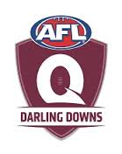
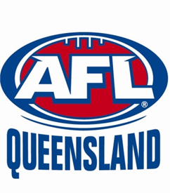
Multicultural &
Indigenous students
AFL Trial Day (Grade 5-6 boys & girls)
Monday 27th July 4:30-6pm
(USQ AFL Oval, Baker St)
• All Darling Downs students are invited to try out for the Indigenous &
Multicultural AFL teams that will compete for the first ever Diversity Cup on
Saturday 8th August.
• This is a free event supported by AFLQ and AFLDD where all playing
equipment will be supplied.
• The Trials are for those in grades 5-6 boys and girls
• Indigenous & Multicultural teams will be selected at the conclusion of the
trials day & selected players given further information on the upcoming
Diversity Cup game (8th August)

Coaches for Indigenous / Multicultural teams 2015 as follows
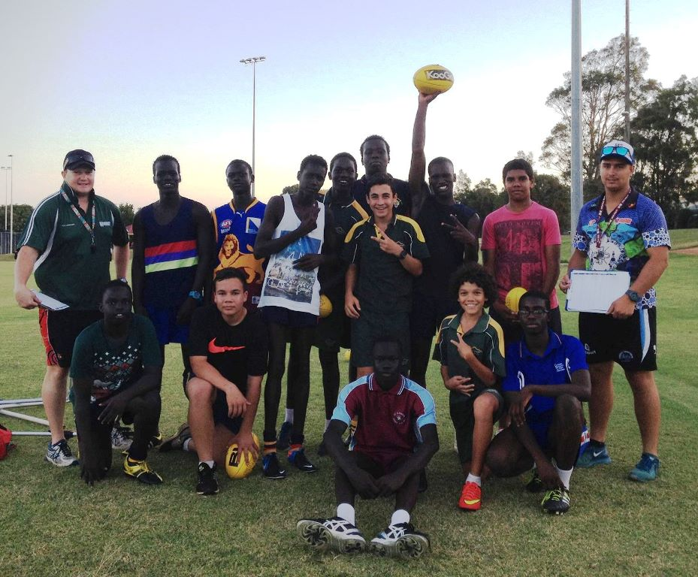
Indigenous coach (Dustin Wilson) & Multicultural coach (Peter Naumann)

For more information:
Keith Webb 0438 890 379
keith.webb@aflq.com.au
Fax: 4659 8001
www.darlingdowns.aflq.com.au
Darling Downs AFL Queensland

Please email, fax, post or drop off your registration form AFL Office 337 Ruthven St, Twba

