Minor Games / Game sense
Presenter: Paul Schwartz

Ball Handling Drills
- Body wraps around ankles, knees, waist / Figure 8’s through the legs / catch the ball from front to back
- Handball out in front of self and regather
- Back to back body twist the football with a partner
- Pass the ball under the legs and over the head with a partner
- Ball Drops–Partner A holds ball above head or waist and drops the ball for Partner B to catch (hands above head)
- Ball Drops – Partner A and Partner B hold balls side by side at waist level, on go call drop ball and catch partners
- Tap the ball with hand out in front on the move self, partner or lane work
- Throw or Handball the ball up and mark self or partner or lane
- Bouncing the football
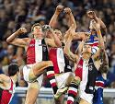
Relay / Tag games
- Spiders/flys
- Forwards/defender(roosters/hens)
- Ball tag
- Dodgems
- Number the lines
Fitness Games
- Knee slaps
- Foot stomps
- Duck fight
- Balance tug (witches hat in middle)
Grids
- Keepings off
- Shepherding
- Tackler
- Criss cross handball
- Making position
- Reactions
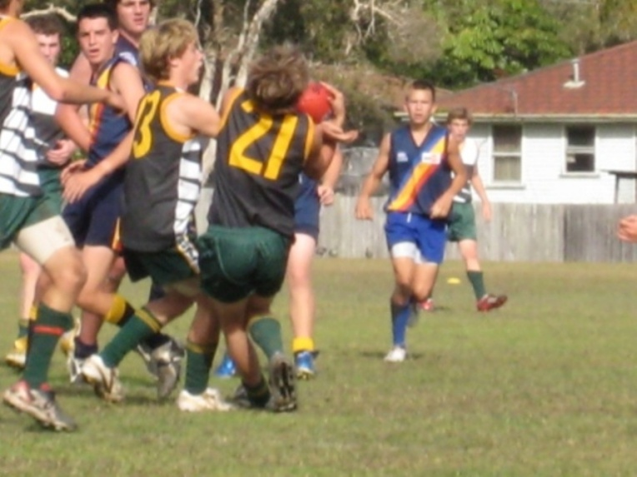
Minor Games
- Free ball / Matball
- Bombs away
- Circle bombardment
- Bombardment
Space Awareness Games
- 30/30
- Alien Invaders
- Scatter Ball
- Tag Team

