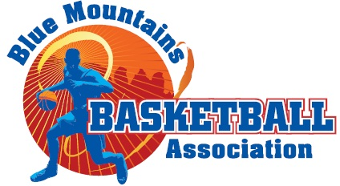

COVID-19
RETURN TO BASKETBALL
The following procedures have been put in place in response to the current COVID-19 situation in NSW
Blue Mountains Basketball intend to enforce these policies and procedures and will ask anyone who is unwilling to comply to leave the courts immediately
Please Stay home if you are unwell or if you have visited any of the NSW hotspots.
- Two (2) Family member spectators per participant to attend games. Spectators MUST maintain 1.5 social distancing at all times.
- Spectators must check in via the QR code and present this when entering the courts.
- No swapping over of spectators during game
- Entry point at the top of stairs on court 1
- Arrive at your game at the exact scheduled time no earlier.
- ARRIVE, PLAY, LEAVE
- Players to arrive ready to play, change rooms are closed.
- Players and spectators to leave promptly after their game allowing us to thoroughly clean before the next game
- If you are wanting to spectate another game you must vacate the court you are on through the bottom exit via the pool end and come back through the Entry point.
- No crossing over between courts
- Team manager/coach to sign all players in and cross out players not attending. Referees will hand the sheet to managers before the game starts
- DO NOT attend if you have any cold or flu like symptoms, visited any of the hotspot areas, been overseas or been in direct contact with a known case of COVID-19 in the last 14 days.
- Sanitise hands on entering and leaving the courts
- Hand sanitiser provided to be used in between halftime breaks, time outs, and substitution
- No handshaking, high fives etc by players or referees (Managers please remind players)
- Only the manager to bring a ball, one ball per team. Ball must be sanitised on entry.
- Each team to supply one person for the Bench
Thank you for your understanding, these rules have been put in place for the health and safety of all players, spectators and volunteers.
Please follow all rules NO EXCEPTIONS. If these rules are not adhered to BMBA will have no choice but to suspend the competition. No Refunds will be given.

