Expression Of Interest  Coaching Positions in 2015 | 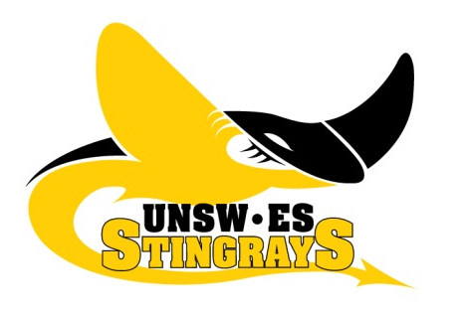
AFL SYDNEY WOMEN’S
The UNSW-ES Stingrays are a women’s Australian Rules Football Team team and form part of the UNSW-ES Bulldogs Australian Football Club – the largest Club in NSW based at the Village Green at the University of NSW, Randwick. We are the original eastern suburbs Australian Football club, with a heritage that goes back to the late 1800s.
The Stingrays are one of 4 founding teams of the Sydney Women’s AFL competition, which started in 2000. We are a passionate group of AFL players and supporters, who love being part of an inclusive and supportive club culture. We are proud to be known for our acceptance of all playing abilities, cultural and sporting backgrounds, and our ability to be a strong and cohesive team, both on and off the field. We are well supported by the men’s club which boasts 5 senior and 1 under 19’s teams.
In 2014 the Stingrays became the first women’s team to be represented in both the Division 1 and Division 2 competitions. Our Division 1 team finished second after the regular season, and was narrowly defeated in their first ever grand final appearance. Whilst our inaugural Division 2 side narrowly missed out on the final series which was a solid performance for their first season. We have a solid playing group and are look forward to an even more successful season in 2015.
We are currently seeking expressions of interest from suitably qualified individuals interested in being the Coach of our Division 2 side. Tracey Kick will continue as the Division 1 Head Coach, bringing with her several years of local and state level experience. Tracey is currently supported by 2 assistant coaches who also assist with the development of Division 2 players.
The Stingrays are looking for the following attributes from prospective coaches:

- Commitment to the 2015 AFL season, including training (1 x 1.5 hours/week for division 2 – possibility of 2 sessions per week dependent on coaching preferences) and a game (either Saturday or Sunday at varying times);
- Demonstrated ability to work as part of a coaching team
- Sound understanding of the game of Australian Rules Football
- Passion for women’s sport;
- Desire to develop existing Stingrays and new players in 2015, with the ability to account for a wide range of ability levels through an innovative approach to training activities;
- A thorough understanding and demonstration of the skills required to coach a team sport, including a commitment to the team values of Respect Unity and Commitment
- An ability to inspire and lead in the name of sportsmanship and;
- Desire to foster and contribute to a positive club culture by being open and accepting to regular feedback and communication.

Previous coaching experience within AFL would be ideal however this is not a strict criterion to fulfill the position. Demonstration of previous coaching and/or teaching experience in a team sport role will be highly regarded. All coaches have to hold a minimum Level 1 AFL coaching certificate. Applicants must hold or be willing to obtain this.

Ultimately, the appointed Division 1 and Division 2 Stingrays coaching staff will work together as a united team that has the best interests of the club and the players at the forefront of their decision-making and coaching vision.

For further information about these opportunities, please email us at unswstingrays@gmail.com

