FREESTYLE SOCCER KIDS
By Jack Kynaston

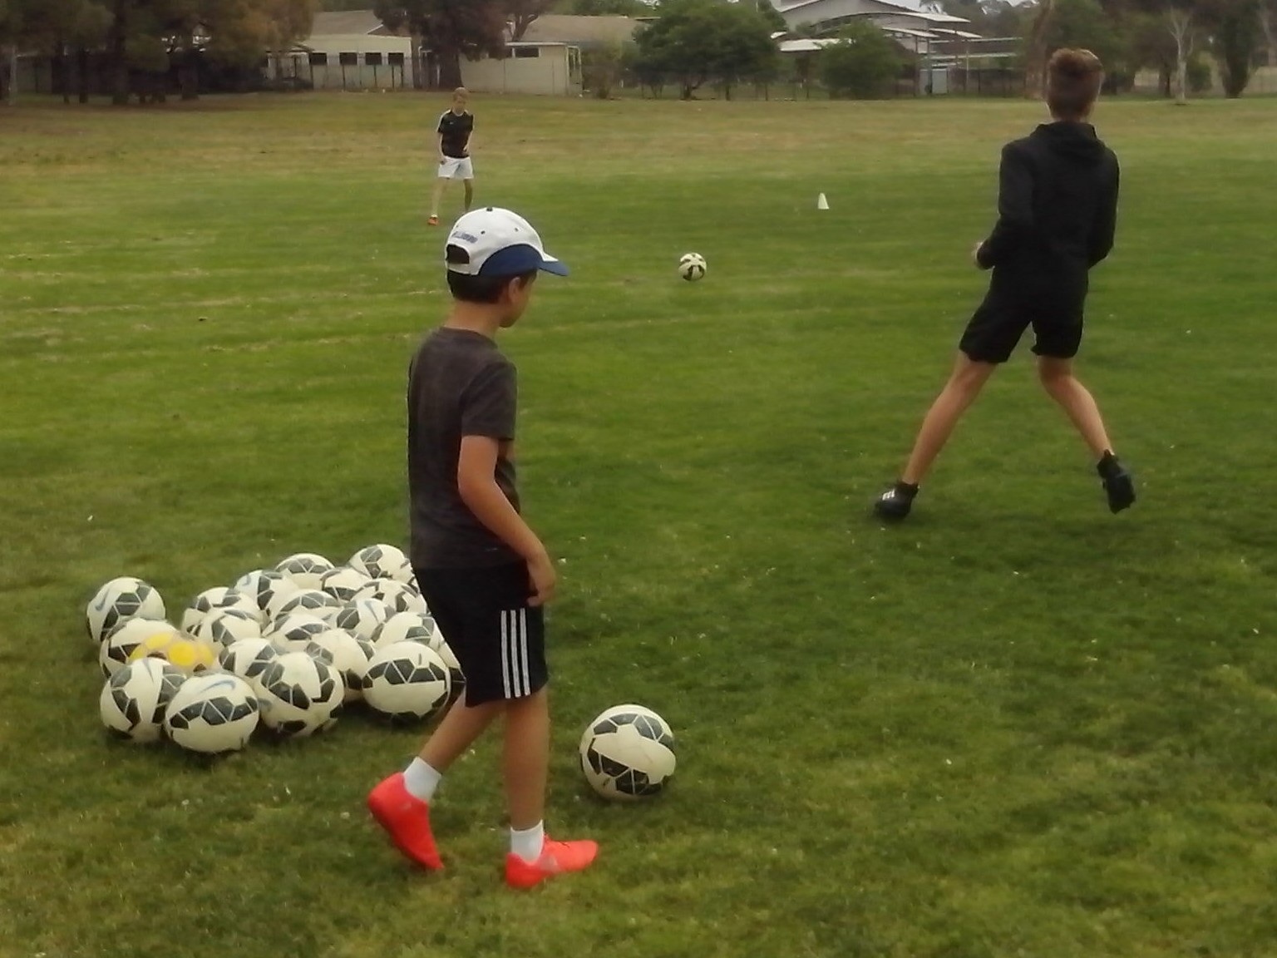

Who looks at all the original and innovative ideas in Australian Soccer?
ALL KIDS
All kids are different. All kids have talent. All kids make mistakes. All kids can practise. All kids can improve. All kids can learn. All kids need is a ball.
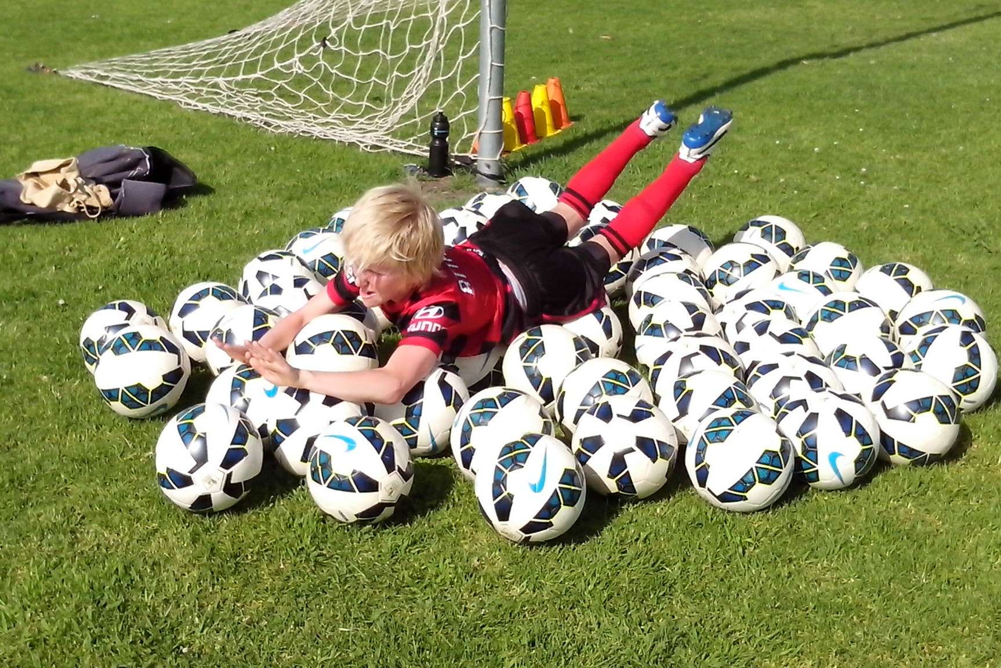
A coaching system teaches skills and tactics so that kids can win games. A learning program observes individual kids and identifies strengths and weaknesses so that kids can grow. There are simple ways to stimulate intelligence, activate energy, integrate natural characteristics, reduce anxiety and inspire confidence with ballplay.
All kids learn. Some kids learn to do what they’re told and they’re easy to coach and other kids learn to think for themselves and they’re more of a challenge. We’re not helping kids by helping them. They need to learn how to help themselves. Kids achieve because they don’t know what they can’t do. Adults give up too easily because they know what they can’t do. We can learn a lot from the next generation.
FREESTYLE KIDS
Kids develop what we give them. We need to give them respect, responsibility, resourcefulness and resilience.
All across Australia, there are thousands of Freestyle kids who train on their own, or with their mates, at skate parks, BMX tracks, tennis courts, basketball courts and cricket nets provided by local councils who understand the needs of youth. Parents don’t tell kids to go to a skate park. They go because they want to improve. Freestyle kids don’t fall apart without adult supervision. They use their initiative to develop their health, fitness, self esteem and social skills. Freestyle kids are unique in Australian sport because they’re not too scared to question the old ideas or challenge the new ideas.
Resourceful kids can see for themselves, hear for themselves, believe in themselves, think for themselves and express themselves without well meaning adults directing their every move, correcting their every fault, protecting them from every failure or rejecting them for being different. Freestyle kids reflect the true Australian sporting identity.
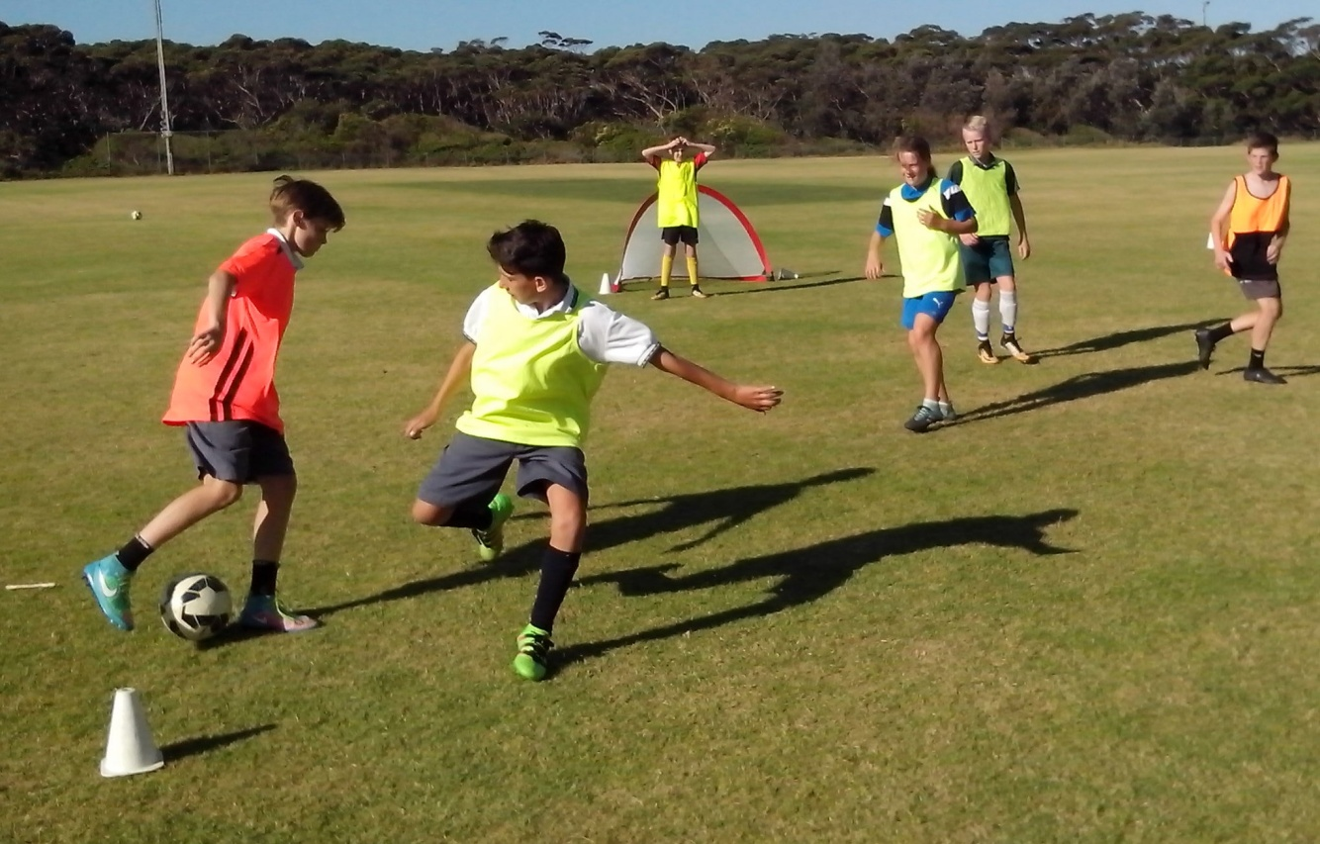
FREESTYLE SOCCER KIDS
A coaching system looks for kids who train when they’re told and do what they’re told. A learning program looks for kids who train without being told.
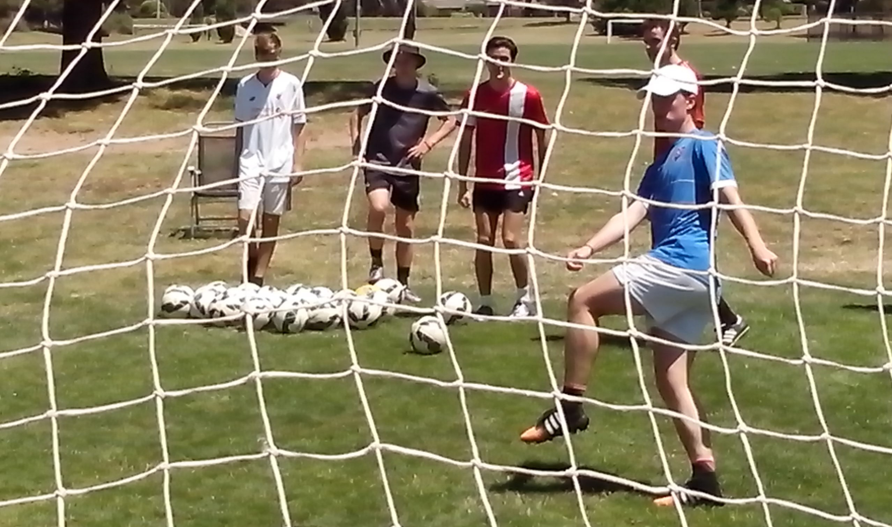
A skills park is like a skate park for Freestyle Soccer kids who know that Australia already has the talent to be a Top 20 Football nation. Some kids stick with what they know and they practise what they can do. They wait for something to happen and they always stay the same. Freestyle Soccer kids explore what they don’t know and practise what they can’t do. They make something happen and they lift their game.
Trying not to lose is not the same as trying to win. Trying to avoid competitive games is not the same as building confidence. The difference between kids who juggle and kids who struggle is simple repetition. Practice makes perfect. If we give kids skill, they will train for 100 hours a year. If we show them how to develop drills, they will practise for 300 hours a year. Freestyle kids are the only Australian players who know how to develop footwork, vision, power, precision, movement, decision, belief, repetition, challenge and intuition.
NATURAL SKILLS
We’re teaching perfect striking technique to kids who don’t know how to move their feet or what to look at when they kick a ball.
Skilful kids dominate a game with the ball. Talented kids dominate a game without the ball. The average Soccer kid has the ball for 5% of each game. They need Soccer skills for 5%. Freestyle kids use natural skills for the other 95%. They grow because they look at what we do, listen to how we do it, ask why we do it, understand where to do it and can decide when to do it. Anyone can keep correcting the same mistakes. Freestyle kids discover and eliminate the underlying cause.
Kids need their natural skills to develop their Soccer skills. They can’t strike the ball smoothly if their feet are glued to the ground and they can’t strike the target accurately if they take their eyes off the ball. They can’t support a ball player if they don’t know where to move or what to call. They can’t learn if they’re too scared to make mistakes.
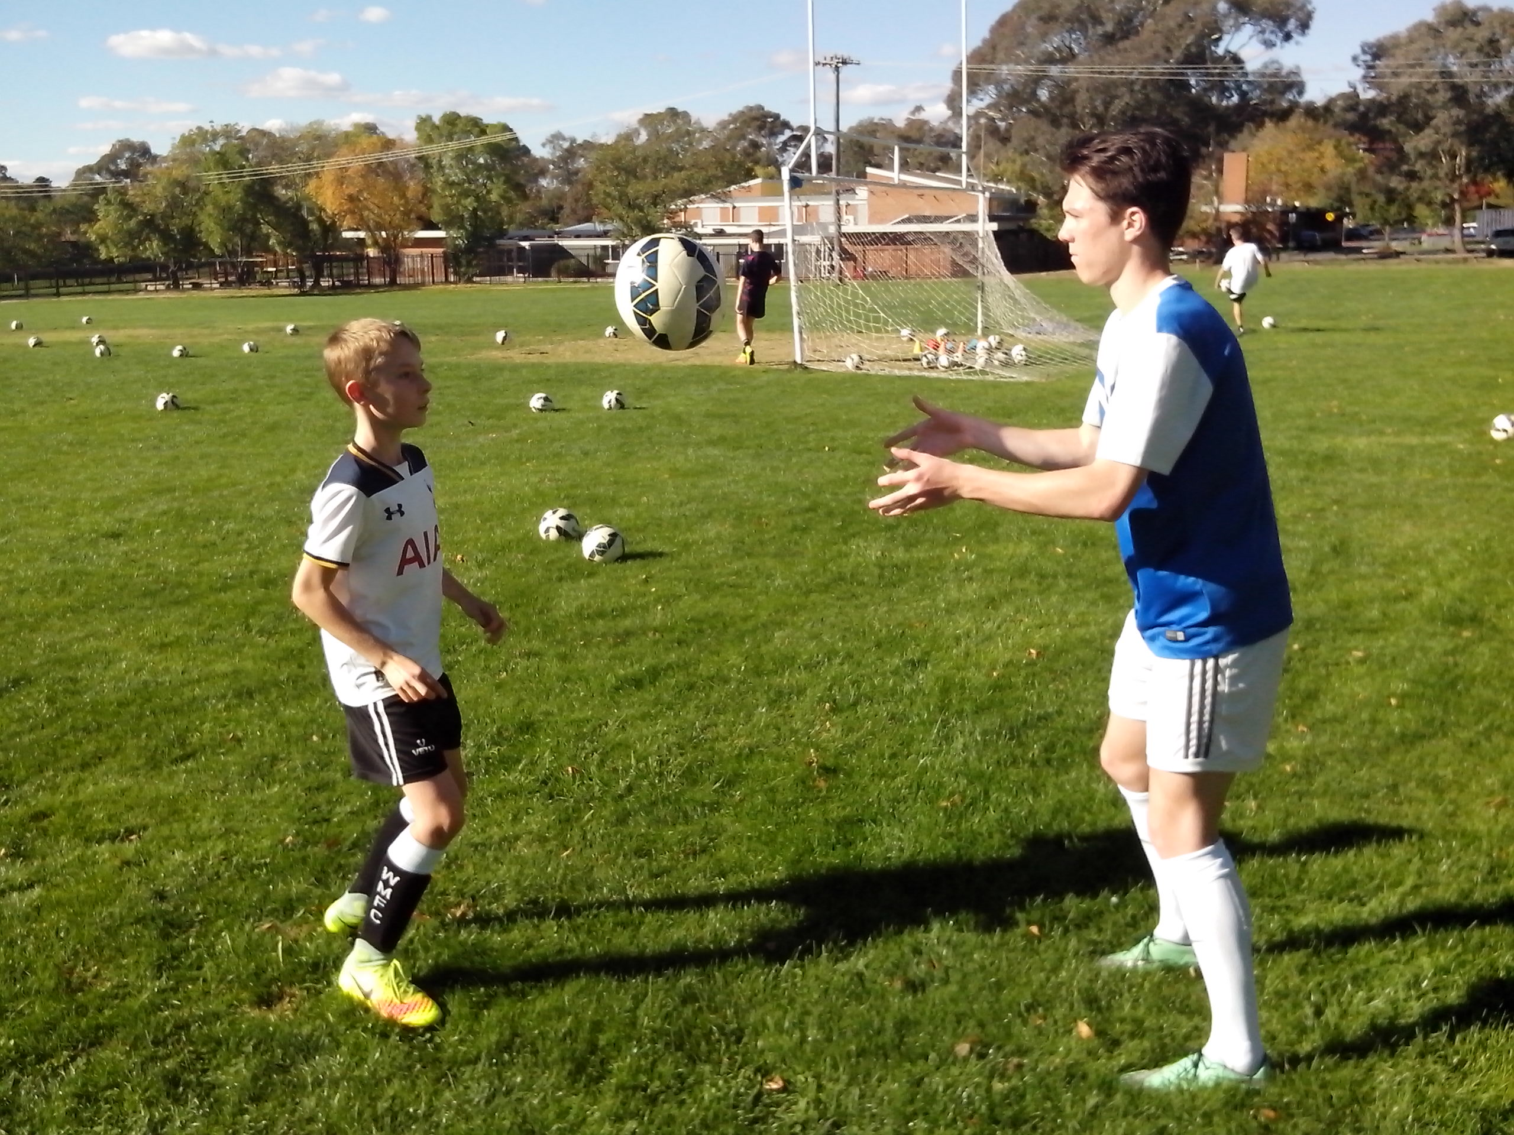
MOTOR SKILLS
Kicking is a basic motor skill just like walking and throwing. We develop motor skills at three levels.
At the cognitive level, we stop to think and we take it slow. At the associative level, we can begin to think on the move. Slow becomes smooth. At the intuitive level, we can make the right move without thinking. Smooth becomes fast. Freestyle kids learn at the cognitive level, practise at the associative level and play at the intuitive level.
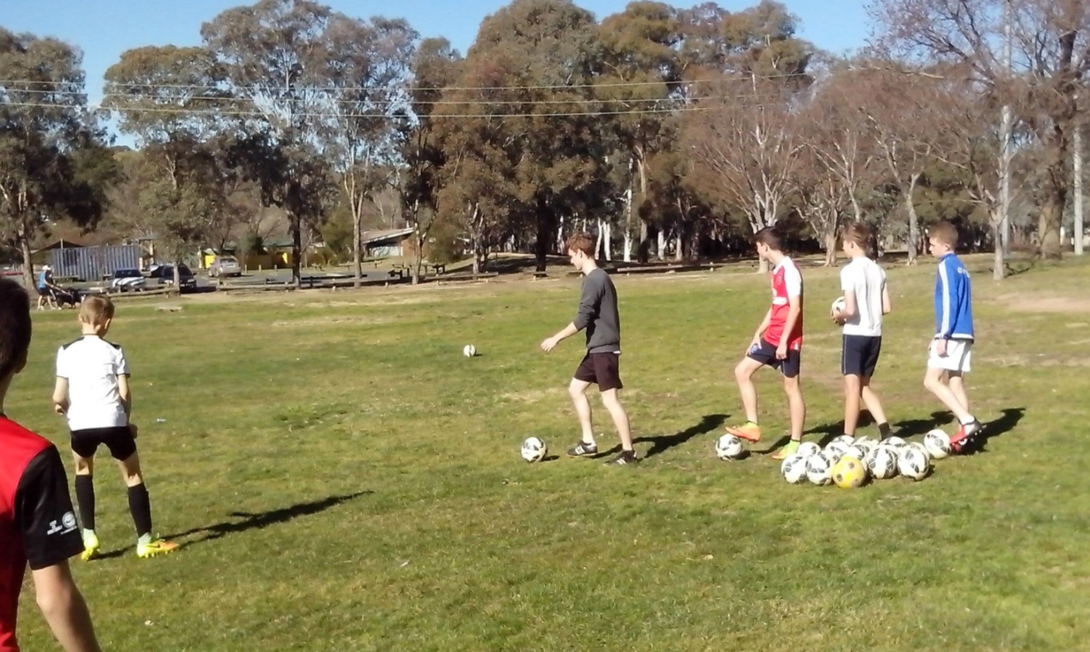
Some Soccer kids stay at the cognitive level for too long. At training, they stand in a line waiting to get one shot at goal every two minutes. They forget what the last shot was like. In games, they stand still and watch the ball player and they wait for the pass before they make a run or they play it safe and wait for the coach to tell them what to do.
Other kids try to reach the intuitive level too quickly without building on their foundation first. At training, they only spend 15 minutes each week at shooting practice so they try power shots from outside the 18 yard box. In games, these same kids blast the ball over the bar from inside the 6 yard box because 100% force is their only default option.
TALENT
Skill is what kids develop when we tell them what to do. Talent is what kids develop when we don’t tell them what to do. Some kids don’t need to be told.
All kids have talent. If we believe that kids have the talent to reach the top, we will look for that talent and discover hidden qualities on the way. If we believe that kids lack the talent to reach the top, we will look for mistakes to correct and we will teach every kid to look, think, stretch, move, train, kick and play the same way for the same results.
In the search for natural Soccer talent, a learning program looks at character, intelligence, mindset, mobility, control, understanding, teamwork, drive, creativity and growth. We can’t teach talent and intelligence to fit and skilful kids but we can teach fitness and skill to talented and intelligent players. All kids are different. Talent is a combination of different qualities. Kids who have both talent and confidence will develop at the intuitive level. Kids who lack both talent and confidence can still develop successfully at the cognitive level. Talented kids who lack confidence are the easiest to improve. Confident kids who lack talent are the most difficult to improve.
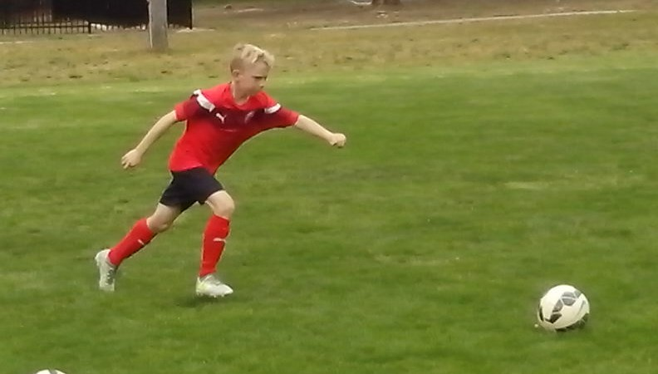
CONFIDENCE
Soccer should be fun, exciting and challenging just like shooting practice on a really windy day.
If kids lack confidence, it affects their performance and gives coaches the impression that these kids lack talent. They don’t. A goal kick takes four seconds from launch to landing but a lot land uncontested because most kids are scared of a high ball. Ordinary kids are scared of being different and different kids are just scared of being ordinary.
The power of one on one is the most effective way to give kids their confidence. All kids respond to an individual coach, teenage mentor or personal trainer who shows a genuine interest in their progress. We can discover so much hidden talent just by building confidence.
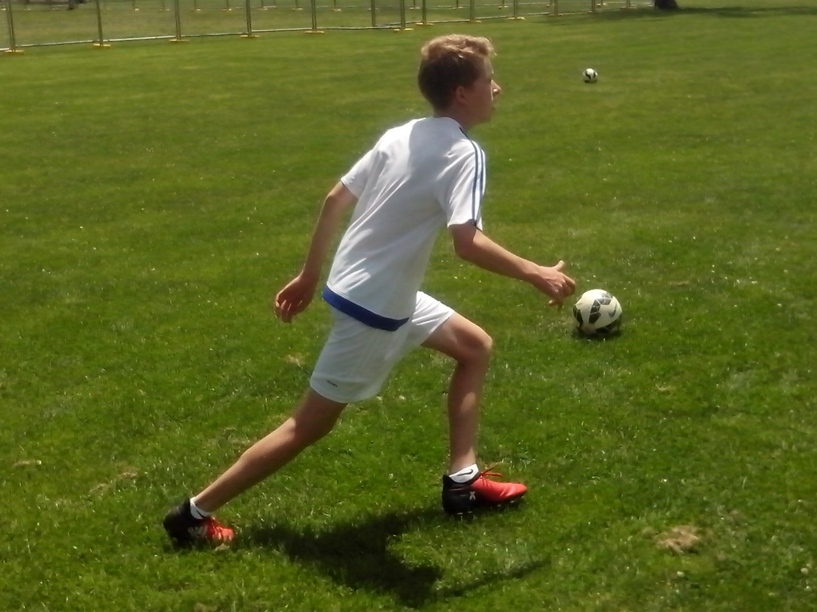
Confidence is the most important goal for any kid or teenager. Some kids don’t know what they’re playing at. They stand dead still and stay dead quiet in a game because they’re dead scared of being dead wrong. Freestyle kids can drive, strive, thrive and come alive because they have the confidence to be themselves and play their own game.
MOST IMPORTANT SUBJECT
The most important subject in Soccer is the player. The most important subject any kid can learn about is themselves.
We don’t know anything about our players. We don’t measure their skill/fitness performance/improvement. We don’t count how many ball touches they get before a game. We don’t know their strengths, weaknesses, skills, talents, fears, needs or limits. We don’t know how fast they can run, how hard they can kick or how far they can throw.
Freestyle Soccer kids practise what they can’t do until they succeed and they keep a record of fitness and skill levels so they know what they’re up to. They never stand around waiting for the coach to arrive. They know that they need 200 ball touches for eye/foot coordination to kick in. They know what to aim for and what to look at when they shoot. They know that they’re responsible for every game that they play because the other team can only play as well as they let them. They never foul, retaliate or complain so they stay focused in a game.
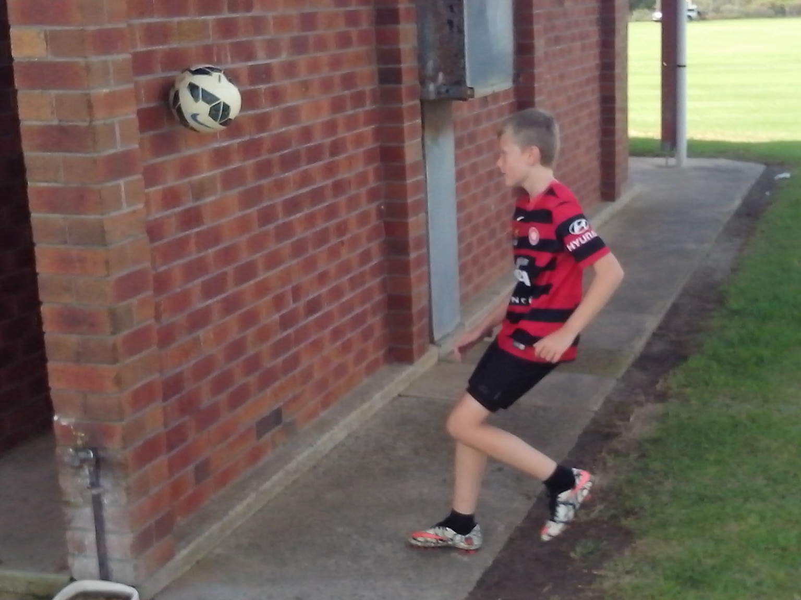
JOY OF DISCOVERY
Coaches develop skills so that kids can play games. Freestyle kids play games so they can develop skills.
Coaches see what they’re trained to see so they look at technique and look for mistakes to correct. When kids head the ball, coaches focus on the head so they can correct the poor heading technique. Freestyle kids look at everything. They soon discover that the kids who lunge at the ball stand flat footed. They search for the underlying cause. Then they use close heading in pairs to coordinate movement and control.
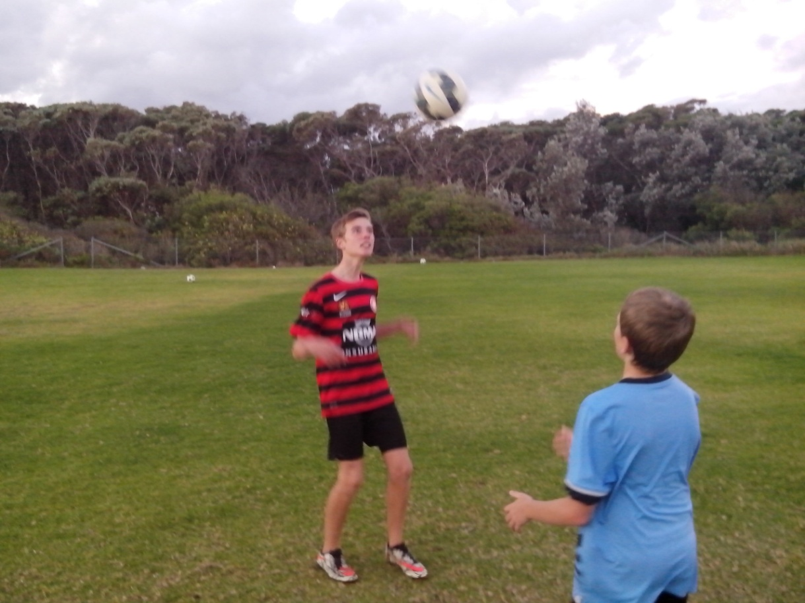
Kids know from practice that it takes 200 kicks for control to become second nature. When kids juggle a ball thirty times, they discover that the last ten numbers are much higher than the first ten. Freestyle kids don’t believe in best practice. They search for better practice. In the leading Football nations of the world, we can look at elite academies to see how they teach or look at the millions of kids on the beaches and streets to see how they learn. These Freestyle kids are 1 million steps ahead of Australian Soccer kids. They make the best of what they have. Some kids learn how to pass. Some kids learn how to fail.
CHALLENGE
Some look at a challenge and can only see a problem. Some look at a problem and can only see a challenge.
The simple solution to a problem is to avoid it. There are simple ways to ignore new ideas or kids who are different. The easy way to avoid concussion is to stop heading. Freestyle kids learn to head the ball safely using close repetition drills. The easy way to stop missing shots is to stop shooting. Freestyle kids who practise shooting for two hours with 100 balls learn how to score goals. The easy way to avoid failure is to blame the ref. Freestyle kids take responsibility for every result.
Keeping the ball on the ground doesn’t build confidence in the air. Playing non competitive games doesn’t produce resilient players. Any kid can become one footed but soon get left behind by two footed kids. Any kid can play it safe and just copy other kids but Freestyle kids open their minds to different ideas so they can lift their game. The most effective way to motivate Freestyle Soccer kids is to tell them what they can’t do and then sit back and watch how they do it. The future of Australian Soccer belongs to the innovation generation.
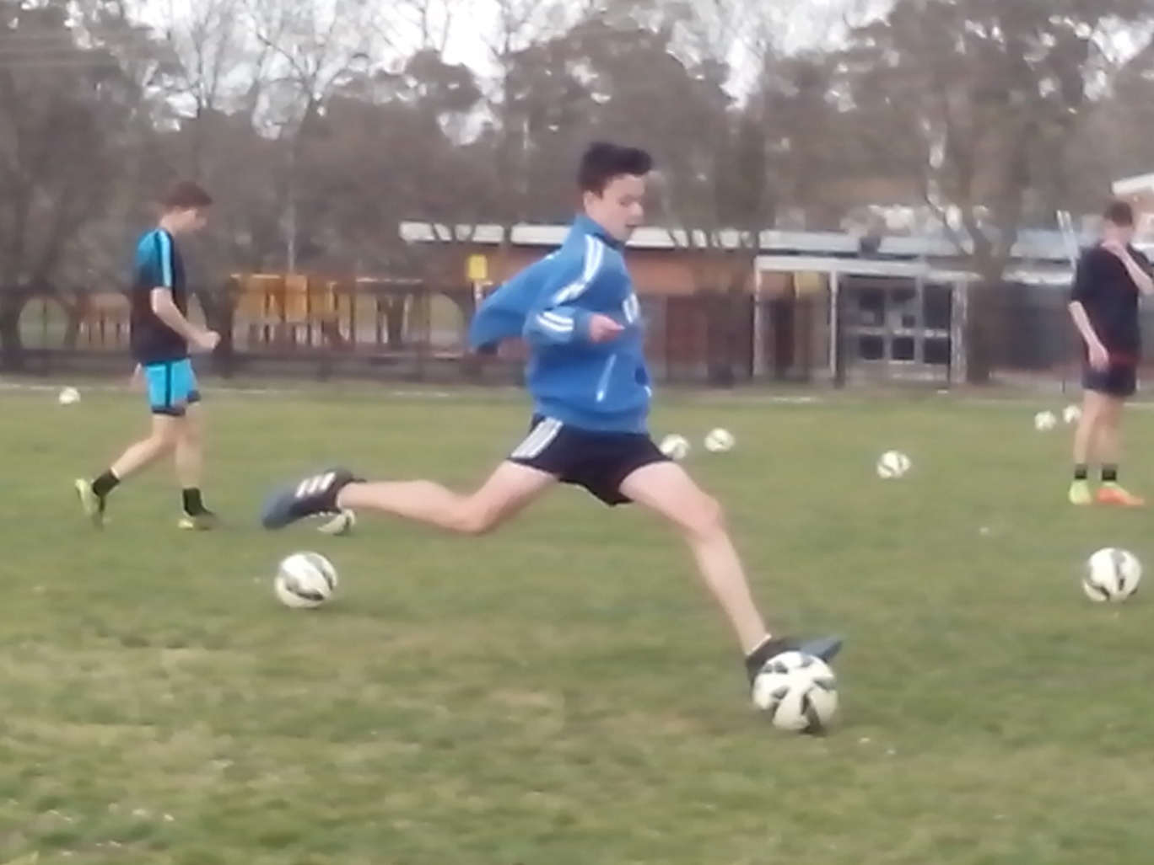
FUTURE SOCCER
Brazilian kids who play on Brazilian beaches are creating Brazilian Soccer. Australian kids who play in Australian skills parks are creating Australian Soccer.
Any healthy, wealthy sporting nation, with a high performance coaching system, should believe in its innovative coaches and talented players. We have the ability to copy every other Football nation in the world. We can use that talent to give other nations something to copy.
Each generation is smarter and more talented than the previous generation. That’s evolution and that’s how we improve. We already know what the old generation can do. The aim of a learning program is to explore and discover what the next generation can do. We can teach the same every day or we can learn something new every day.
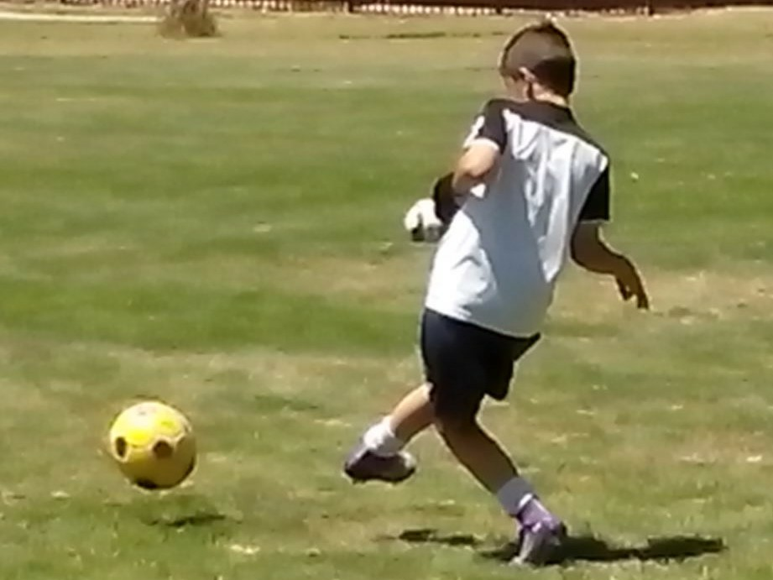
Kids grow because they’re willing to open their eyes, ears, mouths and minds. We become the old generation when we stop looking, listening, asking questions and learning. There are skills that haven’t been invented yet and elite kids who haven’t been discovered yet.

