To the BFC Community, 29/11/2015
Last Thursday 26/11, the club held its Annual General Meeting in front of over 28 enthusiastic members. The AGM is held annually to present the annual report, financial results, and to elect office bearers for the following year.
The annual report was presented and a copy can be obtained by emailing the Secretary on:- darrenadey@blackburnfootballclub.com
Office bearers season 2016
Per the club constitution, all committee positions were declared vacant and nominations called for all positions, with nominations received the following were elected to the committee:
- Senior President: Matt Breen
- Senior Vice President: Mike Tuminello
- Secretary: Darren Adey
- Assistant Secretary: Mike Dwyer
- Treasurer: Paul Molan
- Assistant Treasurer: James McLeod

General Committee:
Phil Stewart, Mick Peake, Michael Prendergast, Trevor Howard, Grant Schumacher, Mike McCoy, Graeme Moore, Leanne Hammond, Mark Edwards
Congratulations and special mention to the following Office Bearers not returning – Garry Connolly (Pres.), Gerard Harkins (VP), Brian Hillier (Treasurer), Gen Committee – Neil Adolphson, Tony DePreu, Kevin Prendergast.
#WeAreBlackburn
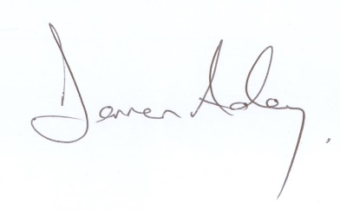
Darren Adey
Secretary
E: darrenadey@gmail.com

