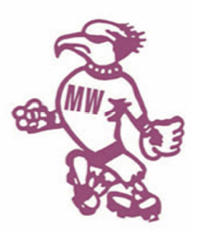

MWSA OZPITCH 2017
TEAM REGISTRATION FORM
Team Name
Manager Name |  | Mgr Email |  | Mgr Mobile

ID | First Name | Last Name | Email | Mobile | MWSA ID  (Admin only)
1
2
3
4
5
6
7
8
9
10
11
12
13
14
15
Please email team list to ozpitch@mwsa.com.au before 06/10/2017 to register your team. All individual player rego forms to be signed and handed in on rego night.

