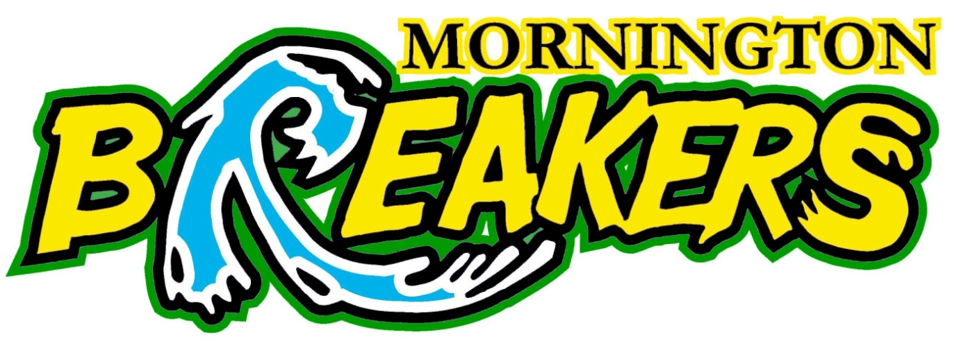

Wednesday, 14 November 2012

Junior Breakers Team Managers Meeting.
Date : Wednesday, 21st November, 2012.
Time : 7.30PM
Place : Club Rooms at Home Stadium.

Mornington Junior Breakers Sub Committee invite all 2012/2013 season Team Managers to attend an information session and formal catch up of all Junior Team Managers. We request each team if they have not selected a Team Manager to ask a team representative to attend on their teams behalf. We hope to be able to answer questions and provide all teams with valuable information and resources needed for the operations of teams in the VJBL. We look forward to meeting you all.

Junior Breakers Sub Committee.

