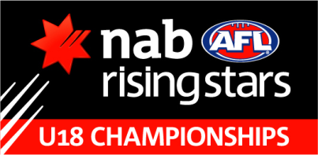

Round 3

WESTERN AUSTRALIA v VIC COUNTRY - SUNDAY 17 JUNE, Patersons Stadium, 11.00am

Backs | 39 Chris Deluca | 41 Nick Rodda | 12 Chase Strange
H Backs | 11 Sean Lynch | 51 Alex Howson | 4 Adam Carter
Centres | 22 Liane Wilkins | 33 Scott Jones | 35 Jackson Ramsay
H Fwds | 8 Corey Chalmers | 23 Marco Paparone | 10 Josh Simpson
Fwds | 24 Jesse Hogan | 21 Mason Shaw | 5 Shaquille McKenzie
Followers | 14 Dominic Sheed | 29 Jack Martin | 2 Dayle Garlett
Interchange | 25 Sam Lowrie | 27 Brendon Lim | 28 Tim Sutherland
 | 20 Kamdyn McIntosh | 31 Riley Hutchinson | 7 Marvin Warrell
 | 13 Shannon Taylor

VIC COUNTRY v WA

Backs | T Blake 10 | T Smith 32 | T Clurey 35
H Backs | N Wright 20 | R Morrison 30 | T Lockyer 40
Centres | W Hams 21 | J Saunders 13 | N Graham 11
H Fwds | L Whitfield 9 | M Close 26 | C McCartney 3
Fwds | S Martyn 6 | J Stringer 39 | T Garner 17
Followers | C Williams 37 | O Wines 33 | M Crouch 4
Interchange | L Pierce 34 | W Hartung 1 | B Kearns 12
 | L Taylor 5 | D Gardiner 27

