Player Name: ________________________________ Team:Under ______Boys/Girls Order Date:____________
Rockhampton Basketball
Junior Representative Uniform
ORDER FORM

Parent Contact______________________________ Phone:_______________ Mobile: _____________________
Email: _________________________________________________________________________________________
Item | Description | Qty | Size | Name req’d  (please print name) | Total
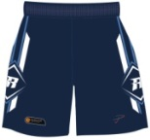 | Team Shorts  Female Sizing – 6, 8, 10, 12, 14,16  Male Sizing – 10,12,14, 2XS, XS, S, M, L, XL, 2XL  $44.00 |  |  |  | $
 | Team Polo Shirt  Sizing – 10, 12, 2XS, XS, S, M, L, XL 2XL  $35.00 |  |  |  | $
 | Team Warm Up Top  Sizing – 4XS, 3XS, 2XS, XS, S, M, L, XL 2XL, 3XL  $32.00 |  |  |  | $
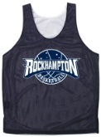 | Team Reversible Singlet  Unisex Sizing – S - 2XL  Kids Sizing – 8 - 14  $22.00 |  |  |  | $
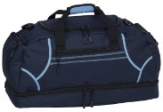 | Team Bag  $35.00 |  |  | Add $15.00 | $
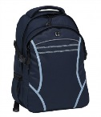 | Backpack  $30.00 |  |  |  | $
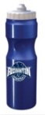 | Team Water Bottle  $10.00 |  |  |  | $
 |  |  |  | Total | $
Please mark payment type:
Submitting Order and Delivery
Order forms are to be submitted with payment at scheduled 'try on' dates as advised. Orders will be available for collection at Junior Competition nights. Collection date will depend on stock production and availability -TBA.
Cash Cheque Credit Card Direct Tranfer
Credit Card Payments: VISA MASTERCARD
Card Number: _______/ _______ /_______/ ______ Exp: _____/_____
Card Holder Name: ____________________________CVC No________
Orders can be emailed to: sales@powerjam.com.au OR in person at
PowerJam Clothing & Promotional - Shop 10, 23 Denham St, R’ton
Phone/Fax: 07 4921 3773 - Monday- Friday - 9am – 3pm
For Direct Transfer:

A/C Name: Power Jam Bank: NAB

BSB: 084-901 A/C No.: 48 792 3295

