Self – Registration - Player

Play Football Self Registration Portal
At any time you become stuck please ring

Support
- Email: playfootball.support@ffa.com.au
- Telephone: 02 8880 7983
- Hours: Monday-Friday 10am - 5pm

BEFORE YOU START YOUR REGISTRATION YOU MUST MAKE SURE YOU GET YOUR ACTIVE KIDS NUMBER BEFORE REGISTRTAION CAN COMMENCE. – This can’t be done before the 1st of January 2019
If you’re not using a voucher then please proceed

https://www.service.nsw.gov.au/transaction/apply-active-kids-voucher

You must first set up a FFA account

As a Participant looking to register for the up-coming season, you will need to create a Football Account (https://www.ffa.com.au/football-account)

If you already have a Football Account please sign in.

Any existing participants will have to ‘claim’ their account details, when a participant creates a Football Account the details used to create the account will be checked to see if there is any details from Myfootballclub that match.
If there is a match the participant will need to ‘claim’ those details as their own and proceed with their registration.

Create a Football account link >>> https://account.footballnetwork.com.au/register
Login to your Football account link >>> https://account.footballnetwork.com.au/

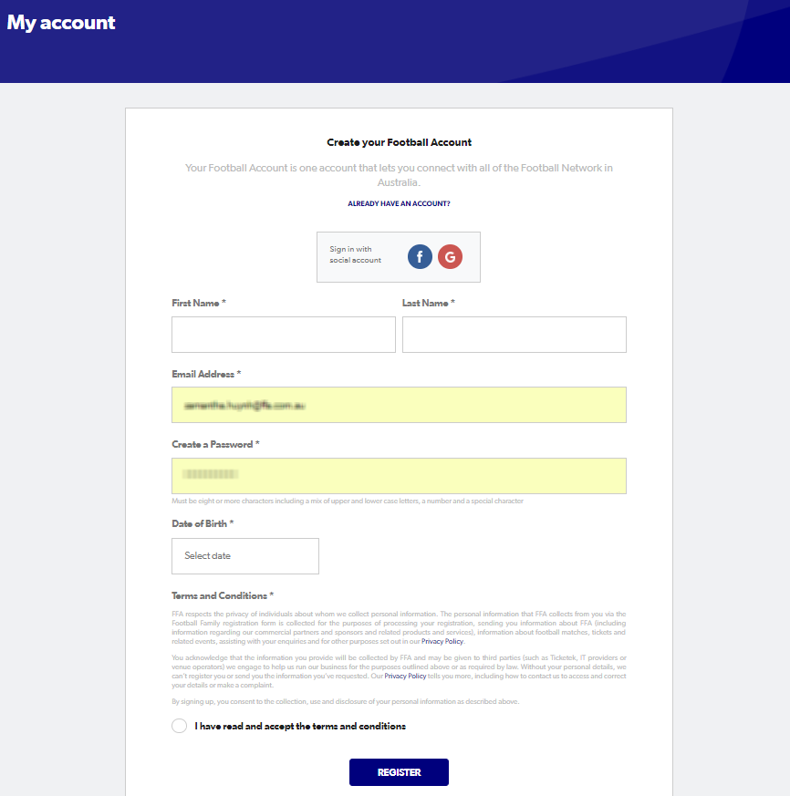
Create your Football Account

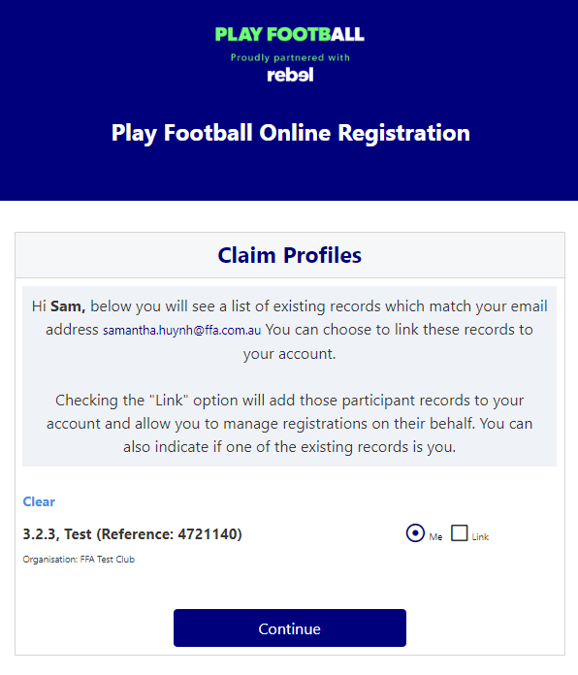
Claim Profiles

Self-Registration Portal
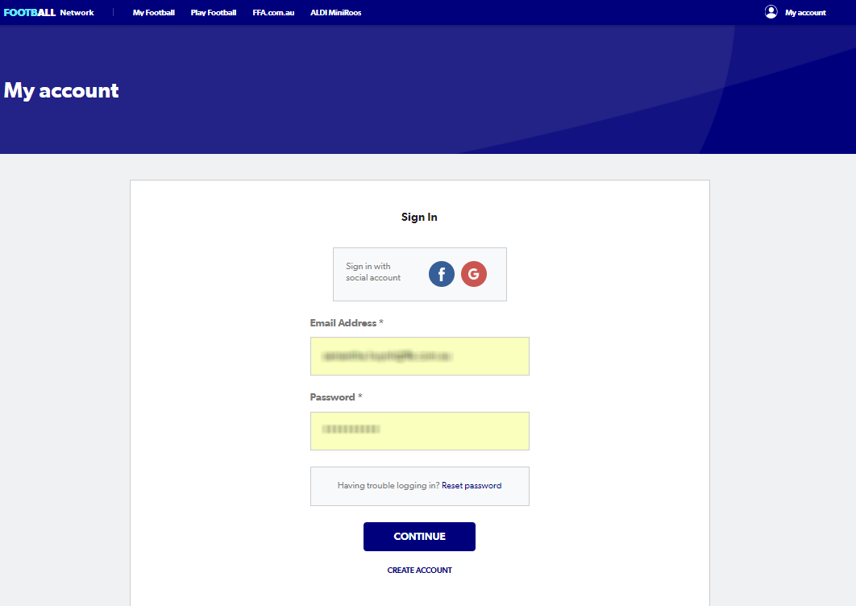

Self-Registration Steps – Registering Myself
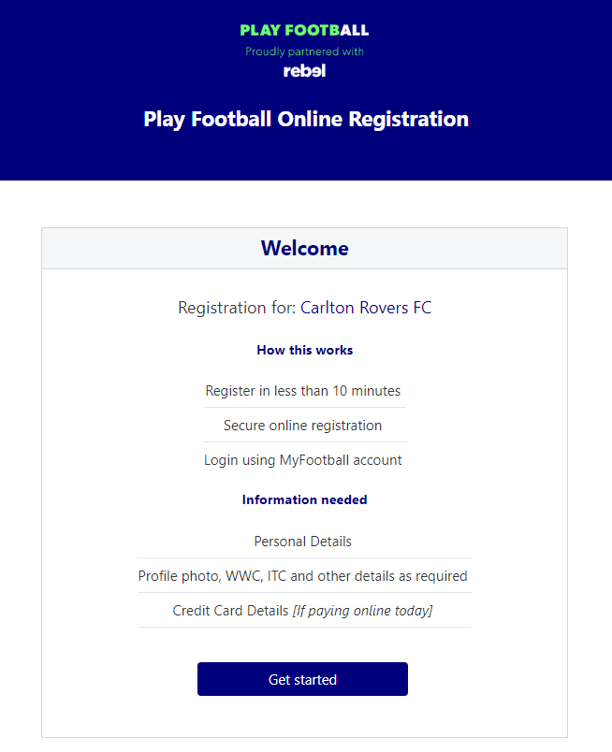

STEP 1. - Select the Participant
- When you have created your Football account, please sign in and you will be presented with the Play Football Online Registration screen with your account details and any individuals you have linked to your account.
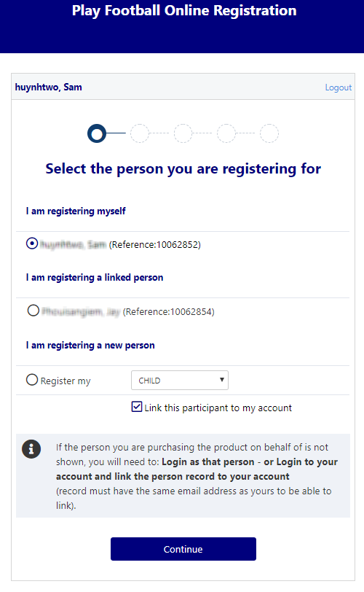
- If you are registering yourself select ’continue’

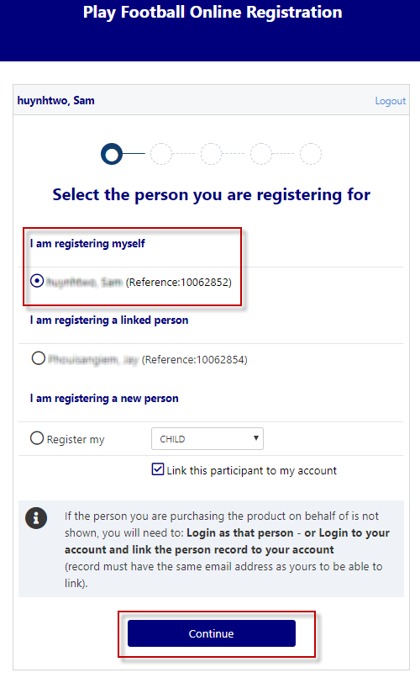
I am registering myself

- If you a registering a ‘Linked’ person select the participant and then ‘continue’

- If you are registering a new person select and continue.

STEP 2.- Select Product
- You will be shown all the ‘Products’ your clubs have on offer, select the product that you have been informed to select by your club. If you are UNSURE of which product to select speak with your club directly.
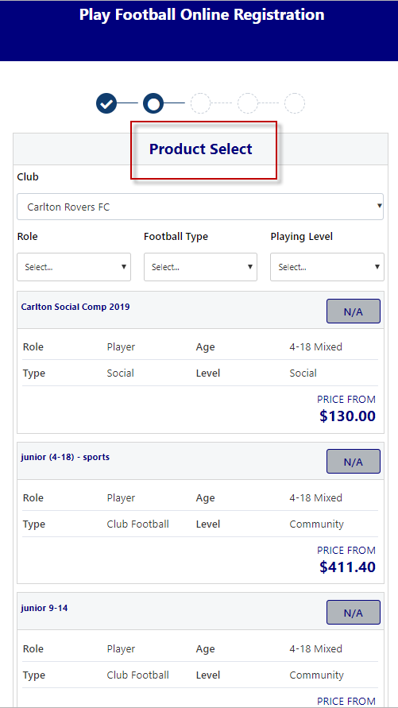
*Products – the package that you are purchasing. u/8 boys

STEP 3.- Product Details
- This step allows the participants to purchase ‘Optional products’ the club may offer.
- Participants can review the breakdown of the included FEES in their ‘Product’ selection.
- If an optional product is to be purchased select the product >select update cart = update the total

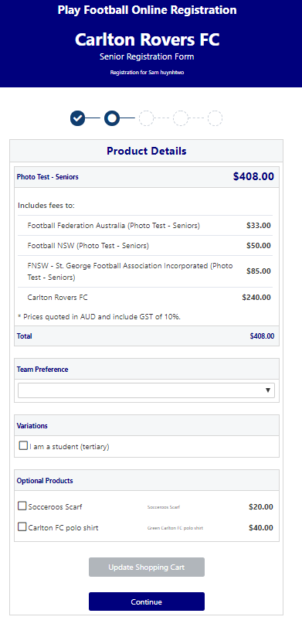

STEP 4.- Participant details
- Participants will be shown a details screen – please update all your details making sure all fields marked with * are completed.
- Additional questions and policy’s will also be displayed in this step
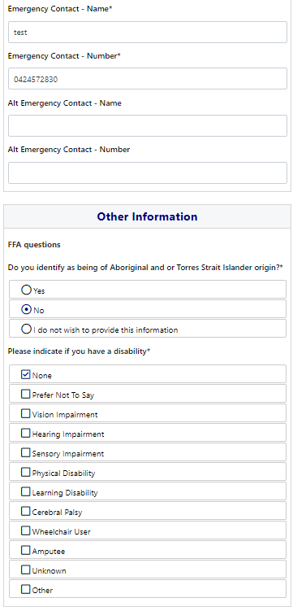
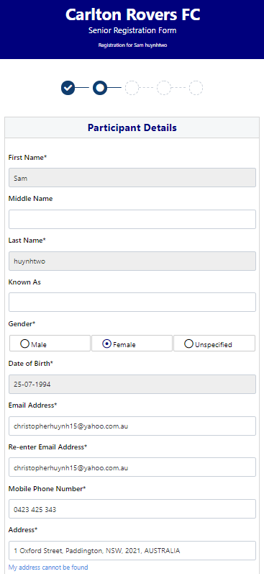

STEP 5. - Profile Photo
- Participants will need to upload a photo if this requirement has been set by your association
- The photo uploaded here will need to meet the image guidelines and will also appear on the participants Football account.
- Basic photo editing tools are also available

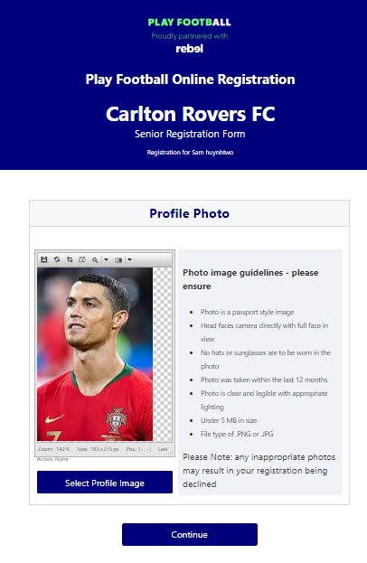

STEP 6. - International Transfer Clearnace

- Participants – Players will be presented with a question identifying if their last registration was with a Football club overseas.
- If your last registration was with an Overseas club you will need to select NO this will prompt the participant to continue processing an ITC request.
- ITC request will be sent when the participants registration is submitted.
- If no ITC is required select ‘ yes’ or ‘I have never registered to play football before’

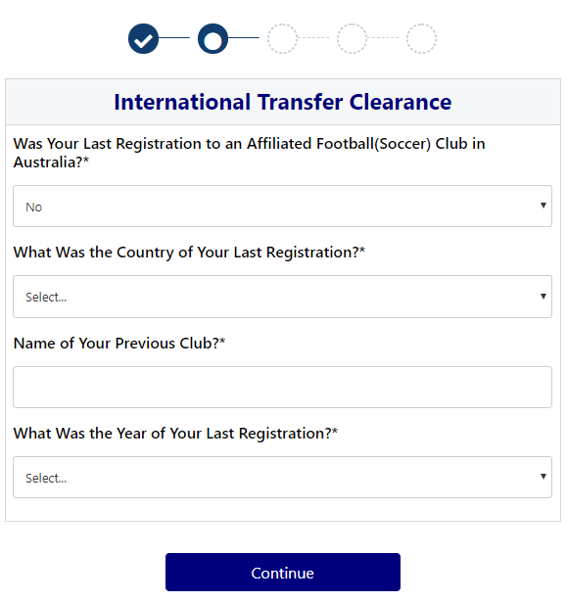
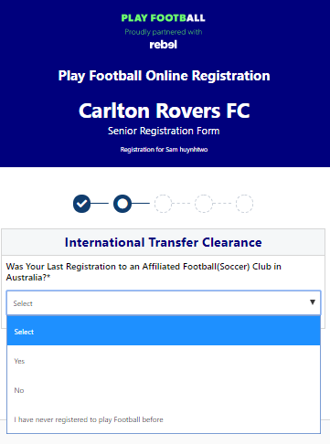

STEP 7. – Review Your Order
- Participants will have the chance to review their order at this step it is important participants review and edit.
- To edit any of the sections select ‘Modify’
- The Terms & Conditions will also appear at this step

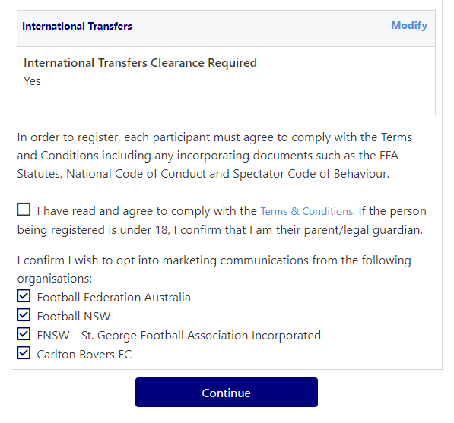
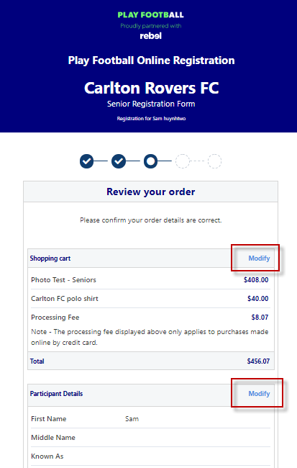

STEP 8. – Payment
- This step provides the participants the chance to review their product
- The product fee breakdown is displayed along with any discounts or additional products the participant has selected
- If the participant has selected an INCORRECT product, select one of the blue circles at the top of the page to go back in the process to select the correct product
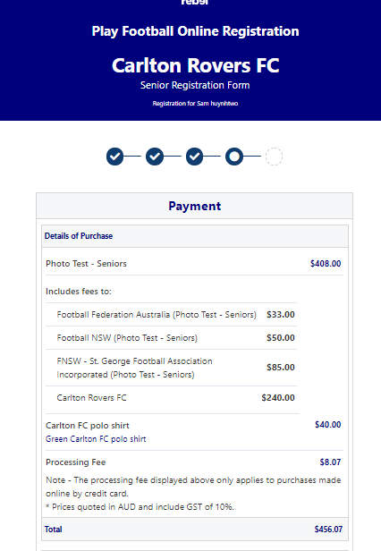
NOTE: If you are UNSURE of which product to select – contact your club directly to get the correct information in regard to your product selection

VOUCHER/COUPONS
- NSW particpants – who have a valid active kids voucher in their will need to enter the voucher details to redeem its value
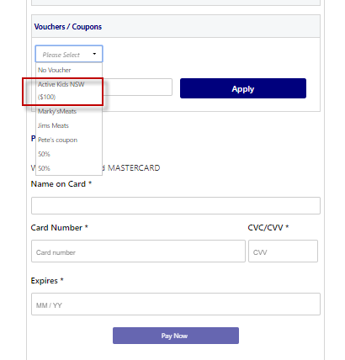

Online/ Offline
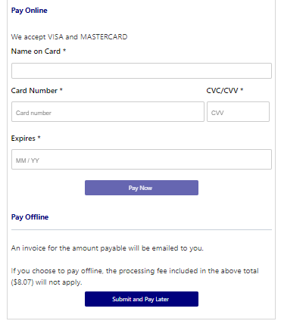
- Clubs set the payment options available for participants
- Online – Visa or Mastercard payments – Payments are to be made in FULL
- Offline – Clubs preference

NOTE: Payment options are set by Clubs – if there is an issue with payment options available to you, please speak with your club directly.

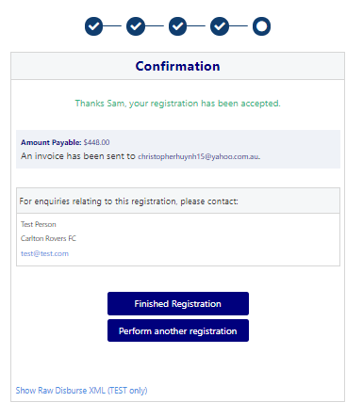
STEP 9. – Confirmation/ Perform another Registration

End of Registration
- Club Registrars will list the contact details for participants to use if they have any enquiries related to their Registration
- Selecting ‘Perform another Registration’ will take the participant back to step 1.
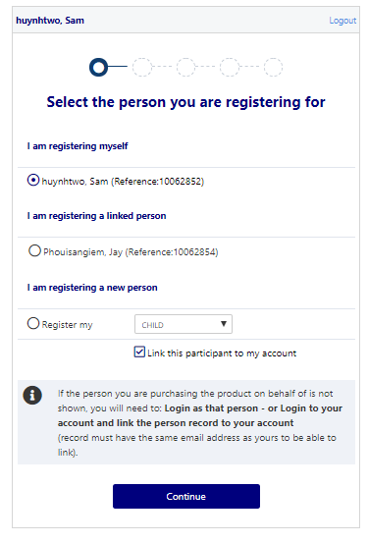
- I am registering a linked person, or I am registering a new person

