FREESTYLE SOCCER LEARNING PROGRAM
By Jack Kynaston
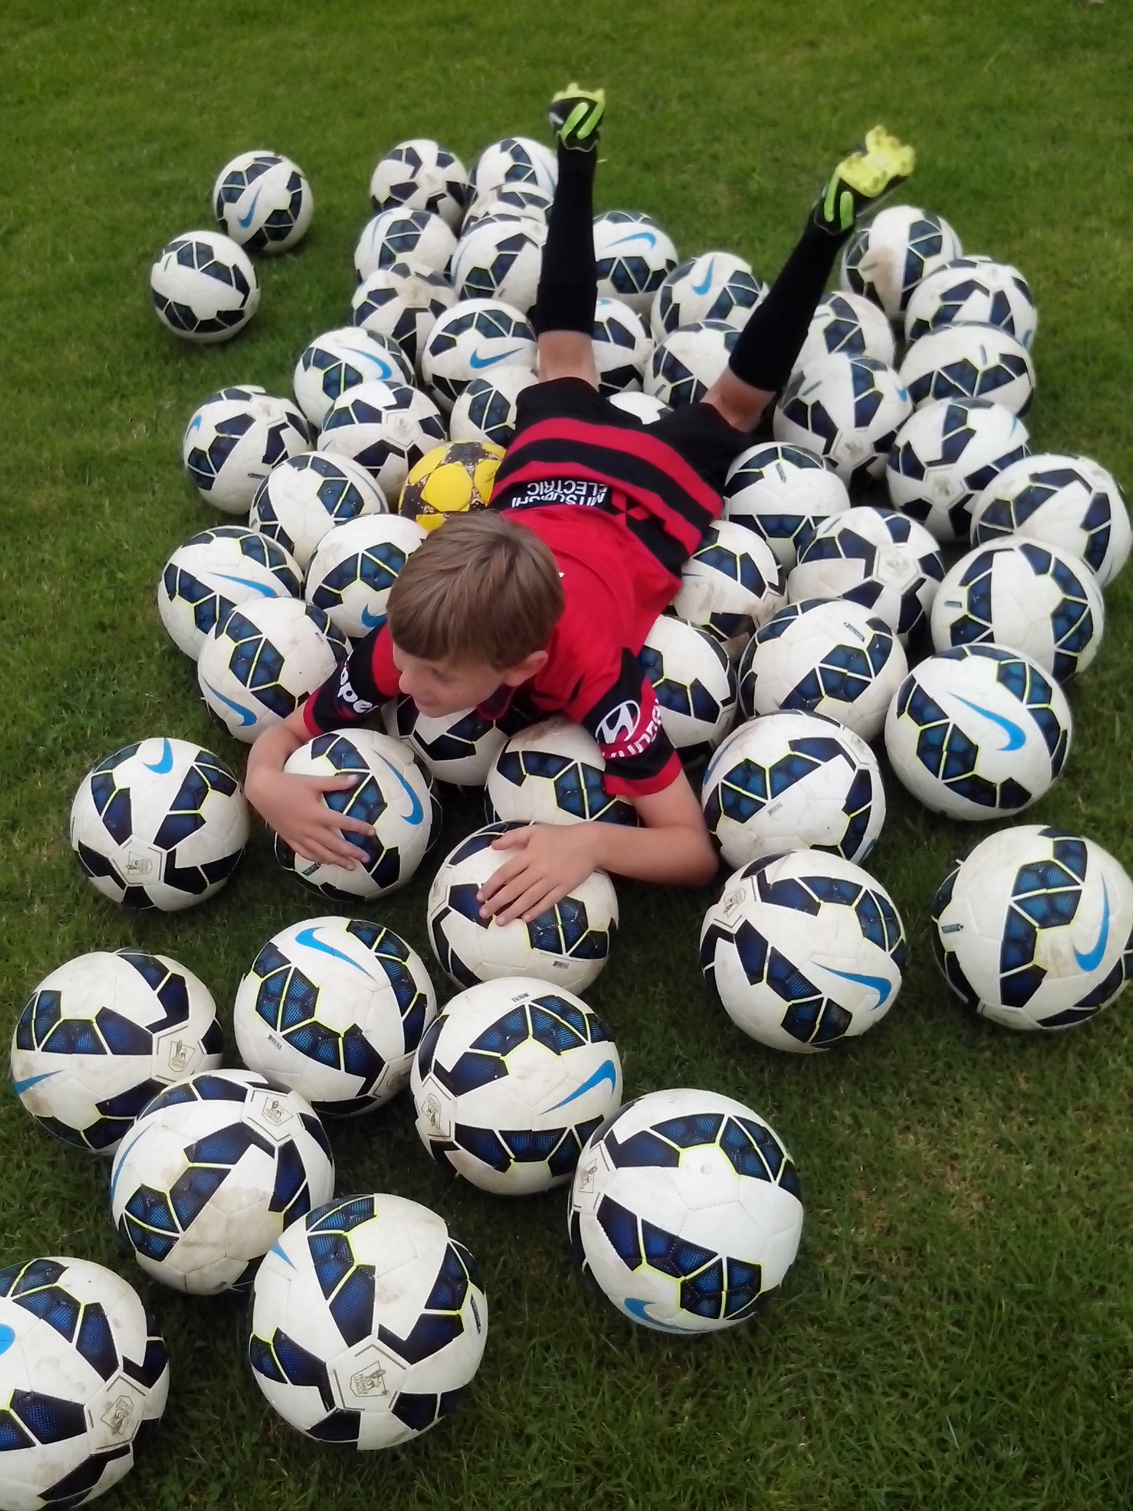
A coaching system teaches everything we know about the game. A learning program explores everything we don’t know.
LEARNING PROGRAM
We can look for ways to improve all the best kids or we can look for all the best ways to improve kids.
In the 1830’s, Rugby School established junior sport so that kids could take responsibility for their own game, run their own drills and develop their own character. Nowadays, junior sport is a kids’ game played by adults who like to make all the decisions. Soccer kids want their ball back. A learning program explores how quickly Australian Soccer kids develop when we give them the responsibility to think for themselves and express themselves. A learning program looks at their natural skills, motor skills and the personal qualities that all kids have.
Freestyle Soccer kids know that Australia should be a Top 20 Football nation. We just need confidence and more belief in our own national sporting identity. A learning program is designed to discover and develop individual talent so that kids can achieve their full potential. Imagine combining a coaching system with a learning program so we can identify and improve what each Soccer kid needs to improve.
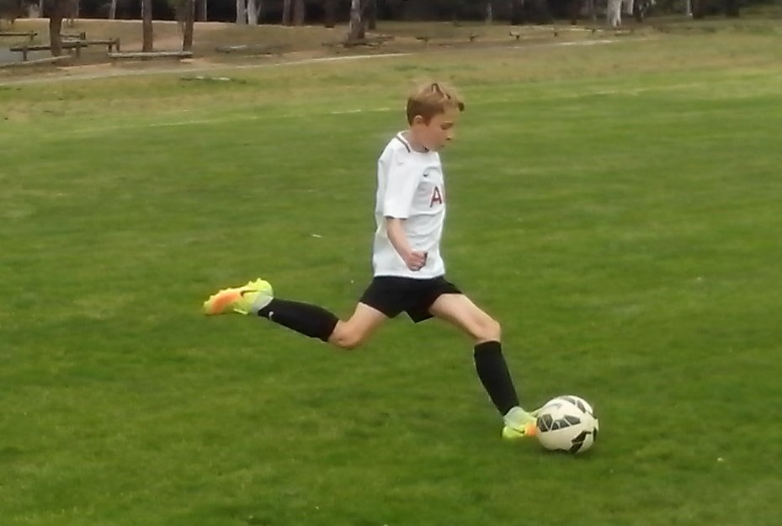
TAKE 5
To improve any Soccer kid in 5 minutes, results need to be clear, immediate, measurable and permanent.
The first five minutes of anything we do is full of mistakes. That’s human nature and that’s how we learn. Kids who don’t know this, give up in the first 5 and their coaches look for mistakes in the first 5.
It takes 5 minutes for eye/foot coordination to kick in. In 5 minutes, a Freestyle kid can take 100 steps, make 100 decisions and get 100 ball touches just by juggling. In 10 minutes, they’re ready to play a game.
There isn’t one Australian Soccer kid who can’t improve in 5 minutes just by coordinating their natural skills, mind skills and Soccer skills. It takes 5 minutes to identify the kids who don’t know what to look at or how to move their feet when they kick a ball. It takes 5 minutes to discover the kids who don’t know where to move or what to call when they want the ball. If it only takes 5 minutes for any kid to improve, it should only take 5 minutes for any coach to disprove. Feel free.
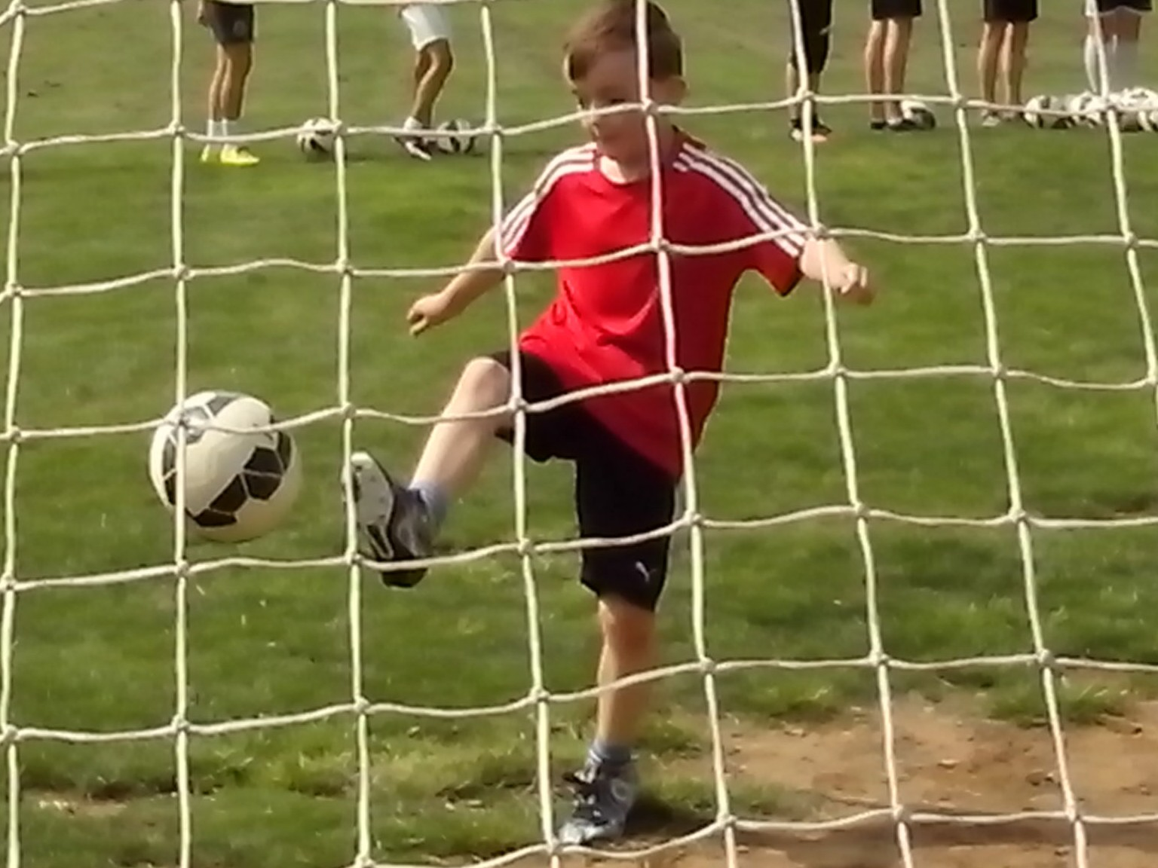
10 KEY ELEMENTS
Some kids are all over the place. Freestyle kids learn to get it together, put it together and keep it together.
We’re looking at Soccer skills and overlooking the natural skills that all kids have. We’re teaching perfect ball technique to kids who don’t know how to move their feet, where to move, what to think about, what to look at when they kick a ball or what to call when they want the ball. There are 10 Freestyle elements that can improve every kid.
A kick is simple. A kid is complex. Any kid can kick a ball. Kids need footwork and vision to pass the ball. Any kid can shoot. Kids need power and precision to score goals. Any kid can stand still and wait for the ball. Kids need movement and decision to create support options. Any kid can become one footed. Kids need belief and repetition to develop close control. Any kid can play safe and stay the same. Australian kids need challenge and intuition to raise their game.
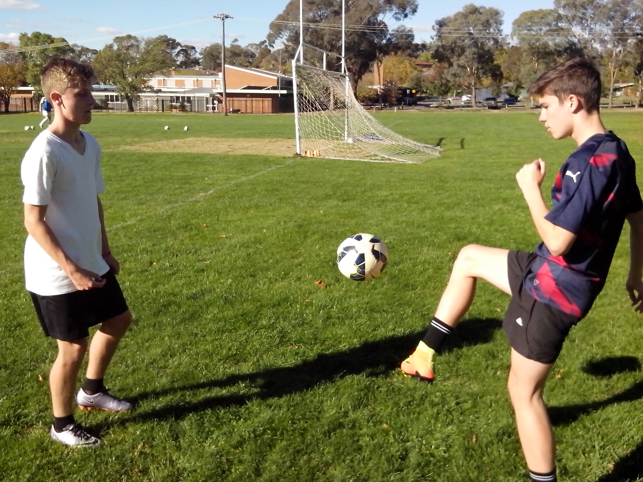
10 QUALITIES
All kids have external qualities that can be coached (fitness and skill) and internal qualities that can’t be coached (character and intelligence).
Skill comes from the coach. Talent comes from the kid. A coaching system teaches skill. A learning program searches for natural talent. When we look for talent in Australian Soccer kids, we can look at ways to develop their character, intelligence, mindset, mobility, control, understanding, team spirit, drive, creativity and growth.
There is so much hidden and untapped Soccer talent in Australia because it’s a lot easier for coaches to teach every kid to look, think, stretch, move, kick, train and play the same way. When it’s easier to make every kid the same, it’s harder to make a difference. A learning program is a search for original Australian competitive Soccer talent. We just need to find one coach who isn’t scared to look at new ideas.
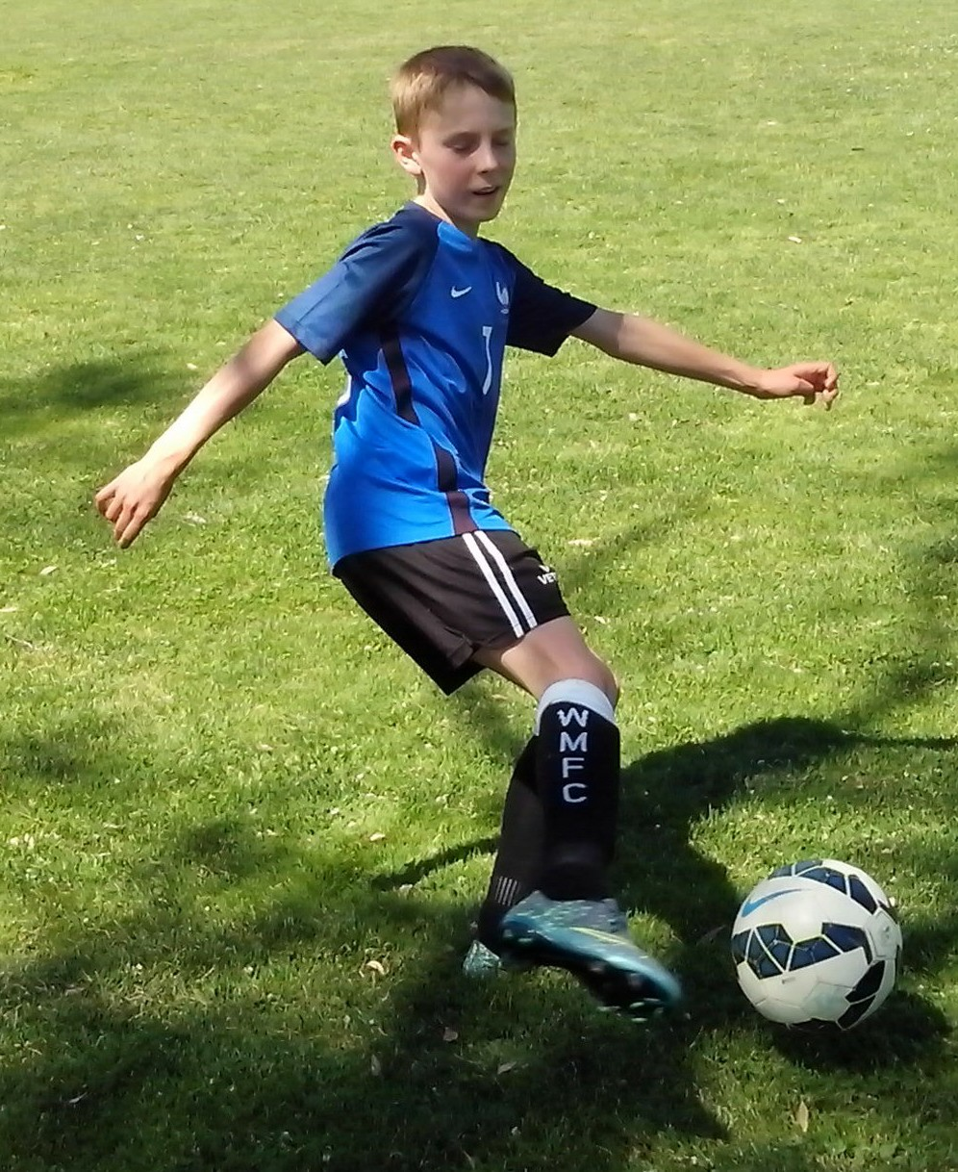
DNA PROFILE
The DNA Profile is a list of strengths and weaknesses.
There are simple ways to improve every Australian Soccer kid. There’s a key to every kid and a drill for every skill. The DNA Profile contains 10 indicators: trapping, passing, heading, dribbling, defence, confidence, fitness, support, juggling and shooting. Kids use the DNA Profile to identify the three strengths that define them and the three weaknesses that they need to improve. They analyse their own game.
Kids can highlight their best skill as number 1 and their worst skill as number 10 and then work inwards from there picking numbers 2, 9, 3 and 8. The top three skills make kids feel good so they’re happy to practise them. The bottom three skills make kids feel bad so they try to avoid them. A lot of kids avoid heading, juggling and shooting.
The key issue is confidence. Kids don’t have the confidence to tell coaches that they lack confidence but will select it if we put it in a list. There are too many talented Soccer kids who lack the confidence to play their own game and we need to identify who and discover why.
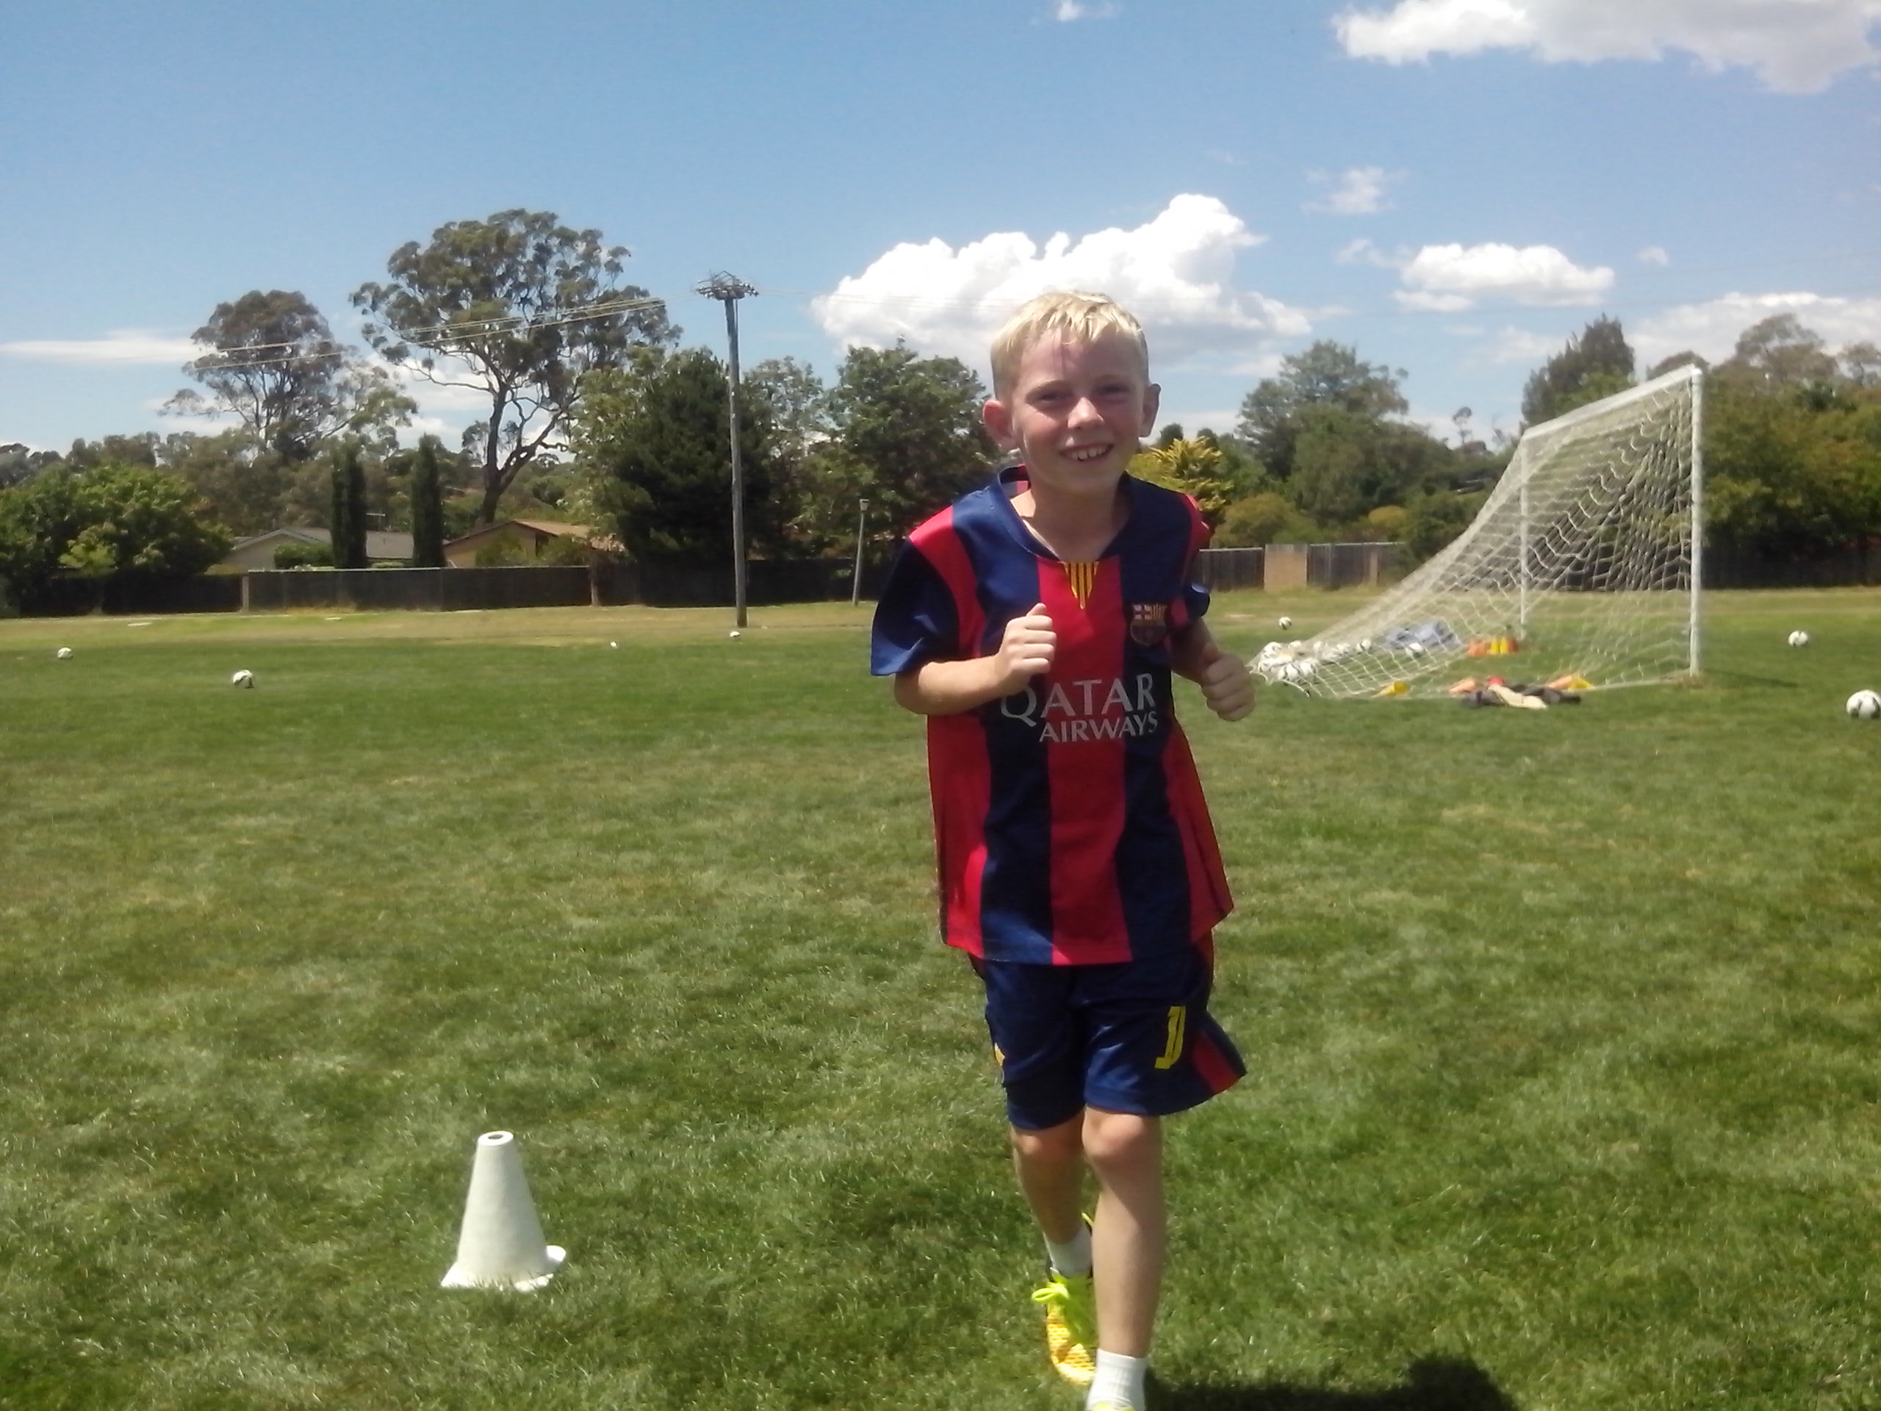
BELIEF
The best coach is the one who can learn about players and the best player is the one who can coach the drills.
Belief is the key to the future of Australian Soccer. If we believe that Australian coaches are innovative, we can encourage them to question old ideas and challenge new ideas. If we believe that Australian Soccer kids are talented, we can give them more responsibility to think for themselves, create new skills and run their own drills.
Australia already has the innovative coaches and talented players to become a Top 20 Football nation but we’re waiting for it to happen. The worst we can be is satisfied. The best we can be is challenged. An untalented kid who won’t stop will beat a talented kid who won’t run. Belief is critical to motivation. If we tell one group that they have the talent to reach the top and tell a second group that they lack the talent, the first group will succeed at a much faster rate. We never tell kids that they lack talent because kids need to believe in their dreams. It’s amazing what kids achieve if they don’t know that they lack talent.
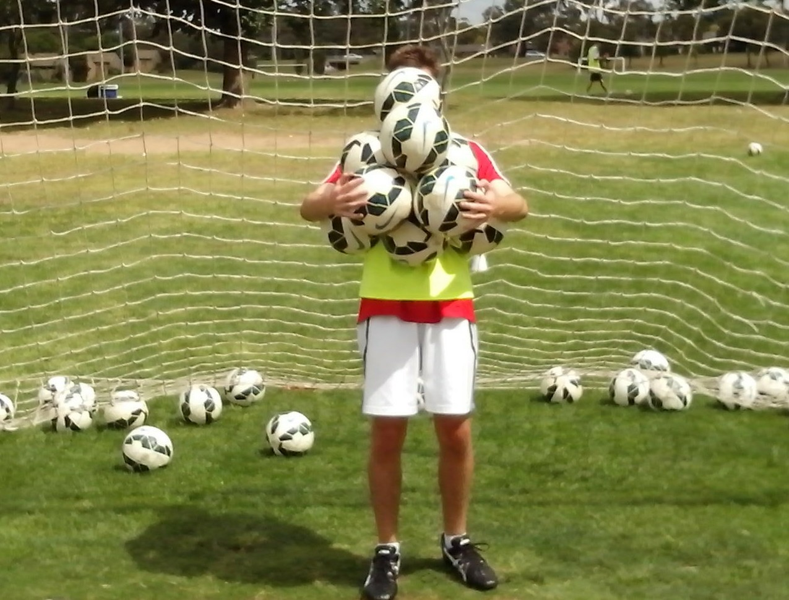
AWARENESS
Awareness is the ability to see and hear what isn’t there. We can see lack of movement and hear silence.
We see what we want to see. Two opposing coaches watch the same incident. One can see the foul but the other can only see a legitimate tackle. We see what we expect to see. If we think kids are untalented, we treat them accordingly and they lose their talent. Experts see what they’re trained to see. They look at technique and they look for mistakes. They’re not trained to see that kids aim for the whole goal or take their eyes off the ball when they shoot straight at the keeper.
Each kid has the ball for 5% of the game. The team coach follows the bouncing ball and never sees where kids move or hears what they call for the other 95%. If you look, you see the kids who stand dead still and if you listen you hear the kids who stay dead quiet. It’s the quiet achievers we need to activate. If you think outside the box, and stand behind the net, you see the strikers who lift their heads as they blast the ball over the bar. If you observe, you pick the kids who aim big and miss big and the kids who aim small and miss small. If you ask kids what they think about in a game, they don’t know what to think.
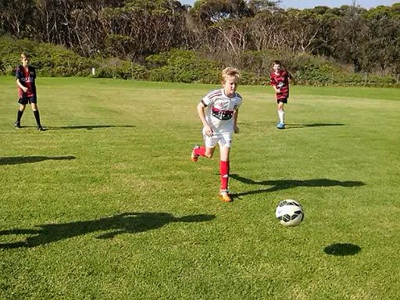
SKILLS PARK
Every club can provide a skills park where Australian Soccer kids can develop the true Australian sporting values and an original Australian style of Soccer.
A skills park, like a skate park, is a confidence course where Soccer kids can believe in themselves and speak up for themselves without well meaning adults directing their every move, correcting their every mistake, protecting them from every failure or rejecting them for being different. Parents don’t send kids to a skate park. Kids soon discover that they don’t fall apart without supervision and they don’t stand around waiting to see what happens. They can make it happen.
A skills park is where natural resources can grow. It’s open to anyone who can look, listen, ask questions and learn without telling kids what to do. Local councils understand the needs of youth so they provide skate parks, BMX tracks, basketball courts and cricket nets where kids are free to challenge their own limits. Soccer kids need practice nets where they don’t get chased away for wearing out the goalmouth. We need to decide if we want to let kids grow or watch grass grow.
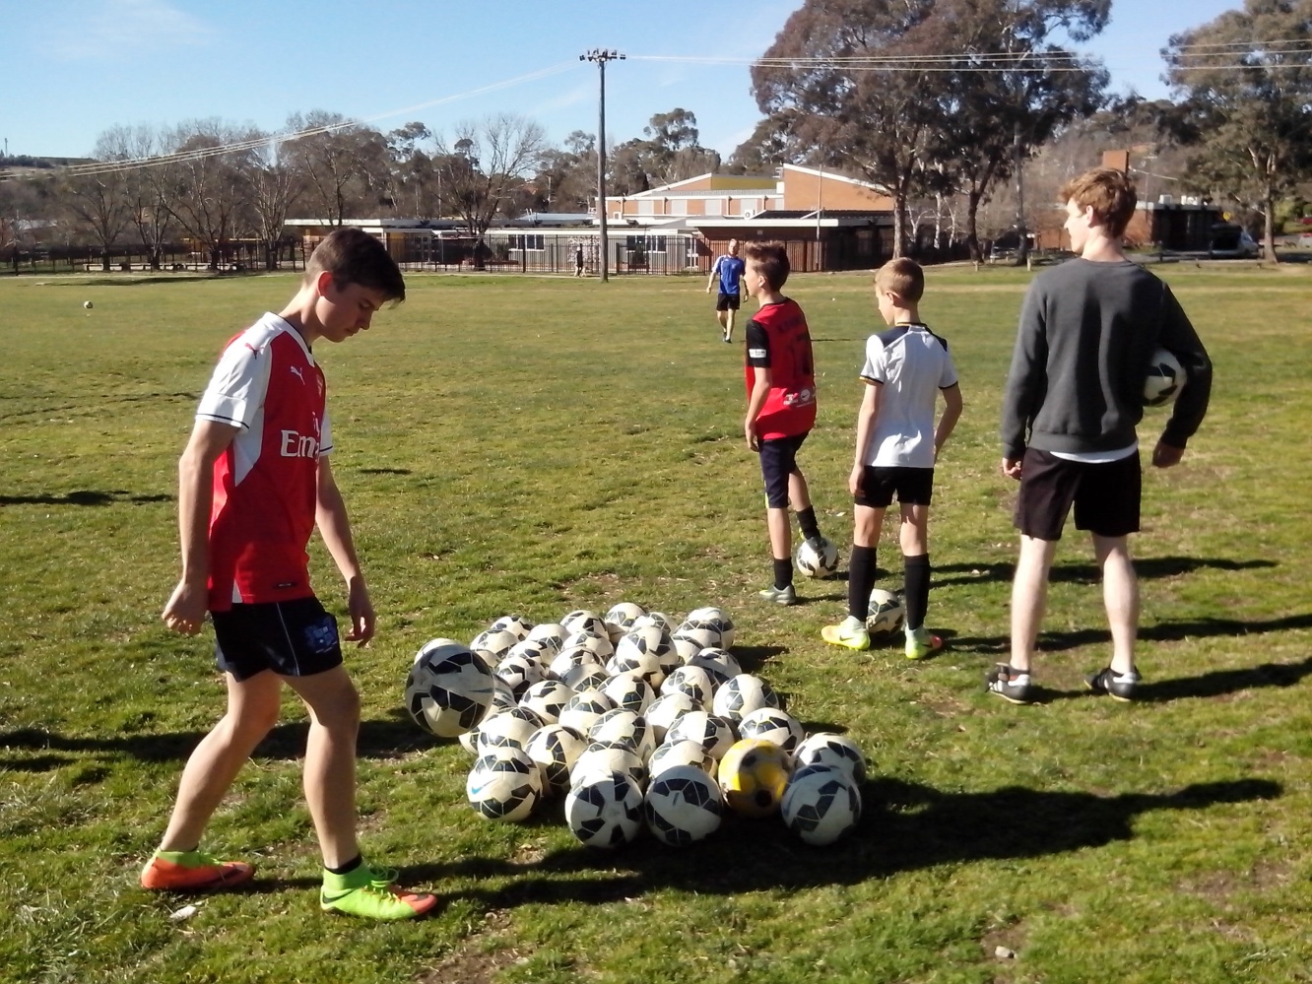
CLOSE REPETITION DRILLS
The kid who stands in a circle sharing one ball with the rest of the squad will make a lot more mistakes than the kid who gets 200 kicks before kickoff.
Kids don’t know how many ball touches they need before they’re ready to play a game and no coach has ever thought about it. It takes at least 200 ball touches for eye/foot coordination to kick in. The average Soccer kid gets 20 kicks before each game and spends the next 20 minutes making unforced errors. Any coach can research that.
Freestyle kids get 200 ball touches in 5 minutes just by juggling. The first kicks are too hard or too soft, too high or too low, too early or too late, too fast or too slow, too loose or too tight, too left or too right. In 5 minutes, kids can develop balance, coordination, timing and rhythm. When kids juggle a ball 30 times, the last 10 numbers add up to a lot more than the first 10 as kids begin to coordinate mind, body and ball. Freestyle kids learn how to achieve an intuitive level of control. Close repetition in pairs teaches kids to move and communicate off the ball.
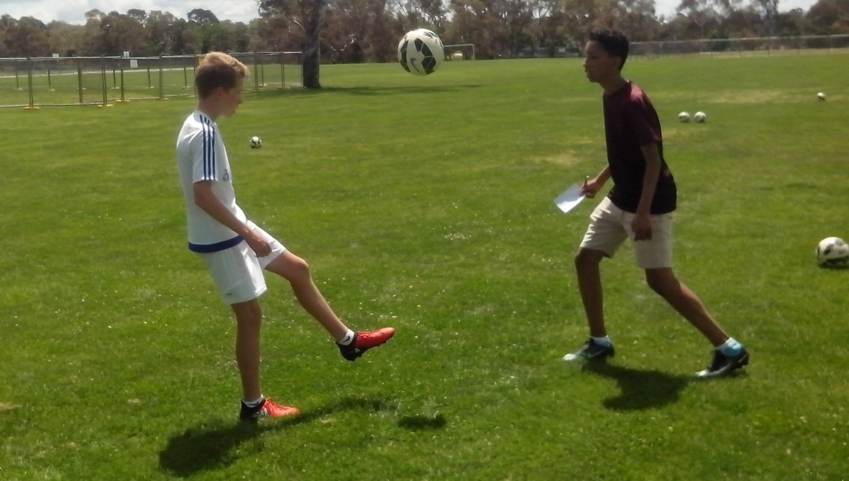
FUSION
Look, think, move, control. Eyes, mind, body, ball.
Kids play the way they train. If we teach kids to kick a ball while they stand still at training, they learn to stand still while they kick a ball in a game. There’s a reason why kids stand dead still and stay dead quiet on the field. Freestyle kids can drive, strive, thrive and come alive.
Kids who stand in the firing line, waiting to shoot, get one shot every two minutes and spend more time disrupting and distracting than controlling a ball. Freestyle kids learn how to run their own rapid fire and power shooting drills so they can exercise their minds and bodies. Coaches don’t play in the games so they don’t need to run shooting sessions before kickoff. The players need to feed and cross the ball.
Any kid can kick a ball. Freestyle kids learn to think, look, listen, call, make decisions and move while they kick a ball. They integrate their natural skills, coordinate their motor skills, stimulate their intelligence and activate their energy. Freestyle kids synchronise their inner game.
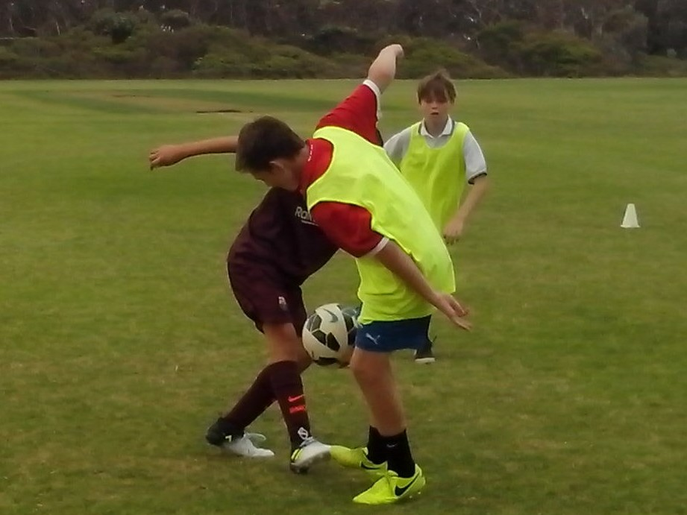
POWER OF ONE ON ONE
In the 10 years it takes to coach each Soccer kid, not one person will spend 15 minutes with that player to discover what skills they actually need to improve.
If a kid lacks confidence, it affects their performance and makes them appear as if they lack talent. Every kid has a different talent. The power of one on one is the quickest and most effective way to identify strengths, weaknesses and lack of confidence. Some sports have an assistant coach, nutritionist, conditioner, statistician, attack coach or defence coach. Some Football codes even have a goal kicking coach. Soccer has one team coach trying to do a bit of everything. A team coach doesn’t have enough time to learn about individual players.
A learning program looks at the vast untapped resources that Soccer can call on to develop its youth players. Any kid can benefit from a parent, personal skills trainer, individual coach, club specialist, retired coach, talent scout, senior player, teenage mentor, goalkeeper coach, buddy system, performance measurement, DNA Profile, sharpshooter, troubleshooter or an annual skills and needs assessment. A learning program ensures that no Australian Soccer kid ever gets left behind.
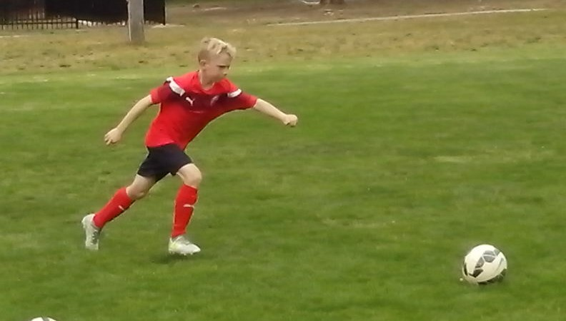
MISTAKES
Do we correct kids because they make mistakes or do they make mistakes because we keep correcting them?
All kids make mistakes. Kids spend years repeating the same mistakes and coaches spend years correcting the same skills because nobody looks for the underlying cause. Talented 17 year old kids, who blast the ball over the bar, or straight to the keeper, have been doing that for ten years because everybody looks at their feet and nobody looks at their eyes. A learning program corrects the mistakes, not the kid.
Some kids are fast learners. If we correct kids every time they miss a shot, they soon stop missing because they stop shooting. If we keep telling kids not to say ‘mine’, that’s the one word that sticks in their head. We need to tell kids what calls they can use.
Some kids make mistakes because they worry about making mistakes. If we tell them to make as many mistakes as they like, they stop worrying. As soon as they stop worrying, they stop making mistakes. This is a different approach so most coaches are too scared to try it.
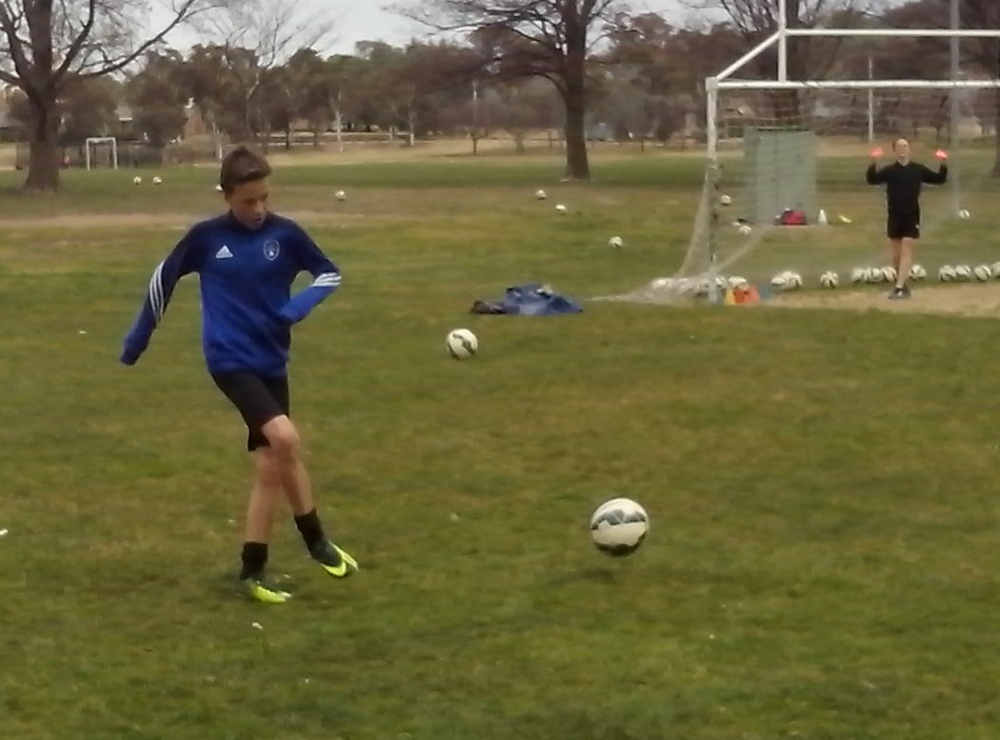
PERFORMANCE MEASUREMENT
Kids achieve because they don’t know what they can’t do. Adults give up too easily because they know what they can’t do.
Confidence is the most important goal for every kid and teenager. Self esteem is built on facts, not sports psychology. Freestyle kids keep a record of their performance and improvement so they know what level they’re up to and exactly how much they’re improving. The DNA Profile enables kids to identify the three strengths that can help them stand out and the three weaknesses that could slow them down.
The most important subject in Soccer is the kid. The most important subject a kid can learn about is themselves. Australian Freestyle kids are the only players who develop footwork, vision, power, precision, movement, decision, belief, repetition, challenge and intuition. In any field, the obstacles to achievement are ignorance, laziness, selfishness and fear. Freestyle kids overcome obstacles by supporting each other.
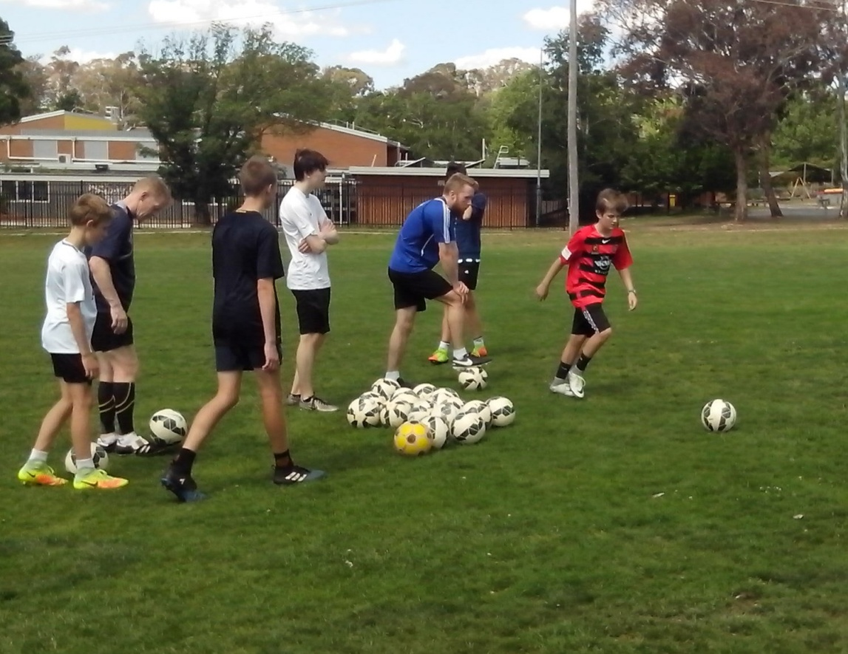
MOTIONAL INTELLIGENCE
Motional intelligence means knowing where to move and understanding why. Too many kids spend too much time standing and too little time understanding.
Each player only has the ball for 5% of the game. Every Freestyle kid plays a full game, on or off the ball, on or off the field. The kids on the bench are the forward scouts who observe the opposing defenders to determine whether they follow their man or stay in position. When they go on the field, they know what the opposition are going to do.
An intelligent attacker never stands with their marker on throws, free kicks or corners. Their job is to make the defender’s job as difficult as possible. With a simple run and call on a corner, they can draw two defenders to the near post leaving team mates free on the far post. Kids want to be original, not a carbon copy of what we wanted to be.
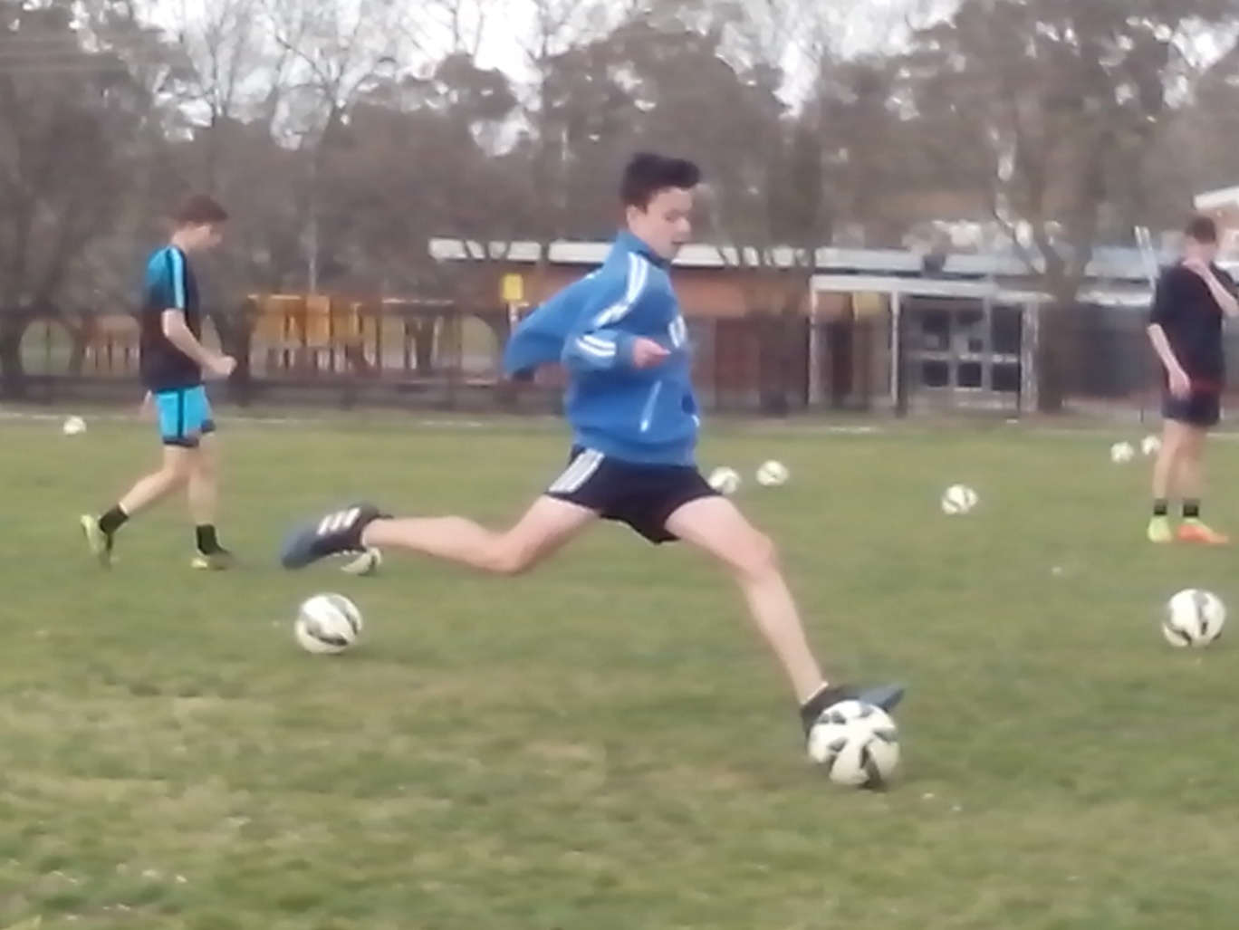
LEARNING THE HARD WAY
A good coach tells kids what to do, a better coach shows them how and the best coach explains why.
Some kids do what they’re told. Some kids learn to do what they’re told. Some kids do what they’re told without learning anything. Other kids learn what to do without being told. Freestyle kids learn to think for themselves. Freestyle Soccer kids learn to believe in themselves.
There are plenty of skilful kids who can learn what to do. Freestyle kids practise how to do it and question why they do it. They discover where to do it and then can decide when to do it in a game. Freestyle Soccer kids are proactive. They don’t stand around waiting to be told what to do or waiting to see what happens. It happens. Some kids look for an easy way out. Freestyle kids learn the hard way. They navigate the path less travelled. If we think kids lack skill, we’ve got a lot to teach. If we think Australian kids lack talent, we’ve got a lot to learn.
