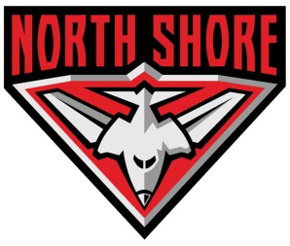
PO Box 2298, Hornsby Westfield, NSW 1635 ABN 89 731 890 780 Email: northshorefc@yahoo.com.au Website: www.northshorefc.com.au
Home Ground: Gore Hill Oval, Pacific Highway, St Leonards NSW.

NORTH SHORE AUSTRALIAN FOOTBALL CLUB

Club Transfer to North Shore AFL Club

I, (full name) …………………………………………….., request a transfer from my previous club,……………………………………. in the ………………………... (league)
to the North Shore Football Club in the Sydney AFL.

To lodge the transfer, the club requires your date of birth : ….. / ……/ …….

Contact number (if we need to discuss any issues with your transfer): ……………

Signed: …………………………………. Date: ….. / ……/ …….

Transfer Process
- The club will lodge the transfer through the AFL online system.
- The previous club has 7 days to approve or decline the transfer.
A transfer can be declined if you haven’t returned club property (ie jumper) or you owe money etc.
- The previous league then has to approve the transfer.
- Once the transfer is completed you will be notified by us.
- You will then be required to register yourself online via sportingpulse (instructions will be provided).

Note:
- All players are required to abide by the Sydney AFL Code of Conduct
- All players are recommended to have private health insurance coverage to cover medical expenses and ambulance fees.

