OLD SCHOLARS FOOTBALL ASSOCIATION

2023 MATCH DAY

PROCEDURES

LEAGUE AND CLUB CONTACTS

Executive |  | Mobile | Email address
President | Tony Freeman | 0418584893 | freeman.anthonyj@gmail.com
Vice-President | Mark Heathcote | 0438978889 | Heathcote123@dodo.com.au
Vice-President | Paul Curtain | 0409 312 889 | curtain@aapt.net.au
Vice-President | Kimbra Pettit | 0417981403 | kimbrapettit470@gmail.com
Treasurer | John Kenny | 0439912846 | jjohnkenny@netspace.net.au
Secretary | TBA
AFL Tas Comp Manager | Sally Donnelly | 0418516032 | sally.donnelly@afl.com.au
Club Contacts
DOSA
President | Todd Curtain | 0477666325 | todd@moonahplumbing.com.au
Vice President | Patrick Carroll | 0407442755 | Patrick.Carroll@tasnetworks.com.au
Vice President | Damon Curtain |  | Damon.curtain@outlook.com
Secretary | Aaron Davey | 0421963922 | adavey@friends.tas.edu.au
Treasurer | Kyle Daley | 0400832804 | k.daley1712@gmail.com
Play HQ Match Day | Sarah Curtain |  | accounts@moonahplumbing.com.au
Hutchins
President | Nick Cleary | 0457036442 | HSOBFCgram@gmail.com
(Use both email addresses) |  |  | nick.cleary@hotmail.com
Co-Vice President | Bella Alcorso | 0488732159 | bellaalcorso@gmail.com
Co-Vice President | Georgia Morris | 0418911709 | georgia.m.morris1@gmail.com
Secretary | Henry Johnstone | 0487703880 | henrywjohnstone@gmail.com
Play HQ | Lewis Franks | 0411725314 | lewisgfranks@gmail.com
OHA
Co-President | Tim Carter | 0418 299 699 | timcarter29@gmail.com
Vice President | Nick Balcombe | 0407787252 | nick@healthdynamics.com.au
Secretary | Breanna Balcombe | 0407935663 | breanna@healthdynamics.com.au
Play HQ rego/match day | Nick Balcombe | 0407787252 | nick@healthdynamics.com.au
Richmond
President | John Conway | 0408 129 561 | jconway@internode.on.net
Secretary | Helen Conway | 0418 602 732 | hconway@internode.on.net

St Virgils
Co-President | Jed Morgan | 0475202249 | svosfc@gmail.com
(use both email addresses) |  |  | jedmorgan@hotmail.com
Co-President | Michelle Cronly | 0497264532 | svosfc@gmail.com
Secretary and Play HQ | Joel Berry | 0427582188 | svosfc@gmail.com

University
President | Luke Bartulovic | 0417051015 | Luke.Bartulovic@ahpra.gov.au
(Use both email addresses) |  |  | lukebartulovic@outlook.com
Vice President | Sam Chivers | 0424199156 | sam_bigman2003@yahoo.com
Secretary | Callum Tate | 0455289356 | callum.tate@outlook.com
Treasurer | Alec Willing | 0481578291 | alecwillingmkc@gmail.com
Match Day Operations | Kylee Chivers | 0416398034 | Kylee.chivers@yahoo.com
Play HQ contact | Callum Tate | 0455289356 | callum.tate@outlook.com

WEBSITE AND SOCIAL MEDIA

- Website - https://websites.sportstg.com/assoc_page.cgi?c=1-3900-0-510741-0&a=COMPS
Here you will find League Rules and Regulations and other reference documents

- Facebook: https://www.facebook.com/oldscholarsfootball

MATCH DAY SET UP

Outdoor Checklist:

- Line Marking
Lines clearly marked within the laws of the game and required distances applicable (diagram last page)
- Away rooms
Clean and swept, toilet paper. Hot shower and lights working. Away team to clean up after use.
- Umpire rooms
Clean and swept, toilet paper, hot showers, table, chairs, lighting
- Goal Post Pads
Suitably fixed to posts and ready for game day
- PA system (if applicable) - In working order with the ability to be heard clearly
- Siren in clear working order (tested pre-game) with back up siren (air horn) in close proximity

Items:

- Stretcher at interchange bench
- Match Footballs

MATCH DAY TIMELINE

- 30min: Meet with opposition club Team Manager
- 30min: Complete Marsh Match Day Checklist via online form (first game of the day only)
- 15min: Team Sheet copies to umpires/away club and timekeepers.
- 15min: Home team to provide match football to umpires.
- 10min: Timekeepers in place with sheets and correct match time displayed
- 10min: Scoreboard attendants are in place
- During: Umpire escort to and from ground at the start, ½ time & full time.
- POST 15min: Gain all clear from umpires, collect goal umpire score cards – check if there are any player reports.
Complete all match day paperwork requirements.
POST Game: Match Day results are entered in Play HQ by Home Team Manager
  - Results to be entered as soon as possible after the match.
  - Home Team: Responsible for ensuring final scores are correct.
  - Home Team: Responsible for updating handwritten changes in Play HQ for BOTH teams. (players and jumper numbers)
  - Away Team: To provide a team sheet with their own club’s best players and goal kickers to the home team manager for entry in Play HQ
MATCH DAY CHECKLIST FOR INSURANCE PURPOSES
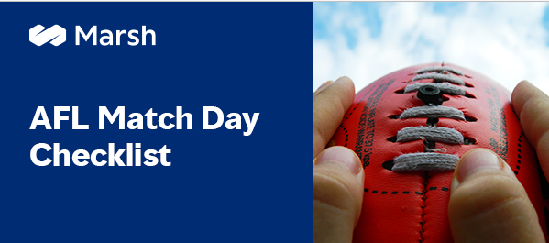
It is a requirement that prior to any match being played, the home club completes a ground checklist for insurance purposes. The link to the web based form is below:
https://bit.ly/3Zrgcgr

HOME TEAM DUTIES

Paperwork:
- Player registration – all listed players are correctly entered Play HQ prior to playing. Ensure Player Points are allocated to each player.
- Team sheet – Squad entered in Play HQ on Thursday night by 8 pm if possible. The Mercury newspaper extracts the teams at a particular time on Friday for inclusion in Saturdays Mercury.
- Update selected team and jumper numbers and print team sheets (4 copies: home team, away team, timekeepers and umpires)
- Ensure player jumper numbers are correct on the team sheet
- Complete Marsh Match Day Checklist via the online form (first game of the day only)

Support Staff:
- Runner(s) – up to 2
- Sports Trainer – Minimum Accredited Level 1 Sports Trainer
- Boundary Umpire (if applicable)
- Goal Umpire (if applicable)
- Umpire Escort
- Timekeeper
- Score board attendant

Support Staff- All team officials must be registered on Play HQ and listed on the team sheet. If they are not listed on the team sheet, they are not permitted to be in the coaches box.
Coaches - It is a requirement that each team coach, including bench coaches to be accredited in CoachAFL and registered in Play HQ. Coaches not accredited and registered will not be able to be selected on team sheet. If a Coach is not selected the team sheet will not save or print.

AWAY TEAM DUTIES
Paperwork:
- Player registration – all listed players are correctly entered into Play HQ prior to playing
- Team sheet – Squad entered in Play HQ on Thursday night by 8 pm. The Mercury newspaper extracts the teams at a particular time on Friday for inclusion in Saturdays Mercury.
- Update selected team and jumper numbers and print team sheets (4 copies: home team, away team, and umpires + timekeepers)
- Ensure player jumper numbers are correct on the team sheet
Support Staff:
- Sports Trainer – Accredited Level 1 Sports Trainer (or minimum ERC level accreditation)
- Runner (s)
- Water carriers
- Timekeeper

The away team is responsible for providing to the Home Team Manager their own goal kickers and best players for Play HQ within 20 minutes of the conclusion of the match. A media release with all results, best players and goal kickers is sent to all of our media partners at 6pm on a Saturday evening.

MATCH DAY PAPERWORK

BOTH TEAM MANAGERS need to provide a copy of their team sheet to the umpires before the start of the match.

GOAL UMPIRES need to pass on their scorecards to the Home Team Manager following the end of the match.

FIELD UMPIRES to decide on the best players at the end of the match and upload via Officials HQ.

HOME MATCH MANAGERS
Ensure all paperwork is collected (Team Sheets, Goal Umpire Cards, and Timekeeper Sheets). These are to be uploaded using the process described below. Keep the original documents on file for the remainder of the season in case they need to be checked. If internet access is unreliable at your location, this upload can be done any time prior to midnight on Sunday night.
Final Scores: Ensure final scores are correct. (Rule 6.1.6.) The scores of each match shall be recorded by both goal umpires, who must stand alone at all times when umpiring, and both timekeepers. If the goal umpires agree, the score recorded by them shall stand, but if the goal umpires disagree, a majority of the four recorded scores shall decide the final score.

Home Team Manager
Match Day Forms Upload:

Scan this QR Code with your phone and follow the prompts. You will be required to submit Home and Away team sheets, goal umpire score cards and timekeeper sheets to the Google Drive.
Keep the paperwork in the envelope provided, for the remainder of the season.

RULES
For full competition rules please refer to the following documents:
2023 Laws of the Game
2023 Community Football Handbook

KEY RULES & REGULATIONS
Footballs
Three match balls footballs of a suitable standard shall be provided for each match.
Stretchers
Clubs must ensure an approved stretcher is available from the interchange bench. The Match is not to commence until a stretcher is available.
A player on a stretcher is to be taken off the ground in the shortest and most direct route.
A player, for whom a stretcher is called, shall not resume playing for a period of twenty (20) minutes of play, as per the Laws of Australian Football (including time on but excluding the quarter/half time breaks)
Officials Uniforms
Sports Trainers must be in the prescribed uniform – purple sports trainer vest.
Runners must be in the prescribed uniform – orange shorts and orange runners top

Water Carriers must be in the prescribed uniform – blue water carrier vest

CONCUSSION/SUSPECTED CONCUSSION
Where a player is injured and the clubs Head Trainer believes they could potentially be concussed they must be referred to a medical practitioner for evaluation and may not continue to play in the match.
Refer to the following AFL documents:
Link: Concussion Management
Management of Sport-Related Concussion in Australian Football
Management of Sport-Related Concussion in Australian Football FAQs
Return to Play Following Concussion Checklist
Return to Play Medical Clearance Form

TIMEKEEPING & LENGTH OF MATCHES AND BREAKS
Competition | Quarter Length | Quarter/Half/Quarter  Breaks
OSFA Seniors | 20 minutes plus time on | 6/15/6
OSFA Reserves | 18 minutes plus time on | 6/15/6

THE ROLE OF THE TIMEKEEPER IS TO:
(a) keep time for each quarter of a Match;
(b) accurately write down goal kickers;
(c) sound the siren as required;
(d) stop and start the clock as required; and
(c) perform any other function as may be directed by the relevant Controlling Body.

BRINGING PLAY TO AN END
• End of Quarter
The Timekeepers shall sound the siren to signal the end of a quarter until a field Umpire acknowledges that the siren has been heard and brings play to an end.

• Siren Heard by field Umpire
Play in each quarter shall come to an end when any one of the field Umpires hears the siren. A field Umpire shall signal that he has heard the siren by blowing a whistle and holding both arms above his or her head. KEEP BLOWING THE SIREN UNTIL THIS OCCURS

CLOCK STOPS
(a) when directed to do so by a field Umpire in general play and after a 50m penalty;
(b) the goal Umpire signals that a Goal has been scored;
(c) the goal Umpire signals that a Behind has been scored; or
(d) the boundary Umpire signals that the football is Out of Bounds or Out of Bounds on the Full.

The clock will not stop when the when the field umpire crosses his or her arms to indicate that he/she is going to throw the ball up.

CLOCK STARTS
(a) when directed to do so by the field umpire;
(b) the football is bounced (or thrown up) in the Centre Square, after a Goal has been scored;
(c) the football is brought back into play after a Behind has been scored;
(d) the football is thrown back into play by the boundary Umpire or brought back into play by a Player, (as the case may be), after it had gone Out of Bounds or Out of Bounds on the Full: or
(e) the football is obviously in play.

UMPIRE SIGNALLING
A field Umpire shall signal to the Timekeeper to stop the clock or restart the clock used for the timing of the Match by blowing a whistle and raising one arm above his or her head.

RESERVES NIGHT MATCHES
OSFA Rule 6.2.4. Reserves night matches played on a weekday shall consist of 20 minute quarters with no time-on.

REPORTING PLAYERS AND OFFICIALS
An Umpire shall report to the Controlling Body any Player or Official who commits or engages in conduct
which may constitute a Reportable Offence per the AFL State and Territory Guidelines published each year by the AFL.
Please refer to the Laws of Australian Football under Rule 22 “Reporting Players and Officials”.
Players will be advised by the umpire that they have been reported. We suggest touching base with the field umpires after the match to check on their overall experience as well as any specific player reports.
During a match, umpires use a card system as described below:
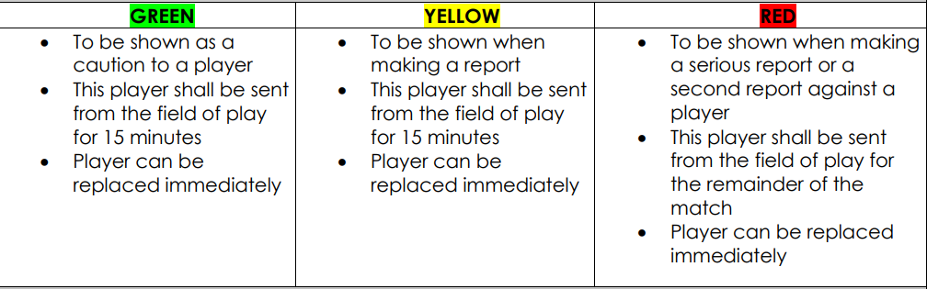

SANCTIONS AND SUSPENSIONS
Upon receiving a report from an umpire the Match Review Officer shall investigate the incident and apply a recommendation per the AFL’s State and Territory Guidelines. The MRO recommendation will be communicated to the Club President/Delegate, who in turn will communicate with the reported player.
Should the player not wish to accept the MRO’s offer of a set penalty, The Controlling Body will refer the matter to the tribunal.
ORDER OFF RULE
Umpires shall use a yellow/green/red card (per above chart) when appropriate to indicate if a player is to be sent for the field and for how long.

Please see the flowchart on the next page which explains the reporting/tribunal process.

Match Review Process
For SFL, SFLW, OSFA, ODFA, STJFL and Masters
TFUA UMPIRE SUBMITS REPORT VIA OFFICIALS HQ FOLLOWING THE MATCH
Tribunal attendance Tuesday evening
North Hobart Oval
Clubs advise Competition Manager of rejection of offer
Clubs advise Competition Manager of acceptance of offer
Competition Manager advises each club of the details of guilty plea/offer

MATCH REVIEW OFFICER MICHAEL HOYLE RECEIVES REPORT FOR CONSIDERATION
COMPETITION MANAGER COMMUNICATES DETAILS OF REPORT TO CLUB PRESIDENTS

MRO ADVISES LEAGUE COMPETITION MANAGER OF HIS DECISION

Competition Manager advises each club the report is going straight to the tribunal

Line Marking Requirements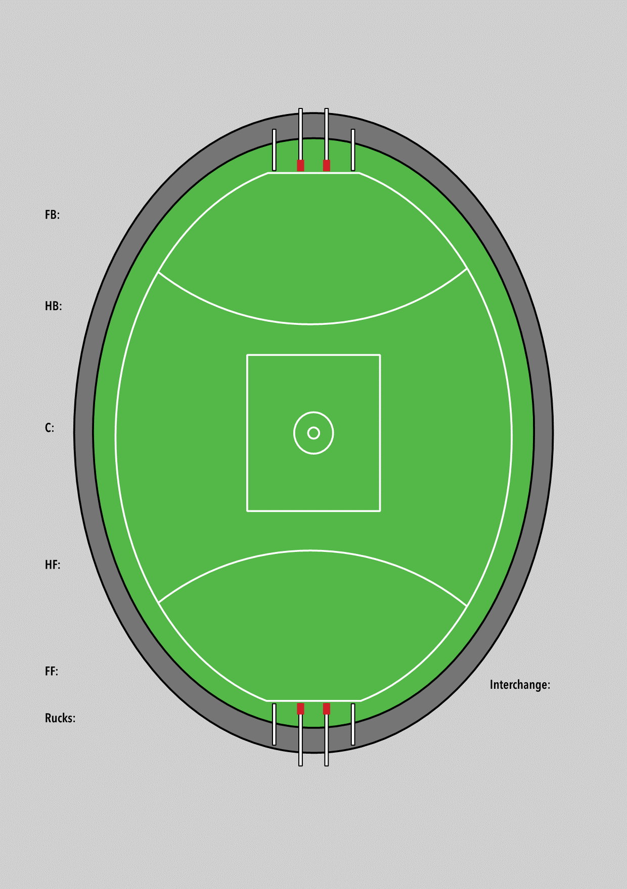
1 Metre line outside boundary line in front of Coaches Box
1 Metre line outside boundary line in front of Coaches Box
Interchange
1 Metre line outside boundary line
1 Metre line 15 metres from top of goal square
1 Metre line 15 metres from top of goal square

