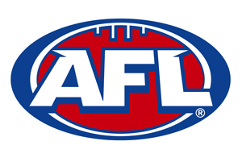
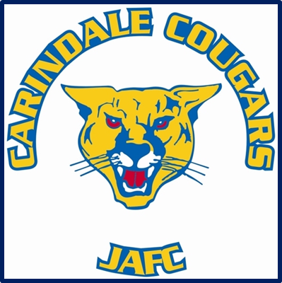

EQUIPMENT

CO-ORDINATOR
ROLE DESCRIPTION
Objectives
- To provide support to the Club Committee members to ensure the
efficient management of Club clothing sales
- To provide a range of reasonable priced clothing that will provide
members and supporters with suitable attire to reflect
professionally on the Club
- To maintain equipment supplies for players, coaches and teams
EQUIPMENT CO-ORDINATOR
ROLE DESCRIPTION
Responsibilities
- Prepare a report proposing a suitable range of clothing for sale for
consideration by the Committee at the commencement of the
season including hats, shirts, and jumpers
- Ensure there is a large selection of sizes for team clothing – jerseys,
training shirts, shorts, socks
- Arrange the wide promotion of clothing items to members,
supporters and the community
- Provide a convenient means by which orders can be placed for all
clothing lines
- Ensure sufficient clothing stocks are maintained to ensure orders
are filled promptly
- Ensure sufficient equipment available for training and match days
including – balls, Manager Kit bags, goal posts, markers, training
aids
- Maintain strong relationships with approved suppliers of clothing
lines and equipment suppliers through regular liaising
- Do regular stock takes of all equipment and clothing

Accountability
- Reports to President
- Reports to the Club Committee
- Provide a verbal update at the monthly Committee meeting
- Seek approval from the appropriate Committee member prior to
committing the Club to any action or financial cost

