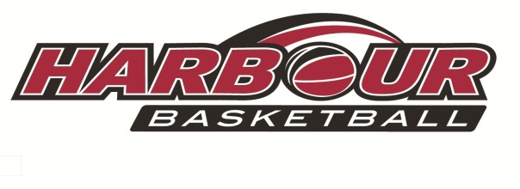

Harbour April Holiday
Basketball Camps

Camp 1: Mon 15th – Wed 17th April
Cost: $150 for 3 days
Camp 2: Tues 23rd – Wed 24th April
Cost: $100 for 2 days

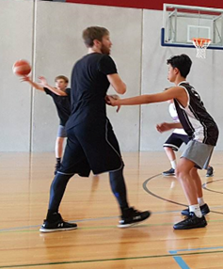
Featuring
Coach Zac Fitzgerald
Sports Mechanics

@ Eventfinda Stadium
Silverfield Lane, Glenfield
9am-3pm Each Day
PitaPit lunch provided (included in cost)
Ages 8-14
Register now through the Harbour
Basketball website!

