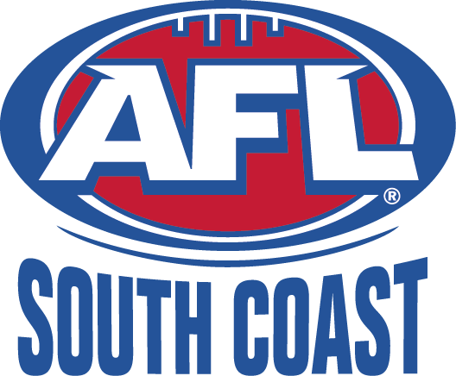
ILLAWARRA JUNIORS

AFL South Coast Incorporated
ABN: 83 986 595 815
Minutes of the Illawarra Juniors Administration Committee Delegates Meeting
held at the Dapto Leagues Club on Thursday 15 May 2014 at 7pm

MINUTES

- Present Committee: Mike Christie, , Bill Reid, Peter Gamble, Dave Johnson
Present Delegates:, Kevin O’Connor (Tigers), Glen Bachelor (Swans), Wayne Barrett, Thommo (Lions), Steve Thorne (Roos)., Simon Williams (Power), Chris Herrod (Hawks)
Guests: Jesse Mulholland
Apologies: Virginia Wise, Dapto/Port, Crows,
Absent:

- Last meetings minutes: accepted and seconded.

- Business Arising:

- U/16 AFL9’s comp
  - to be organized for the next u/16’s bye on 15/6.
  - Regular 9’s rules
  - Mike to send out rules and comp format
  - All participants to be registered.
  - Games to be played after U/14’s at Hollymount (first option) or Bonaira (second option).
- Premiership Flags
  - Thommo showed samples of premiership flags that can be produced by Aceit for about $120 each.
  - Proposal to be sent to AFLSC board to purchase flags to be presented to all premiers.
- U/12 tackle rules.
  - In response to question from Glen, Bill demonstrated u/12 modified tackle technique. Bill explained players cannot deliberately take another player to the ground.
  - Mike to email clubs to reiterate rule interpretation.
- Clarification of 17 y/o rule.
  - 17 y/o’s are not permitted to play u/16’s if they have played any level of senior football in 2014.
  - Mike to resend email to clubs outlining conditions under which 17 y/o’s can play in u/16 comp.
  - It was clarified Mick Talbot is not permitted to play U/16’s as he has played senior football for Shellharbour Suns.

- Correspondence: none tabled

- Chairman’s Report: No report.

- Competition Manager Report: No report

- Youth Girls Manager:
- Jesse has received an invitation to Shoalhaven Youth Girls (13-16) Rep carnival. Jess is trying to get an Illawarra/Shoalhaven team together.

- Representative Manager Report:
- Illawarra have not rec’d an invitation to this years GSJ carnival. Peter Gamble has requested that GSJ reconsider and invite Illawarra U/13 and U/15 sides to maximize chances of Illawarra players who are not in Swans Academy gaining selection in Zone rep teams. Peter awaiting a response from GSJ.

- Umpires Coordinators Report:
- Atmosphere/attitude toward umpires at junior games is good.
- Bill has heard that one junior club paid umpires single ump rate for games with two umpires. Bill has not been able to identify the club.
- Thommo asked if all junior umpires are monitored/mentored during games. Bill advised not all, but as many as possible.

- Football Operations Manager: No report.

- AFL Development Manager Report:
- Most activity at present is around organization for NEAFL game on 6 July. There will be A/K and junior game at half time. Teams to wear club colours.
- Their will be girls A/K and junior girls game at half time of women’s match.
- Illawarra Lions are doing canteen for the day.
- Wave FM breakfast on tomorrow morning at Albion Park.

- Lions Liaison Report: No Report

- General Business:

- Committee Discussion/Decisions
  - None

- Next Meeting: 19 June at 7pm – delegates invited from 7pm to 8.30pm.

- Meeting Closed: 9.45pm

