Here is a very basic weights program to complete before we get started in November for 2015 pre-season. Make sure when completing all of these exercises you follow instructions!!!!
This program is to only be completed no more than twice a week. All we are doing is keeping a solid base from the 2014 season so we can jump straight into the 2015 pre-season, with good baseline fitness.

If you any questions please contact:

Jake Ford : 0408 986 167
Liz Riddell: 0400 395 599
Dan Farrelly : 0408 979 639

Barbell Squat
If the exercise cannot be done properly do not complete exercise and seek professional help!!!
IMPORTANT!!!
FORM with exercise must be done correctly!!!!
- Stand with your head facing forward and your chest held up and out.
- Place your feet shoulder-width apart or slightly wider.
- Sit back and down like you're sitting into an imaginary chair. Your upper body bends forward a little Rather than allowing your back to round, let your lower back arch slightly as you descend.
- Lower down so your thighs are as parallel to the floor as possible, with your knees over your ankles. Press your weight back into your heels.
- Keep your body tight, and push through your heels to bring yourself back to the starting position.
- Complete 10-12 reps for this exercise for 3 sets. Pick a weight which you can control and are comfortable with!!!!!

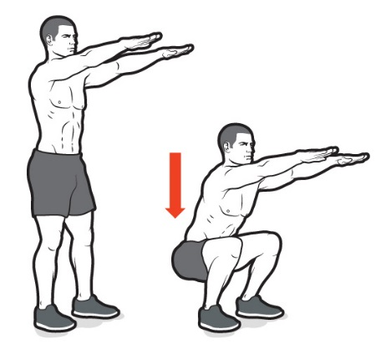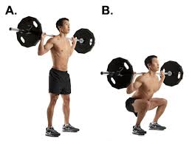

BODY PULL-UP ( Wide Grip & Close Grip)
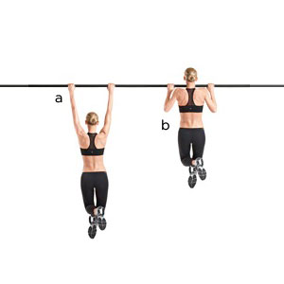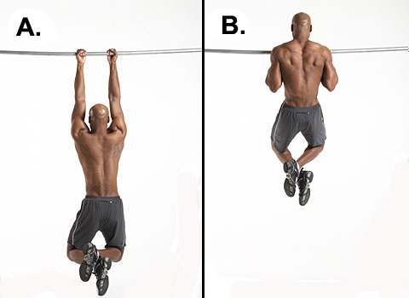
WIDE GRIP: CLOSE GRIP:
Hands shoulder width apart (WIDE) hand close together (CLOSE): (REFER TO PIC) on bar. Making sure to complete full motion till arms are completely straight then pulling body up. DO NOT swing body, movement must be controlled at all time.

PLANK
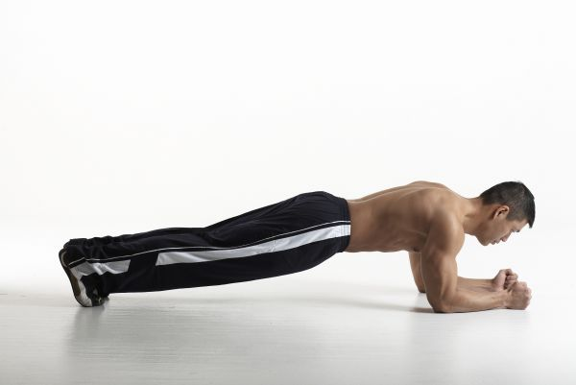
Make hands into a fist and get into position (SHOWN IN PIC). Making sure your chin comes to the fist in your hands. At all times body must be straight and core active.

Body must be in a straight line. Hips must not be dropping or up in the air.

SIDE PLYOMETRIC PLANK
- Step 1: Lie with your left side on a mat. Place feet on top of each other and prop your body up on your elbow and forearm of your left arm.
- Step 2: Place your right hand on your hip, and raise hips so that your body forms a straight line from ankles to head. This is a traditional side plank.
- Step 3: Next, while holding yourself up in the side plank position, raise your right leg up slightly and move it forward and back for 30 seconds.
- Step 4: Repeat on the right side for a complete set.

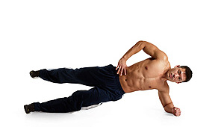

Flat Barbell Bench Press

  - Lie supine on bench, making sure feet are flat on ground. Dismount barbell from rack over upper chest using wide oblique overhand grip.

  - Lower weight to mid-chest. Press bar upward until arms are extended. Repeat. Always keeping proper controlled form.

  - Make sure when performing the exercise only using a amount of weight that you can perform 10-12 reps comfortable for 3 sets.

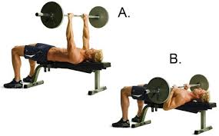

Single Arm Dumbbell Row

- Choose a flat bench and place a dumbbell on each side of it.
- Place the right leg on top of the end of the bench, bend your torso forward from the waist until your upper body is parallel to the floor, and place your right hand on the other end of the bench for support.
- Left hand to pick up the dumbbell off the floor and hold the weight while keeping your lower back straight. The palm of the hand should be facing your torso.
- Pull the resistance straight up to the side of your chest, keeping your upper arm close to your side and keeping the torso stationary. Make sure you contract and squeeze your scapula and holding for 1-2 seconds for optimal contraction.
- Lower the dumbbell straight down till arm is extended.
- Complete this 10-12 reps per arm for 2 sets
