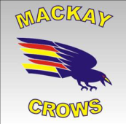
Firstly I would like to congratulate Pioneer High School student Hannah Hillman on her very successful trip to Adelaide where she represented QLD in the National under 18s Ladies championships. Hannah played a vital role in the r Ruck and did an outstanding job. Qld made the grand final eventually going down to Victoria. Great learning experience for young Hannah. Bring on next year as she can represent the State again. This weekend will see 11 of the MacKay’s best Under 15s go to cairns and represent the Capricornia schoolboy’s team. Good luck to coach (Phil McLennan) and the playing group. I would like to congratulate the Eastern Swans and Whitsunday Sea Eagles under 18s on the fantastic display of football played at Rogers’s oval last weekend. Without doubt the best junior game I have seen in 2 years.
Reminder to all senior players that representative training starts next Monday night. Training will be at Harrup Park and starting at 6.00pm. We play Capricornia in a night game starting at 7.00pm. The date for game is June 9th this will also include a ladies representative game. A very big weekend of football.

Regards David Harding (Development Manager AFL Mackay)

