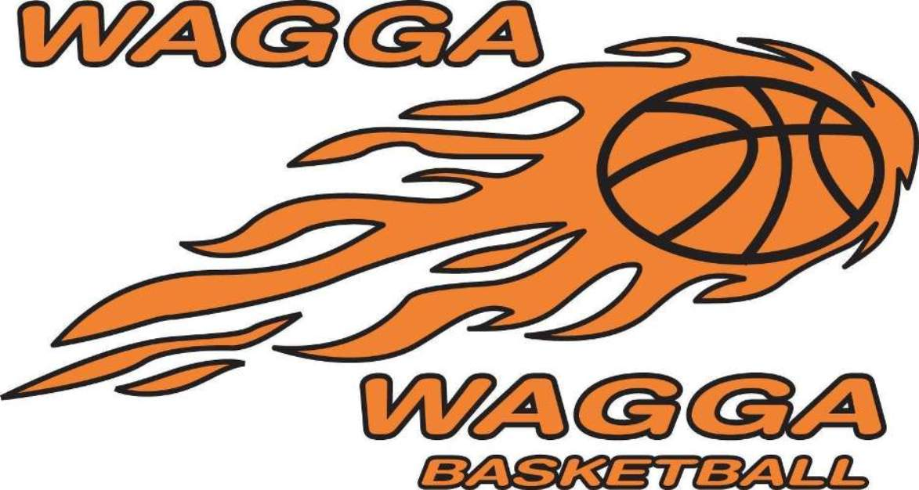

Wagga Basketball AGM

Thursday 20th October 2016
6pm
Bolton Park Stadium

Positions are available on the Board. If you are interested please come along

