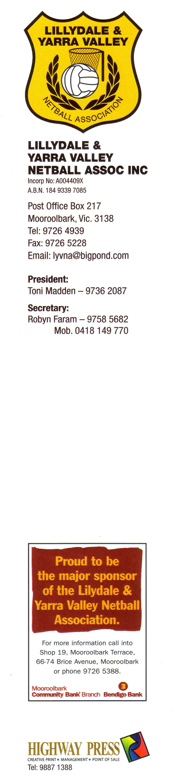
LYVNA
TOURNAMENT ENTRY FORM

Date: 19th July 2015
Venue: Pinks Reserve Regional Netball Complex
123 Liverpool Road,
Kilsyth

Entry fee: $ 60.00 (GST inclusive) per team.
Cheque payable to LYVNA Inc or by direct deposit.
Account Name: Lillydale & Yarra Valley Netball Assoc
BSB: 633108 Account No: 130922651

All teams to supply BADGED UMPIRES
Teams to report in by 8:30am (TBC)

Entries close 10th July.

First aid will be in attendance.

Association name:
Contacts Name:
Address:

Post Code:

Phone: H.
Mobile:
Email:

Teams
Sections Entered
11 & Under Open: team(s) Reserve: team(s)
13 & Under Open: team(s) Reserve: team(s)
15 & Under Open: team(s) Reserve: team(s)
17 & Under Open: team(s) Reserve: team(s)

Total number of teams entered:

Payment: Direct Deposit Cheque Cash

Entries are accepted by mail or email ONLY
No telephone entries will be accepted.
All Associations will be advised of their acceptance/non acceptance.
NOTE: THERE WILL BE NO REFUND FOR LATE WITHDRAWALS.

Any queries can be directed to Robyn Faram Ph: 9758 5682 Mob: 0418 149770
or email secretary@lyvna.com.au

