|  |
| --- |
|  |
| Play, Coach, Ref Football |
| Marketing Collateral Guide |
|  |
|  |
|  |



|  |
| --- |
| © Copyright Football Queensland 2014. This publication is copyright and remains the intellectual property of Football Queensland. No part of it may be reproduced by any means without the prior written permission of Football Queensland. |

The “Play, Coach, Ref Football” Campaign is a nationwide initiative to drive recruitment and retention in 2015. On top of the FFA’s advertising campaign, Football Queensland has created the following marketing collateral for clubs to create consistency across the state.

This document will act as a guide on how to best use the “Play, Coach, Ref Football” marketing collateral in the lead up to the 2015 traditional football season.

The following marketing collateral will be sent to all clubs and zones across Queensland;

* 21.08 x 2.96cm Website Banner (2x Play Football, 1x Coach Football, 1x Ref Football) as a JPEG file
* 30 x 29.5cm Website Tile (1x Play Football, 1x Coach Football, 1x Ref Football) as a JPEG file
* A3 Play Football Poster as High Res PDF and JPEG. InDesign available on request.
* A4 Play Football Poster as High Res PDF, JPEG and Word Document. InDesign available on request.
* News Pictures (as per FoxSportsPulse Requirements)
  + Fading News Option 1: 323px x 221px
  + Fading News Option 2: 506px x 357px
  + Fading News Option 3: 650px x 295px

We advise all clubs to have one form of social media in addition to their club website. Social media will allow clubs to build up their digital community presence as well as provide an extra platform to market your club.

We ask that all zones and clubs try have this marketing collateral in place (on their websites, printed out posters etc) by **Monday January 26, 2015**.

# Website Banners

The following 4 banners (2x Play Football, 1x Coach Football, 1x Ref Football) have been designed for use on your club’s website.

## Sporting Pulse Websites

Given the nature of FoxSportsPulse, clubs who use this website layout will not be able to display these website banners in their traditional format. You may however include them in any articles you publish or on newsletters.

## Other Website Formats

Clubs who do not use FoxSportsPulse have the option of displaying the following website banners if they website design permits. Try to insert a URL link to the banner, if your website will allow.









# Website Tiles

3 Website Tiles have been designed for your club to use on your website. If you do not use FoxSportsPulse, please use these Website Tiles as your website configuration permits.

## Fox Sports Pulse

The following configuration will show you how to set up a Website Tile on your FoxSportsPulse website.

**Step 1.** Log in to your FoxSportsPulse website.

**Step 2.** Click on **Media Library** on the Website Editor Control Panel

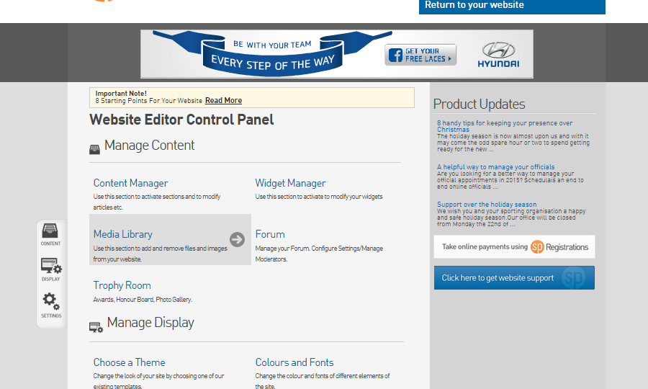

**Step 3.** Click on the green **Upload New Media** button.

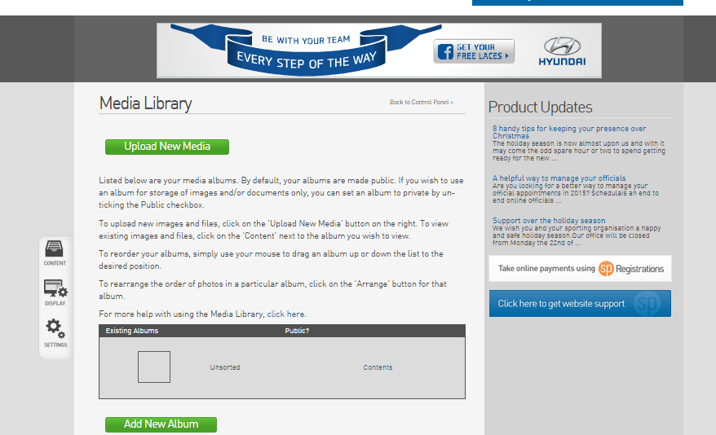

**Step 4.** Click on **Add Files**

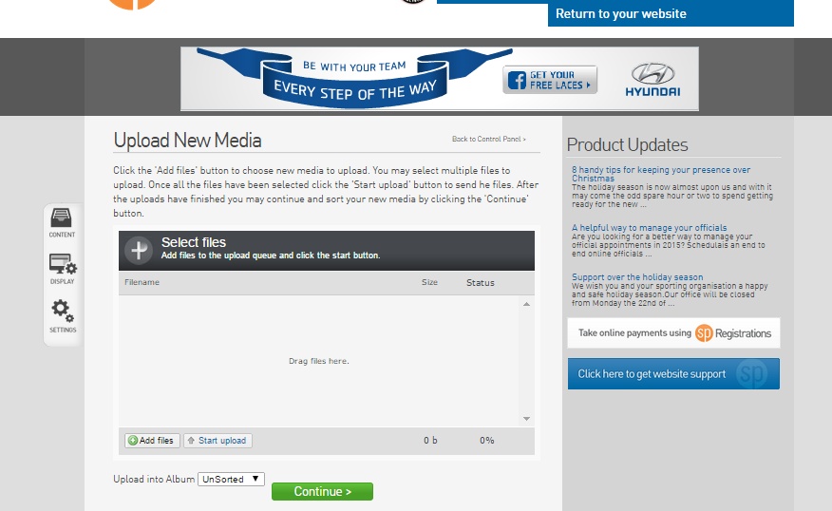

**Step 5.** Select the Website Tile that you wish to use on your club’s website. Once your selection appears, click **Start Upload**.

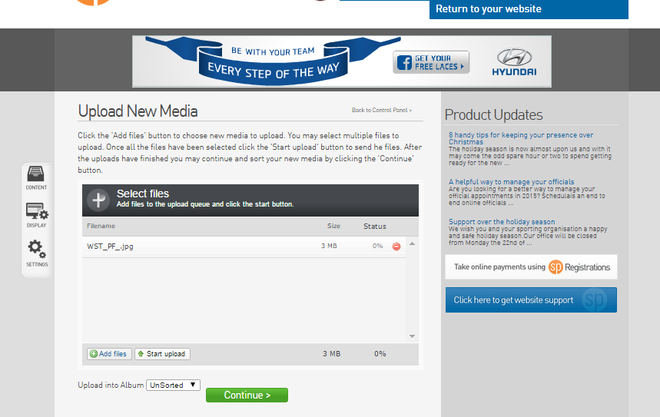

**Step 6.** Once your upload status reaches 100%, click on the green **Continue >** button.

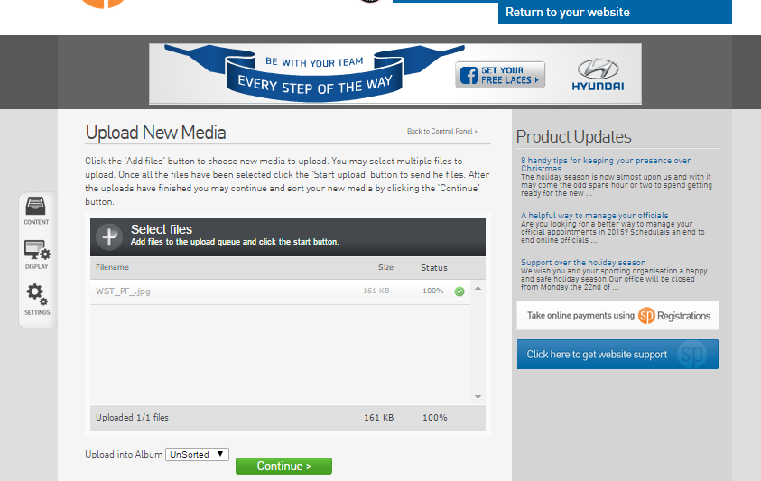

**Step 7.** Highlight the **File Link** address and copy the entire link.

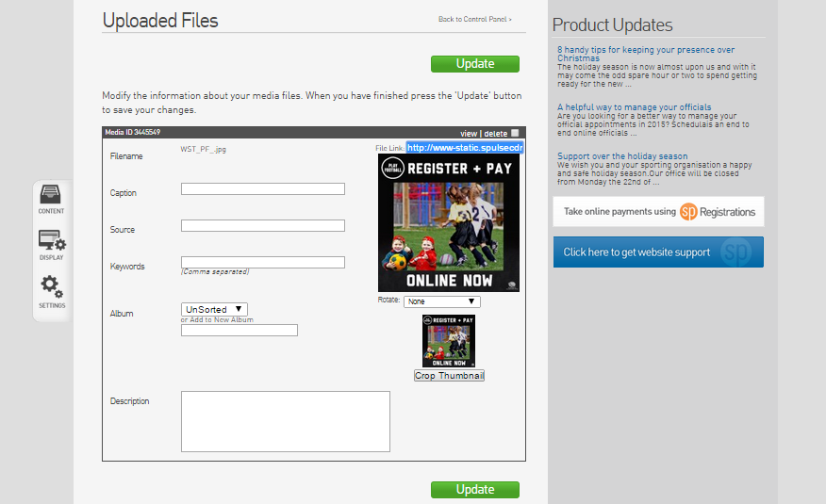

**Step 8.** Go back to the Website Editor Control Panel and click on **Widget Manager**.

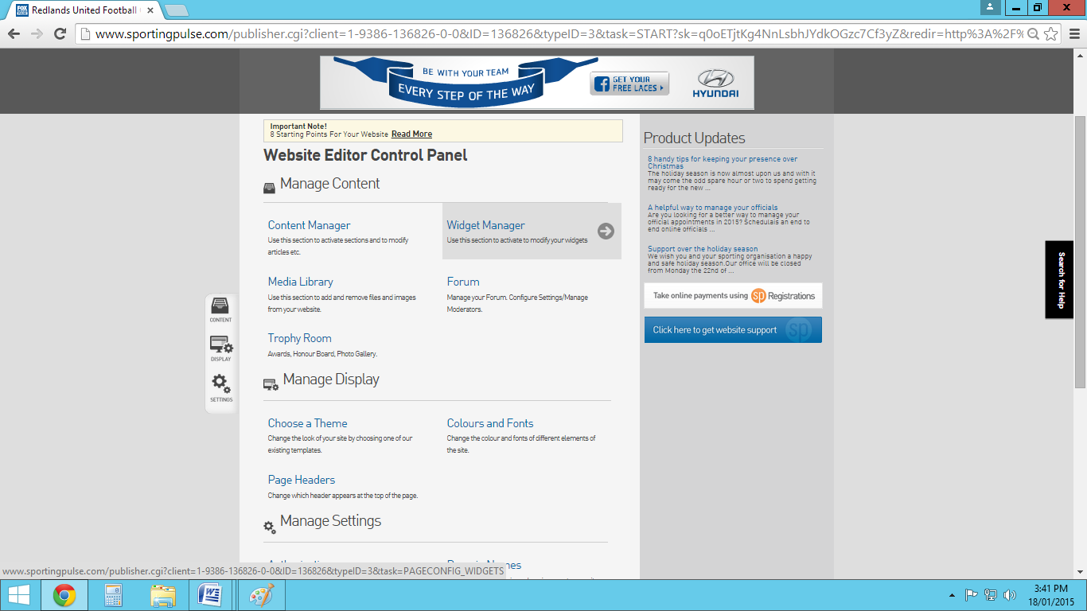

**Step 9.** Click on **Add New Widget** and select **Notice Board**. Then click **Add New Section**.

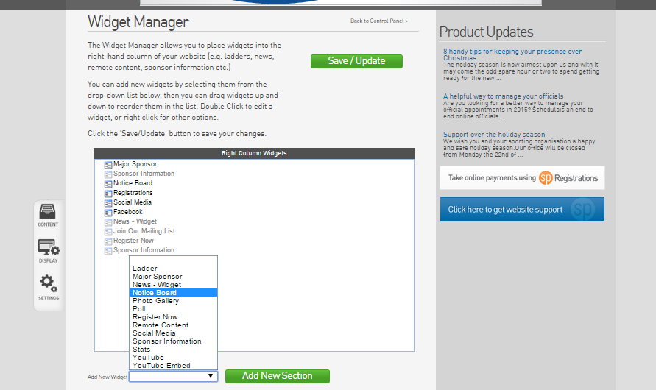

**Step 10.** Slowly click twice on **Notice Board** and change the name to **Register Now**.

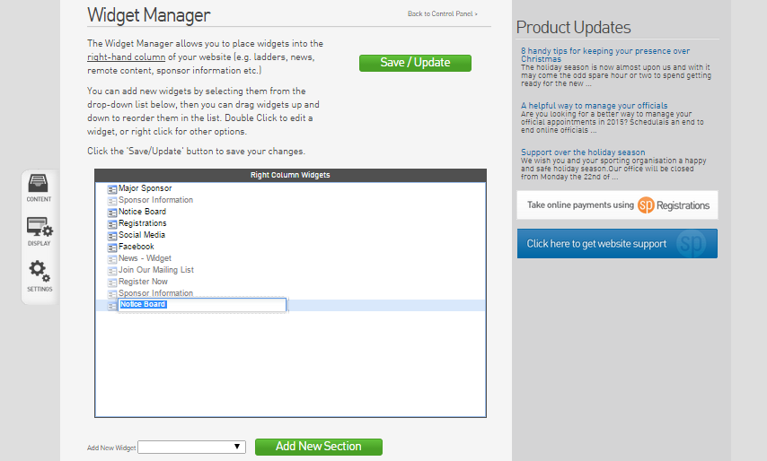

**Step 11.** Right click on **Notice Board** and select **Edit**

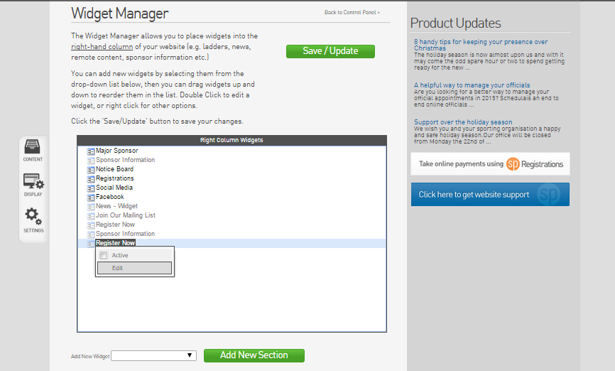

**Step 12.** To insert the Website Tile, click on the **Insert/Edit** Image link as shown below.

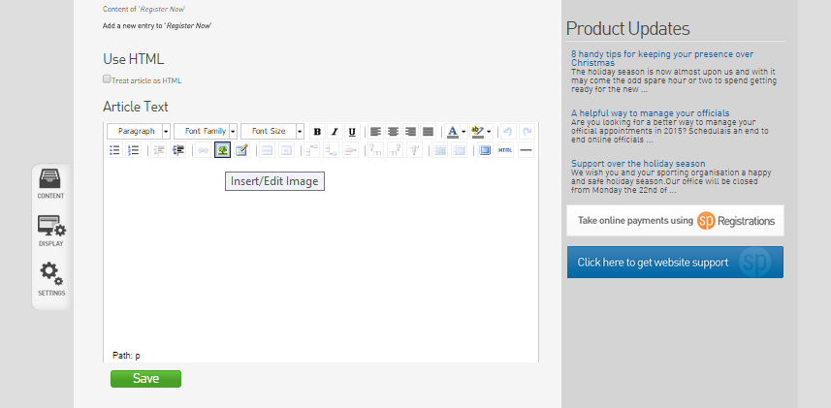

**Step 13.** Paste the **File Link** that you copied earlier in the **Image URL** box as shown below. Click on the **Insert** button.

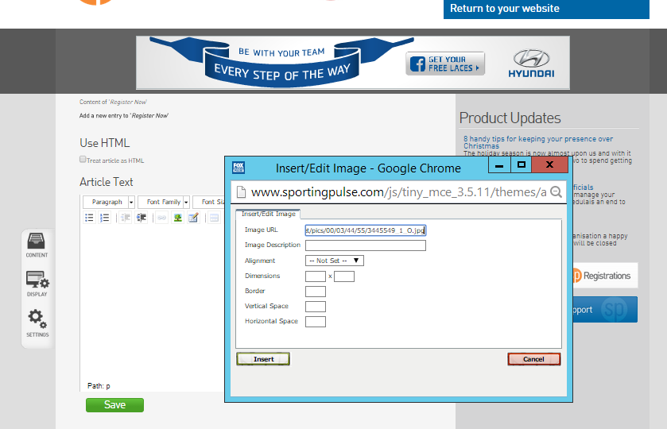

**Step 14.** Select the Website Tile and click on the **Insert/Edit Link** as shown below.

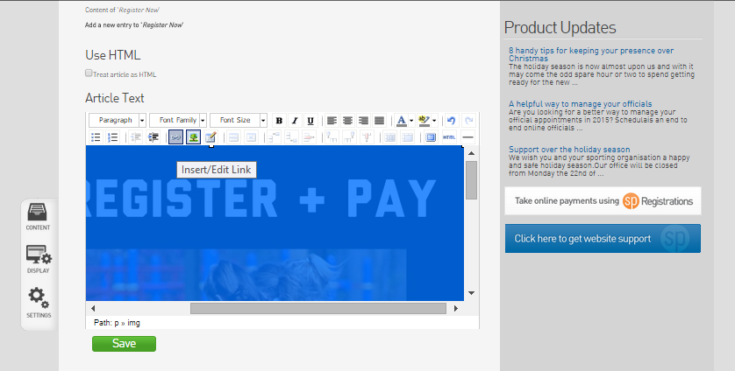

**Step 15.** Insert the link to MyFootballClub, http://www.myfootballclub.com, (or to your club’s registration page) in the **Link URL** as shown below. Then click on the **Insert** button.

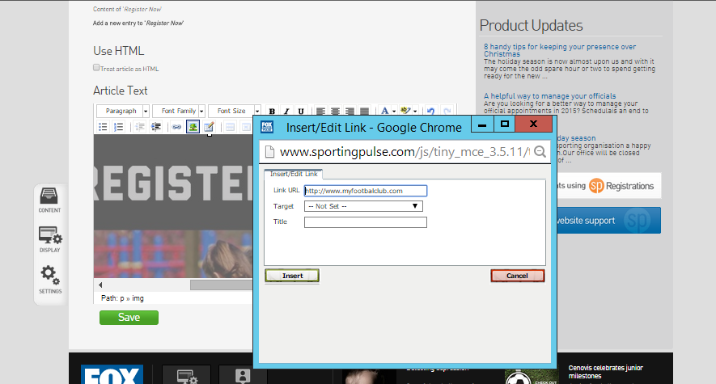

**Step 16.** Once you are happy with the Website Tile and registrations link, click on the green **Save** button.

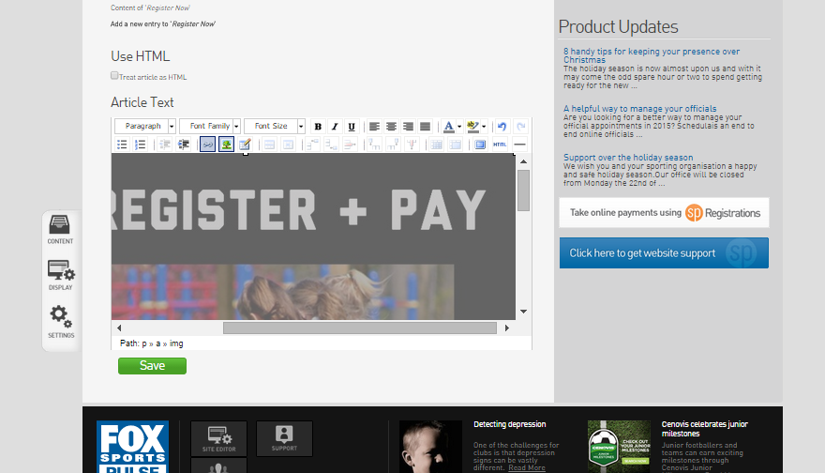

**Step 17.** Go back to the Website Editor Control Panel and click on **Widget Manager**.

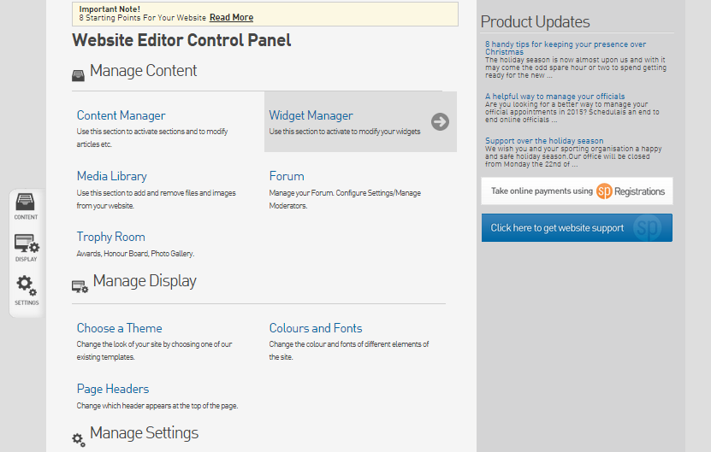

**Step 18.** Right click on **Register Now** and make the widget **Active**. Change the widget order to make **Register Now** appear higher on your widget list. Click on the green **Save/Update** button.

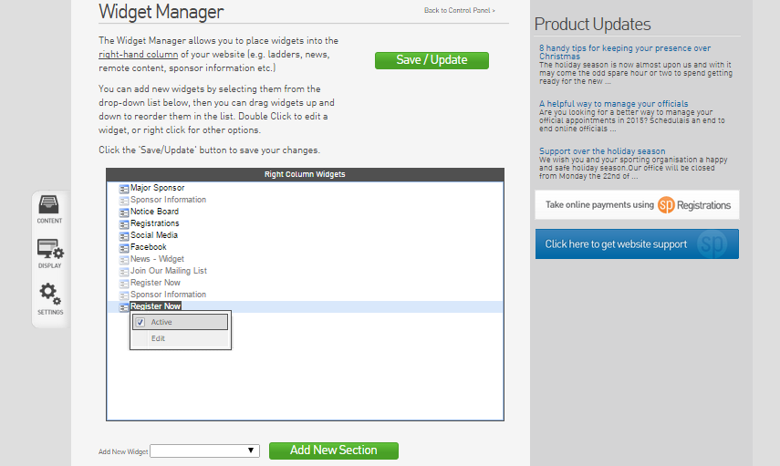

**Step 19.** Return to your club’s website to make sure you are happy with the position of the widget. Adjust accordingly.

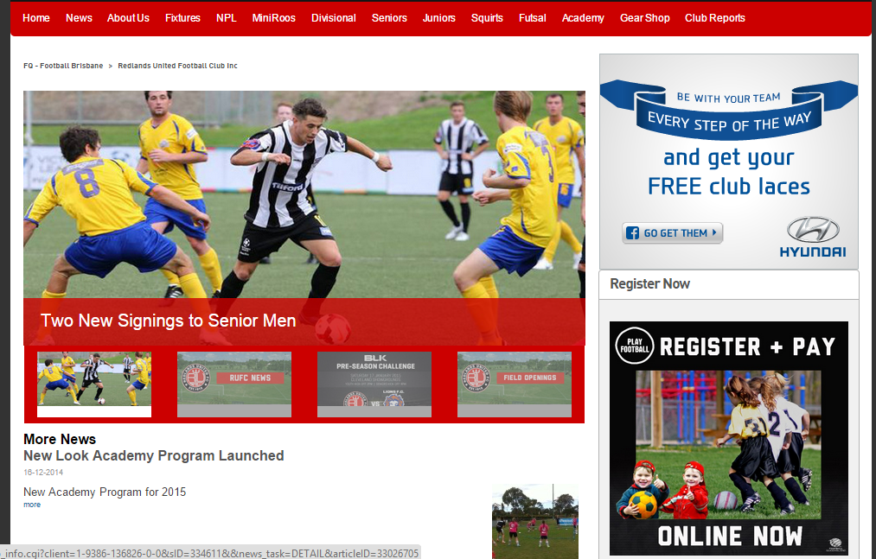

# Posters

The following poster has been designed of your club to print out and display around your club grounds. The posters are available in A3 and A4 size files for your convenience as a High Res PDF, JPEG and Word Document (A4) (InDesign available on request). There is also a Microsoft Word document that you can edit and add in your club’s sign on details (we will provide a word document with the option of using your own club photo to personalise the poster instead of the photo currently in use).



# News Images

The following news images have been created to the specific news image sizing requirements for the **Fading News Options** on FoxSportsPulse. There are 3 sizes;

* + Fading News Option 1: 323px x 221px
  + Fading News Option 2: 506px x 357px
  + Fading News Option 3: 650px x 295px

These images can be used to accompany any sign on or promotional articles that feature on your website.

  
Fading News Option 1

# Social Media

By March 2015, we advise all clubs to have at least one form of social media. The most effective form of social media for clubs is **Facebook. Facebook** will allow your club to create an online community for your club and is a great way for you to answer any questions you may get and have them on display for other members who may have the same question. It’s also a great way to promote events and games.

Once you have established your **Facebook** page you can start posting the marketing collateral in this guide. One way to extend the reach (amount of people who see your posts) is to take advantage of the network of friends that your club members already have on **Facebook**. An example of a post that will expand your social reach is;

(Status) *The 2015 Football season is fast approaching! Whether you love kicking the ball around on the pitch or just want to stay active with mates, Football is fun for everyone.*

*Tag a friend who you want to play football with this season!*

*For more information about Signons click here <insert link to the signon information from your club’s website>*