

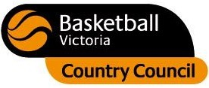

#### **REGISTRATIONS REQUIRED**

#### Please register by **Monday 4th July,2011**

#### Registration forms are available from [www.gsba.com.au](http://www.gsba.com.au) or at the Shepparton Sports Stadium

#### Please contact Aimee 0430163473

#### [manager@gsba.com.au](mailto:manager@gsba.com.au)

#### SKILLS DAY coaches Megan Moody, current Bendigo Braves player & qualified Level 1 coaches

**Where: Shepparton Sports Stadium**

**Address: Numurkah Rd Shepparton**

**When:** Monday 11th July

Girls- 10am – 12pm

Boys 1.00pm – 3.00pm

**Cost:** $5 per player

**U12 & 14s Boys and Girls**