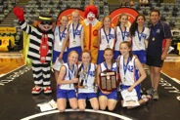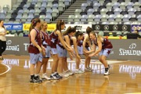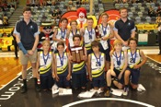Bball_Vic_rgb.png

Basketball Victoria is pleased to announce that once again, the McDonald’s Hoop Time Senior (Grade 5/6) All Star Boys and All Star Girls State Championship Finals will be returning at Hisense Arena.

The top 2 Senior ASB & ASG teams will take the court prior to the **Melbourne Tigers v New Zealand Breakers** NBL game on **Sunday the 14th of December** in a final showdown to crown the new state champions!

The presentations will be made in front of the crowd and the teams will then watch the main game. It is a wonderful experience for all involved & a wonderful way to finish off McDonald’s Hoop Time for the year.

The Senior All Stars State Grand Final day at Dandenong on Tuesday 25th November will act as a qualifier into these Championship Finals.

Basketball Victoria would like to thank McDonald’s  for their continued support of our junior development programs and CTI Melbourne United Basketball for nurturing future basketball stars.

**McDonald’s Hoop Time Announcement**