50 WAYS TO LIGHTEN UP AUSTRALIA

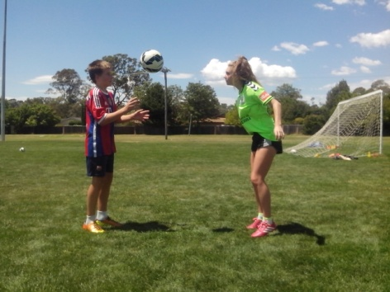
Lighten Up is the Power of One on One

If we think that kids lack skill, we’ve got a lot to teach.

If we think that kids lack talent, we’ve got a lot to learn.

CONTENTS
Introduction
Breakthrough
Freestyle Soccer
Open Learning Program
Learning Drills
200 Touches
Lighten Up
Head
Shoulders
Thighs
Inside Feet
Laces
Safety Net
Optimism
Loosen Up
No Worries
Switch On
Feetball
Roboball
Motor Skills
Ready
Set
Go
Reboot
Footwork
Vision
Power
Precision
Movement
Decision
Belief
Repetition
Challenge
Intuition
Tune Up
Cheer Up
Teaching Aid
Close Repetition Drills
Ballwork in Pairs
Buddy System
Keep Up
Brighten Up
Listen Up
Teenage Mentor
Soccer Whisperer
Psst!
Counterbalance
Double Shot
Fun and Games
Match Preparation
Heading
Juggling
Flexibility
Diversity
Creativity
Learning the Four R’s
Purpose
Energy
Injury Prevention
Recovery
Self Drive
Innovation
Responsibility
Confidence
Cold Case
Rhythm
Pathfinders
Insight
Encouragement
Talent
Improvement
Speed Up
Growth
Small Change
Short Circuit Training
Future Soccer
50 Ways to Encourage Soccer Kids

INTRODUCTION
A Skills Park is where kids have the freedom to make decisions, take risks, make mistakes and take responsibility.
Lighten Up means something different to everyone. If we’re too serious, worry too much, lack confidence, are overweight, unfit, in the dark, rush, try too hard, get sent off, miss simple goals, shout at kids or blame referees for a loss, we have a good reason to Lighten Up.
The only obstacles that can hold back a kid, adult, club or sport are ignorance, laziness, selfishness and fear. Innovative kids need an environment, at least once a week, where they aren’t scared to lose, fail, make mistakes, get corrected or laughed at. A Skills Park allows kids to think for themselves and compete with their mates without being protected from failure.
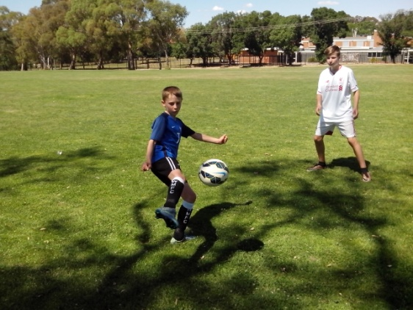
Soccer is just a game. Kids are a lot more important than winning, being correct or making a profit. It’s time to Lighten Up Australia.

BREAKTHROUGH
We need to look at what we do and wonder why and then look at what we don’t do and wonder why not.
A healthy wealthy sporting nation, with a high performance coaching system, should be in the Football World Top 20. We have talented players and innovative coaches but we lack belief in them.
Junior sport is a kid’s game played by adults who like to make all the decisions and call the shots. Kids want their ball back so they can play their own game. We can’t identify talent if we only see kids who wait to be told when to train, what to think, where to move and what to do.
The real Australian sporting character can be found at the skate parks, BMX tracks, basketball courts and cricket nets where confident kids are free to develop their skills without well meaning adults constantly coaching them and pointing out every mistake that they make. We need to lighten up and let kids think for themselves, challenge their limits, make their own decisions, create their own moves, make their own mistakes, learn from them and move on to the next challenge.
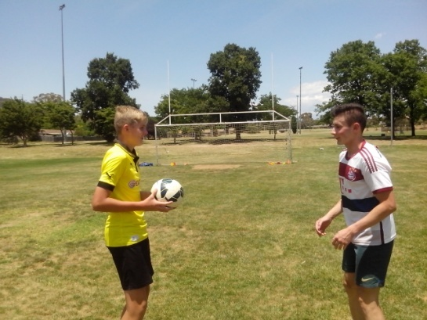

FREESTYLE SOCCER
Freestyle Kids teach themselves to learn and learn to teach others.
Freestyle Soccer is designed to improve Australian Soccer by learning about players and identifying their strengths, weaknesses, talents, skills, fears, needs and limits. There isn’t one Australian Soccer kid we can’t improve in 5 minutes just by learning about them. Some kids are flat footed. Some are one footed. Some kids stab at the ball. Some lack confidence and hide their talent. Some kids are scared of heading the ball. Some kids lack the basic motor skills of throwing or kicking.
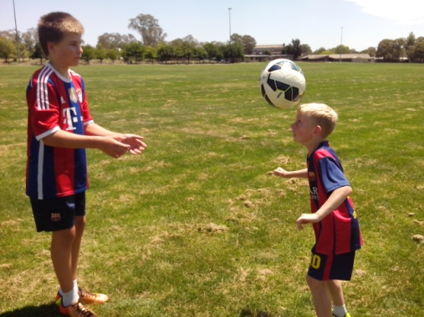
Some kids try too hard to kick the ball too hard. Some kids tense up and rush their kicks. Some kids never get enough touches of the ball to develop eye/foot coordination or make ball control second nature. Some kids make mistakes because they worry about making mistakes. Lighten Up can improve all of these players and lift their game. It’s amazing what kids achieve when they don’t know what they can’t do.
OPEN LEARNING PROGRAM
Kids with an open mind look at everything and can make their own decision which path they want to take and how far they want to go.
A coaching system teaches Soccer skills so that teams can win games. A learning program observes natural skills so that kids can improve their Soccer skills. We can observe players, evaluate their mistakes, target the underlying cause, measure performance and improvement, research and develop appropriate training drills and discover talent.
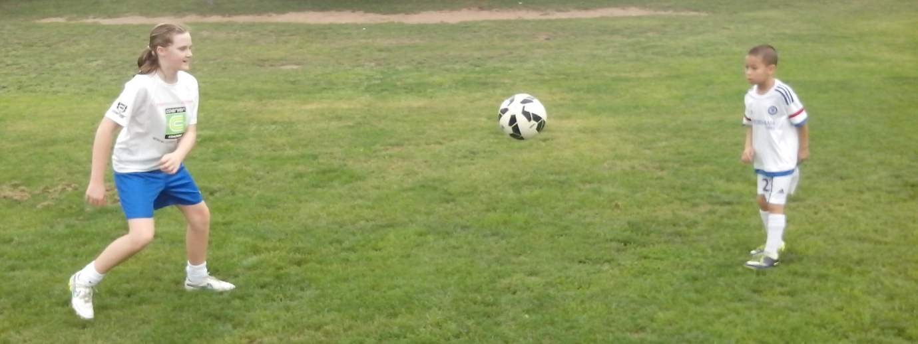
When we look for the natural talent that all kids have, we can use the basic tenplate for qualities, abilities and values. We learn a lot about players by assessing their character, intelligence, mindset, movement, control, understanding, teamwork, drive, creativity and growth.
If we open our eyes, ears, mouths and minds to new and different idea, we can look, listen, ask questions and can think for ourselves. We need to understand our players and discover their talent or the rest of the Football world will believe Australia lacks the ability to reach the top. When we’re ready to develop an Australian coaching system to suit the needs of Australian players, the first step is to Lighten Up. When kids shoot at goal they need to follow it up. When we teach Soccer skills, we need to visit the ovals and follow it up. We know what we’re teaching kids but we don’t know what they’re learning.
LEARNING DRILLS
When the teaching glass is half full and the learning glass is half empty, we need both halves to make a full game of it.
The kid is the key to the game. If we can improve ANY Soccer kid, we can improve Australian Soccer. If we can improve ANY Soccer kid in 5 minutes, just by learning about them, we can change the way junior Soccer is coached. Lighten Up is designed for all those coaches who don’t believe that Australian kids have the talent to reach the top.
Any kid can improve in 5 minutes because they’re willing to look, listen, ask questions and learn. Adults may take a bit longer. Kids can achieve because they believe. They can improve because they move.
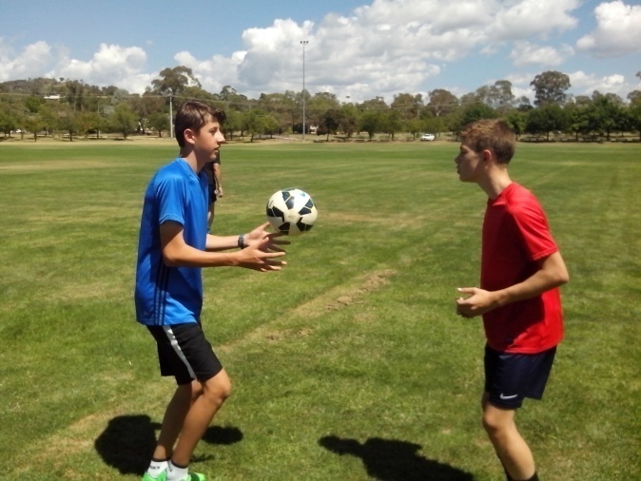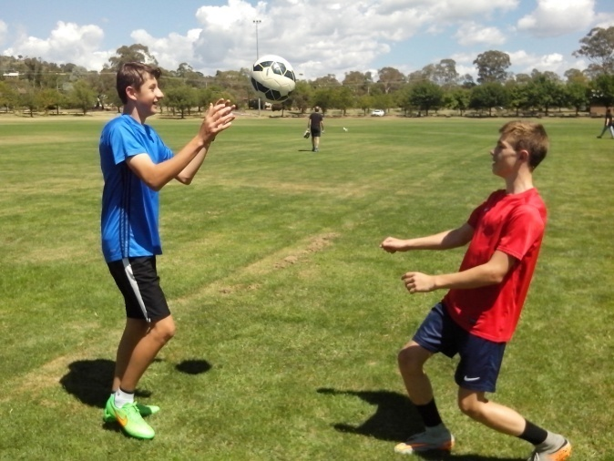
Soccer skills are very simple and easy to learn. If kids want to achieve their full potential, they need to use their brains and move their bodies. Freestyle kids use 10 key elements to integrate their Soccer skills with their natural skills.
Learning Drills look at footwork and vision, power and precision, movement and decision, belief and repetition, challenge and intuition. Lighten Up is the most effective learning drill and can be used by kids or anyone else to assess mistakes and identify their underlying cause.

200 TOUCHES
As Freestyle Soccer gradually flows into the mainstream game, coaches will begin to hear a lot more about 200 ball touches.
A good coach tells kids what to do so they can follow orders. A better coach shows kids how so they can practice on their own. The best coach explains why so kids can help each other and run the drills. Soccer kids need at least 200 touches of the ball to reach the intuitive level where eye/foot coordination kicks in and control becomes second nature. Anyone who teaches kids can quickly discover that.
When kids practice Lighten Up, their first touches are too hard or too soft, too fast or too slow, too early or too late, too high or too low, too loose or too tight, too left or too right. After 200 touches, the weighting period is over and control becomes consistent and creative. Players achieve eye/hand coordination and eye/foot coordination.
Catch phrases catch on. When everyone gets used to ‘200 Ball Touches’, we can upgrade to ‘200 Kicks Before Kickoff’.

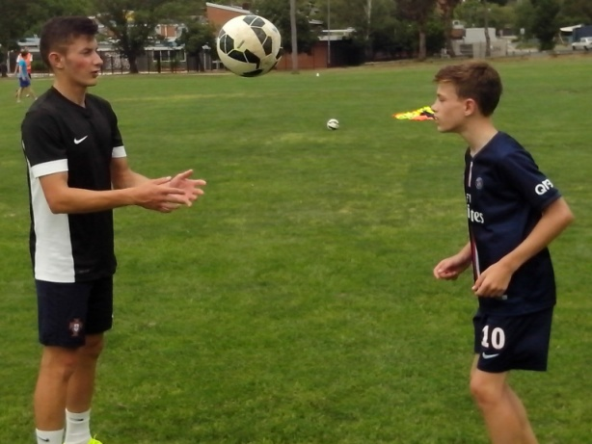

LIGHTEN UP
Soccer is about a kid and a ball. Freestyle Soccer is about a moving kid and a moving ball. Lighten Up is about two kids and a ball.
Lighten Up is a close repetition ball drill that can improve any Australian Soccer kid in 5 minutes. It consists of three sets that are designed to promote continuity and ingenuity. The secret to Lighten Up is to get kids up on their toes and constantly transferring weight from one foot to the other so they improve balance and coordination.
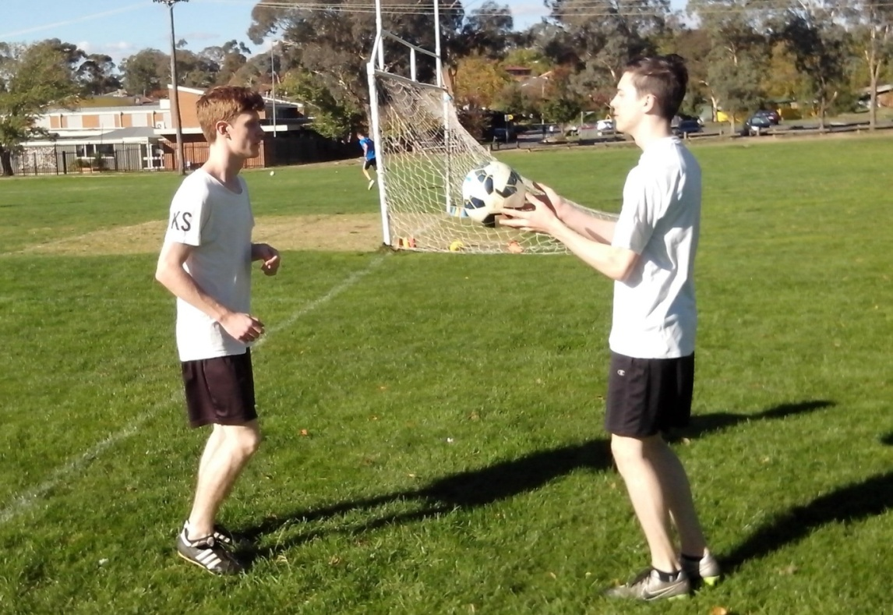
The thrower stands two metres from the receiver and throws the ball continuously to the head until the player becomes more comfortable. Once a player gets in their comfort zone, they stop thinking too much and start controlling the ball intuitively. The thrower gradually moves down to the shoulders, then the thighs, the inside of the feet and finally the laces (instep). When they start again at the head, control is a lot more natural. Both players increase their concentration.

HEAD
In a Coaching System, we have all the information written down for us. In Lighten Up, we have all the information right in front of us.
A lot of kids are scared of heading the ball because they were hurt when they were younger. The biggest mistake for kids is that they let the ball strike them instead of them striking the ball. They close their eyes, brace themselves and sure enough the ball hurts their head. Some coaches go too far or too high when they throw a ball at a kid.
Lighten Up enables kids to practice close heading at their own pace so they can develop a feel for the ball and confidence before increasing their range.
Heading is one of the most neglected skills in Soccer. Once kids gain the confidence to head the ball, they will attack the high ball in a game while a lot of other kids will wait, hesitate and spectate.
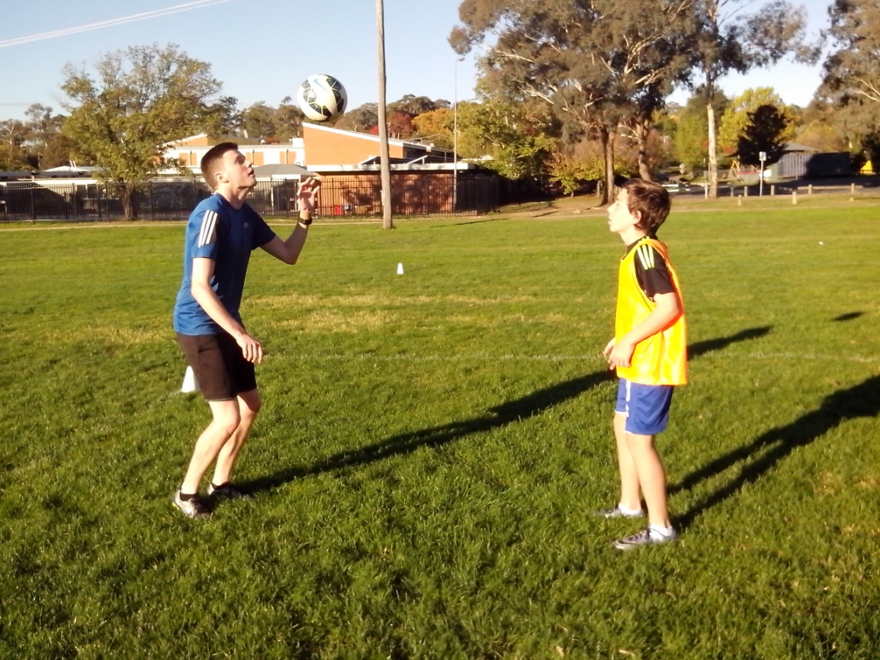
SHOULDERS
If we want to try something new or different, we need to be up for it not down on it.
Pele would often pass the high ball first time with his shoulder instead of bringing it down to the ground. Nowadays, referees will often blow for handball because they haven’t seen a shoulder pass before. There isn’t much empathy for players who look different. Freestyle kids use their shoulders and thighs to control a high ball or pass it first time.
In Lighten Up, the shoulder is just a natural progression as the thrower warms up the receiver. It enables kids to loosen up. A lot of kids have trouble focusing on the game before kickoff. They haven’t seen their team mates for at least a day so they have a lot of catching up to do. Lighten Up ensures that they only distract one kid at a time.
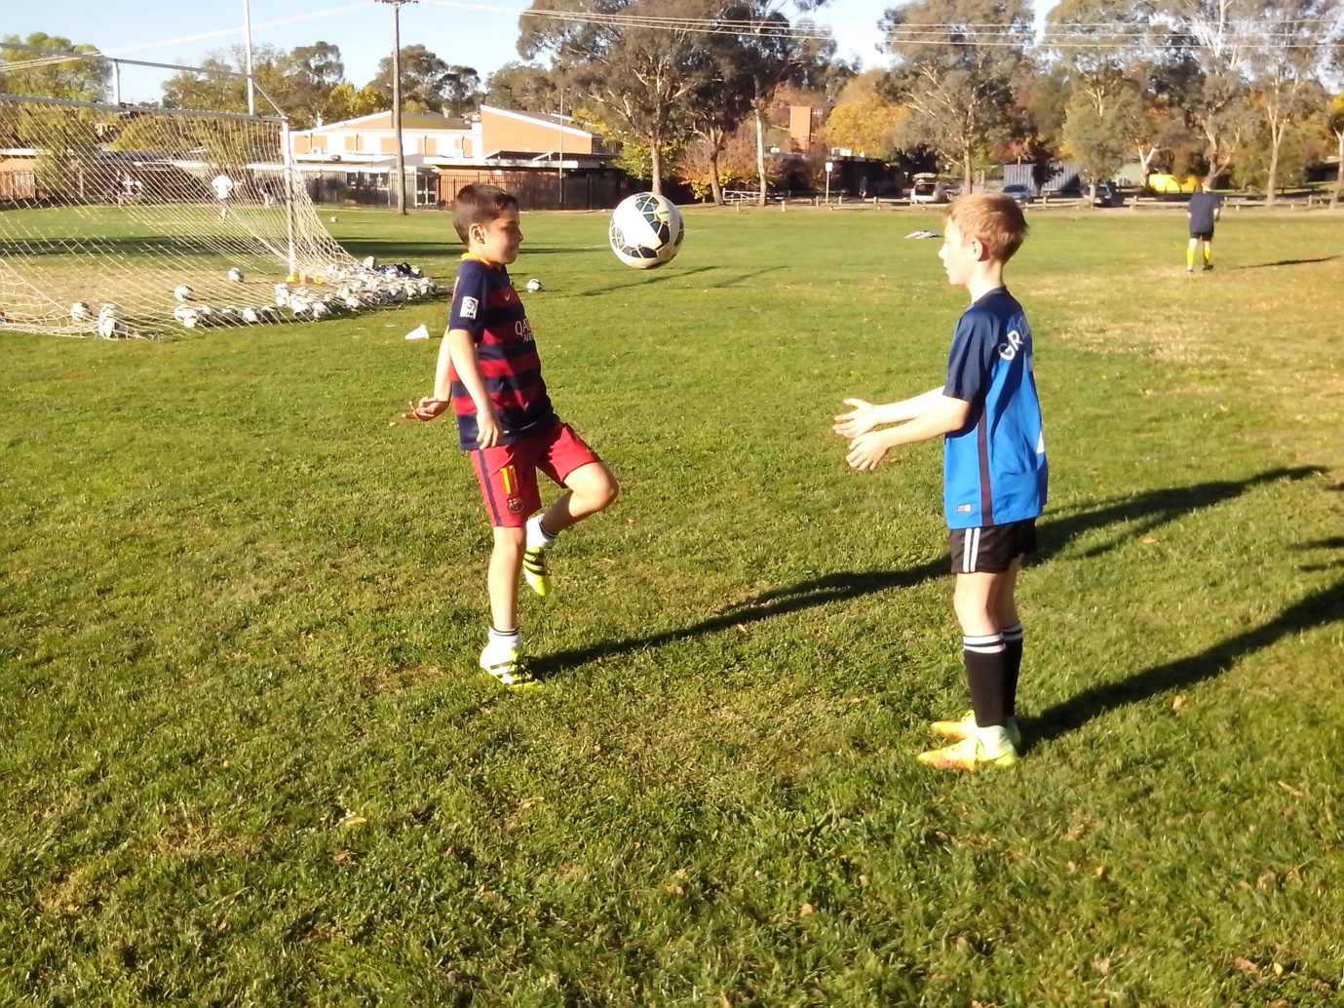

THIGHS
If we can use kids to develop the game, we can use the game to develop kids.
Little kids strike the ball with their knees so that it goes anywhere at a fast pace. The thighs provide a larger control surface. When a high ball drops in a game, players use their thigh to take the pace off the ball and the ball drops nicely for their feet to use the second touch.
When kids use their thighs in Lighten Up, an interesting phenomenon occurs. Some kids put their weight on the standing leg and some kids put their weight on the striking leg. Some kids make a tentative stab at the ball and they neglect following through so the ball doesn’t go far.
All kids are different and they develop a different stance and a different posture when they control a ball. Some kids develop bad habits that stay with them undetected for years. Without a learning program or a learning drill like Lighten Up, kids spend years repeating the same simple mistakes and coaches spend years correcting the same simple techniques instead of spending 5 minutes discovering and overcoming the underlying cause.
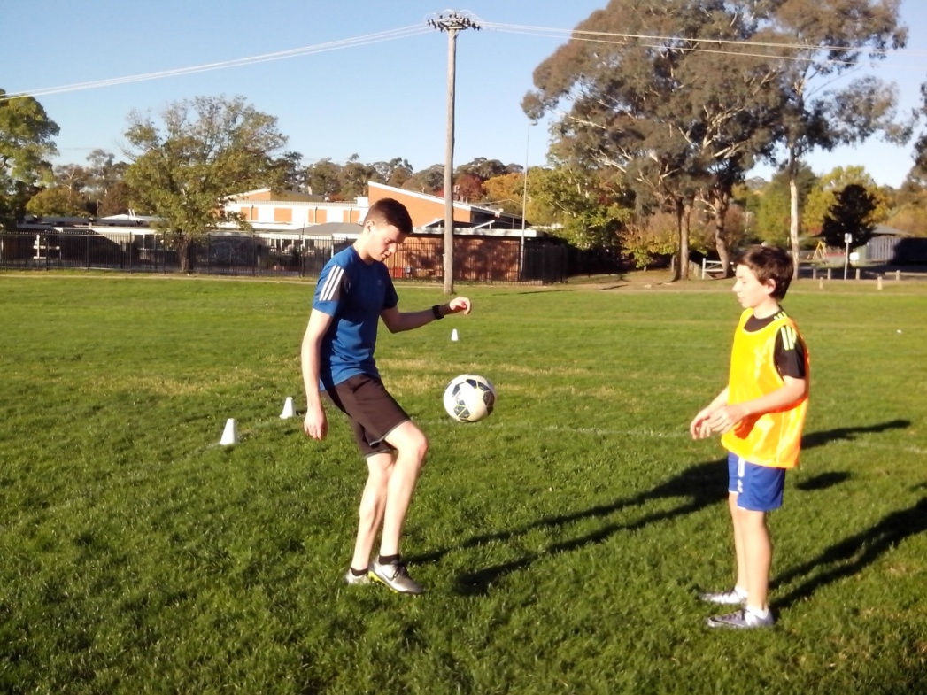
INSIDE FEET
Kids can use the inside of their feet to pass the ball forward but shouldn’t use it to juggle because it throws out the upper body.
The average Soccer kid is happy just to kick a ball. The Freestyle kid looks for different ways to control a ball. They use a different part of the foot to vary the direction, range and elevation.
Lighten Up enables players to become more agile and widen their range of skills. The inside of the foot provides a wider control area so that kids can place precision shots over the keeper and into the goal.
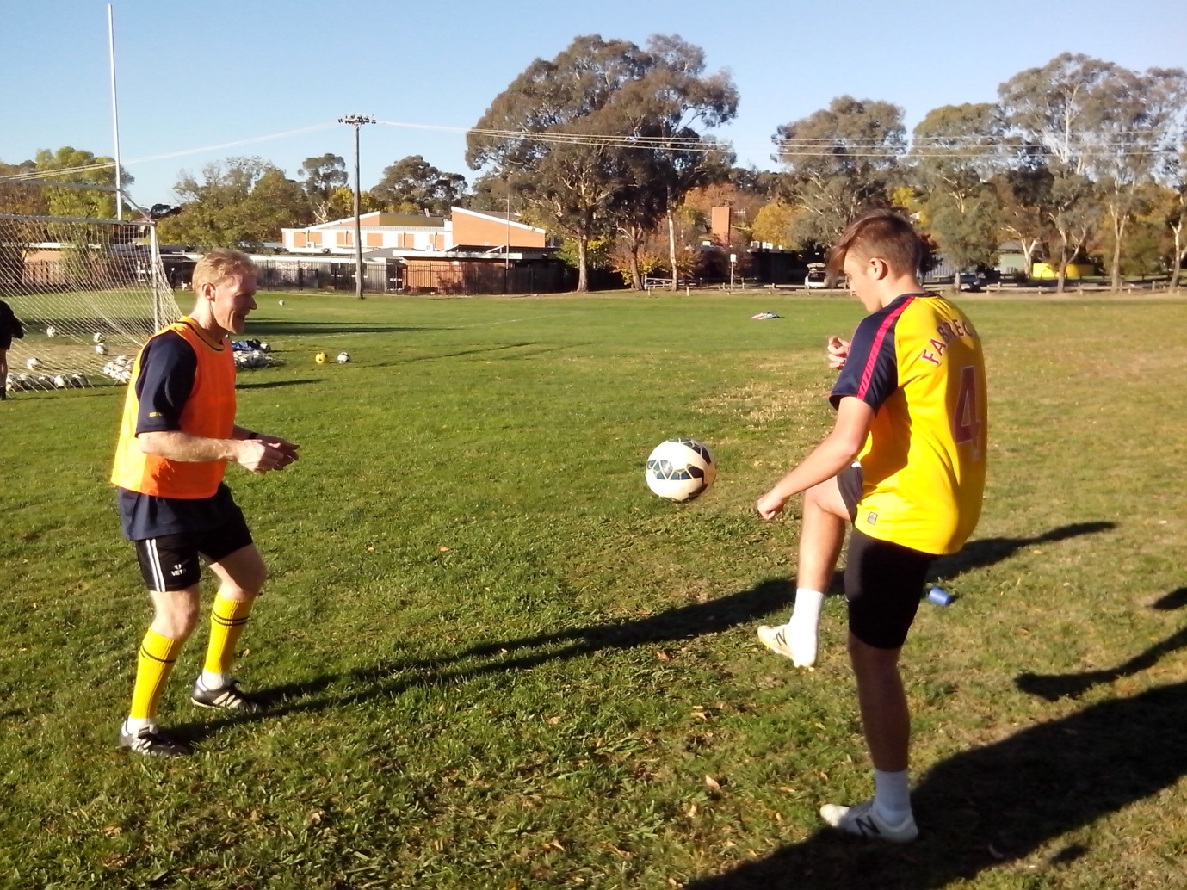
A lot of kids are slow to move because they’re heavy on their feet. They stand back on their heels and wait for something to happen. Freestyle kids get up on their toes and make something happen.

LACES
When strikers keep blasting the ball too high, Lighten Up helps them to get over it.
Some kids straighten their foot too early so that they kick the ball with a stiff leg and produce backspin that puts the ball over the crossbar. Lighten Up teaches kids to keep their knee over the ball when they volley so they can produce top spin to keep the ball down or make it dip. Juggling teaches kids how easy it is to switch backspin to topspin with a slight change in the angle of the ankle. Any kid can improve if we encourage them to keep trying their best. They might not control the ball well at first but at least they’re willing to have a stab at it.
Lighten Up shows kids how to control the ball, their temperament and their power by developing their timing first. A good kick looks good, feels good and sounds good. When their timing is off, the kick will make a higher slapping sound. When their timing is perfect, the ball will make a deep sound. Freestyle kids use sound judgement to fine tune their kicks so that they know when they’re ready to play a game.
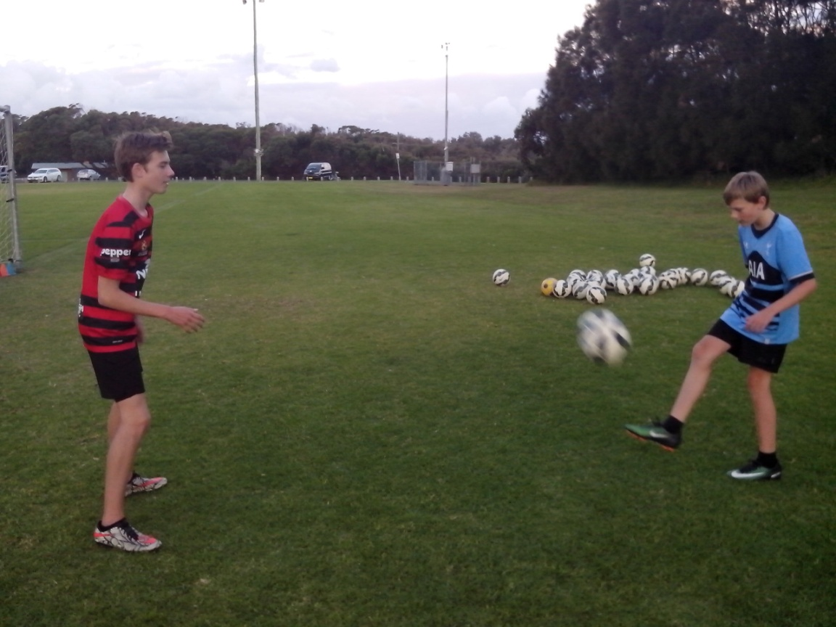

SAFETY NET
The earlier we can overcome mistakes and develop their skill, the earlier kids can build their confidence and discover their talent.
Intelligent, athletic 17 year old College kids are repeating the same mistakes they learned when they were seven because nobody was able to spend a few minutes with those players to identify unforced errors.
When kids struggle to strike the ball because they stand flat footed, or they struggle to strike the target because they take their eyes off the ball, they haven’t just picked up the problem. They’ve been doing the same for 10 years and nobody notices because we look at technique.
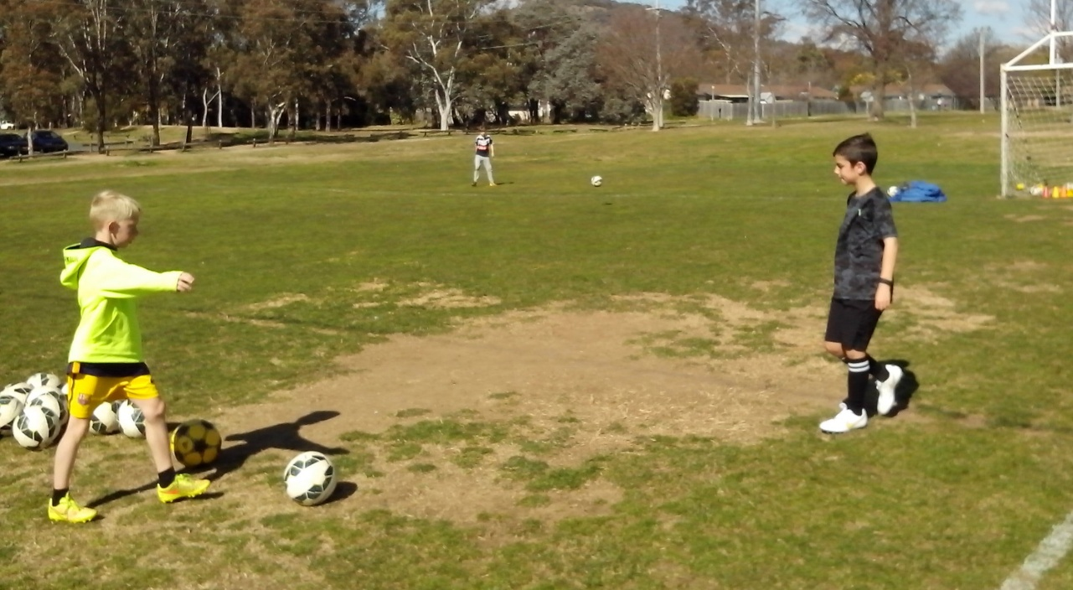
The Safety Net ensures that every 10 year old Soccer kid is assessed for footwork and vision before poor habits become permanent habits. In 5 minutes, Lighten Up can identify flat footed, stiff legged or one footed players who stab at the ball because their feet are glued to the ground. It takes 5 minutes to teach kids about small targets and show what to aim for before they shoot and what to look at when they kick. If we can’t see talent in kids, it doesn’t mean that kids lack talent.
OPTIMISM
Freestyle kids are happy to compete with themselves and their mates. Lighten Up gives them the basic technical skills.
When we look at the players of the future we can see the innovation. The next generation won’t want to stand around waiting to be told how to think, where to move or what to do. They need to go further than the old generation.
If we want Australia to compete with the leading Football nations of the world, we need to create a resilient generation that believes in itself. Freestyle kids have the confidence to make mistakes and coaches have the talent to be innovative. Resilient kids who go to the skate park and BMX tracks use competition to stimulate innovation.
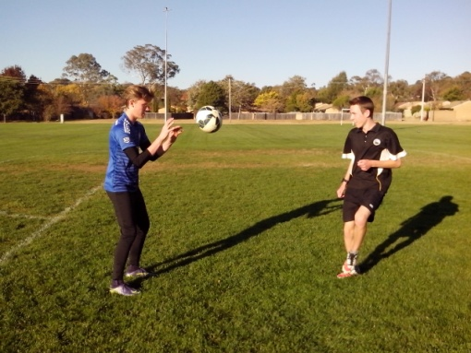
Kids want consistency. We try to protect kids from the fear of losing games and then we undermine their confidence by constantly pointing out their mistakes in the belief that we’re helping them. We can help kids more by not helping them, so they can play their own game.

LOOSEN UP
Freestyle Soccer is a simple set of steps that can improve any Australian kid who is willing to listen. Lighten Up is the first step.
The greatest pressure in a game comes inside the penalty area. Kids tense up, rush their moves and try too hard to kick the ball too hard whether they are strikers or defenders. There are talented strikers who panic in front of an open goal because they never get enough close repetition shooting practice to become familiar with marksmanship.
When kids tighten up, the key to relaxation is to Lighten Up. Kids will find dynamic power when they stop looking for it. When a sprinter moves into the final stretch, they relax so that their muscles can perform at the optimum level. The top players look lazy in the goalmouth because they are in control of their own performance. Lighten Up enables kids to get hundreds of ball touches so they become bored and move from the conscious to the intuitive zone.
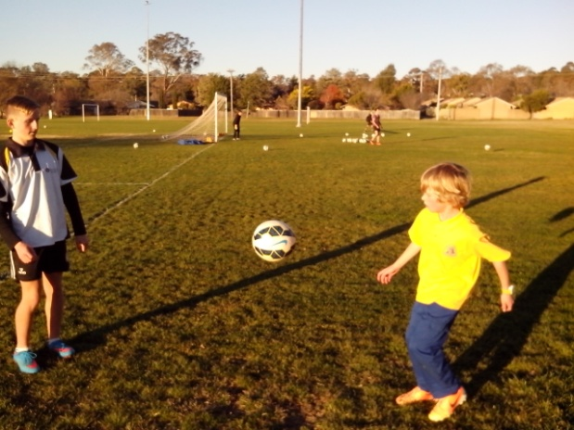
NO WORRIES
A lot of kids make mistakes because they worry about making mistakes. They just need to Lighten Up.
We can protect kids from losing or give them skills to cope with it. Freestyle kids learn more from their mistakes than other kids because they make more of them. When kids constantly challenge their limits, they are going to consistently fail until they overcome the challenge. Most kids never fail because they play it safe and take the easy way out.
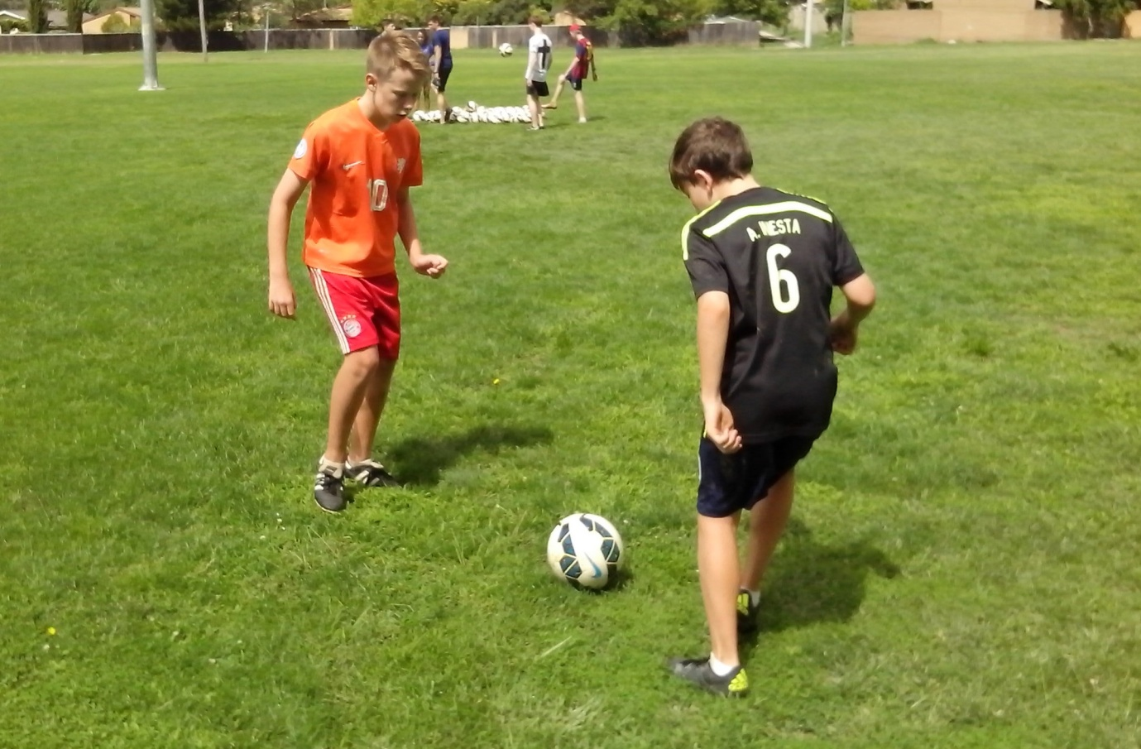
The biggest mistake we can make is to stop mistakes because they will keep recurring. If we encourage kids to make as many mistakes as they like, we can observe the mistakes and discover the underlying cause. Otherwise we believe that kids lack the talent to reach the top.
There’s nothing wrong with kids making mistakes. The problem is when kids worry about them and then they make more mistakes.

SWITCH ON
A lot of kids are in the dark because they don’t know how good they really are. Lighten Up is a power drill that switches them on.
Kids go to school and training to learn. Some switch off and just learn to do what they’re told and some switch on and learn to think for themselves. Any kid can look good copying the same mechanical drills. Freestyle kids discover how to initiate their own power drills.
Kids have a choice to become anything they want including ordinary. When we all use the same perfect system we all become ordinary. The only problem with a perfect system is when we believe it’s perfect and we stop looking for ways to improve.
Freestyle kids aren’t impressed with best practice. They want better practice where they can move, think for themselves, make their own decisions, make their own mistakes, learn how to overcome them and move to the next challenge without adults calling the shots. It’s better for kids to make the wrong move and call than not move or call at all.
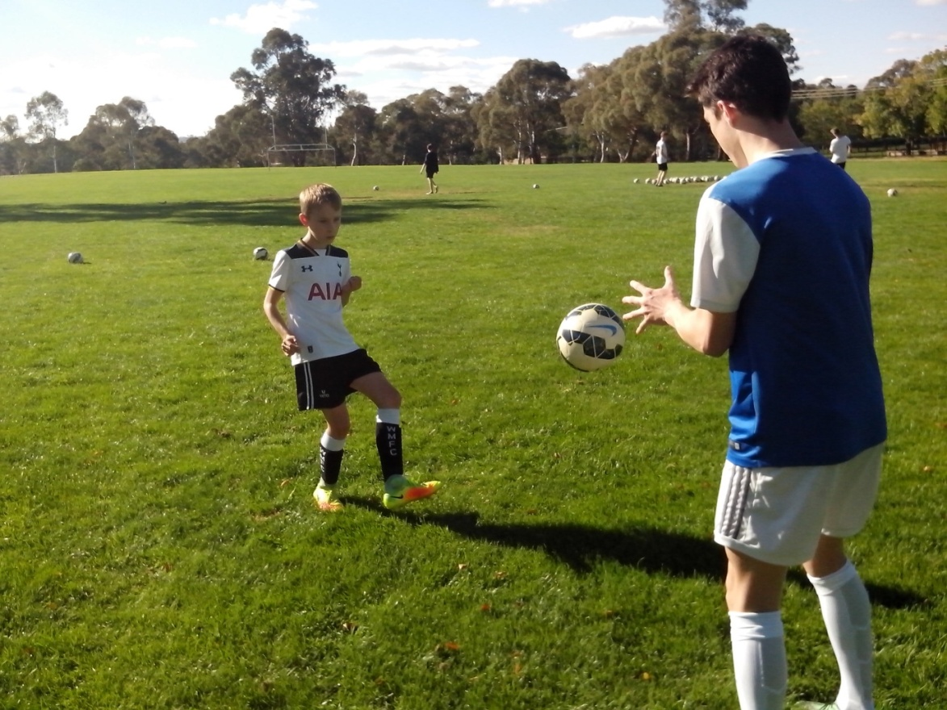
FEETBALL
Give Feet a Chance
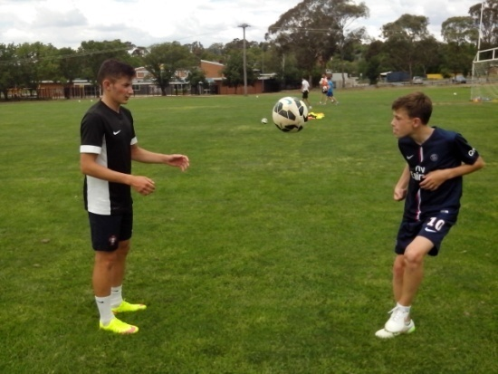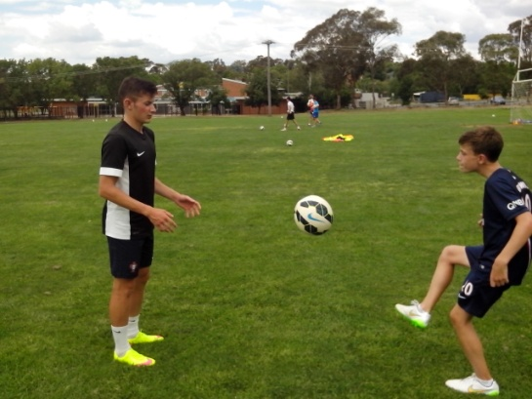
Anyone could be forgiven for thinking that Soccer is played with one foot. Kids are becoming so stiff and awkward because they stand around waiting for orders when they could be playing with a ball.
If we keep telling kids where to stand and what to do, there’s a risk that we can program intelligent players to replace mechanical robots and give them artificial intelligence so they know what to think.
Kids need to take a chance if they want to advance. They need to solve their own problems if they want to stimulate their intelligence and they need to use both feet if they want to maximise control.
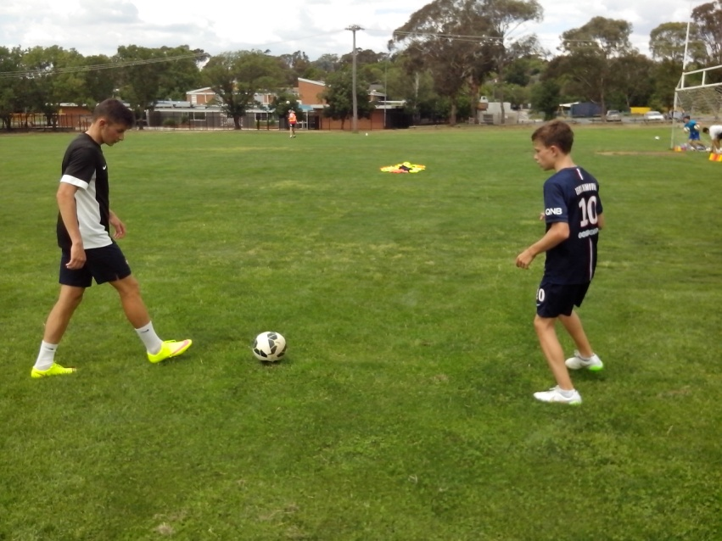
ROBOBALL
If it’s all the same to us, we need to look for something completely different.
In the leading Football nations of the world, kids learn their junior Soccer on streets, beaches and parks. In Australia, kids learn their junior Soccer in an environment controlled by adults.
Australian Freestyle kids are the skaters, board riders, basketball players, bike riders and cricketers who practice on their own or with their mates without any well meaning adults hovering over them.
We don’t believe that kids have the talent to cope with challenge so we help them by protecting them from failure and then we help them even more by telling them every time they make a mistake. Kids are the first to know when they make a mistake. They don’t need to be told that they got it wrong. They need to be shown how to get it right.
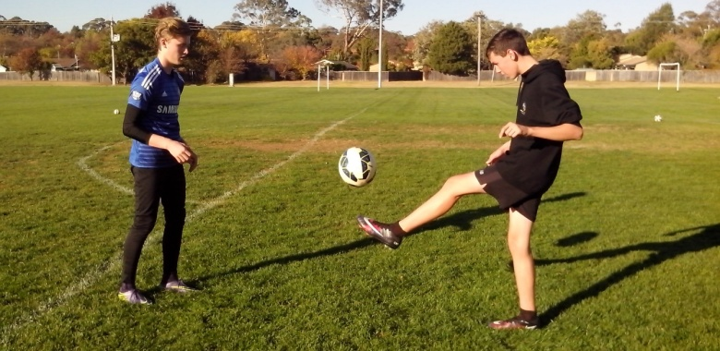
The skate parks, basketball courts, BMX tracks and surf beaches are producing the most talented and confident Australian kids. Freestyle kids just want their own practice nets so they can discover their own skills. We need to Lighten Up and give them the space to grow.

MOTOR SKILLS
Kicking and throwing are simple motor skills just like walking and running and these will improve with steady repetition.
Modern kids need to improve their basic motor skills so they can achieve a full range of natural movement. Soccer skills depend on effective motor skills. We all develop motor skills at three levels.
At the cognitive (conscious) level, we stop and think before we move. The mean average Soccer kids become hesitant.
At the associative (familiar) level we become more comfortable with the move. The skilful Soccer kids become more confident.
At the autonomous (intuitive) level we make the right moves without thinking. The talented Soccer kids become more resilient.
The average Soccer kid needs 200 touches of the ball to evolve from a hesitant level to a confident level through to a resilient level. Lighten Up works with a flat footed kid and can create an animated version within 5 minutes. Kids need to exercise their whole bodies on the ball.
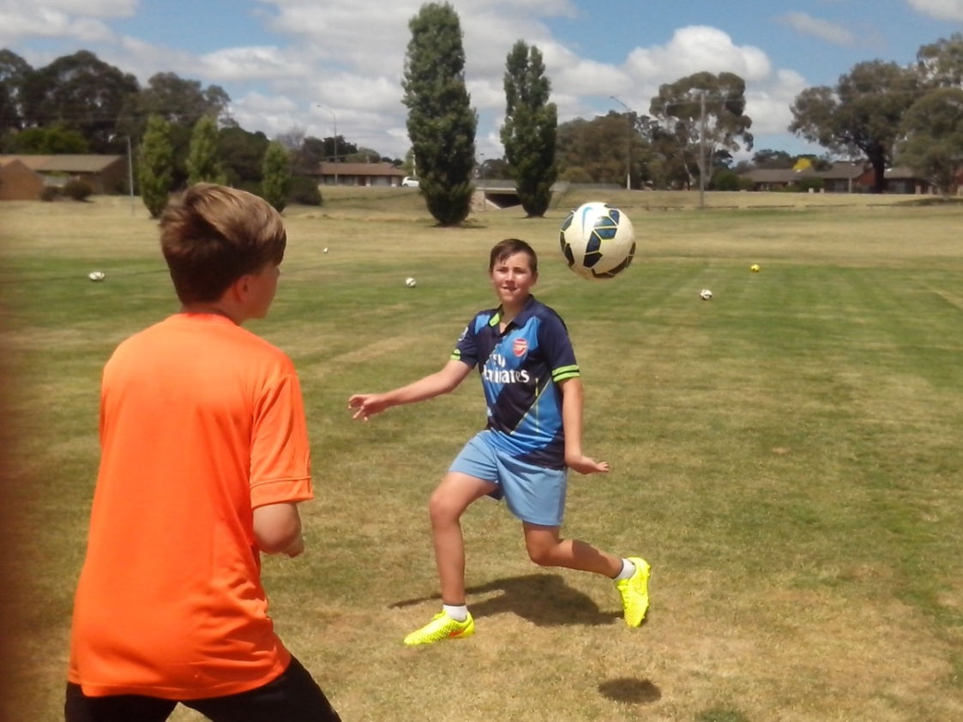

READY
At the cognitive stage, kids become hesitant and hold back.
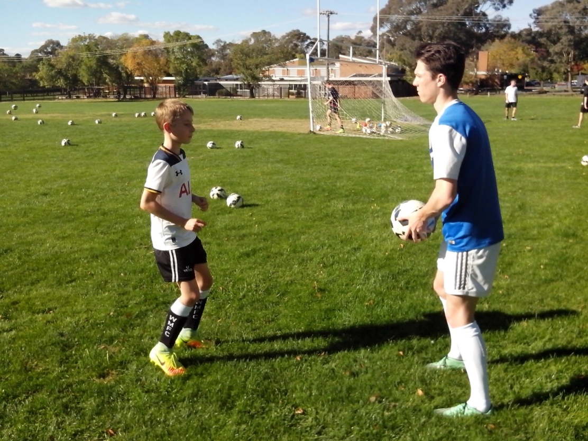
On their first set of Lighten Up, kids have to stop and think before they move because it’s all new to them. Most first timers move backwards to give themselves more space to control the ball first time. That’s human nature (fear of the unknown).
The thrower can help any kid to find their feet because they know what to look for. When the feet are glued to the ground, the kicking foot stabs at the ball. When kids get up on their toes, and jog on the spot, they can swing the kicking foot through the ball smoothly. Soccer kids can’t develop perfect striking technique if they stand perfectly still. They need to integrate thought, movement and control.
At the conscious level, kids think too much about each kick. This is what happens when kids stand in an assembly line and kick the ball to the coach once every two minutes. They forget the previous kick. Lighten Up gives kids the continuity they need to develop their touch.
SET
At the associative stage, kids become confident and begin to relax.
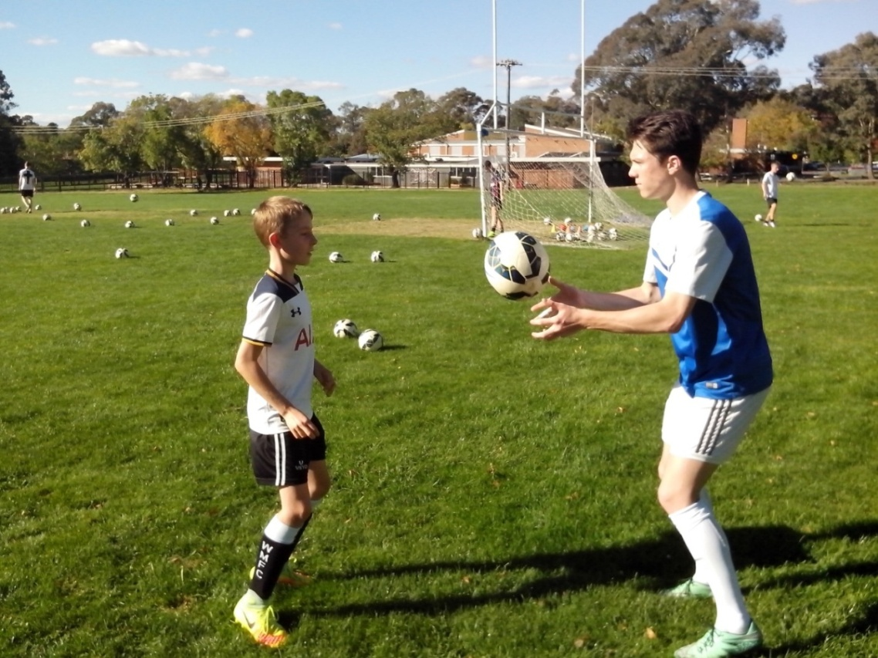
On second thoughts, kids become more comfortable on the ball when they know what’s coming. They begin to relax because they know the drill.
Kids who lack confidence will always compensate by juggling the ball too high or kicking the ball too far. Force is always the default option when kids believe they lack skill. When the most common call from the sideline is ‘big kick, big kick’, kids don’t mind missing their shots as long as they don’t look weak in front of their mates.
Lighten Up teaches kids to control their power so they can control the ball. Close repetition drills are exactly that. Close control gives kids more ball touches in 5 minutes and repetition creates habit. Kids who just stand around get really good at it and can do it without thinking. Kids who get 200 repetitive strikes become good on the ball. As kids move through the second set of Lighten Up, their mistakes disappear.

GO
At the autonomous stage, kids become resilient and can improvise.
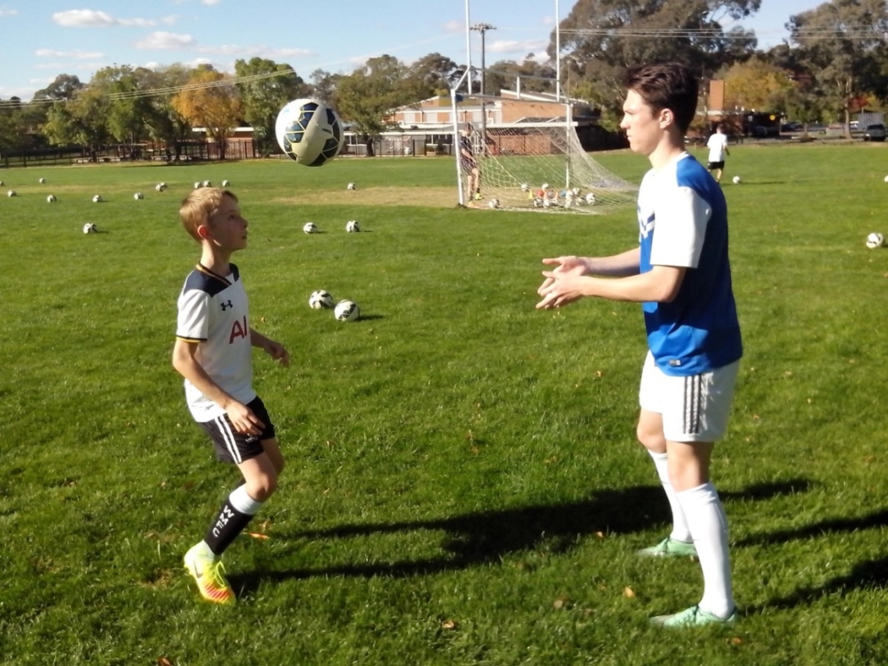
By the third set, most kids start to make their own decisions and wonder why they couldn’t do that before. The difference is very simple. A lot of kids are learning perfect control while standing flat footed so that they stab at the ball awkwardly instead of striking through it smoothly. Coaches focus on the kick and overlook the kid.
Experts see what they’re trained to see. They’re trained to look at technique and look for mistakes to correct. When kids learn to head the ball, the coach focuses on the head and studies the heading technique. There’s no reason for them to look at the feet or notice that they’re glued to the ground.

REBOOT
Ordinary kids keep the ball on the ground and play it safe. Freestyle kids attack the ball in the air and lift their game.
When we leave a particular skill for a while and then return to it, our control is more familiar and comfortable. Our subconscious mind can solve a lot of problems. On each set of Lighten Up, kids become more familiar with the moves and more comfortable with their kicks.
Ordinary kids question their ability to shoot in case they get it wrong. Freestyle kids shoot first and ask questions later. These are the kids who take risks when adults aren’t hovering over them worrying about them.
Adults develop practice that suits their theory. Freestyle kids, who train all the time, develop theory that suits their practice. It’s natural to assume that coaches in Australia lack the experience to be innovative but at least they can see the game with a fresh set of eyes. We don’t lack talent in Australia. We just lack belief in our talent.
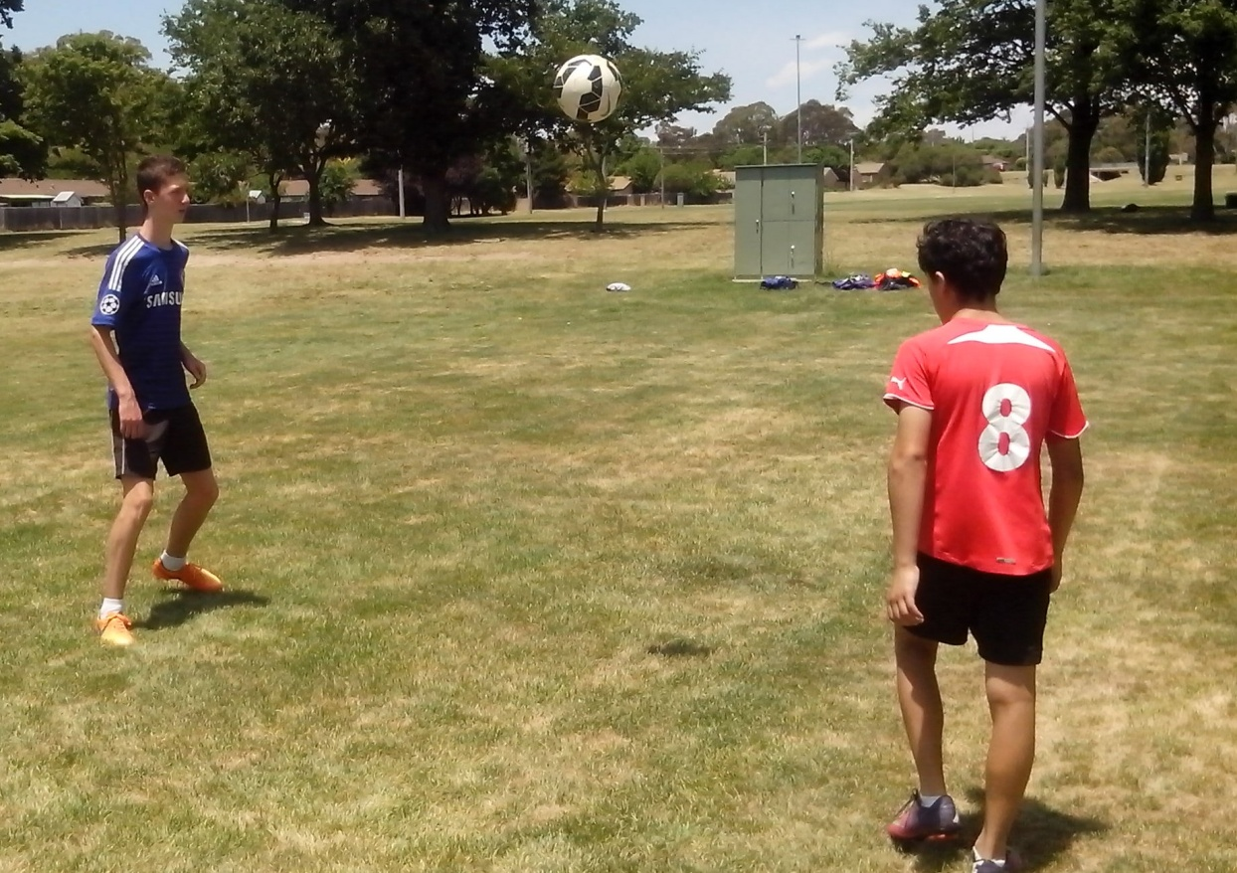
FOOTWORK
Every Australian Soccer kid stands flat footed when they stab at the ball because they learn to play the way they train.
We’re teaching perfect ball control to talented kids who don’t know how to move their feet, and they lack natural balance and coordination. We can improve any Soccer kid in 5 minutes just by learning about them. Anybody can throw a ball to a Soccer kid and discover that their feet are glued to the ground but that their kicking technique looks perfect.

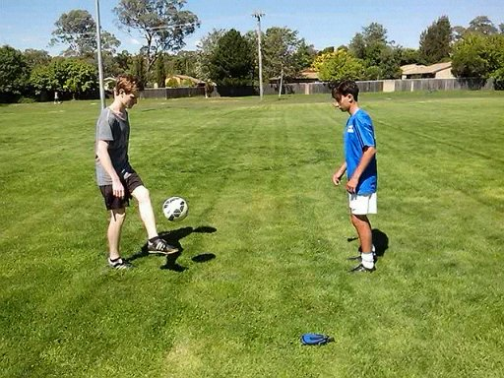

Imagine if we all learned to walk the perfect way by taking one perfect step every 2 minutes. That’s how we teach kids to shoot at goal. We learn to walk by walking. We all have different styles and different builds. We can learn to kick by kicking. Lighten Up enables kids to get 200 kicks in 5 minutes and develop a style that they’re comfortable with.
VISION
Most kids take their eyes off the ball as they strike it. Anyone can see that.
Most Australian Soccer kids have never been told what to look at when they kick a ball and most coaches have never thought about it.
Kids are result oriented so they look up at the goal as they shoot. Some kids can just raise their eyes to look up. Other kids lift their heads and blast the ball over the crossbar. Freestyle kids learn to check the target first and then keep their eyes on the ball when they kick. They pick out a small part of the net so that they aim small and miss small. Most kids see a big goal and think it’s impossible to miss.
Any kid can stab at a ball without looking at it. Lighten Up teaches kids to focus on the ball so they can strike it in a certain spot. Plenty of Freestyle kids have the talent to control a ball by kicking across it.
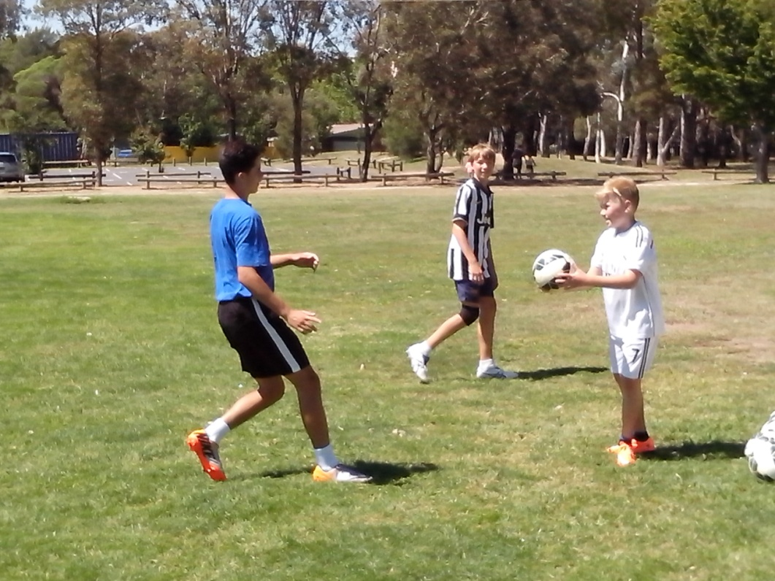
POWER
Any kid can learn to control a ball as soon as they learn to control their power.
Freestyle marksmen discover how to finish because they learn where to start. They always begin shooting practice with close up shots in the 6 yard box so they can develop timing before increasing power. Some kids sting like a butterfly and float like a bee because they try too hard to kick the ball too hard and the energy dissipates in a spin.
Lighten Up can develop power in three simple sets. Kids use the first set to develop their timing. The second set improves their coordination and the third set increases the degree of difficulty.
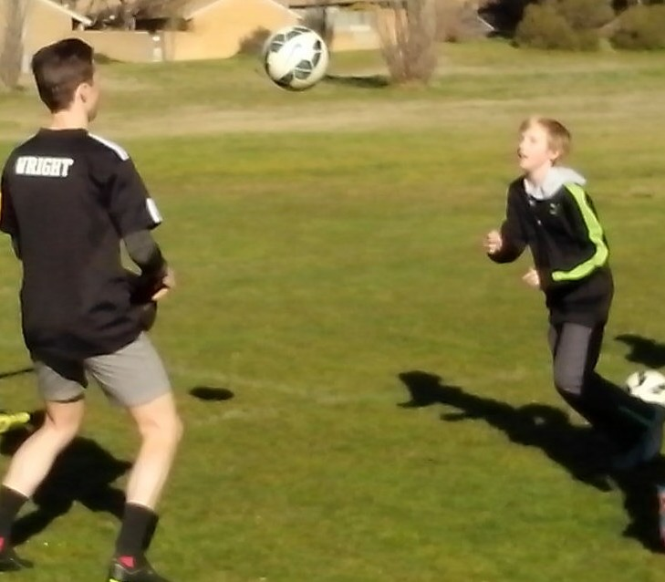
The thrower remains close on the first set but gradually moves backwards as the receiver makes a strong connection with the ball.

PRECISION
Freestyle strikers know how to score because they learn how to miss. They understand why shots go to the keeper or over the bar.
Goal scoring is a balance between power and precision. Most shooting practice in Australian Soccer is over the top. Boys especially use 100% power in the penalty area and some even develop the ability to blast a ball over the crossbar from inside the 6 yard box.
The first skill that kids develop from Lighten Up is timing. They can hear the difference in the sound when they stop slapping at the ball and start striking through it. Perfect timing makes a deep sound. Lighten Up enables kids to get timing first and then add the power.
When they learn to shoot, Freestyle kids always start with close up shots to develop eye/foot coordination and then they gradually move back and increase the range, speed, power and intensity. Regular shooting practice shows Soccer kids how much they’re missing.
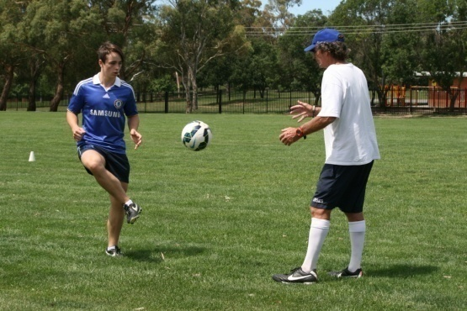
MOVEMENT
Kids learn to play the way they train.
When we teach kids to kick a ball while standing still, we’re actually teaching them to stand still while kicking a ball. When players stand around in a circle sharing one ball before each game, they’re only getting minimal ball touches and they’re learning to stand around waiting for someone to pass before they make a run. Freestyle Soccer kids just hate to stand still. That’s not their idea of competitive sport.
Lighten Up teaches kids to integrate the mind, body and ball so that they control the ball while moving their feet and making decisions. Freestyle kids feel free to look, think, listen, call, make their own decisions, make their own mistakes, learn from them and move on.
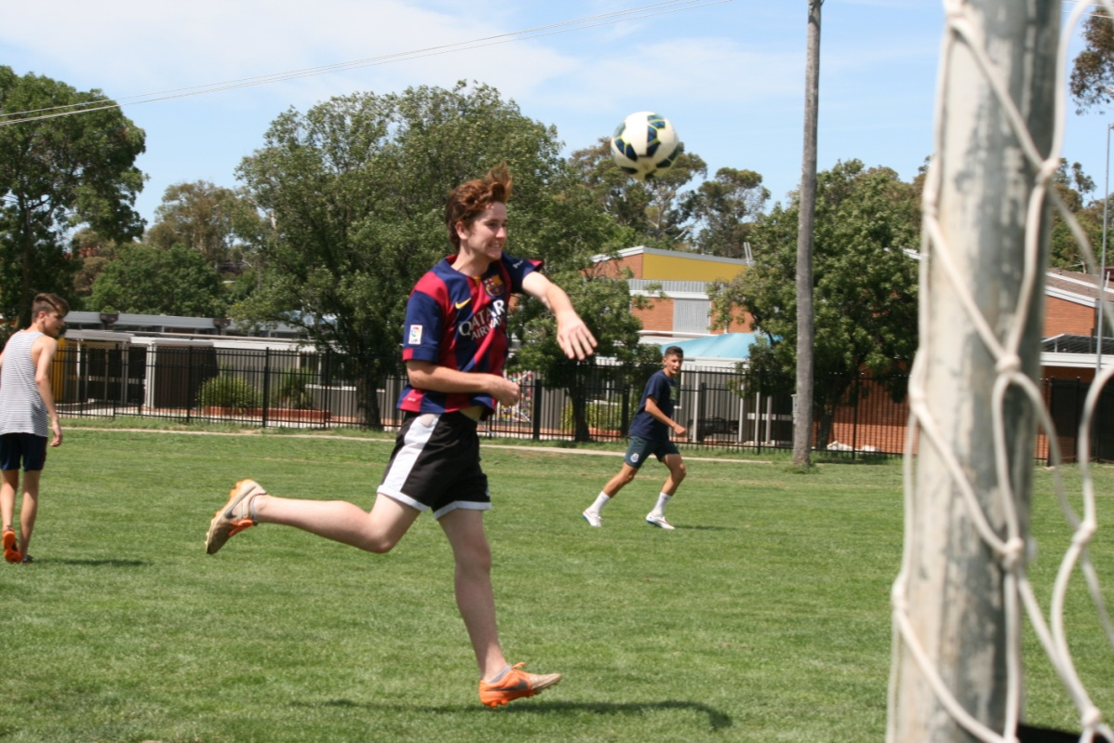
Once kids become competent with their ball control, they’re ready to practice Lighten Up on the Move. Any kid can stand still and wait for the ball to come to them but it’s a lot more exciting to optimise a strike by improving position. Freestyle kids can attack a high ball with a diving header and use their whole body to increase momentum.

DECISION
Hesitate, wait, too late, stagnate.
Close repetition drills enable kids to make 200 decisions, take 200 steps and get 200 ball touches in 5 minutes while most kids stand in a line waiting for their turn to kick the ball to the coach.
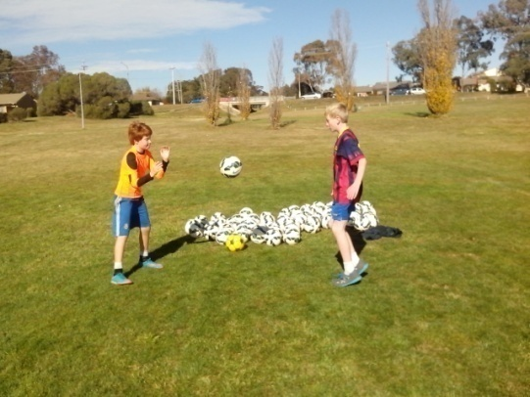
Any kid can trap, pass, dribble, screen, head the ball and shoot. The most difficult skill in Soccer is choosing the right one at the right time. Some kids pass the ball because they’re too scared to shoot and some kids dribble because they’re too selfish to pass the ball. It’s the natural skills that determine how well kids develop their Soccer skills.
Freestyle kids always start drills with short, simple, relaxed control and then they gradually increase the speed, range, power and degree of resistance. Once kids have an intuitive grasp of Lighten Up they speed up the feed so that the ball player can sharpen their reflexes. Freestyle kids will always push themselves harder than anyone else can so that they never get caught out by the pressures of a game.
BELIEF
What’s significant for the future of Australian Soccer is not how easy it is to improve any kid but how hard it is to convince any adult.
It’s virtually impossible for an adult to observe what kids are doing without stopping them to correct their mistakes. We honestly believe that we’re helping kids by constantly reminding them what’s wrong with them. If we can observe kids making mistakes without correcting their technique we could actually discover the underlying cause.
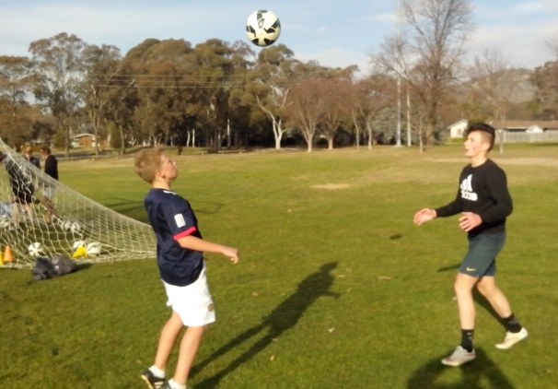
Kids don’t make mistakes on purpose. Most of the time, they’re just doing what we tell them to do. No coach is ever going to question their own coaching when the default option is to assume that kids lack the talent to reach the top. That makes it easy to focus on the elite kids. Sport should be a challenge. The real challenge is to focus on the untalented kids. If we Lighten Up we can believe in any Soccer kid.

REPETITION
Any kid who stands in an assembly line, waiting to shoot at goal, is going to get 200 touches of the ball in less than 6 hours.
No Australian Freestyle kid wants to be the same as everyone else. That’s why kids go to the skate park to discover how good they really are when they only have themselves to make the important decisions. Freestyle kids go for skills, drills, thrills and spills.
Kids who lack close repetition training play consciously and stop and think before they take any chances. Some of them worry about losing the ball and some of them hesitate and try to second guess what the coach wants in case they get it wrong. Freestyle kids play their own game and react instinctively depending on the situation. They constantly surprise themselves by scoring unplanned goals. Repetition stores a variety of moves in the back of their minds.
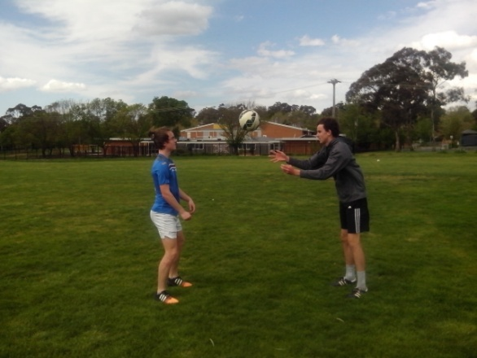

CHALLENGE
Playing with a ball is just a juggle. The real reason for kids in sport is the struggle. Kids want to challenge their personal best.
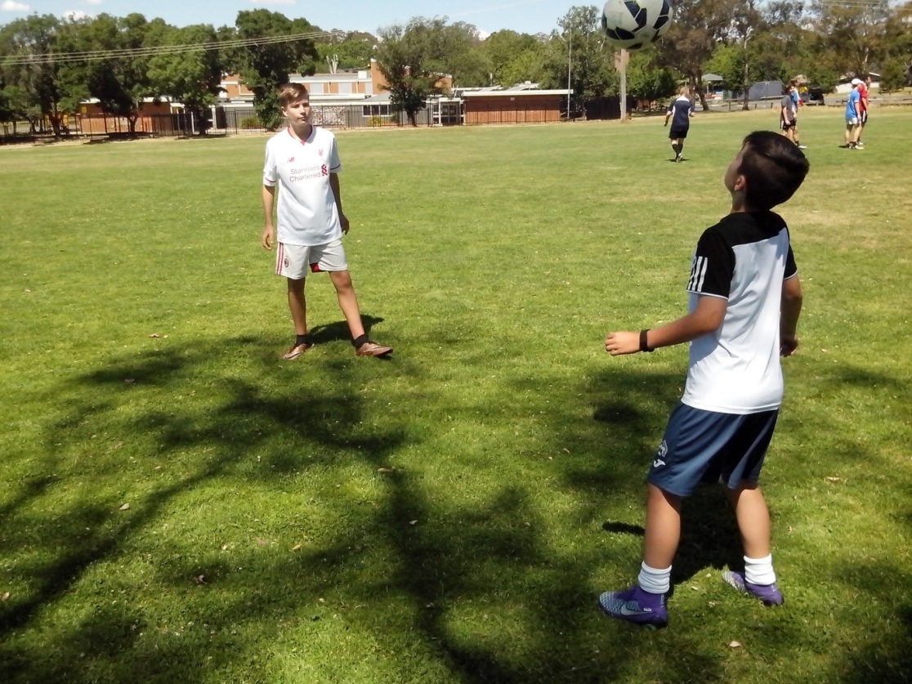
There’s a certain type of kid that goes out to the skate parks and basketball courts to practice their skills. They really don’t need protection from failure because they need failure to know where they’re up to and what they need to do to achieve their goals.
Freestyle kids fail more than ordinary kids and they keep failing until they work out how to overcome the challenge. Freestyle kids are inventing new skills and improvising old skills and most adults have no idea what they these kids are doing which suits the kids.
Freestyle kids use Lighten Up and juggling drills to control a ball at any angle or height while more talented kids never get off the ground. A 50-50 high ball in a game will reveal who the Freestyle kids are.

INTUITION
Freestyle kids think outside the goal square so they can expect the unexpected and predict the unpredictable.
Kids who think too much in a game usually think about what can go wrong. The penalty taker should just put the ball down, pick a spot and go for it. Ordinary kids telegraph their shots to the goalkeeper because they always take an extra look and an extra touch to make it easier. It never gets easier.
Freestyle kids make the best of what they get. They take their best shot before the keeper can get into position. If they make a mistake, they don’t worry about it. Mistakes aren’t a problem but worrying is.
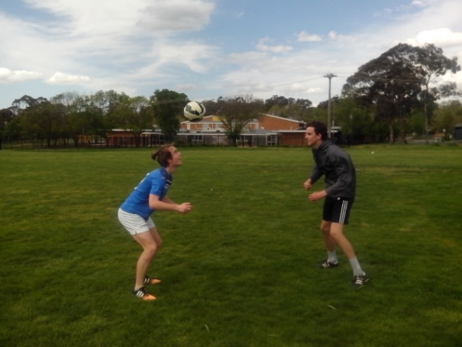
We will never discover how talented kids really are if we only see the players who do what we tell them to do. If we give kids the freedom to initiate their own moves we can discover the innovation generation.

TUNEUP
A perfect system is the one that can diagnose what players need.
The Zone is what players refer to when they get thousands of ball touches and reach an intuitive level of control. During the season, a kid might lose form and then struggle to regain it. They try too hard and their game becomes too conscious. Lighten Up enables kids to relax on the ball and get their touch back so it becomes second nature.
When Freestyle strikers stop scoring and try too hard to kick the ball too hard, they always return to Lighten Up so they can reboot their timing and rebuild their power and precision from a solid base. Lighten Up is a regular service that checks power, timing, movement, balance, wear and tear. Every Soccer player can benefit from a regular tuneup. Any skills specialist can be trained to identify technical faults.
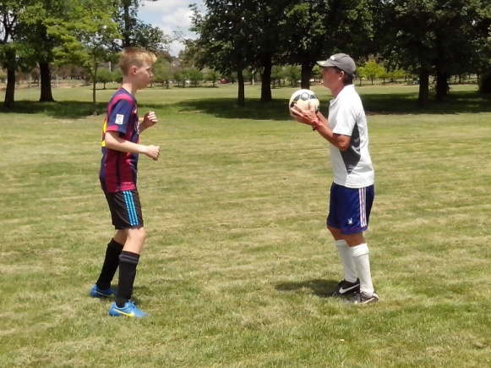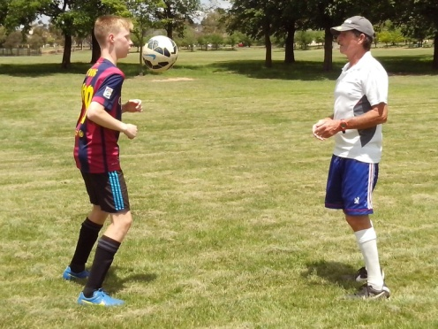
Freestyle kids use DNA Profile as a self assessment so they can continue to progress in the off season without arresting their skills development. Lighten Up gives any kid a quick assessment of their natural skills. It takes 200 ball touches to reconnect muscle memory.
A Teaching Program gives kids what we think they want. A Learning Program discovers what they actually need. Every club should provide an annual assessment for each player so that kids know how well they’re doing and what they need to work on for the next season.

CHEER UP
When kids are happy, it’s easy to find the happy coach. When kids are miserable, it’s easier to find a new coach.
If we worry too much about winning games, or making a profit, we lose sight of what’s really important in junior Soccer. We need to develop kids and inspire their confidence so they can achieve their full potential. Lighten Up puts the fun back into fundamentals.
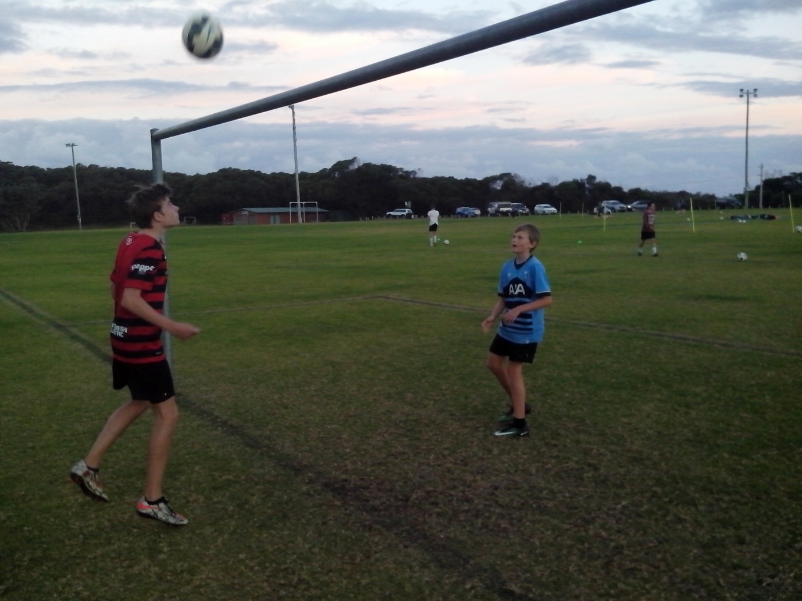
Some people get too serious about Soccer and Tighten Up. Freestylers learn to enjoy their game and Lighten Up. Everyone feels down at some stage and the best way to get out of it is to think about others.
Lighten Up is the most effective way to help any Soccer kid in 5 minutes and the players appreciate the extra attention and support. In senior Soccer, Soccer skills are critical to understanding the game. In junior Soccer, people skills are critical to understanding the kids.

TEACHING AID
Lighten Up helps kids synchronise thought, movement and control.
Freestyle Soccer coordinates a learning program with a teaching program so that we can actually identify what each individual needs to improve instead of giving them all the same skills and drills.
Lighten Up is a close repetition drill. It’s a close drill that develops touch and it’s a repetition drill that sharpens reflexes. As a learning drill, it enables us to evaluate footwork and vision, power and precision, movement and decision, belief and repetition, challenge and intuition. As a teaching drill, it improves coordination, balance, timing, power, agility and confidence while kids get 200 ball touches.
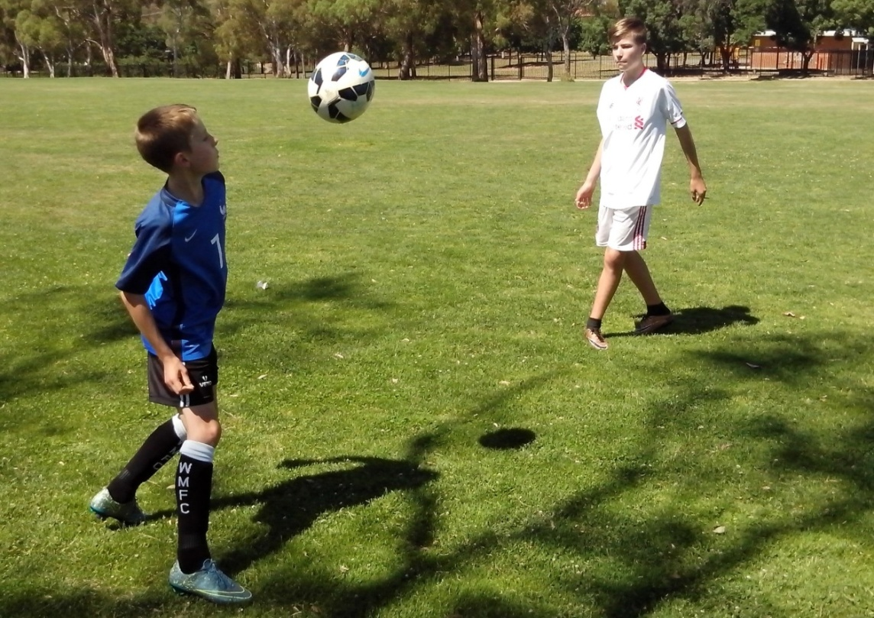
The future of Australian Soccer is great because there’s so much natural playing talent and we haven’t even started to learn about it yet. A teaching program looks at everything we know about the game. A learning program looks at everything that we don’t know.
CLOSE REPETITION DRILLS
Team mates learn to push each other in close competition drills.
Lighten Up is the foundation drill for most other close repetition drills, learning drills, teaching drills, recovery drills, improvement drills and power drills. Some kids are scared of heading the ball. Heading in Pairs gives them confidence to attack the ball in the air.
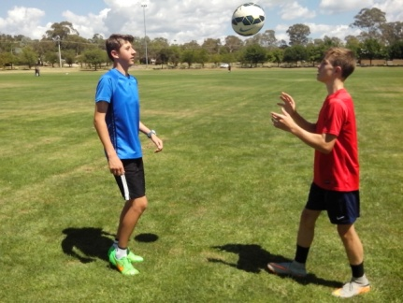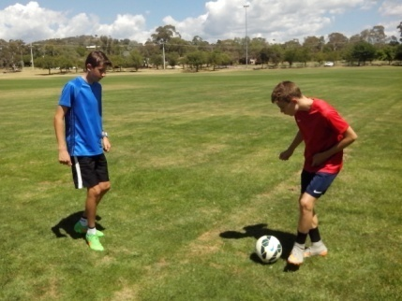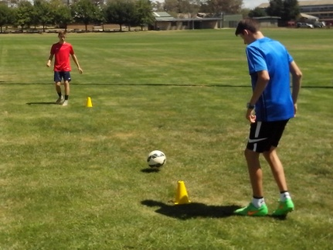
Some kids are flat footed and need One Metre drills to sharpen their agility. Some kids need Free Range Practice to develop footwork and vision. A lot of kids pass the ball and then stand there and admire it.
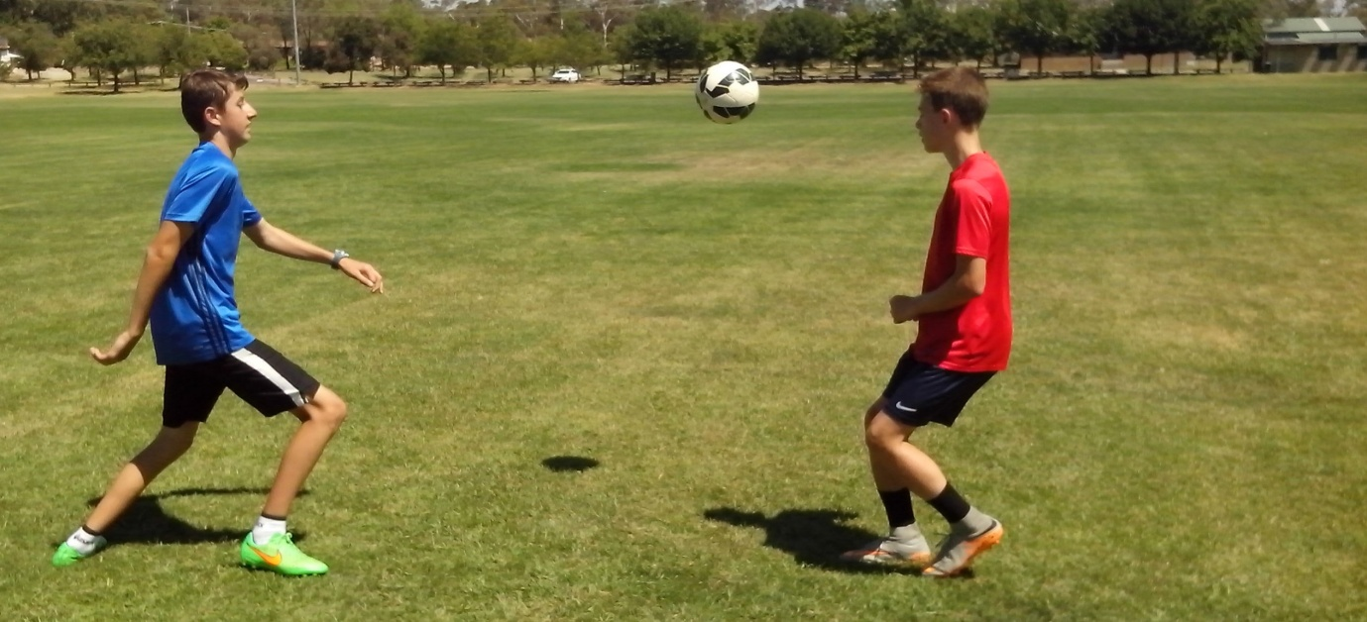
One Bounce in Pairs teaches kids to pass and move, give and go, hit and run. Some kids are ready to upgrade to the next level. No Bounce in Pairs teaches them to keep the ball off the ground. Close repetition drills teach players to communicate, coordinate learning and teaching, integrate natural skills with Soccer skills and activate their energy.

BALLWORK IN PAIRS
Lighten Up is an app that enables teenagers to keep in touch using face to face communication and interaction without technology.
Kids can’t practice Ballwork in Pairs with a team coach because the coach can’t neglect the rest of the team. Every junior Soccer team should have an assistant coach, a teenage mentor or access to a club specialist skills coach because it’s critical to identify generic faults before they become permanent habits. Strikers, who look up at the goal every time they shoot, have been doing the same for years and nobody has ever noticed because they focus too much on technique.
Do coaches shout at kids because they make mistakes or do kids make mistakes because coaches shout at them? Lighten Up enables kids to learn from their mistakes without any shouting. Ballwork in Pairs teaches kids the concepts of control, support and possession. When two kids control a ball between them, they learn to look and listen when they have the ball and move and call when they want the ball.
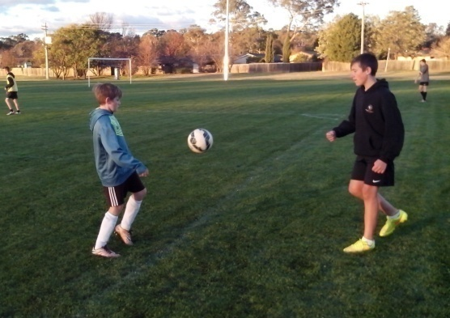

BUDDY SYSTEM
The Buddy System ensures that no kid ever gets left behind.
In every group, there’s always one kid who struggles to catch up with the rest. It’s always too easy to pick on the runt of the litter and often that’s just enough to motivate them to try harder and challenge others.
A Soccer team is only as strong as its weakest link and every kid is equally important. It benefits the team to make sure that every kid is an essential part of the whole.
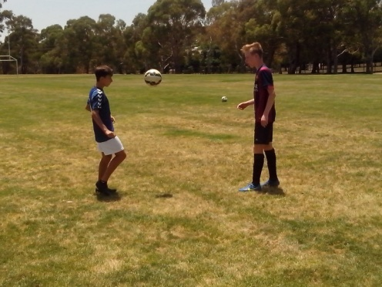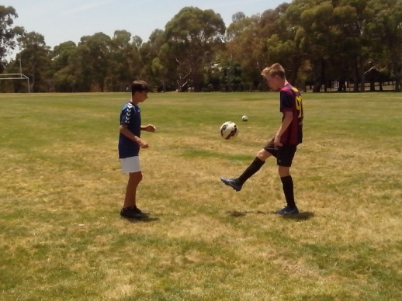
The Buddy System pairs off kids so that they push each other at training and support each other in a game. At training, ballwork in pairs is the quickest and most effective way to coordinate control and support and improve possession. If squad numbers are uneven, the team captain can demonstrate drills and skills with the team coach.
Lighten Up enables kids to work together, communicate face to face and appreciate their team mates. Buddy System helps Soccer players to develop respect, responsibility, resourcefulness and resilience.
The real Australian Freestyle kids don’t want protection from failure. When they’re left to train on their own, they look for the risks. Fear of failure is what the old generation want to teach the young generation.

KEEP UP
Any goalkeeper can get 200 throws before the whistle blows.
When kids throw the ball in Lighten Up, they improve their eye/hand coordination. On match day, the goalkeeper can always warm up a couple of team mates before getting down to the more ballistic groundwork that they need before a game.
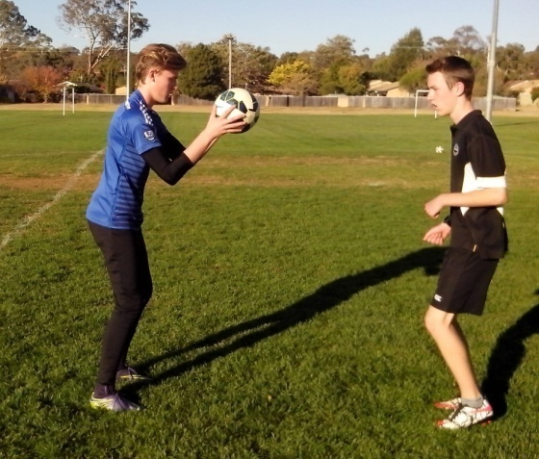
The thrower learns how to encourage the receiver so they can develop footwork in the first set, timing and rhythm in the second set and confidence in the third set. Experts see what they’re trained to see so they focus on perfect technique. Freestyle kids aren’t trained to see anything so they look at everything and can see the difference in each player. Anyone can see when a kid is standing flat footed, stabbing at the ball, hopping like a kangaroo or blasting at the ball too hard. When a kid develops perfect balance and coordination, through close repetition, control looks good, feels good, sounds good and is good.

BRIGHTEN UP
Kids make Soccer fun and they make Soccer work.
Once we identify and teach the skills that kids don’t have, we can discover and develop the talent that they do have. Lighten Up uses one touch control to improve basic skill. Brighten Up uses two touch control to develop balance and coordination.
In a game, kids aren’t always in the best position to strike a high cross first time. Freestyle kids get thousands of ball touches so they develop an intuitive understanding of the ball and can choose from a wider range of options. These kids work on the quality of their first touch so they can execute a relatively simple chest/volley or thigh/volley. They also practice double headers or head/volley to widen their range.
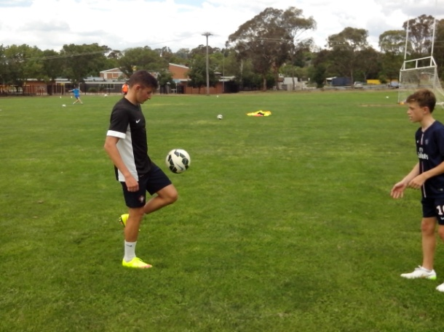
All the most creative kids learn how to master the conventional techniques before they begin to improvise and impose their own style.

LISTEN UP
Parents control which user friendly sport they want their kids to play.
The parent is the original individual coach that any kid has. Every team of little kids has that one player who absolutely dominates. That kid doesn’t have a diploma in team training. He or she is a graduate of home schooling classes on the oval with mum or dad. The early developer will always benefit from the effects of individual coaching until the rest of the kids catch up with the advantages of team training.
Lighten Up is ideal for parents to practice with their kids because parents have a unique perception and investment. When they train together, the parent looks closely at basic motor skills, mental skills, physical skills and natural skills. During the game, the team coach follows the bouncing ball while the parent watches closely what their kid does for the other 95% of the game.
It’s only natural that parents can’t understand why coaches don’t see the talent in their kid at grading or in a game. No junior sport should ever alienate parents who have the final say in what their kids play.
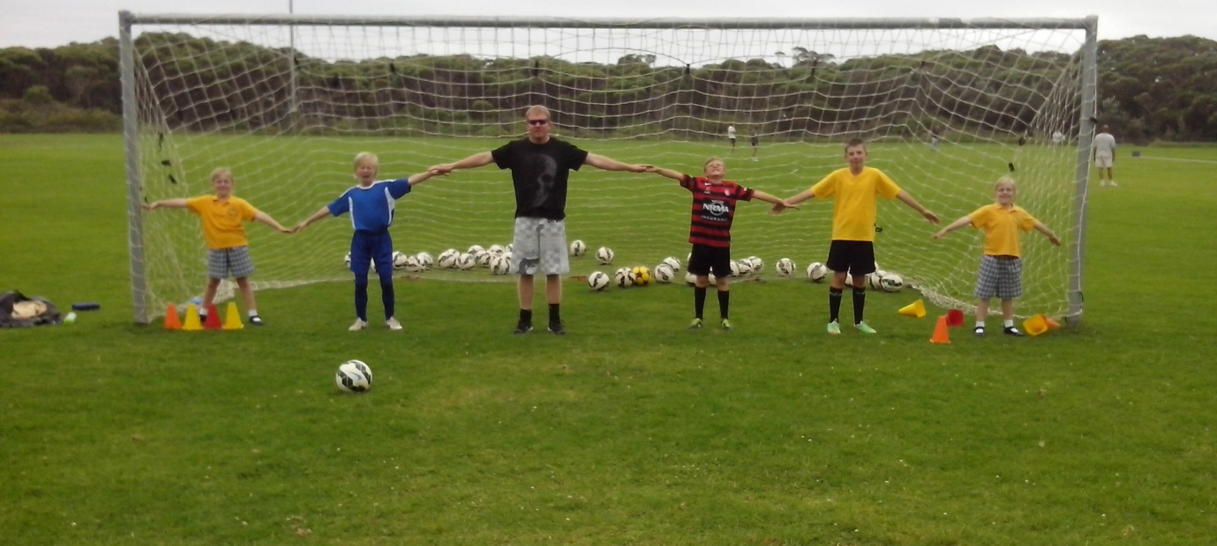

TEENAGE MENTOR
The Teenage Mentor of today is the Soccer Coach of the future. If we invest in them now, they will gradually gain interest.
A team coach teaches techniques and tactics so that teams can win games. They don’t have time to take individuals aside, learn about their strengths and weaknesses, or create personal training programs.
Every team has at least one elder sibling who can assist the coach and take some pressure off him. The teenage mentor can run a small grid game while the coach focuses on specialist skills or they can work one on one with the players. Ideally, a teenage mentor should be about three years older than the team players so that they can relate to him better than to an adult and he can demonstrate skills to them.
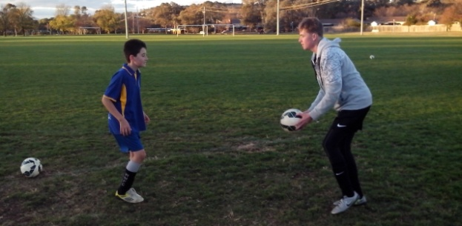
Lighten Up is ideal to introduce teenage mentors to kids in a team because players can get 200 ball touches in 5 minutes, appreciate someone taking an interest and feel the improvement immediately. If a sport can’t identify problems when a kid is seven, they will inherit a lot of one footed, mechanically awkward 17 year old talented players.

SOCCER WHISPERER
There are plenty of great teachers. The wise teacher is the one who keeps learning.
The quality of a coach is not measured by what they teach but by what their players learn. They’re not always the same thing. When we teach kids to kick a ball while they stand still, most of them are learning to stand still while they kick a ball. Kids play the way they train. When we teach players to stand in a circle sharing one ball with the rest of the team before kickoff, they’re learning to stand around flat footed and wait for the pass.
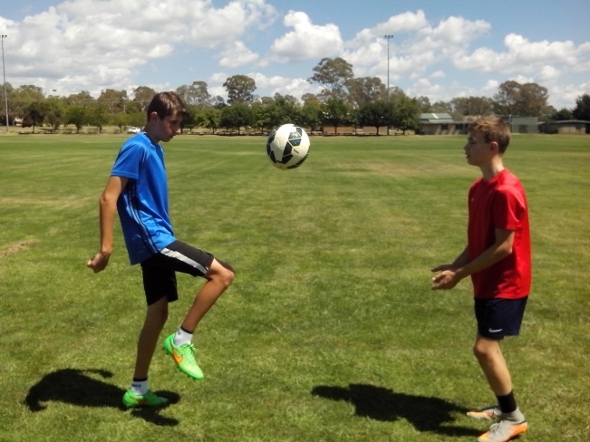
When we correct every mistake to make kids play better, some kids get the message that they’re just making a lot of mistakes. When we stop a kid from running and calling, and tell them that they’re playing the wrong way, they learn quickly and they stop running and calling.
The Soccer Whisperer uses Lighten Up to discover how a player integrates their Soccer skills with their natural skills. A team coach can read the play. A Soccer Whisperer learns how to read the player.

PSST!
Training is never dull when kids begin to Lighten Up.
Every club should provide a Personal Soccer Skills Trainer so that kids can identify and develop their peak skills and their weak skills. All kids are different and they need someone at a club who can analyse their game and discover what each kid needs to improve.
In a game, the team coach is busy enough following the bouncing ball. A Personal Soccer Skills Trainer can watch a game and focus on what individuals do on and off the ball without being distracted by the pressure of the contest.
A Personal Soccer Skills Trainer can assess the needs of any player in 5 minutes and liaise with the team coach to identify appropriate close repetition drills.
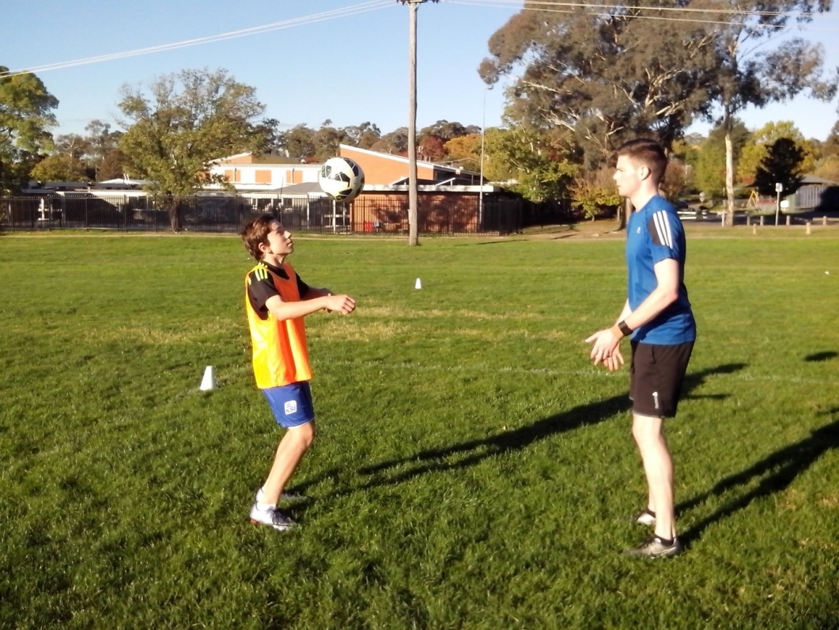

COUNTERBALANCE
Any innovative coach can enliven and enlighten any Soccer kid.
Modern kids need to use their basic motor skills before they lose them. They need to understand the importance of balance and counterbalance. Kids can’t sprint flat out with their hands in their pockets because they need their arms to drive forward.
Soccer kids need to move their whole body when they control a ball. They can change the elevation of a lob just by leaning forward or back. When a kid stands on one foot and swings the other foot back and forth, they soon discover their arms coming into play.
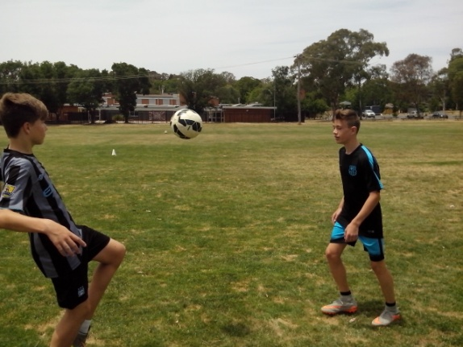
Lighten Up helps kids to become more animated when controlling a ball. At first, kids look stiff and awkward in their control. Gradually, they begin to loosen up as they bend the ankles, knees and hips for control and they bend the arms and upper body for balance. Lighten Up gives Soccer kids at least 200 ball touches in 5 minutes.

DOUBLE SHOT
We can aim to create a lot of mean average kids or learn about them and discover that they’re all different.
Freestyle kids don’t do ordinary. They can pick any training drill and look for more ways, better ways, smarter ways, faster ways and different ways to take it to the intuitive level so that the results are clear, immediate, measurable and permanent. Double Shot adapts Lighten Up for two feeders. They can feed the same skill or a different skill. They can develop a random feed so that the receiver doesn’t know what’s coming and they can make it more demanding by practising on the move. They can keep each other on their toes.
Ordinary kids are happy to be told when to train and what to do. Freestyle kids will look at the practice, listen to the theory, ask questions and then discover how to make the drill more challenging. There are thousands of Freestyle kids in Australia who team up with like-minded kids because they never get enough challenge from adult coaches. Freestyle kids need to drive, strive, thrive and come alive.
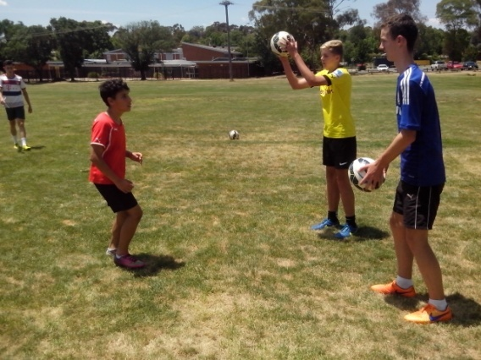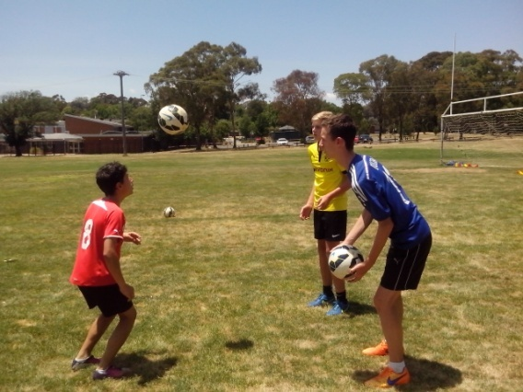
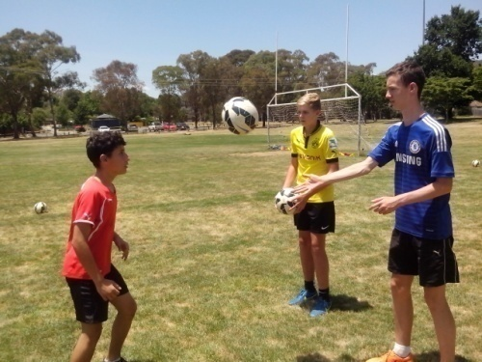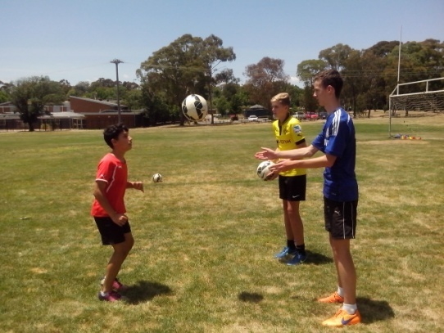
FUN AND GAMES
When we stop kids playing in the goalmouth it’s time to lighten up and decide if it’s more important to let kids grow or let grass grow.
Local councils understand the needs of youth and provide skate parks and cricket nets so kids can practice skills on their own or with their mates. Any club can think outside the goal square and discover what kids need to improve their game and confidence. It’s no wonder most kids can’t shoot. Grass can always regrow. Kids only get one go at it.
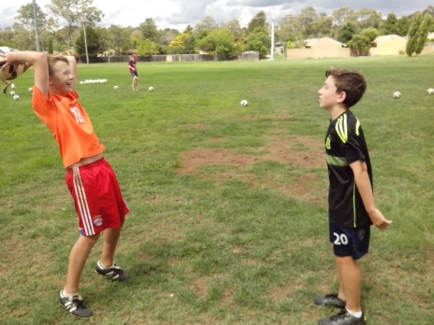
It’s a simple matter to reverse the net and play behind the goal where the grass is always greener. Every oval has an isolated area where one goal can be set up for kids to use to warm up on match day. A mobile goal can be relocated to different parts of the oval for shooting practice. Australian kids don’t play Soccer on the beaches or streets like in the real Football nations. If they want to catch up with the World Top 20, they need to know that they are free to practice on their own without being told.
MATCH PREPARATION
When teams can stand around in a circle sharing one ball, most Australian Soccer kids have no idea how to prepare for a game.
The mean average Soccer kid gets down to the oval on match day and the first thing they do is place a dead ball on the ground 25 metres out from goal and proceed to blast it over the crossbar with cold muscles on a cold morning. Undeterred, they try even harder the second time. It’s no longer an even playing field but all downhill from there.
Kids who get 200 ball touches make a lot of mistakes before kickoff. Kids who get 10 ball touches make plenty of mistakes after kickoff. Lighten Up makes ball control look good, sound good and feel good.
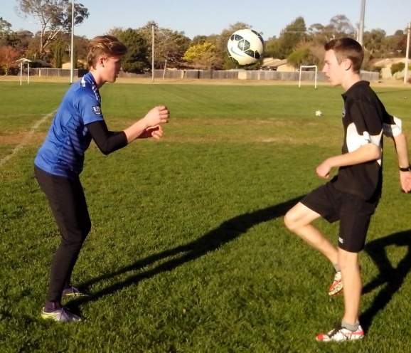
It’s not fair for kids to prepare for a competitive ball game with only a few isolated touches of the ball. They need to reach an intuitive level. When kids warm up in pairs, they can increase their concentration and improve their circulation while synchronising mind, body and ball.

HEADING
Plenty of kids are scared of getting hit in the head so they close their eyes, brace themselves and get hit in the head.
Fear ensures that heading, juggling and shooting are the most neglected skills in Soccer. Kids will avoid heading at training and deliberately slow down to avoid contesting the 50-50 ball in the air.
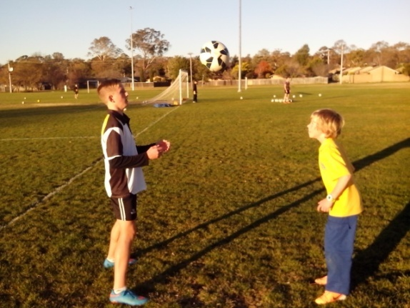
Heading hurts because little kids let the ball strike them instead of them striking the ball. They won’t overcome that by toughening up. Concussion is real and kids need to be aware of safe heading procedures from an early age. Lighten Up enables kids to head a ball that is only being thrown a maximum of 2 metres.
Once they realise that the ball doesn’t hurt, kids become more comfortable with heading. If they get 20 short headers in 30 seconds, they get bored with it, stop thinking about it and overcome the problem. As kids become more confident the thrower moves further back. Heading in Pairs teaches kids to master the high ball in a game.

JUGGLING
If kids hate juggling, there are plenty of other ways to improve them but no way to give up on them.
We can learn how a kid thinks, looks and moves when they juggle a ball for 60 seconds. We just need to know what to look at and what to look for. There’s a key to every kid and a drill for every skill and the challenge is to discover it and develop it. Lighten Up is just an app.
The more kids play with a ball, the more they develop their basic motor skills. The more kids use their mind and body, the more control they have of the ball. Juggling is the first taste of freedom that Soccer kids have so they can take responsibility for their own development. They can do anything with a ball and not be corrected. They can do the right thing and learn from it and the wrong thing and learn from it.
Kids who don’t believe that they can juggle a ball change their minds after 5 minutes of Lighten Up. Juggling is just a lot of individual ball touches put together in a sequence like individual notes in music. Once kids memorise the notes, they can improvise their own version.
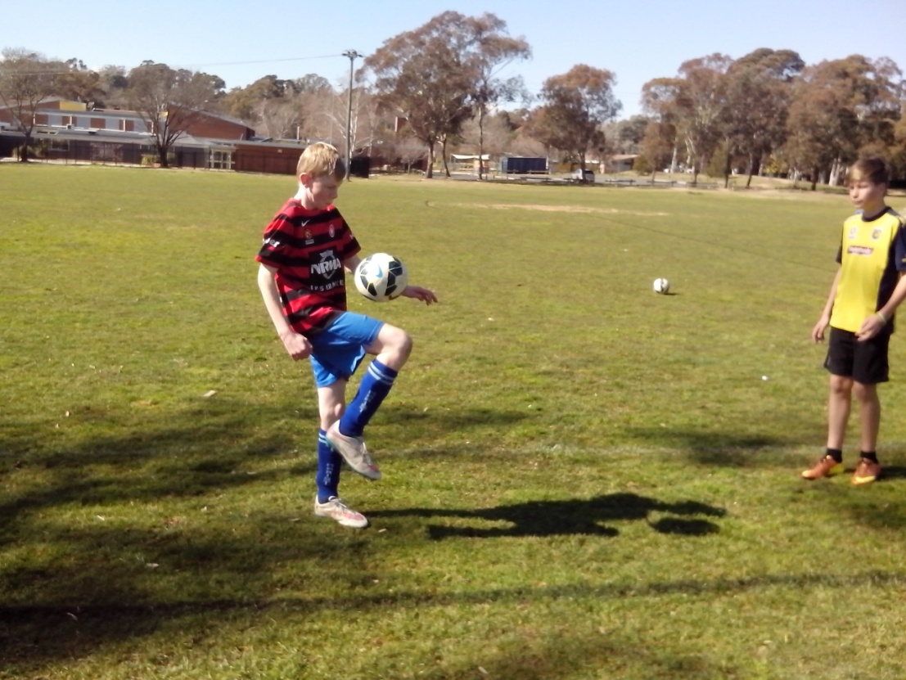
FLEXIBILITY
Lighten Up can make a supple difference to every kid.
Some boys stab at the ball with stiff, straight legs. Some girls stab at the ball with their toes so they can get more power. Lighten Up shows kids how they can increase their control when they bend their knees and ankles. A slight variation in the angle of the ankle can change a kick from backspin to topspin.
Flexibility enables strikers to get their knee over the ball when they shoot so they can use topspin to keep their shots down or dipping. Juggling is one of the most effective ways for Soccer kids to develop flexibility and agility because it keeps kids on their toes and moving with the ball. No kid can juggle a ball while standing dead still.
The first 5 minutes of anything we do is full of mistakes. That’s human nature and that’s how we learn. Ordinary kids give up in the first 5 minutes and never discover how good they really are. Freestyle kids understand the First 5 so they keep going until they loosen up.
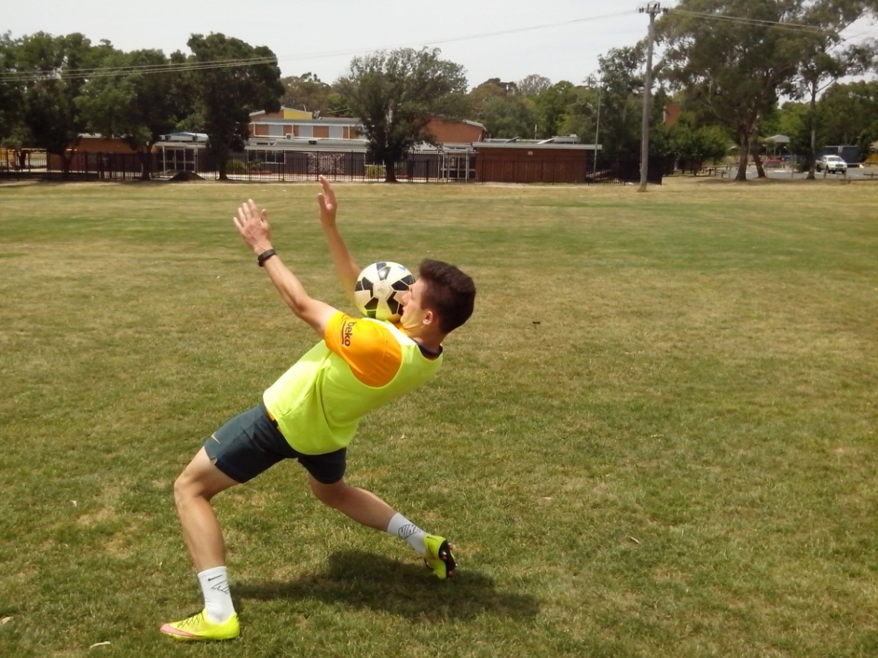
DIVERSITY
There’s more than one way to achieve. Freestyle kids learn always.
A lot of kids are happy just to kick a ball. Freestyle kids constantly look for different ways to control the ball. There are so many ways that kids can improvise a range of skills. Lighten Up enables kids to intuitively read the speed, spin and flight of the ball.
If we want Australian Kids to grow up and compete with the leading Football nations of the world, we need to develop close repetition drills where they get thousands of ball touches so they can think, move and control a ball at the instinctive level.
In 20 years time, people are going to look back at our coaching systems and wonder if we gave kids a fair go to develop their talent. Did we have the confidence to let kids achieve their full potential or did we hold them back because we were scared that they would fail?
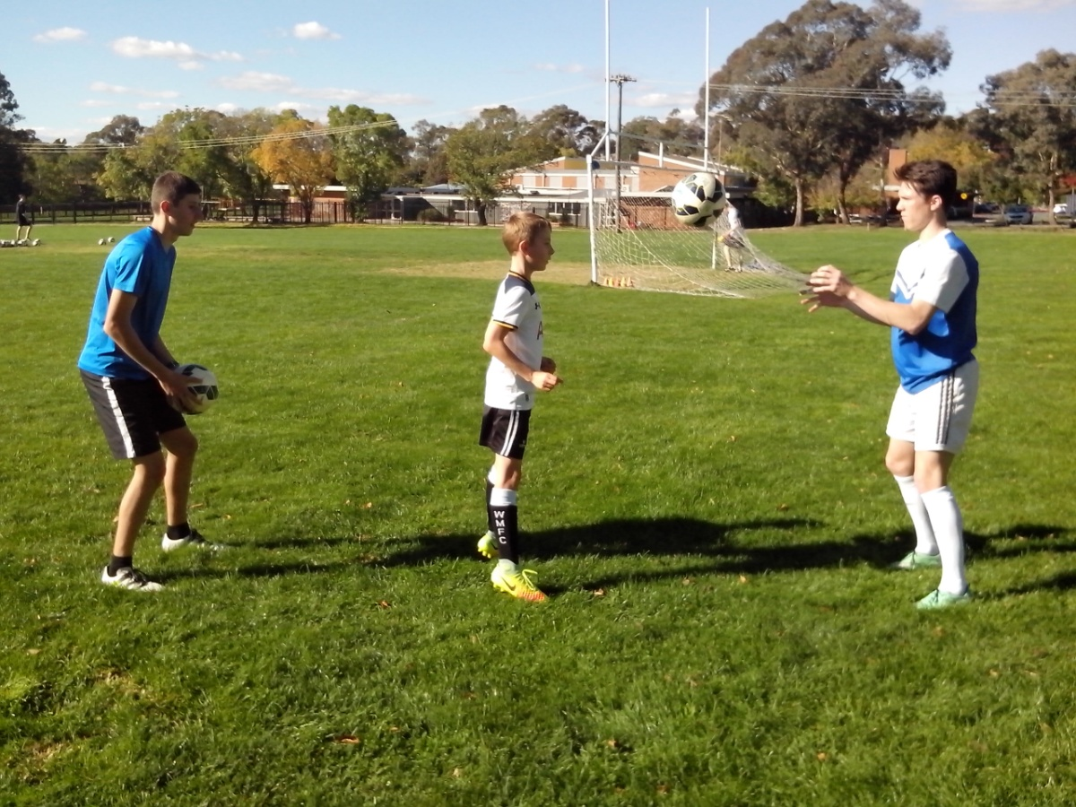
CREATIVITY
Talent is a precious resource. We need to coach the skill into kids without coaching the talent out of them.
It’s too easy to pick the most creative kids because they’re different and then teach them all to be the same. There’s a 14 year old Messi or Ronaldo out there somewhere and we need to understand them when we discover them because they won’t do what we expect them to do.
If we only look for the kids who train when we tell them to train we might overlook the kids who train when we don’t tell them to train. The Australian Freestyle kid has an inner drive that the average kid doesn’t own. Some kids are happy kicking against the side of a house.
Lighten Up and Juggling enable kids to take control of their skills development. Close wallball practice provides kids with 1000 touches in 10 minutes, keeps them on their toes and develops both feet. We need to encourage players to practice on their own at home.
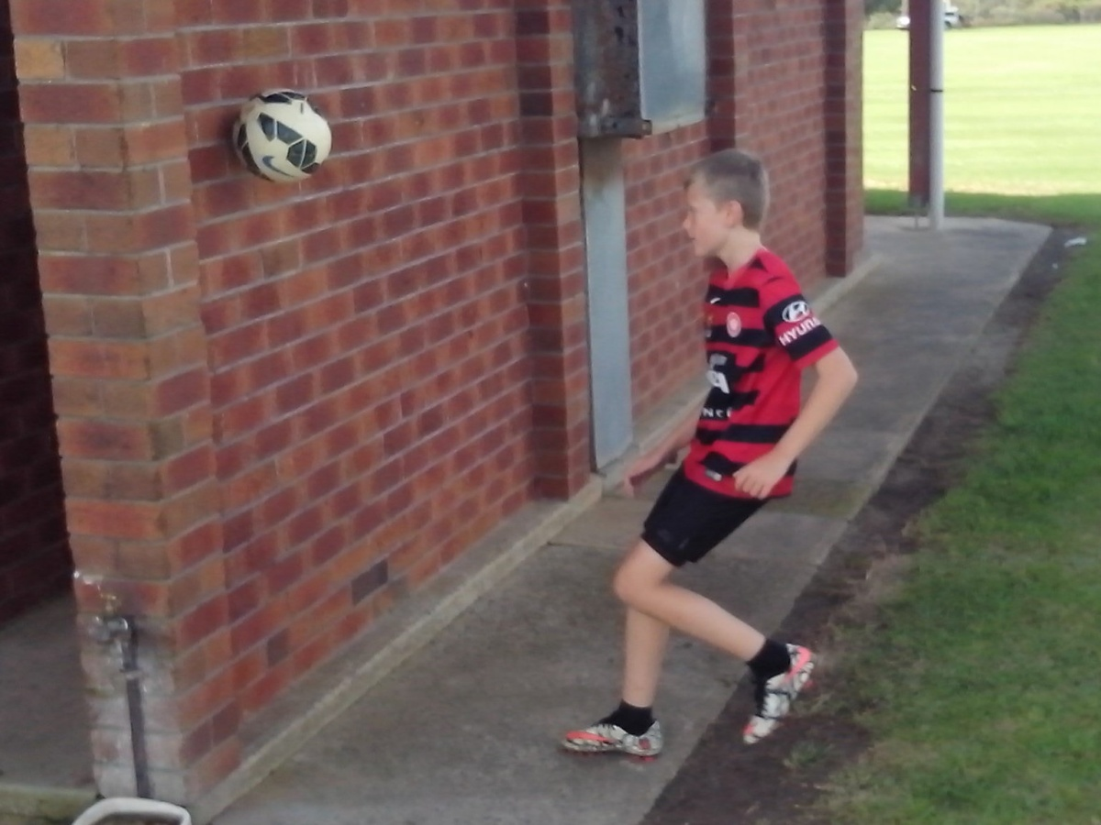
LEARNING THE FOUR R’s
Kids develop what we give them. We need to give them Respect, Responsibility, Resourcefulness and Resilience.
Freestyle kids treat other kids the same way they want to be treated. Lighten Up enables kids to teach each other and learn from each other instead of standing around in an assembly line waiting to kick a ball.
Kids don’t fall apart when we leave them on their own. They get a ball out and they kick, shoot, play games and have plenty of fun. If we give kids a ball, they can improve any skill. If we give them 50 balls, they can improve any drill.
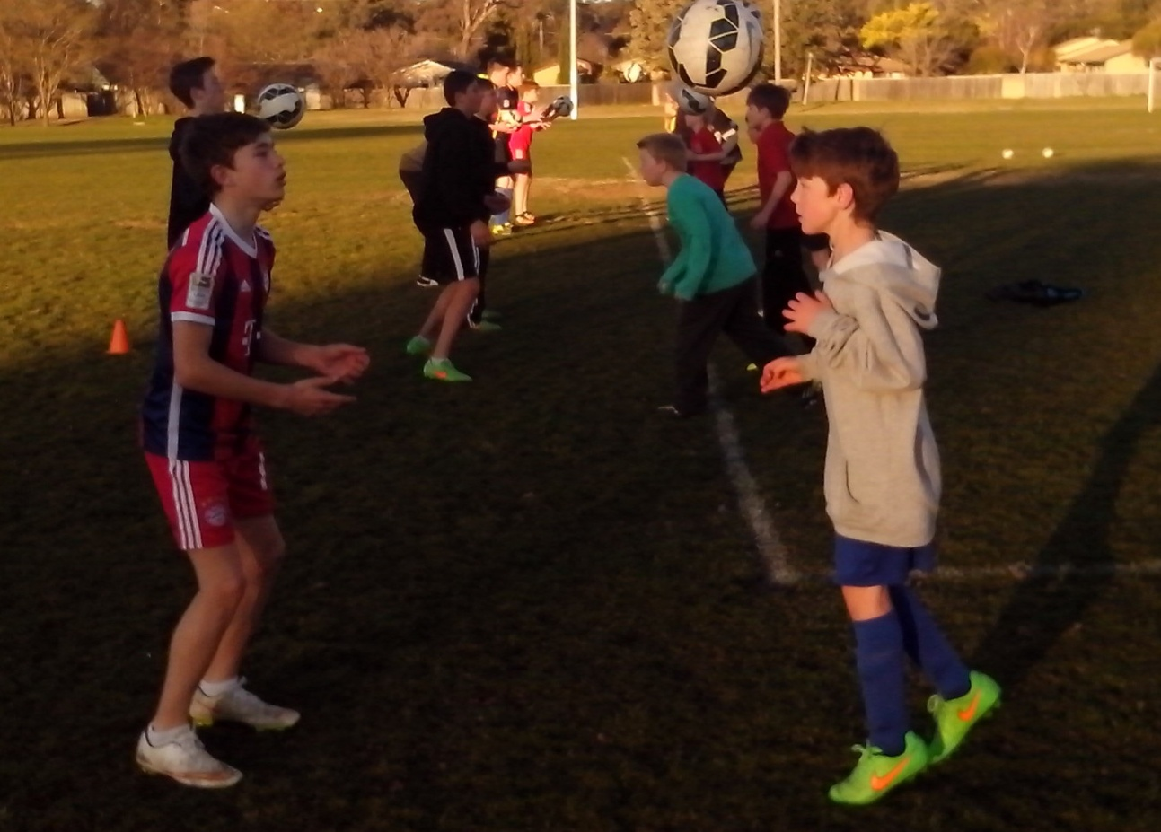
It’s amazing what kids can achieve when they still believe that they can reach the top. Kids don’t know that they’re untalented because they keep improving when they have the right encouragement. Coaches don’t know that kids are untalented because they don’t have a Learning Program. Nobody knows how good these kids really are.
PURPOSE
Freestyle results are immediate, clear, measurable and permanent.
Nobody can make a skateboard rider go to the skate park. They make themselves. Nobody can make a Soccer kid juggle a ball. Something inside them motivates them to spend a lot of time and effort keeping a ball close to them while other kids work just as hard kicking the ball as far away as possible. Everyone can develop a sense of purpose.
All kids have external characteristics that can be coached (fitness and skill) and internal characteristics that can’t be coached (intelligence and character). We teach ordinary Soccer kids what to do and how to do it so they can play. Freestyle kids learn when and where to do it and understand why so they can coach. When there’s only one team coach for each training squad, Freestyle kids can use Lighten Up to help each other. Passionate kids are in the game for the long term.
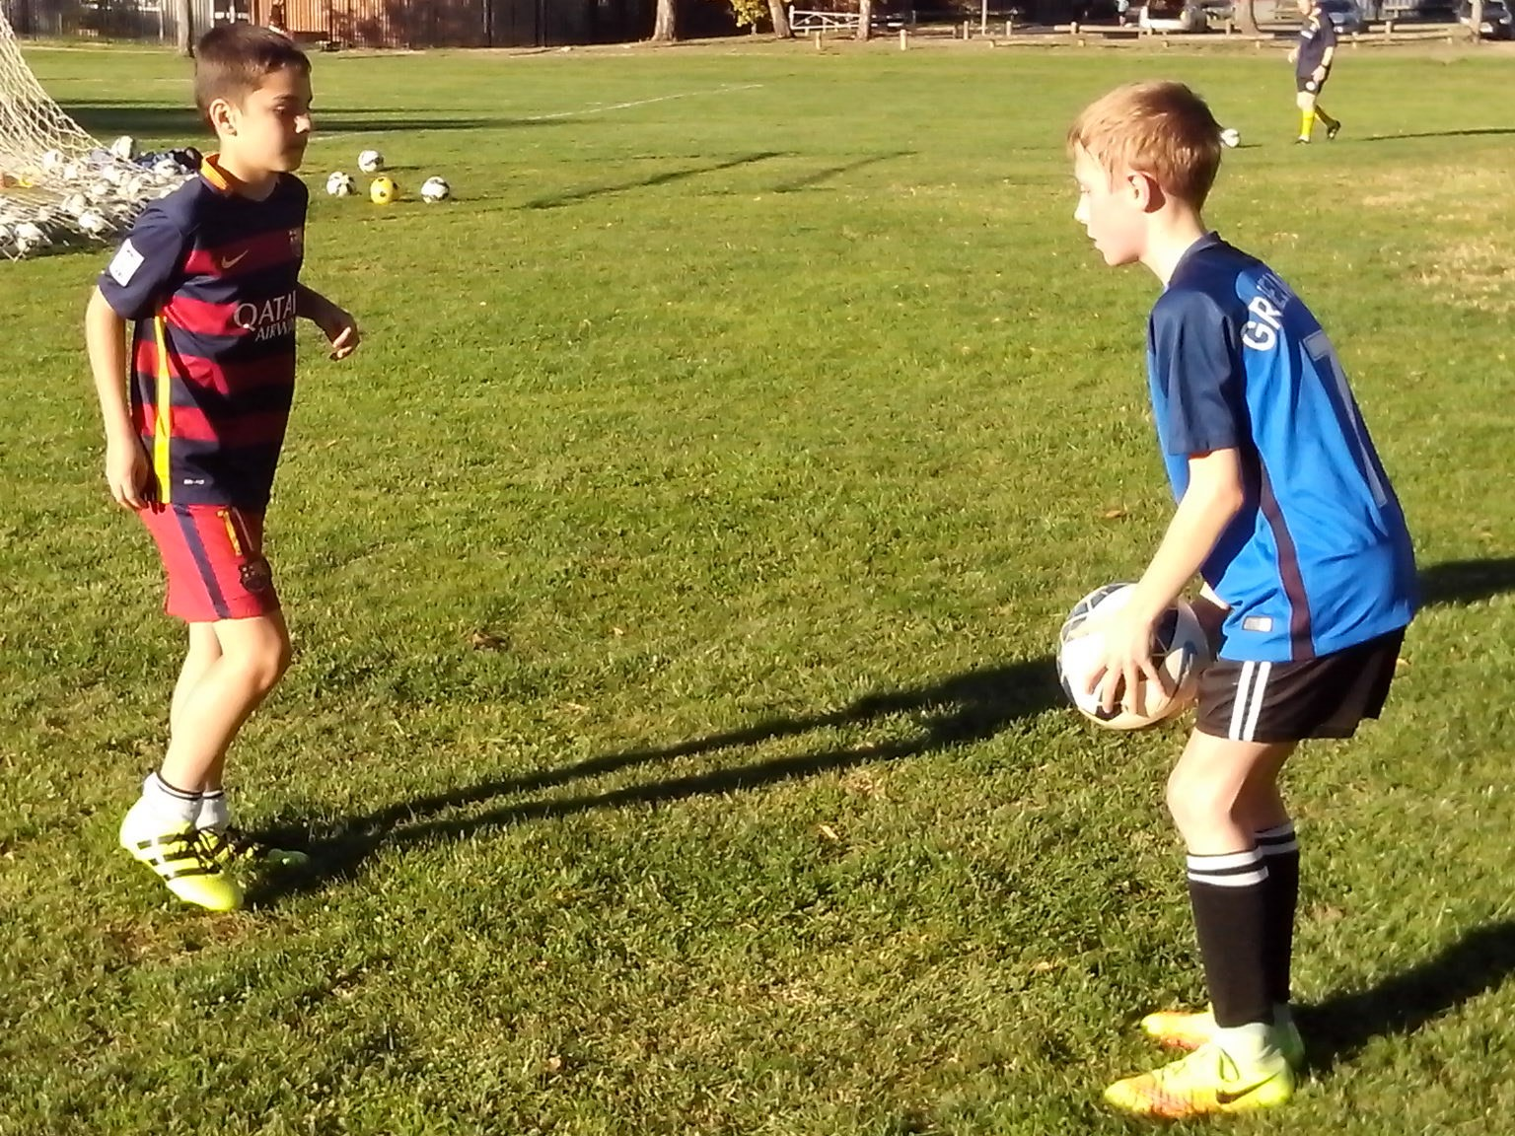
ENERGY
The role of the coach is to convert natural matter into energy.
Some kids start every game flat out and soon lose their energy. Freestyle kids learn how to pace themselves. They start out easy and gradually increase their momentum. They learn how to finish because they know how to start.
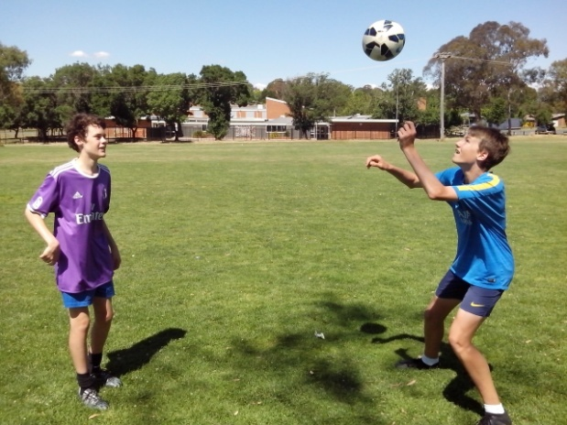
Ordinary kids get to the oval on match day and place a dead ball 25 metres out from goal and then they blast it over the crossbar and they’ve got nowhere to go from there. The second shot goes further.
Freestyle kids use Lighten Up to prepare for a game. They get 200 ball touches and develop timing, rhythm, power and stamina. The Freestyle kid is the kid who picks up the pace in the last 20 minutes of a game. The more they run in this game, the more they can run in the next.

INJURY PREVENTION
In a ball game, close ball control should be an integral part of preparation.
Kids learn not to sprint flat out before warming up but they don’t think twice about blasting a 20 metre dead ball shot over the crossbar with cold muscles. Most kids have a poor understanding of the effects of ballistic force on growing muscles.
It takes at least 5 minutes of close repetition drills to develop eye/foot coordination and warm up the kicking muscles so that kids are ready to add power to precision. A substitute can sit on the bench for 30 minutes and go on the pitch and miskick a long ball 30 seconds later.
Inexperienced kids will always try too hard to kick the ball too hard whereas Freestyle kids can switch seamlessly from a 5 metre pass to a 25 metre drive because they develop a feel for it. Lighten Up before a game may reduce the risk of straining the hamstrings or quadriceps.
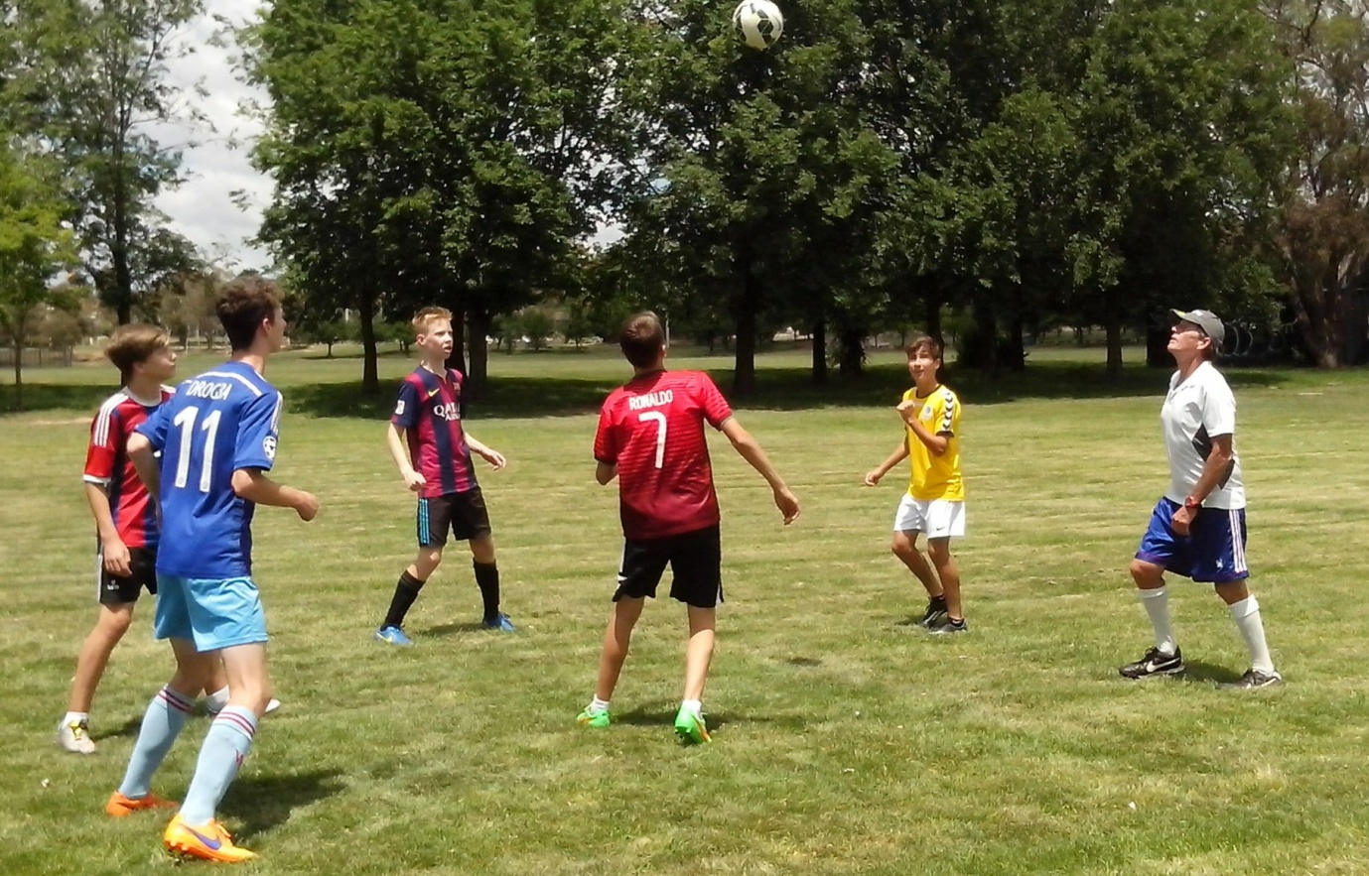

RECOVERY
Lighten Up should be a part of every recovery program.
When kids are recovering from lower limb injuries, it may take a while for them to resume full training. Lighten Up is a low impact high return drill that enables them to develop at their own pace. An injured kid can become a weak link in a team so it’s important that team mates take turns to help these kids recover. The Buddy System ensures that no kid is ever left behind. We never give up on kids.

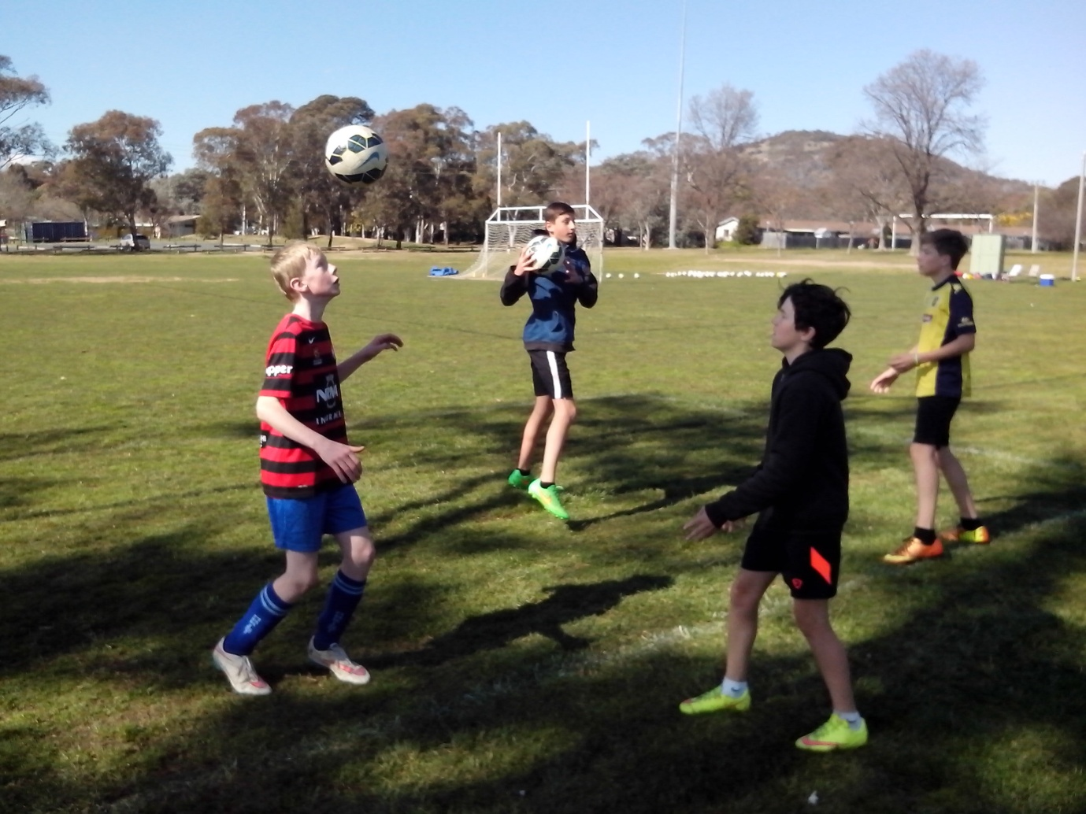
Soccer kids don’t stop growing in the off season. Players who pause during the holidays or when they go away can’t reach their peak immediately. When there’s a circuit break in training, it takes a couple of sessions and hundreds of ball touches to find the timing, develop the touch and reconnect the power. Some kids take a while to get it.

SELF DRIVE
We can’t drive Freestyle Kids. They learn how to drive themselves.
Freestyle kids know what they need to practice before a game. When they juggle a ball, they can feel when their eye/foot coordination kicks in and the unforced errors disappear. No Freestyle kid will ever go into a game with inadequate preparation. These are the kids who warm up in the backyard before they even get down to the oval.
Coaches need to engage with players and get feedback on their strengths, weaknesses and needs. Specialists in Soccer Skills tell kids what they want. Specialists in People Skills ask kids what they need.
Every kid has the potential to reach the top if we can give them the right inspiration and point them in the right direction. Lighten Up is a simple way to spend 5 minutes helping a Soccer kid to improve. That might not mean much to an adult but it means a lot to a kid who has struggled so hard to kick the ball that they miss it every time.
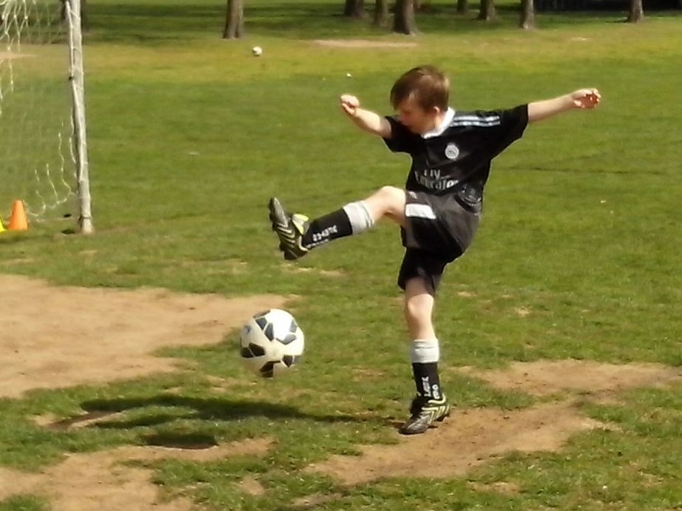
INNOVATION
Don’t be frightened to be enlightened. Innovation just isn’t what it used to be.
There are skills that haven’t been invented yet and elite kids who haven’t been discovered yet. Innovation is going to come from the next generation because the kids of today haven’t learned what they can’t do yet. The key is to identify the optimists before they learn enough to grow into pessimists.
The young generation want to know it all. The old generation already know it all. In a coaching system, we can teach everything that the old generation can do. In a learning program, we can discover everything that the next generation can do.
Each generation is smarter and more talented than the previous generation. That’s the theory of evolution and we just need the practice. The talent is already there. We just need to believe in that talent. Otherwise we will keep waiting for the young generation to become the old generation. We can wait until it’s too late.
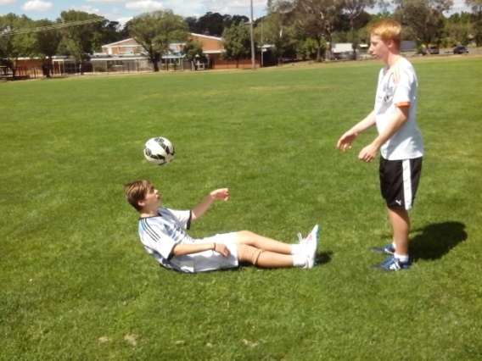

RESPONSIBILITY
When a healthy wealthy sporting nation, with a high performance coaching system, is not in the Top 20, it’s everyone’s responsibility.
It’s too easy for kids to stand around waiting for adults to tell them how to think, when to train, what to do and where to do it. It’s even easier when the team fails and the kids can blame the coach or the ref.
Kids don’t fall apart when we leave them alone. They learn to accept responsibility so they only have themselves to blame if it goes wrong.
On a skate park, basketball court, cricket nets, bike track or skills park, freestyle kids have no fear of thinking for themselves, relying on themselves, speaking up for themselves or creating their own moves.
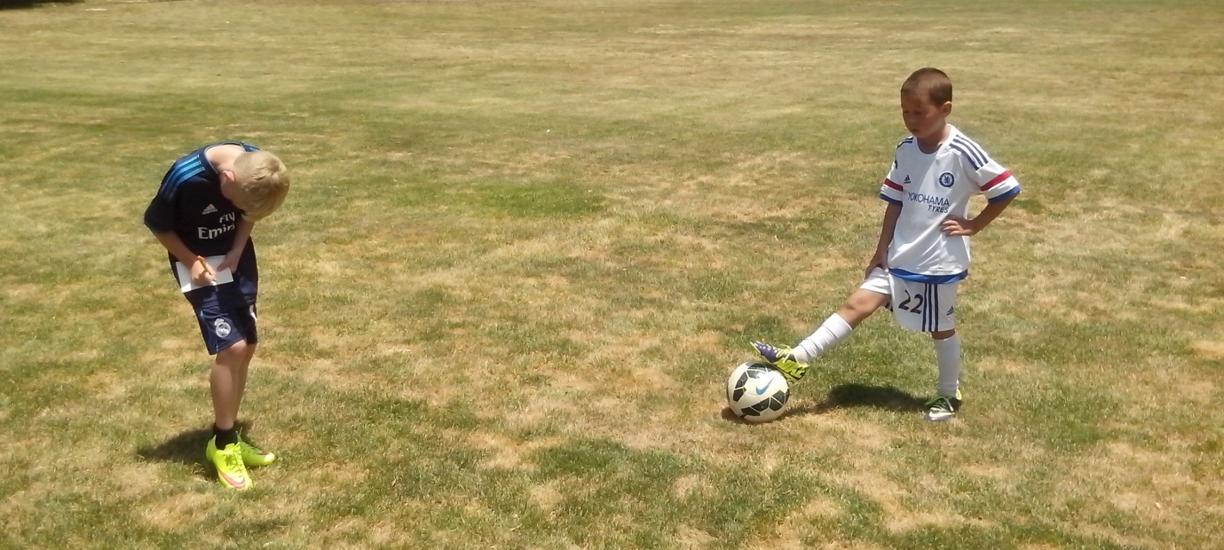
Lighten Up enables kids to get used to taking responsibility for their own skill development and for their mates. Soccer is a competitive team game with a ball. It’s competitive so kids need to drive and strive. It’s a team, so kids need to think about others. It’s a game, so kids need to have fun and it’s a ball so kids need to have a ball. If we can find a way to improve any Australian Soccer kid, no matter how talented or untalented, we can improve Australian Soccer. We don’t need to get the best players if we can make the best of the kids we get.

CONFIDENCE
Some kids just need a good kick.
There are three skills that identify confident Soccer kids. Freestyle kids love to juggle the ball, head the ball and shoot for goal because these are the skills that challenge them.
Fear of failure is the greatest obstacle in sport. Some kids of scared of getting hurt when they head a ball. They’re scared of dropping the ball when they juggle and they’re scared of missing when they shoot in case the coach shouts at them or their mates laugh at them.
Kids learn very quickly. If they get laughed at during shooting practice they soon learn to pass the ball instead of shooting in a game. Kids need to lighten up because there are too many talented strikers who are too scared to shoot in games. The solution is simple. Tell kids to make as many mistakes as they like at shooting practice and they will start to relax and take more chances in the game.
Confidence is the most important goal for any kid or teenager. If we really think that kids lack the talent to reach the top, we just need to look at their confidence and do something to improve it.
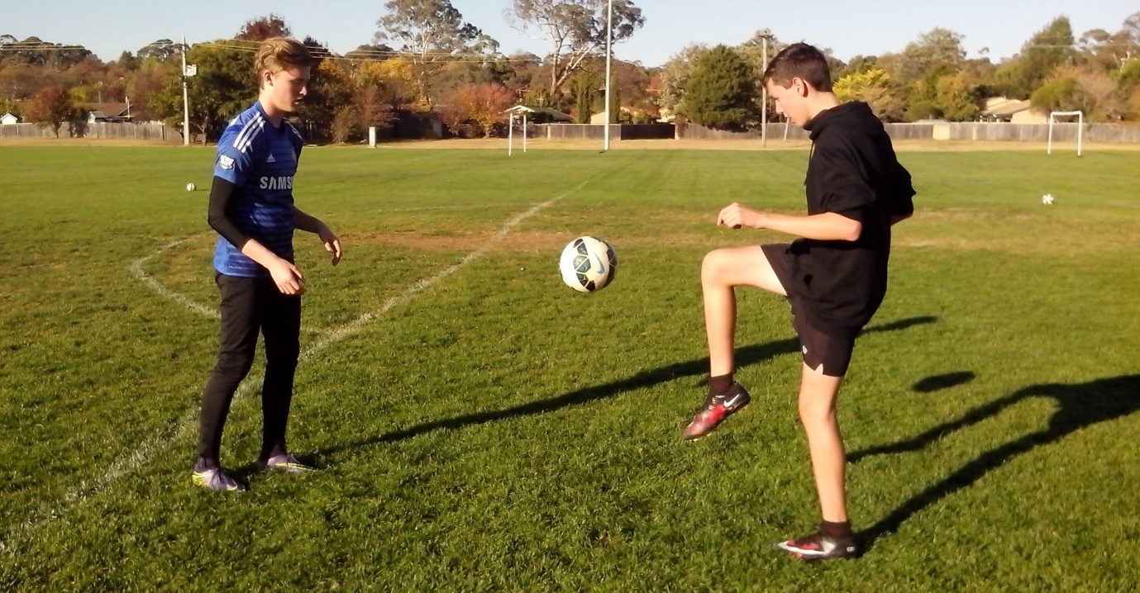
COLD CASE
Some strikers have been missing for years. Coaches don’t know why they’re missing and the kids don’t know what they’re missing.
We can teach the same every day or learn something new every day. A Learning Program never stays the same but always changes. The more we learn about shooting, the more we discover about players.
Striker have been taking the same shots and missing the same goals for the last 20 years. When Freestyle kids practice shooting on their own, they look at what they do, think how and discover why. Anyone can see how shots can go wide, over the bar or through to the keeper.
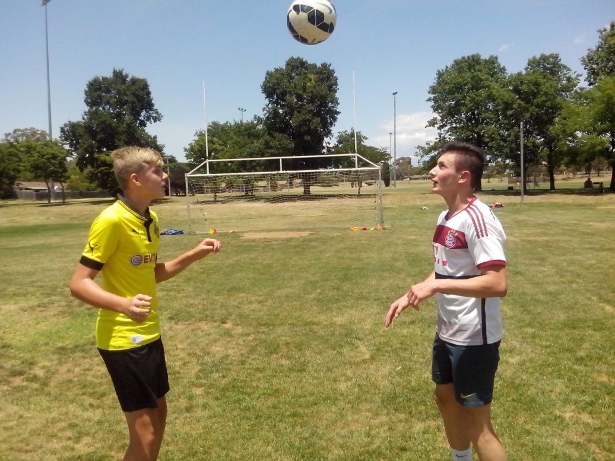
Experts see what they’re trained to see so they look for technical faults to correct. Freestyle kids don’t have preconceived ideas so they look at everything. When shooting becomes a cold case, they can look at it with a fresh set of eyes. A two hour shooting session with 100 balls shows what happens when kids stand flat footed, rush their shots, try too hard to kick too hard or take their eyes off the ball and look up at the keeper. Lighten Up can solve most shooting problems.

RHYTHM
The top players move to their own rhythm and they know the score.
There are plenty of skilful karaoke players who follow the bouncing ball and wait to see what happens. The talented players move to a different beat and make it happen. They specialise in improvisation.
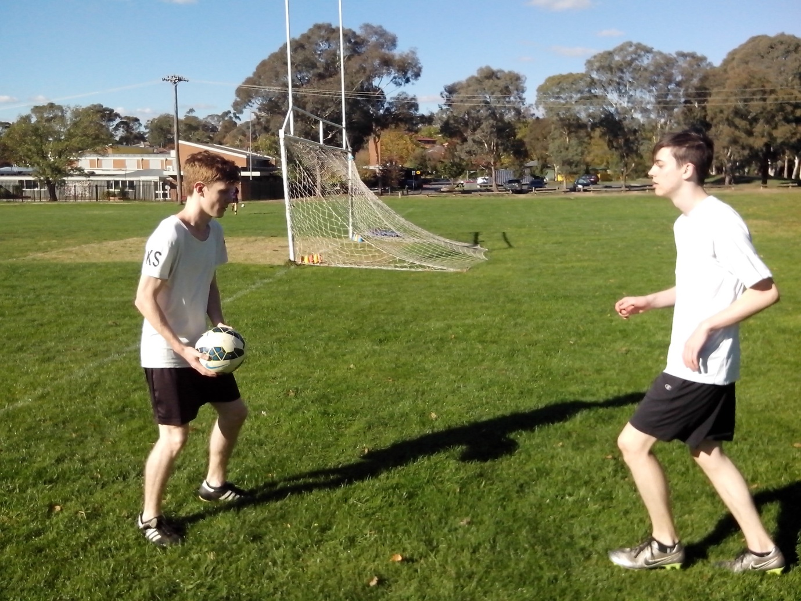
Lighten Up is a simple motor skill that develops a steady rhythm just like walking and running. One footed players develop an unsteady rhythm that affects their natural control. Any kid can learn to improve their weak foot in a short time using various close repetition drills.
A 7 year old player can get away with using one foot. A 17 year old player will get outmanoeuvred and intimidated by a smarter opponent. When we watch the Brazilian players warm up before a game, we can put it to music because their skills and drills have a natural rhythm.

PATHFINDERS
We can help kids find their feet if we know what to look for.
A lot of kids play the straight through ball that nobody can catch. Freestyle kids learn to change the flight details to keep the opposition on their toes. Lighten Up helps kids to rotate on the ball so they can play the diagonal through ball that penetrates the defence.
There are so many different ways that Soccer kids can improve their natural skills and develop their Soccer skills. Freestyle kids look at every way they can until they find the Freeway.
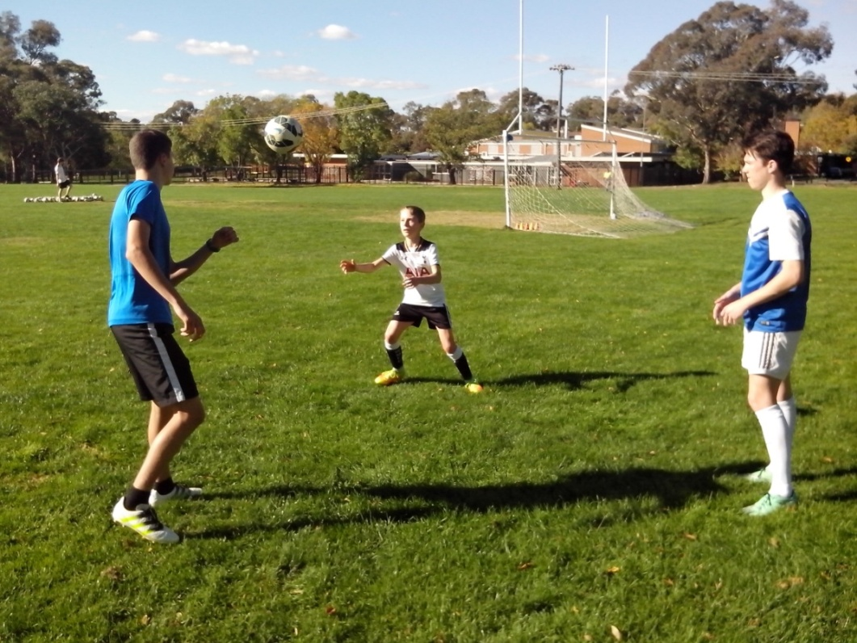
Some kids are very straight forward. They look straight ahead, run straight forward and kick straight forward. Freestyle kids read between the lines. They look, think and move 360 degrees so that they are constantly aware of everything that goes on in a game both on the ball and off the ball.

INSIGHT
The eyes have it. Kids with vision use their initiative, intelligence, intuition and innovation.
When we develop Soccer kids to follow the needs of a system, all the information we need is written down. When we develop a system to follow the needs of kids, all the information we need is in front of us.
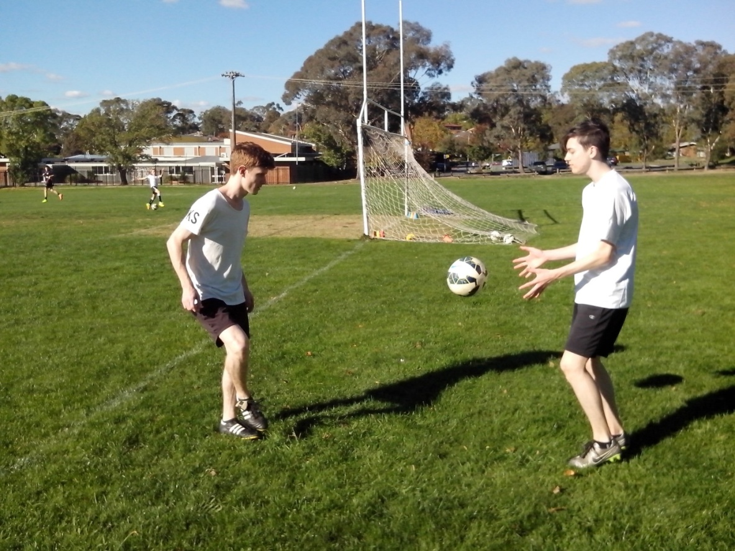
Lighten Up gives us insight into any player. We can focus totally on one individual without being distracted by a competitive game. It doesn’t take long to assess their natural skills or evaluate their strengths, weaknesses, talents, skills, fears, needs and limits.
No two players are ever alike so we discover something different in every individual. When kids become the most important subject in Australian Soccer, we can teach them all to be the same or learn to make a difference. If we learn about kids, we discover their talent.

TALENT
There is so much untapped talent in Australian Soccer. We can’t teach talent. We need a learning program to discover and develop it.
There is a belief that the vast majority of kids lack the talent to reach the top. If we can’t see talent, it doesn’t mean that kids don’t have it. A coaching system is a teaching program. We can’t identify talent by teaching skill. Skill comes from the coach and talent comes from the players. If we can’t see talent in Australian Soccer kids, we need to find a better way to look for it so that we can make the best of it.
We can’t see much talent in the kids who only train when we tell them to train and do what we tell them to do. Any kid can learn to stand around and wait for orders. We need to look for the kids who train when we don’t tell them to train and who create their own moves when we don’t tell them what to do. That’s original Australian talent.
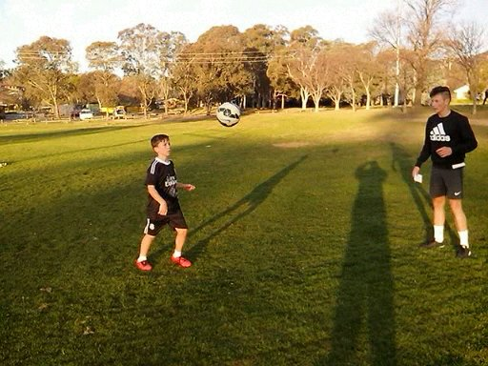

SPEED UP
Freestyle kids are continuously upgrading their skills.
We all have a choice. We can take the easy way out or the hard road. Ordinary kids will always avoid the pressure while Freestyle kids will always take the challenge and look for more difficult training drills.
Rapid Fire drills enable kids to face the pressure, absorb it and get used to it. Lighten Up is a simple introductory drill where the ball player knows what type of ball they’re going to receive. Speed Up is a random drill where players are forced to keep on their toes and react instinctively. Eventually kids learn to relax and stop thinking about it.
Some kids will never discover the joy of playing at the intuitive level because they never get enough touches of the ball to master control. Some kids will never have the freedom to play their own game or spend a 2 hour shooting session with a hundred balls. Some kids will never have the confidence to discover how good they really are.
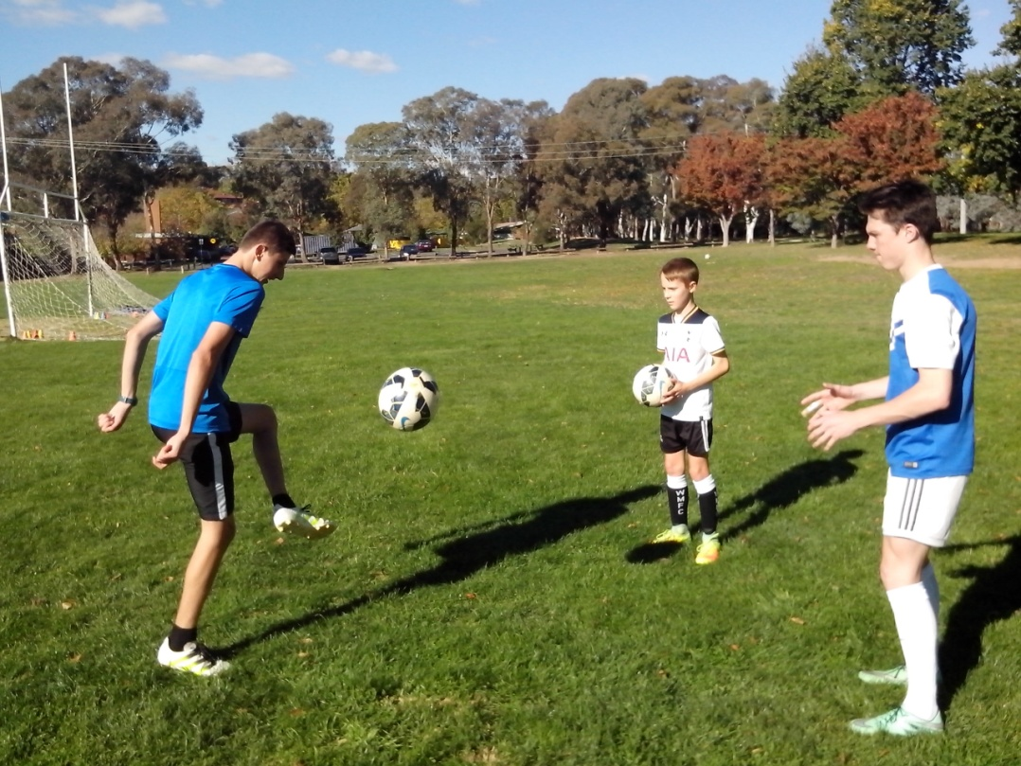
GROWTH
The Zone is where kids find the skills they never knew they had.
The most important subject any kid can learn about in Soccer is themselves. It’s no good just telling kids what to do. We need to identify their strengths, weaknesses, skills, talents, fears, needs and limits and we need to measure their performance and improvement so that we can base their confidence on facts not subjective opinions.
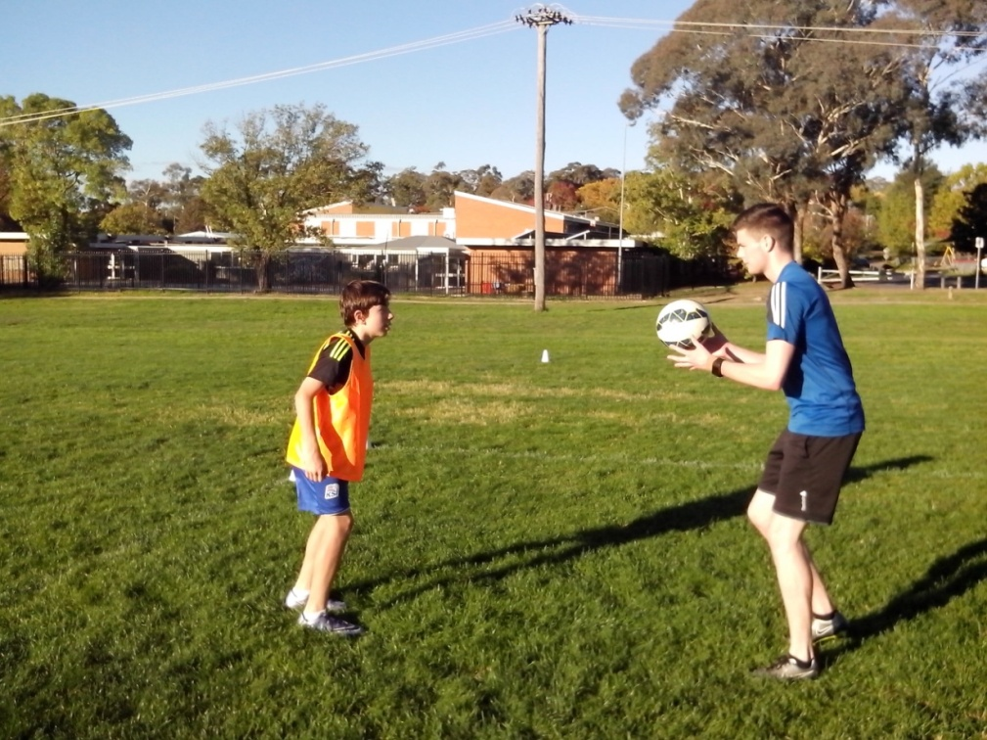
Kids are very smart. They can tell if a coach believes in them or not. They know who helps them grow. If kids believe in the coach, and the coach believes in the kids, the kids will believe in themselves.
Junior Soccer is not about winning games or making a profit. It’s about improving every kid so that they can achieve their full potential and then those kids will decide what they want to get out of the game.

SMALL CHANGE
Nothing stays the same if we want to improve our game.
When we’re all the same, nothing ever changes. Kids are shooting and missing the same way they did 20 years ago and nobody is learning anything about it.
The aim of Freestyle Soccer is to learn everything about Australian Soccer kids so that we can develop an Australian coaching system that reflects the Australian spirit and character. The first lesson is Lighten Up and this provides clues to the rest of the game.
Freestyle kids are never satisfied with generic mistakes. They keep looking at skills and drills until they can find a better way to succeed. No Freestyle kid would let poor shooting continue for so long without doing something about it. It’s not that hard to learn what’s and then discover what’s right. We can’t do that without a learning program.
If we give kids the confidence to run their own drills, they will get results. Kids don’t lack talent. Adults just lack the belief in that talent.
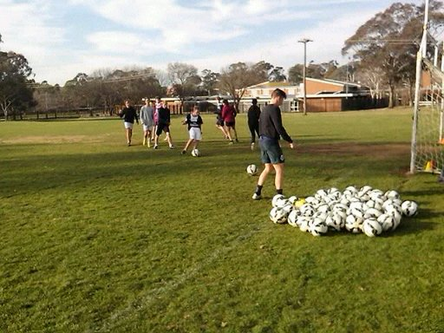

SHORT CIRCUIT TRAINING
Lighten Up is catching. It’s also throwing and kicking.
A lot of Soccer kids are very straightforward and play the ball straight in front of them. When a cross floats over in a game, these kids can usually make good contact with the ball but fail to rotate their body enough to change the direction of the flight. Freestyle kids learn to control and shoot from every angle and range so they never get caught out in a game. They’ve done it all before so it’s in their subconscious.
Lighten Up is an effective way to develop side volley and rotational volley so that kids can get used to the basic close technique before increasing the speed, intensity, distance and pressure. Freestyle kids will use a low hard ball in the box to practice deflections to the far post using their head or foot. They get behind the flight of the ball but make a sudden adjustment to ensure that the ball glances off. These kids use peripheral vision to give themselves more than one option.
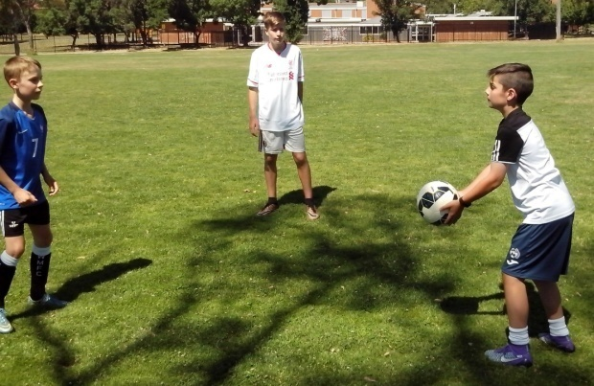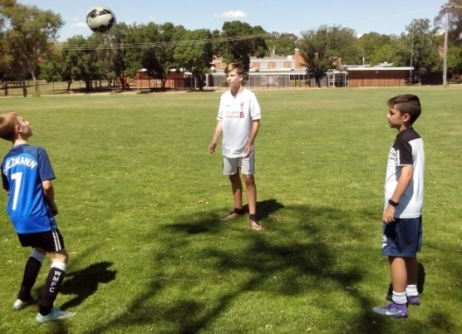
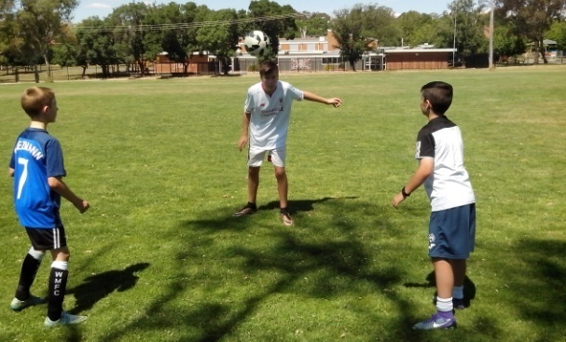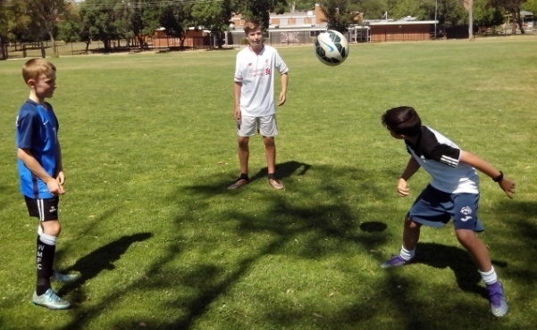
STAND AND DELIVER
Any club official can spare 5 minutes to make a difference.
Kids love to run around and do stuff. Adults love to sit around and talk about it. At every club, you can pick the officials sitting around and talking important stuff.
If one club official spent 5 minutes helping one kid to Lighten Up, that kid would be rapt and both of them would learn a lot. The biggest issue in junior Soccer is the scarcity of individual coaching. 17 year old kids are repeating the same mistakes they learned when they were seven because a team coach doesn’t have the time to work with them one on one and discover the underlying cause of their basic mistakes.
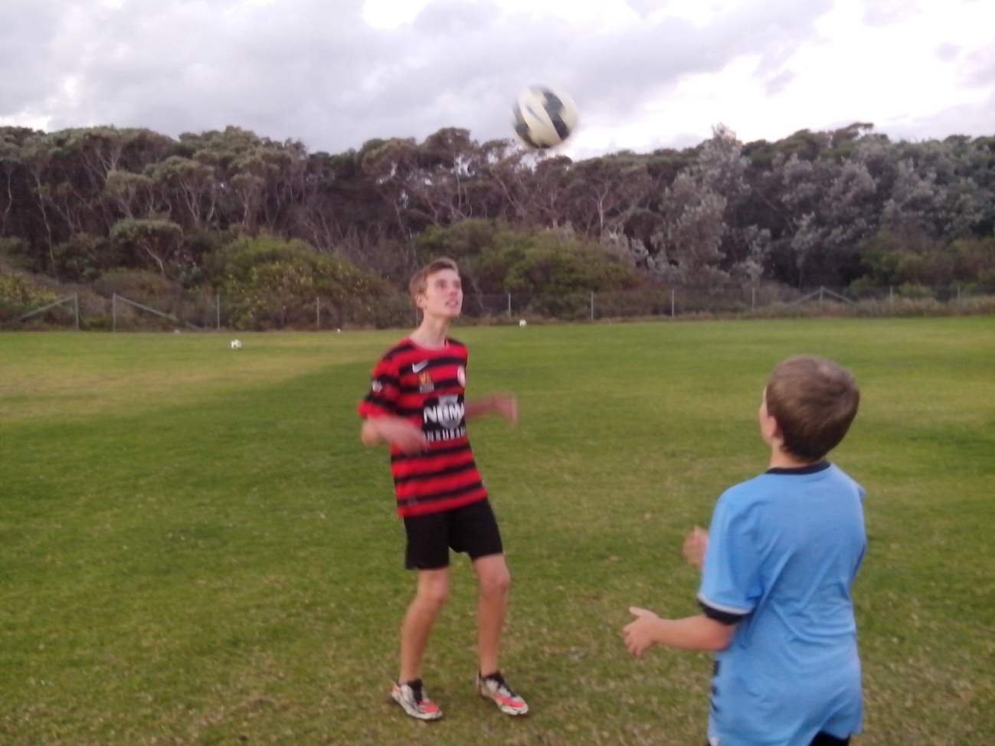
There are only so many 5 minutes in a day. All you need to do is stand two metres in front of a kid and throw the ball to them and you will quickly read that player and notice how they move and how it influences their ball control. It only takes 5 minutes reading time.
FUTURE SOCCER
The most important resources for the future of Soccer are talented kids, innovative coaches and plenty of balls.
We can teach the kids of today how to kick, how to shoot, where to stand and what to do. The kids of the future will learn how to pass, how to score goals, where to move and how to think for themselves.
We don’t have to improve Australian Soccer. If we can improve Australian Soccer kids and develop their talent, they will have the confidence to improve Australian Soccer.
If we don’t know how to score goals, let’s find out. What are we waiting for? It’s time to think for ourselves and make our own decisions.
In the short term, kids remember what the game was like. In the long run, kids remember what the coach was like. A team coach prepares a player for one season. Lighten Up can prepare a kid for all seasons.
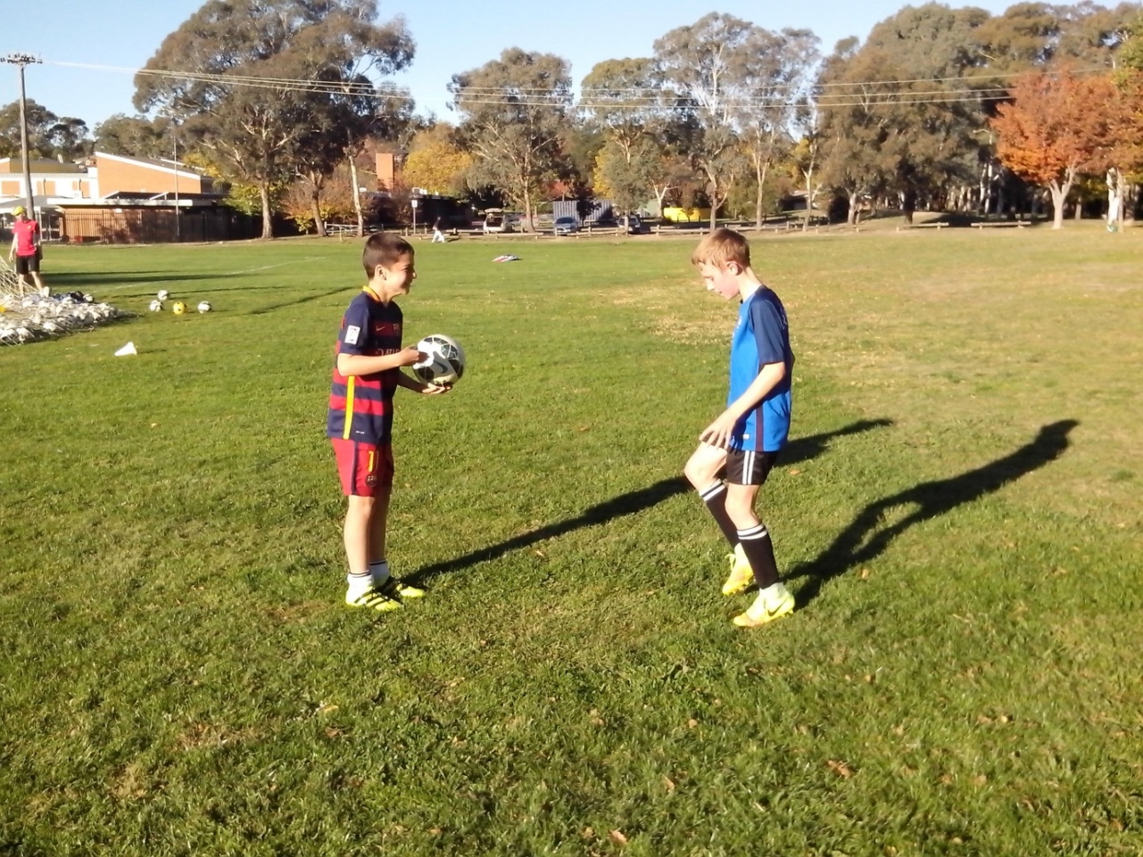

50 WAYS TO ENCOURAGE SOCCER KIDS
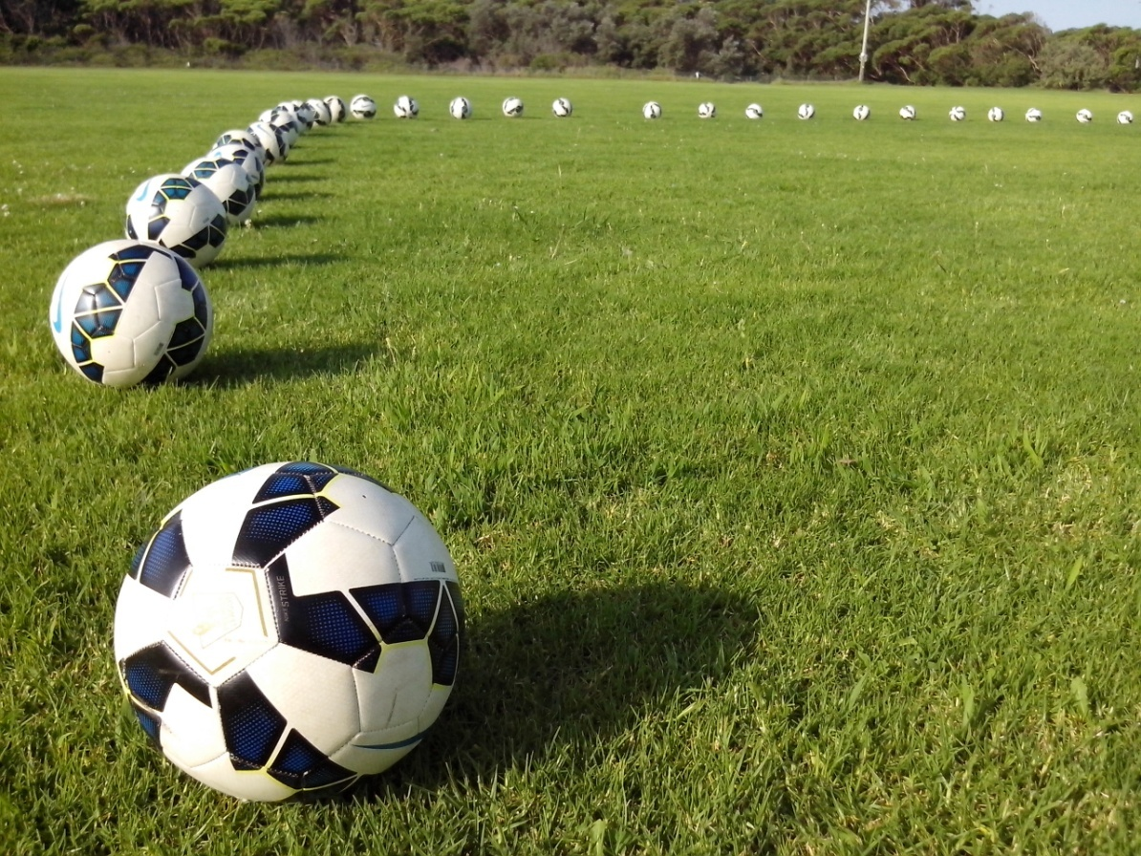
Have a Ball.
Keep it Going.
Well Done.
Nice Shot.
Good Game.
Big Improvement.
Thank You.
Help Each Other.
You Can Do It.
Think for Yourself.
I’m Proud of You.
Think Positive.
What do You Think?
Make your own Decisions.
Lighten Up.
Make More Mistakes.
Good clearance.
Keep Up the Good Work.
Go For It.
Great Job.
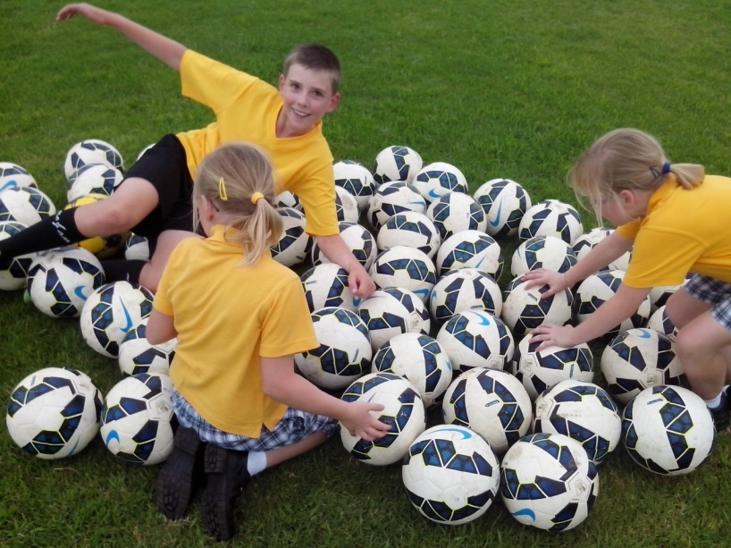
Feel /Free.
Yes You Can.
Great Cross.
Be Unique.
You Were Outstanding.
Getting Better All the Time.
You’ve Improved a Lot.
Be Yourself.
Keep Growing.
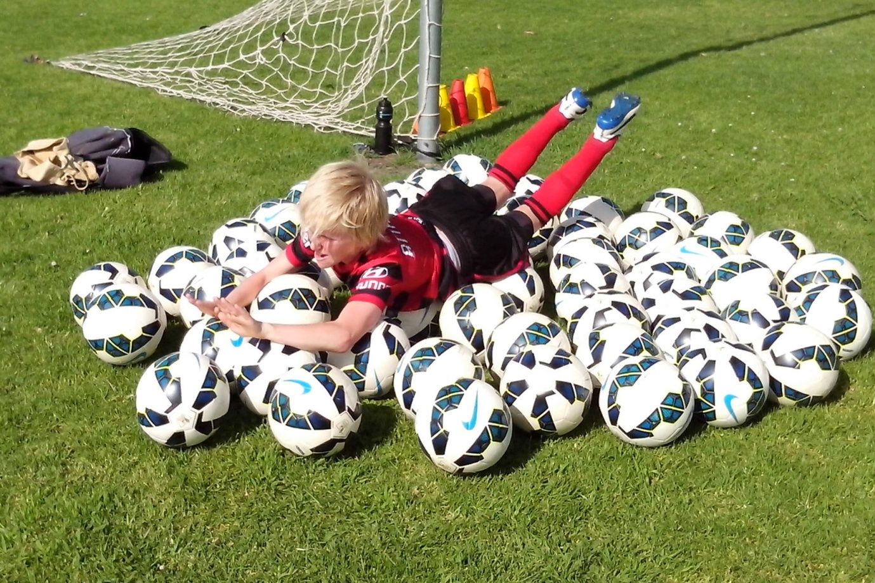
Be Different.
I Like How You did That.
That was Great.
I Believe in You.
I Will Help You.
Impressive
Back Yourself.
It’s Fun to Coach You.
Trust Yourself.
That was Great to Watch.
Have Fun out There.
I Appreciate You.
You’re Getting Better.
Support Each Other.
Oops. That was Lucky.
Great Idea.
Well Done.
Believe in Yourself.
Be Creative.
Just Try Your Best.
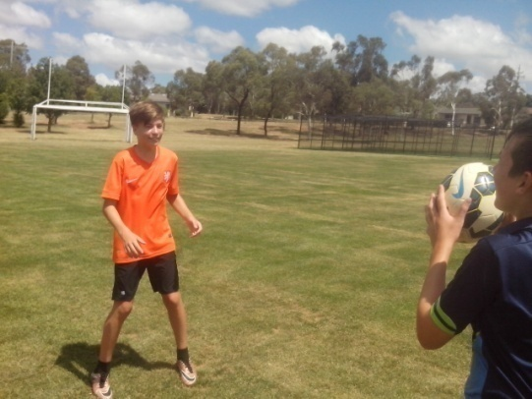
Take Risks.
Don’t Worry About Mistakes.
Excellent.
Brilliant.
You Will Make a Difference.
Inspire Your Team.
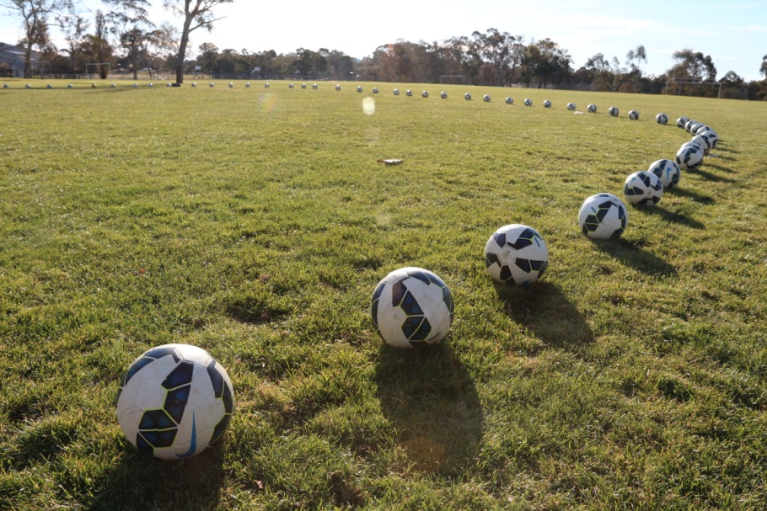
Great Thinking.
Challenge Yourself.
Good Work.
Don’t Give Up.
Fantastic.
You’re Inspiring.
You always Do Your Best.
You Went Well Today.
That’s As Good As it Gets.
I believe in You.

