Queensland Annual Report 2015

2015 again started tragically for AFL Masters in Queensland with the accidental deaths of Gary and Leigh Mitchell. They both came to Superules at a club level back in 1995 and as a dynamic husband and wife team did everything to lift their struggling club. In 1999 they joined the QLD Board as Registrar and Secretary and served for 12 years, supporting four Presidents and 30 clubs across Queensland. Along with their two sons Jason and Brenden, the Mitchell family will always have a special place in the heart of AFL Masters.

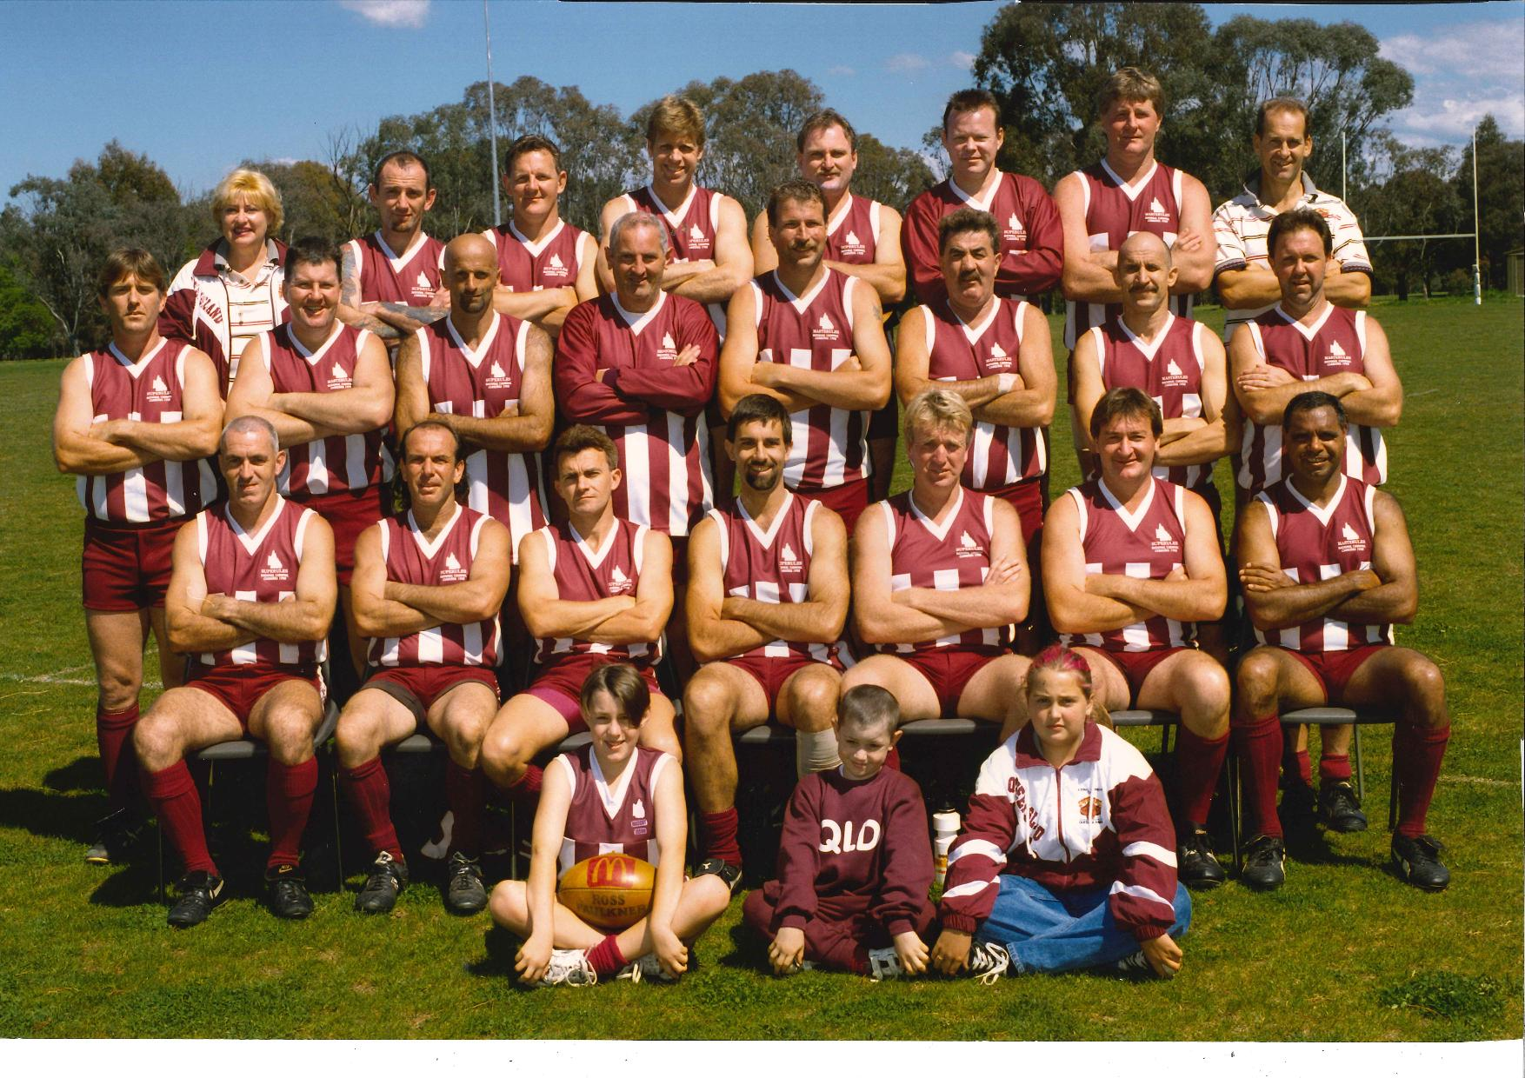
Canberra Carnival 1998 – Leigh Mitchell first left top row, Gary Mitchell first left bottom row, Jason and Brenden Mitchell front left and centre.

2014 Board members Derek Delany, Steve Burchill and David Sullivan continued into 2015 and were joined by Country Director Maurie Soars and Registrar Arnold Keuker.

North QLD continued their country carnival program and worked very hard to integrate AFL Masters footy into the wider community and introduce the game to as many Queenslanders as possible. Expansion came via two new teams, the Mount Isa Miners and Charters Towers Gold City Suns, and we warmly welcome them into the AFL Masters family. The Metro competition continued with two age groups, over 35s and over 45s, and played a 12 round fixture throughout the year. New clubs from Glasshouse Mountains and Coomera entered the competition and we look forward to their long association with AFL Masters. We continue to target new clubs that can fill a geographic void in both metro and country areas.

After a strong showing at the Adelaide national carnival, Queensland once again fully supported the national carnival in Tasmania, entering five sides in every age group. Many thanks must go to the team coaches who were very professional on and off the field and got the best out of their players.

- 35s-40s Gavin Kearney
- 45s Chris Harman
- 50s Bill Moorhead
- 55s John Terrick
- 60s Glenn Phillips

Congratulations to the 19 Queensland players who won All Australian honours and Simon West in the 35s-40s who jointly won the B&F award.

The carnival was a great experience for all 108 QLD players who went and thanks to Curtis and his team for putting on such a great show. We also welcomed six Tasmanians into our over 60s team; friendship and team spirit knows no state boundaries.

In 2016 the carnival is “coming home” to the Gold Coast and we welcome all interstate footballers and their families to what will be a fun-filled event.

The prestigious Superman of the Year award for 2015 was for the first time a joint award. The winners were Glenn Phillips for his tireless work in getting the Over 60s carnival competition off the ground, and Arnold Keuker for his tireless work in implementing SportingPulse throughout the Queensland teams. Both gentlemen spent many hours on tasks that will greatly improve the experience of playing AFL Masters football in Queensland in the future and we congratulate them for their dedication and commitment.

Finally, I would like to thank the current Queensland committee, all our club delegates and the national executive for their passion and drive to make AFL Masters football a game and an organisation to want to belong to.

AFL Masters – Footy for Fun, Fitness and Friendship.

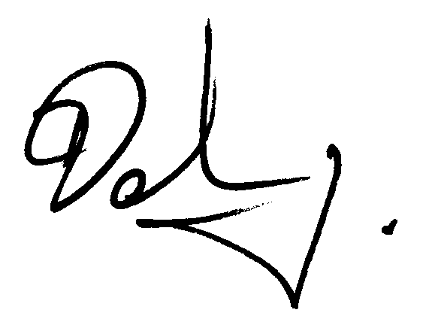

Derek Delany
Queensland President

