**DAY 1 – EXERCISES YOU MAY NOT KNOW!**

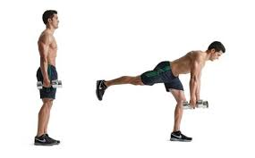 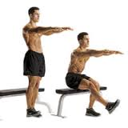

SINGLE LEG DEADFLIFT SINGLE LEG SQUAT

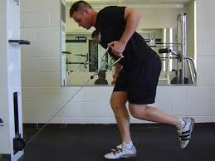 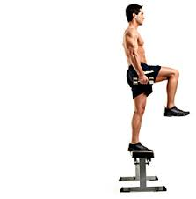

1 LEG CABLE ROWS STEP UPS (USE 1 DUMBELL AND HOLD ABOVE HEAD)

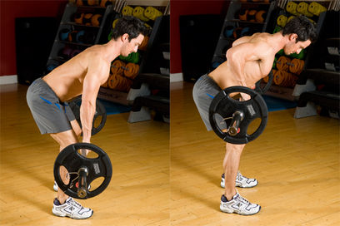 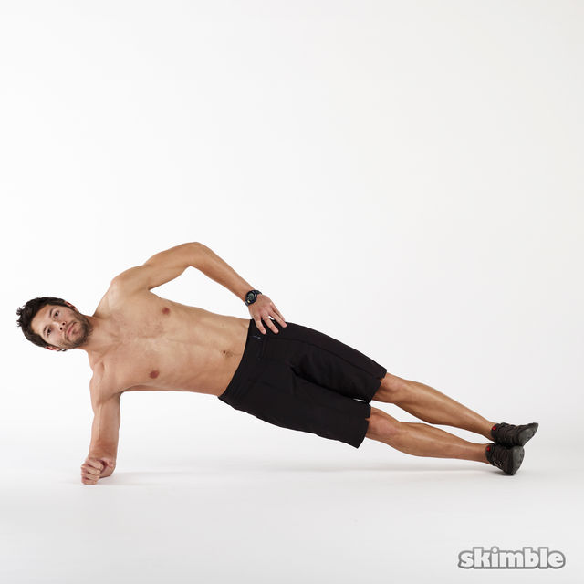

BENT OVER BARBELL ROW SIDE PLANK

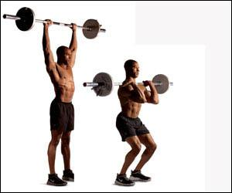

PUSH PRESS

**DAY 2 – EXERCISES YOU MAY NOT KNOW!**

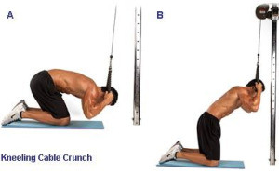 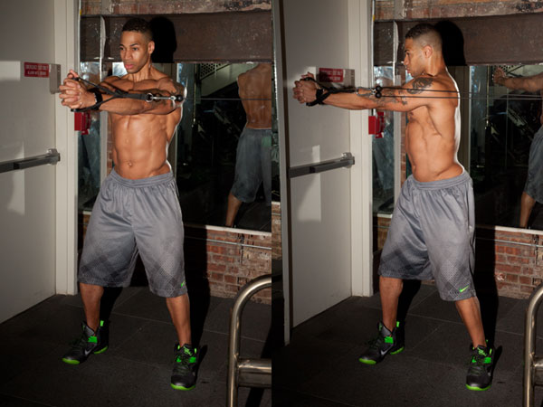

ROPE CRUNCH CABLE TWISTS

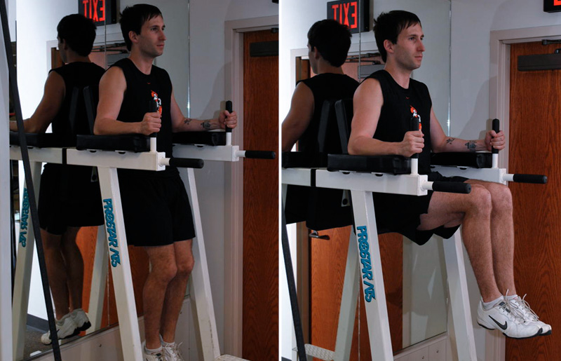 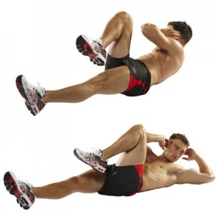

ROMAN CHAIR BICYCLE CRUNCHES

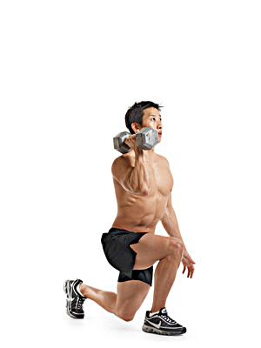 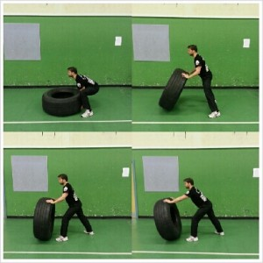

WALKING LUNGES(ONE DUMBELL) TYRE FLIPS

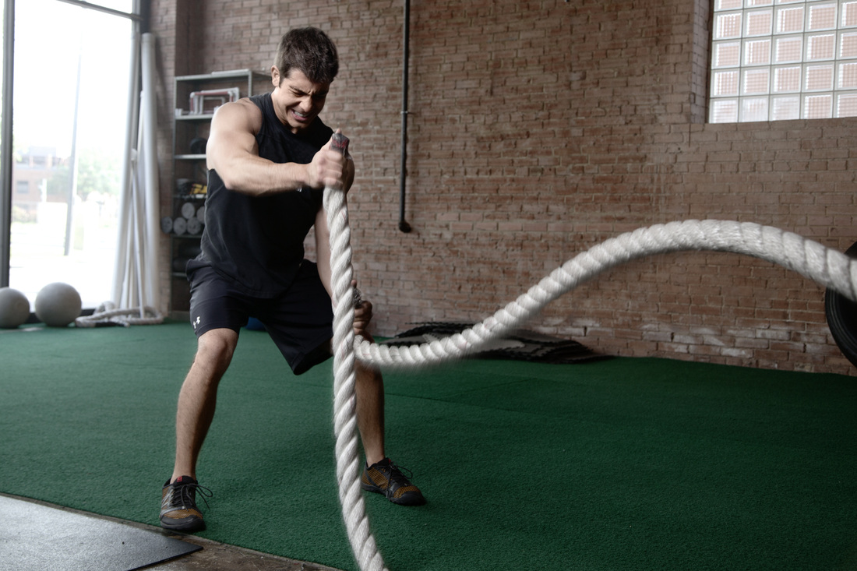

BATTLE ROPES