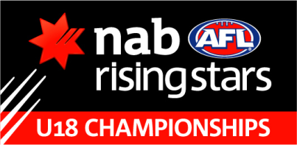

Round 3

SOUTH AUSTRALIA v VIC METRO, SATURDAY 16 JUNE, Alberton Oval, 12.00pm

Backs | Matthew Scharenberg 29 | Matthew Wallis 36 | Harley Montgomery 11
H Backs | Sam Colquhoun 7 | Aaron Luccon 40 | Trent Dumont 13
Centres | Nick Amato 6 | Oliver Johnson 14 | James Aish 16
H Fwds | Sam Mayes 26 | Ethan Gill 39 | Tim Broomhead 20
Fwds | Troy Menzel 25 | Brodie Murdoch 31 | Ben Kennedy 4
Followers | Brodie Grundy 42 | Nathan Stark 12 | Travis Schiller 3
Interchange | Tom Schott 33 | Tim O’Brien 24 | Matthew McDonough 15
 | Alex Spina 9 | Dwayne Wilson 5

VIC METRO v SA

Backs | M Haynes 25 | M Dick 24 | J McKenzie 9
H Backs | N Vlastuin 22 | K Jaksch 33 | T Temay 11
Centres | T Tyquin 13 | J O’Rourke 14 | J Macrae 16
H Fwds | J Ballard 27 | L McBean 40 | B Lennon 19
Fwds | L Hunter 8 | J Stewart 38 | J Daniher 36
Followers | S Gilmour 34 | B Wood 17 | N Hrovat 6
Interchange | J Kelly 1 | A Corr 37 | J Billings 12
 | L McDonald 20 | C Salem 23 | T Boyd 31

