
MINUTES of mundijong centrals junior foOtball club

annual general meeting
NOVEMBER 14, 2017

Agenda No. | Issue/Topic | Points of Discussion/Details
 | Venue | Mundijong Oval Clubrooms, MUNDIJONG
 | Commence | 7:00pm
 | Attendees | Linda Branley, Warren Westphal, Lindsay Atwell, Sharon King, Evelyn Green, Bill Denholm, Michelle Denholm, Damien Hodge, Karina Miller, Mitch Crosby, Michelle Hewitt, Stacey Siroen
 | Apologies | Brenda Carrall, Priscilla Hawthorne, Kylie Hastie
1. | Proxy Votes | Priscilla Hawthorne, Rob Durant, Amy Waldron, Brenda Carrall, Bianca Boalch
2. | President Report | -Welcomed attendees  - thanked outgoing committee
3. | Minutes from Previous AGM | The minutes from the 2016 AGM were accepted as a true reflection of events.  .  Minutes accepted by: Linda Branley  Seconded by: Warren Westphal CARRIED
4. | Business Arising from Previous AGM | No business arising from the previous AGM
 | Treasurer’s Report | - Linda thanked the sponsors – so important to the club.  - Linda also thanked Robbie Gibb our independent auditor for volunteering his services.  - Linda explained that Merchandise has quite a high amount of stock remaining – a quiet year for merchandise  - Profit for Briggs canteen was up on last year.  - Linda submitted report from Redgum Accounting re: professional opinion about GST obligations for the club
 |  | 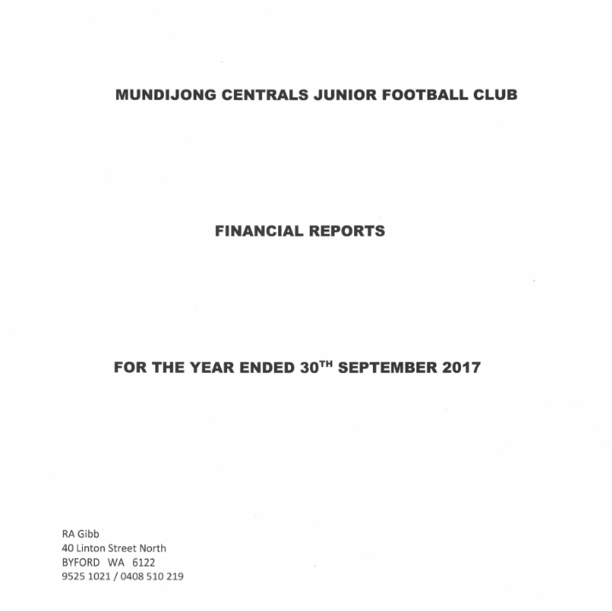
 |  | 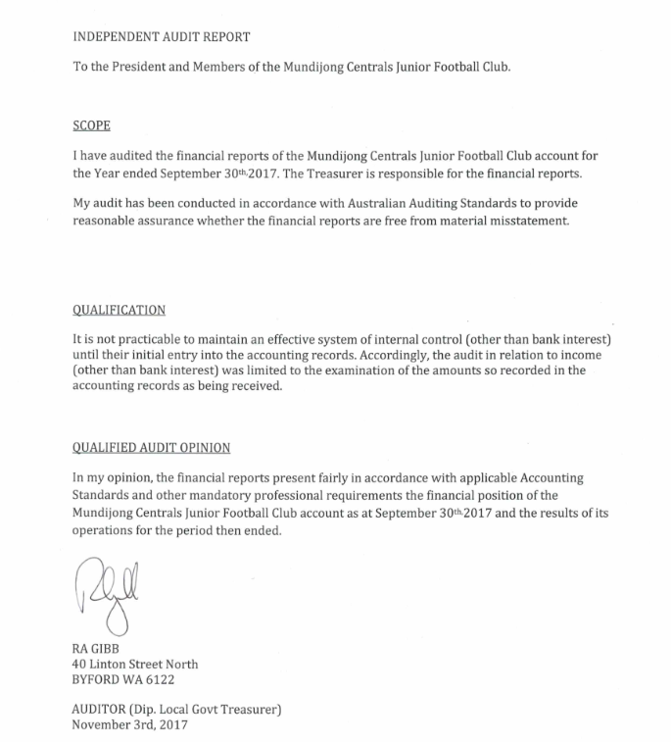
 |  | 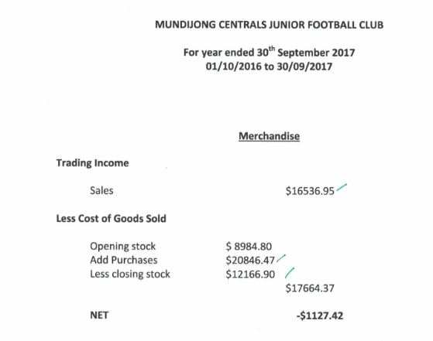
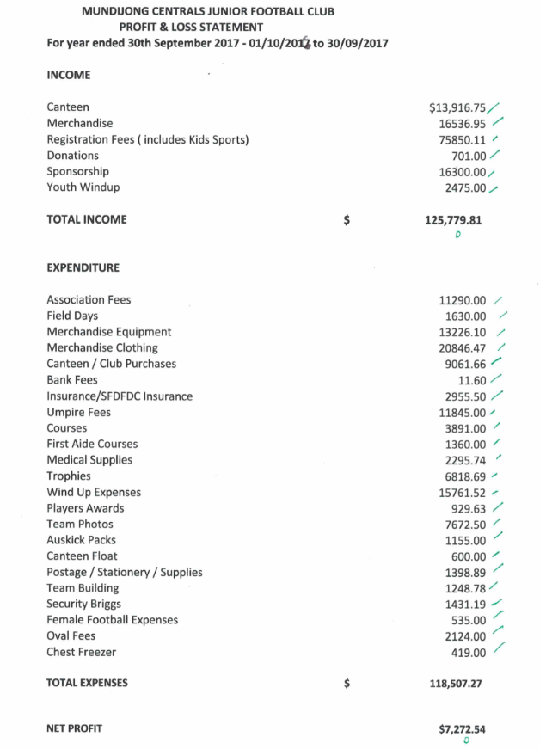

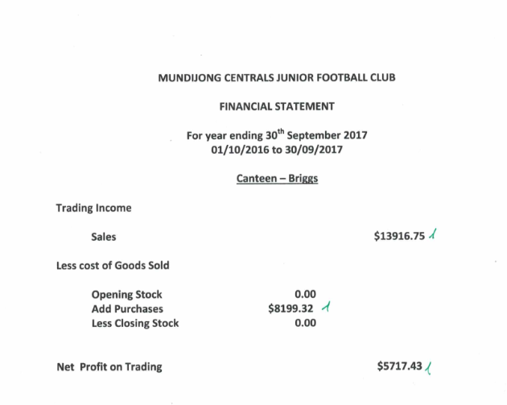
6. | Business Arising from Treasurer’s Report | Treasurer’s report was accepted by Mitch Crosby and Seconded by Michelle Hewitt. CARRIED
 | Election Of Office Bearers | - President  Lindsay Atwell nominated by Linda Branley and seconded by Bill Denholm ACCEPTED  - Vice President  Mitch Crosby nominated by Bill Denholm and seconded by Karina Miller ACCEPTED  - Secretary  Karina Miller nominated by Warren Westphal and seconded by Stacey Siroen ACCEPTED  - Treasurer  Linda Branley nominated by Karina Miller and seconded by Warren Westphal ACCEPTED  - Youth Registrar  Michelle Denholm nominated Warren Westphal and Evelyn Green nominated by Lindsay Atwell. Secret Ballot result was that Evelyn Green appointed to Youth Registrar ACCEPTED  - Jnr Registrar (Yr5-6)  Karina Miller nominated by Sharon King and seconded by Mitch Crosby ACCEPTED  - Jnr Registrar (Yr3-4)  Priscilla Hawthorn nominated by Karina Miller and seconded by Sharon King ACCEPTED  - Girls Registrar (all years)  Michelle Denholm nominated by Warren Westphal and Brenda Carrall nominated by Brenda Carrall. Secret ballot result was that Michelle Denholm appointed to Girls Registrar ACCEPTED  - Auskick Coordinator  Bianca Boalch nominated by Linda Branley and seconded by Damien Hodge ACCEPTED  - Auskick Registrar  To be filled at a general meeting – no nominations  - Coach’s Co-coordinator - Youth/Junior  Bill Denholm nominated by Karina Miller and seconded by Damien Hodge ACCEPTED
7. |  | - Coach’s Co-ordinator - Auskick  To be filled at a general meeting – no nominations  - Merchandise Coordinator  Michelle Hewitt nominated by Mitch Crosby and seconded by Karina MIller ACCEPTED  - Risk Management Coordinator (First Aid)  Warren Westphal nominated by Linda Branley and seconded by Bill Denholm ACCEPTED  - Asset and Equipment Coordinator  Damien Hodge nominated by Warren Westphal and seconded by Karina Miller ACCEPTED  - Fixtures Coordinator  Linda Branley nominated by Mitchell Crosby and seconded by Lindsay Atwell CARRIED  - Event Coordinator  To be filled at a general meeting – no nominations  General Committee Members:  - Stacey Siroen
8. | General Business | - Signatories on all of the Mundijong Centrals JFC and the Junior/Senior Combined Mundijong Canteen operating account to be changed to include Mitch Crosby (Ron Porter to be removed). Karina Miller to be added. Remainder are to remain the same as Executive has not changed.  Signatories for the MCJFC club bank accounts (held at Bendigo Bank) are to be:  Lindsay Atwell – President  Mitch Crosby – Vice President  Karina Miller – Secretary  Linda Branley – Treasurer  - Fee Structure:  Defer to the next General Meeting – need to find out fees etc from South Fremantle DF AGM.  - Thankyou gift vouchers  As with previous years Linda Branley raised a motion for Robbie Gibb to receive a $50 thank you gift voucher for auditing the club financials.  - Youth Football  Mitch Crosby said we need to focus on youth football – we need to be on the front foot to get all those kids back. Need to work hard to keep a team in each year. Be proactive – in Feb for example, reach out to the schools, current players etc. Linda said we need to get reminders out throughout December and January regarding registrations. Warren Westphal commented that the Executive Committee makes all the decisions as to what goes on. He believes there will be at least 7 players lost if something doesn’t change.  Karina suggested we get the message out that we will have teams in each year group. At the first general meeting, the team make up is discussed and then their views/concerns are collated and exec then make their decisions based on those views. Warren said he would like the general committee to have more transparency over the process and an opportunity to contribute.  Mitch suggested we canvas coaches/potential coaches well before registrations so that we have a good picture of who coaching staff are going to be.  Action: Secretary to send out nomination forms to all coaching staff (coaches/assistants) and team managers for expressions of interest in returning for 2018.  Registration reminders will also be sent out weekly coming up to registration time  Exec to make decisions based on consultation with general committee – general committee to discuss team placements and then exec to meet.  Year 8 Gathering in Rockingham  Evelyn Green raised that all year 8s to have a get together and sausage sizzle at Rockingham foreshore on Sunday 3rd December 10.30am to 1.30pm. She said she sent an email out to all Year 8 coaches/teams. Warren said he hadn’t seen it. Linda suggested that the club pay for sausage sizzle and drink for players. Linda asked for a motion to be passed for contribution by club of $200. Sharon King accepted and Karina Miller seconded. Motion passed.  Linda asked for coordinators of event – Evelyn Green, Bill Denholm and Lindsay Atwell said they would be responsible on behalf of the club.  Sundowner for Volunteers  Karina asked for a date to be set for Sundowner in January to recognise volunteers. No meeting between now and January to plan it. Tentative date proposed Friday 19th January 2018 6pm. Linda to check with seniors pre-season and cricket for potential conflict.
9. | Next general meeting date | Tuesday 9th January 2018, 7pm
10. | Meeting closed | 8.48pm

