# Working hard to keep possession

## By Tony Carr

It is hard work for any team to win the ball back. So it is vital for players to work just as hard to keep possession because that is key to scoring goals and winning the game.

To warm up, get your players to work on passing and receiving skills before moving on to dribbling. Dribbling and passing are two ways of keeping possession and this will prepare your players for the session ahead.

Set up an area which is a box inside a box. The inside box should be 10 yards square and the outside box is 20 yards square.

**Note:** Trying to win the ball back individually can be difficult so defending players must benefit from taking a rest in the larger box after they have chased the ball down.

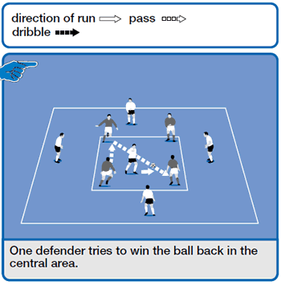

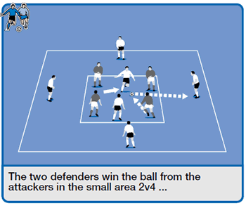

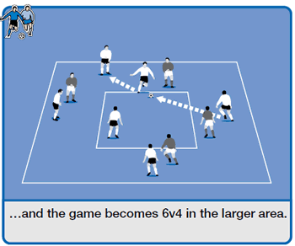

## How to play it

Four attackers play in the 10-yard square box against one defender. The defender tries to win the ball.

If successful, the defender passes the ball out to a team mate. His team then takes the opponent's place in the small box.

The attacker that lost the ball must now defend and try to win the ball back.

## How to develop it

Play four attackers against two defenders in the smaller box. If the two players win the ball, can they pass out to their team mates?

Now the game is 6v4 in the larger box. If the four players win possession, the game restarts in the smaller box with the players rotating roles.