 **CENTRAL DISTRICTS SOFTBALL ASSOCIATION**

**ANNUAL GENERAL MEETING (A.G.M.)**

**MINUTES**

**Monday 8th July 2019 | 7pm**

|  |  |  |  |  |
| --- | --- | --- | --- | --- |
| Chairperson / President: | | Kim Heinrich | | |
| **Management Committee:** | | | | |
| Vice President: | Elaine Lee (Apology) | | Treasurer: | Sharee Forrester |
| Secretary: | Veronica Geesing | | Umpires Director: | Judith Lukas |
| Match Director: | Kay Anagba | | Development Director: | Kym McDonagh (Apology) |
| Records Officer | Pat Roberts (Apology) | | Umpire Allocations Officer: | Kay Anagaba |
| Uniforms Officer | Dee McDonagh (Apology) | | Technology Officer: | Sue Darcy |
| **Clubs Represented By: As per the Attendance sheet Appendix 1.** | | | | |
| Life Members & Special Guests | Present:  Apologies: | | | |
| Falcons: | Present: Chris Taylor, Lisa Elliott, Khala Sainsbury | | | |
| Independent: | Present: Jason Booth | | | |
| Masters: | Present: | | | |
| Phantoms: | Present: Danielle Stansfield, Stacey Rutland, Deb Jones | | | |
| Road Runners: | Present: Claire Barker, Linda Thornton, Anne-Marie Wilkinson | | | |
| Tigers: | Present: Emma Carter, Cindy Enthoven, Hayley McDonagh-New, Erin Bussenschutt  Apologies: Pam Rosser | | | |
| USC: | Present: Jane Wreghitt, Kylie Rigby, Trudy Soraghan  Apologies: | | | |
| Valley View: | Present: Isadora Roberts (Observer), Elizabeth Peacock, Denis Peacock, Catherine Gregory,  Apologies: | | | |

**AGM Items of Business**

|  |  |
| --- | --- |
| **Item** | **Business** |
| 1.0 | Welcome  Meeting opened at 7pm  Kim opened the meeting, thanked everyone for attending and explained the format of the meeting |
| 2.0 | Apologies  As recorded as above |
| 3.0 | Minutes of previous AGM  Moved Sue Darcy  Seconded Judith Lukas  The minutes were accepted as a true and correct record of proceedings |
| 4.0 | Matters arising from the Minutes  None |
| 5.0 | Annual Reports  President – as attached  Vice President – as attached  Secretary – as attached  Treasurer – as attached  Questions and comments for the Treasurer:   * Questions re where the variances were from the budget to come with the profit shown in the P&L   We highlighted the following areas:  Overall Income was up by $4,519 largely due to Club Room Hire being up by $800 and Match Fees being up by $2,450 on budget.  Overall Expenses was up by $772 and largely due to Trophies being up by $743 and Umpiring Payments up by $350 on budget.  Match Director – as attached  Development Director – No Report  Umpires Director – as attached  Umpires Allocations – as attached  Records Officer - No report  Technology Officer – as attached  Uniform Officer   * All uniforms are back except for 2 and they will have to be billed to the members involved. |
| 6.0 | Honorary Life Member Nominations  None were made |
| 7.0 | Special Business  CONSTITUTIONAL AMENDMENTS  Questions were asked and answered about the proposed changes by the floor.  Moved by: Judith Lukas  Seconded by: Sharee Forrester  The Constitutional change as a whole was then put to the floor to vote.  The vote from the floor was Unanimous. |
| 8.0 | Election of Office Bearers:  Catherine Gregory declared all eligible positions open for election and stepped down from the role of President and Chairperson.  Sharee Forrester assumed the role of Chairperson and called for Elections.  **President**  Kim Heinrich was nominated by Jane Wreghitt  Seconded by Sue Darcy  Kim accepted the nomination  No other nominations  **KIM HEINRICH APPOINTED BY MAJORITY**  **Vice President**  Sue Darcy nominated herself  Seconded by Chris Taylor  Sue accepted the nomination  Linda Thornton nominated herself  Seconded by Jane Wreghitt  Linda accepted the nomination  A secret ballot was cast  22 Votes All Up  12 for Linda  10 for Sue  **Secretary**  Sharee Forrester nominated Judith Lukas  Seconded by Catherine Gregory  Judith accepted the nomination  Cindy Enthoven was nominated by Erin Bussenschutt  Cindy declined the nomination  No other nominations  **JUDITH LUKAS APPOINTED BY MAJORITY**  **Umpires Director**  Jason Booth was nominated by Beth Peacock  Seconded by Lisa Elliott  Jason accepted the nomination  Sue Darcy was nominated by Judith Lukas  Seconded by Kay Anagba  Sue accepted the nomination  A secret ballot was cast  23 Votes All Up  13 for Jason  10 for Sue  **Records Director**  Pat Roberts nominated herself by email  Seconded by Sharee Forrester  Pat accepted the nomination  Trudy Soroghan was nominated by Linda Thornton  Seconded by Claire Barker  Trudy accepted the nomination.  A secret ballot was cast  23 Votes All Up  12 for Pat  11 for Trudy |
| 9.0 | General Business   * Date for first 2018/2019 CDSA Delegates Meeting will be set by management committee and communicated to clubs as soon as possible. |
| 10.0 | Change of Signatories  By agreement the following people will be removed as signatories from the CDSA Bank Account:  Catherine Gregory  Veronica Geesing  Elaine Lee  And the following people will be added as signatories on the CDSA Bank Account:  Kim Heinrich, President  Linda Thornton, Vice President  Judith Lukas, Secretary  Sharee Forrester, Treasurer |
|  | Annual General Meeting Closed at 8pm |

I ______________________________________________ hereby declare that the minutes of the Annual General Meeting held on Monday 8th July 2019 are a true and correct record of the events.

Signed: __________________________________________________________________________________________

Date: ___________________________________________

Appendix 1

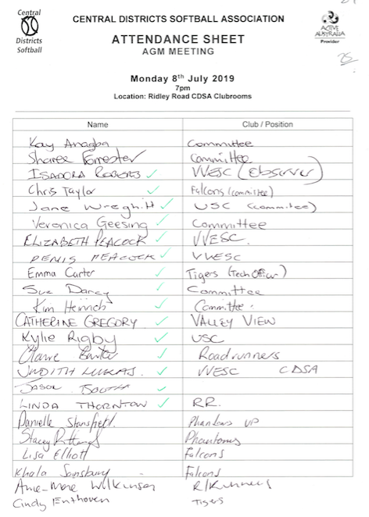

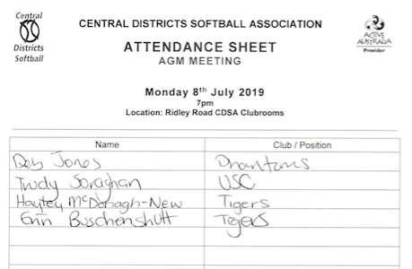

President Report 2018/2019 Season

Hello and welcome to the 2019/2020 CDSA AGM. A few months ago I took over the role of CDSA president, I can tell you that settling into the role is quite different from that as a club president. There is so much to do to ensure that CDSA continues to grow and function as an association should. We are continuing to build and foster our relationship with City of Playford Council to ensure that our facilities are upgraded to be able to accommodate the future growth of CDSA. Although it is baby steps at this time, I believe that in the near future we will have a fantastic facility for us to be able to host Senior & Junior State Championships. We will continue to work collaboratively with our affiliated clubs to ensure that our competition especially our junior competition continues to grow. Our association will not flourish and grow if our clubs do not support CDSA. We as a committee at the end of the day only want what is best for CDSA and it’s members and their affiliated clubs.

For the committee members stepping down I would like to personally thank you for your support. Also for those committee that are continuing on I look forward to your continued support.

Regards

Kim Heinrich

Vice President Report 2018/2019 Season

I would just like to say thank you all for giving me the opportunity to take the role on for

Firstly, I apologise for my absence, but I would like to personally thank all of the CDSA members and especially the current Management Committee for putting various initiatives into play to assist CDSA to be once again a successful Association.

The A Grade Forum showed that there are quite a lot of ideas to keep CDSA at a competitive level. Hopefully this will continue.

As there is an intention to have a Junior Forum, this could also create ideas for the development of Junior players. Because without Juniors CDSA will not keep going.  Perhaps, one of these ideas might include some type of Boys Competition, because once the Boys are of age there is nowhere for them to play, (a lot of people and I believe that some of the Boys (and their Parents) might be worried about playing against Adult Men at NAMSA.

On the note of developing and encouraging Juniors, the current committee is also working on organising a CDSA Junior academy, which is also very exciting.

In reference to the AGM, if you are thinking about applying for one of the vacant positions, please put up your hand or nominate yourself, because with new people, comes new ideas.

In closing, I would once again like to thank all of the current Management Committee and the outgoing Committee Members for their time and dedication to CDSA.

Good luck for the future.

Elaine Lee

Secretary Report 2018/2019 Season

I would just like to say thank you all for giving me the opportunity to take the role on for CDSA secretary.

This was something I had not thought of doing until last minute of the AGM last year and I thought why not give it a go.

In the beginning I was mentored by Sharon Mayne which was great to have someone to ask the question of what was expected of me.

Also attending a council organised training night to help with knowing how committees are run, I then attended a liquor licence night to achieve my RSA with the new changes to help if we were to take on the running of the clubroom bar from this I gained more information in relation to what was expected of us as an association.

As most people would be aware 6 months in I was diagnosed with an Invasive Malignant Melanoma and I was advise by my doctors to remove stress from my life so I resigned from the role but was convinced by other committee members to just step down until I felt comfortable enough to return to the role, so this is where I would like to take this opportunity to thank Sharee for assisting me and taking on the extra commitment whilst doing her own role, I truly appreciate your help.

I also appreciate Jude and Kay for all their help as when I stepped back in I was a little lost as to where we were up to and they both helped me get back up to speed especially at the pointy end of the season.

Also having other committee members to assist me with many tasks made the world of difference and to be honest it was a great learning experience and made me realise the depth of what our committees have to endure thought-out the season and even in the off season.

I have a newfound appreciation for anyone who takes any one of these roles on as it is not an easy task at all making decisions for many people with different view’s.

As I have come to the end of my term I am happy to step down and not re-stand for this position but Thank You all once again for this opportunity and I wish the new committee best of luck in moving forward for the season ahead.

Kind Regards

Veronica Geesing

Treasurer Report 2018/2019 Season

Current CDSA Chq AC Balance as at 6/7/19 is $4,121.65

Term Deposit AC Balance as at 6/7/19 is $13,137.91

This year our accounts have been audited again by Sharon Perkins and her Audit report is attached to your Balance Sheet & Profit and Loss Reports. We see that we are ending on a profit of $4,247.11 as per the report. Our income was $42,959.31 and our expenses were $37,712.20 resulting in the profit this season. The incoming committee will need to continue to monitor match fees and increase them slightly each year to ensure we remain in this position going forward.

It’s always hard when setting the budget and fees prior to team nominations but we do have to ensure we continue to end each year with a small profit to start the next season off. The only way to do this is to ensure fees rise in small amounts yearly with cost of living to ensure we are factoring in our outside expenses that will increase generally each year.

The incoming committee will endeavour to have our fees set for the new season by the end of August to publish to clubs. We do have to wait to see what Softball SA advise at the annual briefing day before we can finalise our fees and budget.

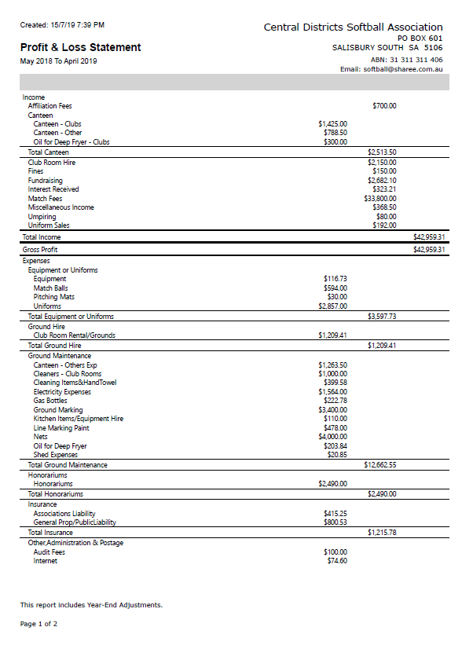

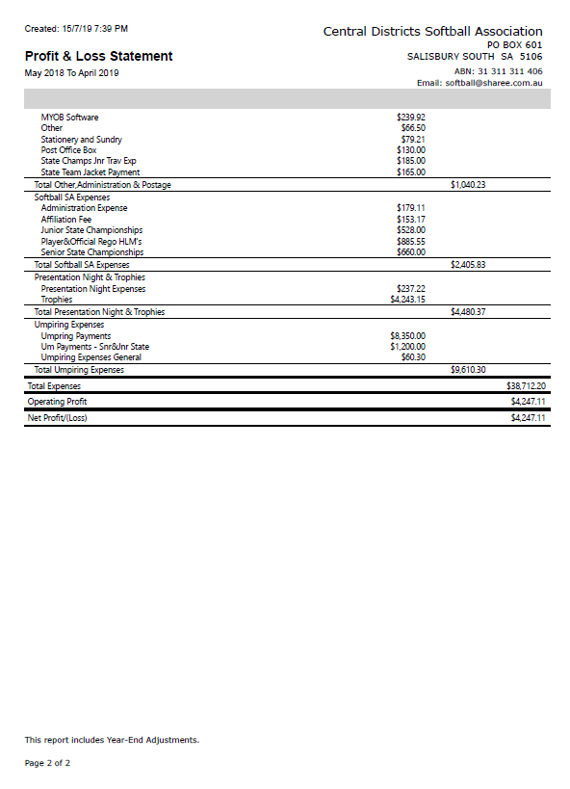

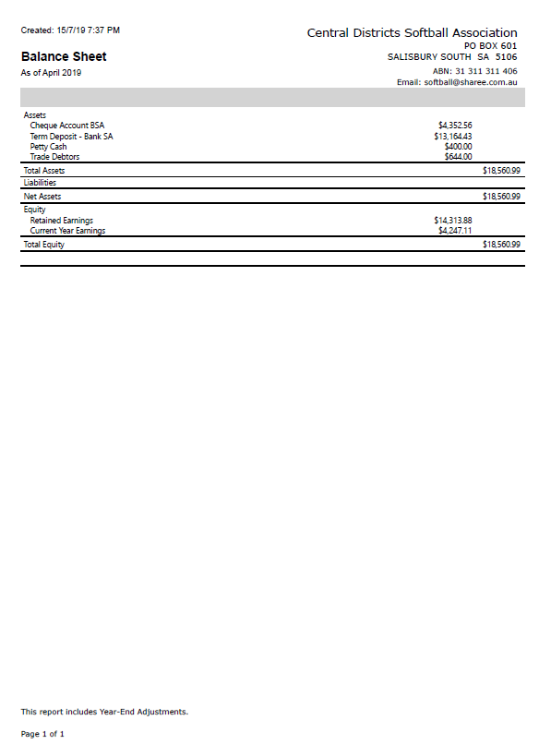

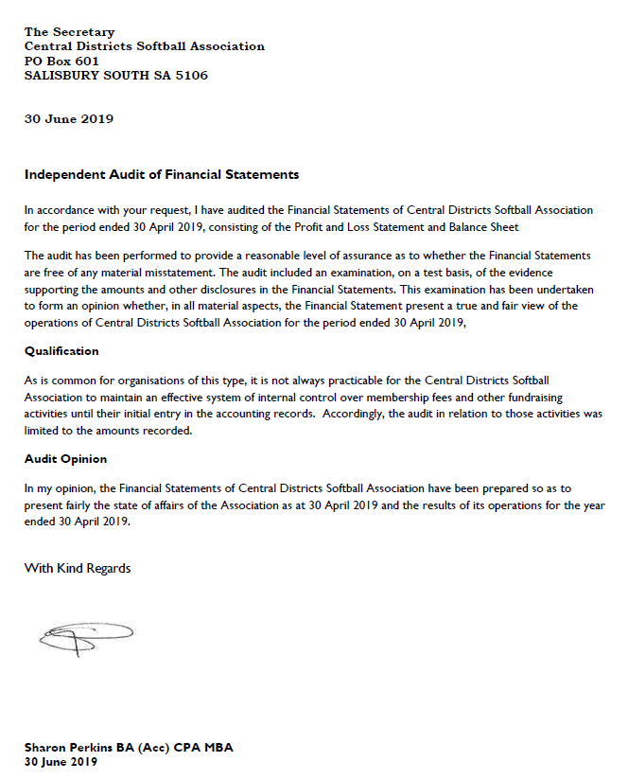

Match Director Report 2018/2019 Season

**Teams** - The season got underway with 4 senior divisions, with 3 teams in A grade, 2 in B grade, 8 in C grade and 4 in D grade.

Juniors stayed strong in numbers with 7 T-ball teams, 7 in U13 and 5 in U16. This season also saw a return of the boys’ competition. Many thanks to Kym McDonagh for being the driving force behind this. It was a great encouragement to the growth of the association and providing pathways into the senior competitions.

**Draw** - This season saw us playing 17 weeks minor rounds and 3 weeks of finals. The weather was mostly kind, with only one week of juniors affected by heat, and 2 weeks where lightening affected play.

Due to low numbers in the top 2 grades, we unfortunately had to run a combined A/B grade draw for the minor rounds. This made life difficult for the 2 B grade teams having to face A grade for most of the season, but a guaranteed spot in the Grand Final was hopefully a small silver lining. It was pleasing to see the return of A grade this year. Thanks to the teams for showing flexibility to manage the byes and double-headers to maximise games for you all. Whilst this is not the ideal situation, it will hopefully be the steppingstone we need to rebuild our elite competition at CDSA.

In order to create a draw with as many games as possible for juniors we had 3 rounds of double headers for U16. This utilised bye weeks necessary for U13 to make an even draw. We acknowledge this is not ideal either for the U13s who just want to get out and play every week, but timing made it difficult to accommodate double headers for this grade as well.

**Grounds** – The clubrooms are now exclusively leased to CDSA, and the full playing field is available to CDSA for Hire. Please note, CDSA only hires the grounds during the summer season for game days. Any team/club practices outside of these times must be arranged with Council. Please also be aware, when the hall is being hired by a private group, the clubrooms are not accessible to any other members. If using the grounds, it is your team’s responsibility to arrange access to the outside toilets if required.

Council have erected the new storage shed and one permanent backdrop so far, as planned in the Sportsfields restructure plan. Council have also committed to a second permanent backdrop, and (if funding is secured) a renovation of the clubrooms.

**Lines** – Kym took a well earned rest from line marking this year, so I decided to take on the task. I had some teething problems learning how to use (and troubleshoot) the machine) but I think we got there in the end. I would like to thank Kym for his advice and support.

**Nets and bases** – set up was attended by Jason Booth and helpers.

**Equipment** – No significant equipment purchases this season. We did lose some shades due to high winds, and we are looking into options to get them replaced.

Now that we have the new shed we need to arrange a working bee to transfer the trailer, equipment and shelving across. I will be arranging that soon, so please look for a Facebook post regarding this.

**Canteen** - The running of the canteens was managed each week by clubs and ran smoothly. Thanks to every club for your efforts I am sure you have all put the funds raised to good use.

Regards

Kay Anagba

Umpire’s Director Report 2018/2019 Season

I outlined at the beginning of last season 5 principle areas of focus in the role of Umpires Director:

1. Grow Umpire Numbers

I’m very pleased at the number of green shirts throughout the season, either starting or continuing in the green shirt program. Of about 15 green shirts, 5 umpires progressed to obtain their Blue Shirt Level 1 Accreditation.

I would like to thank all those Blue Shirt umpires who assisted in the mentoring of the umpires, and for the first season, our mentors received a base payment for their time as mentors. We now have 5 newly minted Blue shirt umpires who themselves can help with those in the green shirt program.

It’s not easy to always find opportunity to support fellow umpires when we are busy with other roles we all undertake.

An environment that is supportive and encouraging of new umpires is something we all must continue to strive for.

The Zero Tolerance Policy is just one way we can be very clear about where the line in the sand is, where behaviour is concerned.

1. Improve training and development opportunities

The Green shirt training session was very very well attended.

But the preseason information session, and Ask a Blue were poorly supported, by all but a few umpires.

Nonetheless those who did attend all got something out of the opportunity.

I also attended 3 nights of Green Shirt training at WB, to ensure that our introductory umpire training was in-line with theirs, which equally complies with the nationally accredited program.

1. Rule Understanding

The rules of the game has to be a focus for everyone playing the game. This is not just something umpires alone should have to concern themselves with. With the exception of the month of April, the Basic Exam is accessible year ‘round. There is no better way to learn something about the rules than to have a go at answering the questions by referring to the rule book. Especially this would be highly worthwhile for coaches.

I encourage every Blue Shirt to register for and complete the Open exam each year to keep your knowledge up to date.

We do have to acknowledge that our young umpires cannot possibly know every rule, and every penalty, and temper our expectations during the game accordingly. But equally we should be always seeking the answer to what we don’t know, so we can continue to improve as umpires.

1. Current Umpiring Resources

The CDSA website has been updated to a degree over the last season, however the main place for information about umpiring should be the Softball Australia website which has all the latest information:  
<http://www.softball.org.au/umpiring/>

The CDSA website should simply be a link to the SAL resources, rather than be a copy of SAL’s website that constantly requires updating.

1. SSAU Resources

CDSA is one of 2 level 4 Associations in SA, as such we are billed $400 by SSAU. This enables us to ask for and receive umpiring support, as an association we should be trying to get the maximum for our money by way of training and development opportunities provided by SSAU.

Locking in Ask a Blue nights in early in the season is wise, otherwise the resources provided by SSAU will get rapidly booked up, and we miss out.

Judith Lukas

Umpires Director

Umpire Allocation Officer Report 2018/2019 Season

Thankyou to all the umpires for another tireless year of service. Without you, the games cannot go ahead.

Thankyou to Judith for your advice and support over the season.

Congratulations to all the green shirts who put in a fantastic season, and especially to those who earned their blue shirts.

I would just like to highlight again that communication is key in this role to ensure availability and ability are rostered correctly. Thankyou to the umpires and the clubs for their partnership in this.

Regards

Kay Anagba

Technology Officer Report 2018/2019 Season

I would firstly like to thank all of the current committee for their hard work and many hours given to moving CDSA forward in challenging times for softball. I’ve enjoyed my time as technology officer and wish whomever takes over the role Goodluck in getting CDSA’s online presence out to as many new people as possible.

I would also like to wish the incoming committee every success with the coming season and would hope they push forward with several ideas that the current committee have got planned:

Junior Forum

Boys Competition

CDSA Junior Academy

Regards

Sue Darcy