# 3v3 to coach support play

## By David Clarke

In this 3v3 game, you can get players to learn about providing support and being in the right position to cover when the ball is lost.

**Support play**

In a 3v3 situation, one of the most important jobs is to support the player on the ball. There should be forward support to provide an attacking outlet and rear support to give a defensive outlet.

A pass back to the player covering the defensive area of the team can be an attacking move because it can open up space on the other side of the pitch.

## Support players need to think about:

* The angle of support
* The distance of support

## Getting this right means the supporting player:

* Has a full range of forward vision.
* Can receive the ball comfortably.
* Has space to pass the ball to a team mate.
* Can move forward into space in front of them.

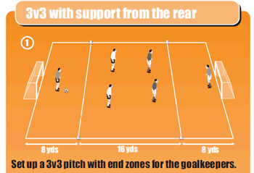

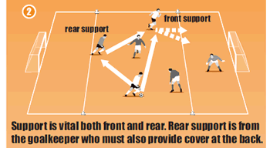

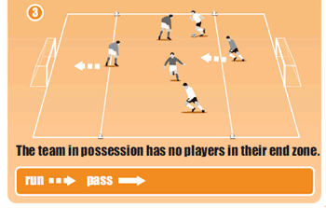

**How to set it up**

In this game, rear support comes from the goalkeeper who must move out of his goal when the team is attacking. When the team is in possession of the ball none of the three players are allowed in their defensive end zone.

Goalkeepers have to support from the rear and be ready to get back if the team lose the ball. So the attacking team always has an empty end zone so the defending team can quickly attack if it wins the ball.

The attacking team therefore has a 3v2 advantage in the middle of the pitch. The defending team can have players in any zone, but when it wins the ball and attacks, all players including the goalkeeper must move out of the defensive end zone.