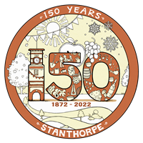

**WHAT’S ON?**

**1. Italian Artists’ Exhibition Opening featuring local and**

**international artists and traditional handicrafts on Saturday**

**4th June at 5.00 p.m. in ‘Sunset Room’ with complimentary**

**glass of wine and canapés. (Exhibition runs from Monday 30th May to**

**Friday 10th June, daily from 10.00 a.m. to 3.00 p.m. – Free Admission)**

**2. Dinner Dance (Italian Buffet), featuring entertainment by**

**‘Two Wheel Drive’, Italian language students and guest**

**speakers in ‘Tuscany Lounge’ on Saturday 4th June at**

**6.00 p.m. (Places limited so bookings essential. Cost $70 p.p.**

**Pay at Vince Catanzaro’s Office - 46813004; tables for 10 available)**

**3. Italy v Australia Football Match on Sunday 5th June, at the**

**International Club, featuring Ladies’ and Men’s teams.**

**(National anthems will be played prior to the first match. Ladies - 9.30 a.m.**

**Men – 11.00 a.m. Presentation of Trophies - 1.00 p.m. Canteen run by**

**Inter Football Club).**

**4. Italian Cars Display on Sunday 5th June within the grounds of**

**International Club. (Free admission)**



**Italian Community Celebrates**

**Venue: Stanthorpe International Club**

**Dates: Sat. 4th June & Sun. 5th June 2022**



