# Winning the 1v1s

## By David Clarke

Watch any level of football and you will notice players who can win 1v1s find themselves in good positions to create problems for the opposition. This gives a big advantage to your team and means that more goalscoring chances will be created.

You could say: Win the 1v1s and you're on your way to winning the game.

If your player has the ball or is trying to win it in a 1v1, he needs to analyse the situation and opponent. It is vital to make quick decisions and use movement, skill and a change of pace to win the 1v1s.

I use this simple-to-set-up game that asks some difficult questions of my players and gets them thinking of ways to succeed.

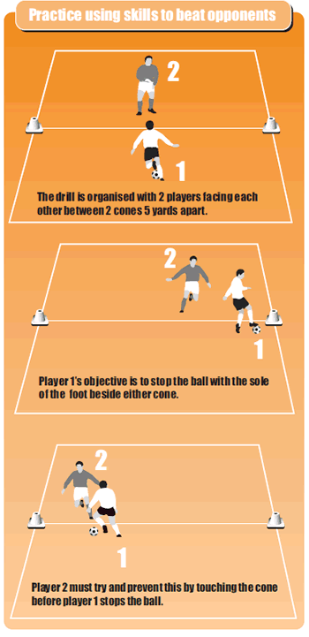

## How to play it

* Split your players into pairs.
* Players cannot tackle each other.
* Use two cones five yards apart – gradually make the distance wider to make it harder.
* Player 1 must beat player 2 by stopping the ball at the cone before player 2 can touch the cone.

## The defender must analyse:

* Which way the player will move?
* Should he take a chance and gamble on which way the player will move?
* How is the attacker's body shaping up to move?

## The attacker must analyse:

* Whether he should turn?
* Which turning technique to use?
* If choosing to sprint, should he slow down or run at the same pace?