# Get players to take turns

## By David Clarke

How often do you see players run in straight lines? Very rarely, there's always an opponent in the way. This means ball manipulation is vital for players moving with the ball. If they cannot turn, they will very likely lose the ball.

Think about the obstacles they have to get around or movements to make it easier to pass the ball to a team mate. Turns are vital to a team's ability during a match to get into goalscoring positions.

It is easy to set up simple circuits for your players to practise turning and to become comfortable turning with the ball under control. I use these two sessions with my players to coach turning with the ball.

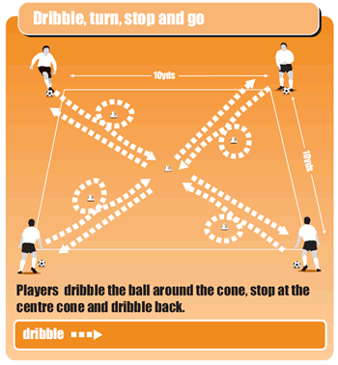

## Single turns

* Put a player, or players, on each corner of a 10-yard square.
* Put a cone two yards in from each corner and a cone in the middle.
* Players dribble the ball around the first cone, then at the centre cone they stop the ball, turn and dribble back.
* The players all go at the same time on your call of "go".

It is important you let players take their time when they start doing this. At first they just need to practise simply getting the ball around the cone. Then try to get them to use both the inside and outside of their feet.

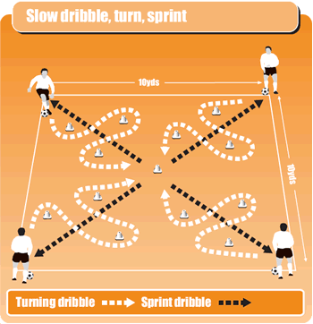

## How to advance the session

* Using the 10-yard square, you need players on each corner.
* Place 12 cones in four groups of three (see picture above) and a cone in the centre.
* Players start by dribbling slowly through the three cones.
* Then stop the ball at the centre cone, turn and sprint back, keeping the ball under control.
* Players all begin at the same time on your call of "go".
* Initially, control is more important than speed.
* Get your players to speed up once they have done the exercise a couple of times.
* Concentrate on the ability of your players to control the ball using the inside and outside of their feet.