# Play through the middle

## By David Clarke

It's understandable for some players to want to bypass the crowded, pressurised environment that is the centre of the pitch.

But hitting long balls forward or always targeting play to the wings makes teams predictable and boring.

This is a practice that will boost confidence and remind players that getting the ball into midfield and using it smartly can often be the best way to attack.

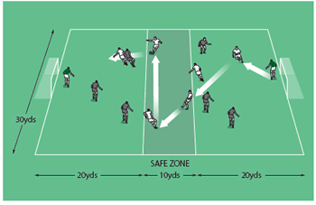

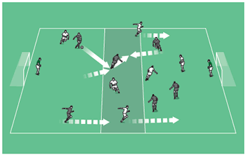

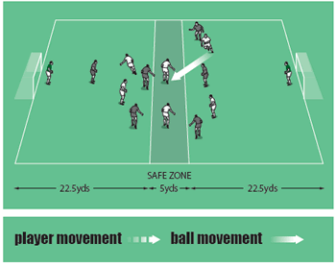

## How to play it

* You need balls, bibs, cones and goals.
* Mark out a 50x30 yards area split into three zones.
* There are two teams of six, each also has a keeper.
* The team in possession is allowed up to 20 seconds unchallenged in the central (safe) zone. It can stay there for that time or break out, but if still in the zone when time elapses, the opposition can go in and try to win the ball.
* If the team in possession loses the ball in any area of the pitch, its players must vacate the central zone.
* The size of the central zone is key to the challenge and skill of the game as players will discover so, after six minutes, increase or decrease its size to see what effect it has on the game.

## Developing the session

* You can advance the session by allowing one opposition player to go in the central zone. This puts more pressure on midfielders.

## Technique and tactics

* The safe zone encourages play to go through midfield, with players getting used to receiving on the half-turn or practising controlling technique.
* While doing this without the fear of being tackled, the option to survey options and pass the ball on is encouraged. However, the margin for error increases when the central zone is shortened.