The best way to practise the long pass

By Tony Carr

Move the ball before you kick it
In a soccer match, the ball is moving when you receive it so when you practise your long kicking, make sure you move the ball to make your kicking practise more match-like.
This is the technique you need to teach your players for long kicking:
- Push the ball to the side, slightly in front of the body.
- Put the non-kicking foot next to the ball
- Kick through the centre of the ball.

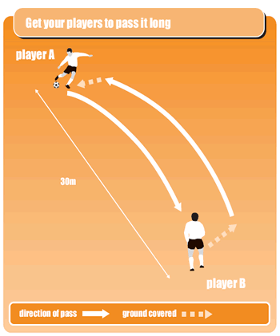

Key coaching tip
To kick it long along the floor, you don’t need to follow through after striking the ball. Instead, strike it sharply and stop your follow-through just after hitting it.

