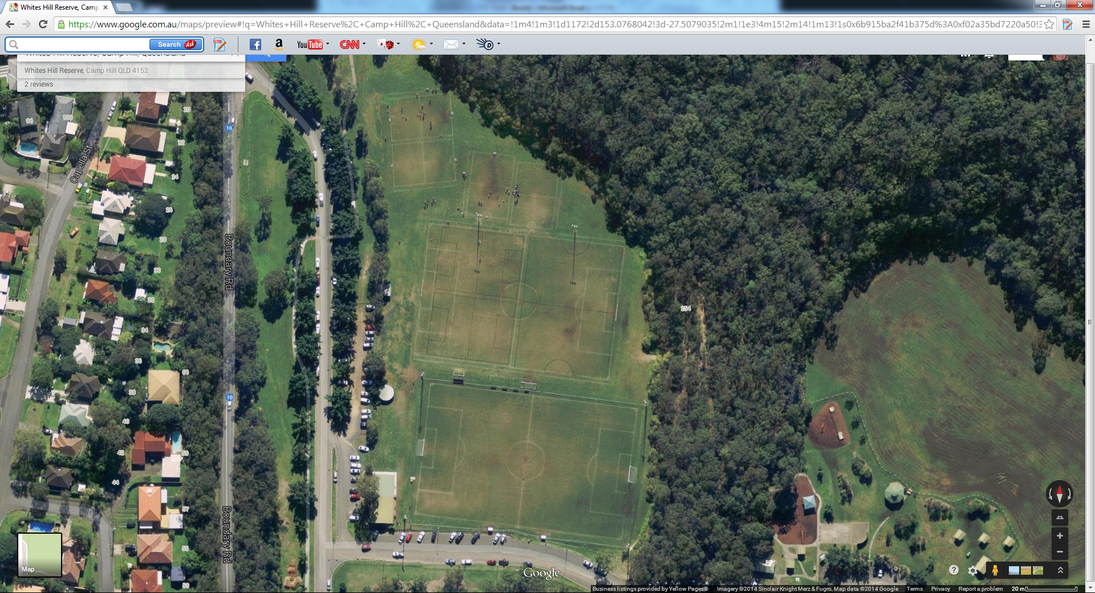

Field2A u8/u9

Field 2B u8/u9

Field 3 U8/U9

Field 2CD u10/u11

Field 2 full size

Field 1A u10/u11

Field 1 full size

Field 6 u6/u7

Field 5 u6/u7