# Vision attack

## By David Clarke

This is a brilliant transitional game.

I expect a lot from my players so, true to form, here's a session that means they can be defending one second and attacking the next!

This practice helps to coach players in decision making, knowing where the goal is, and in basic skills such as shooting, shielding and passing.

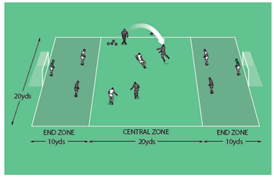

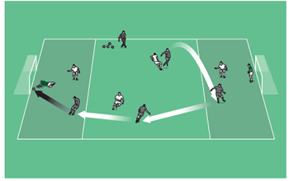

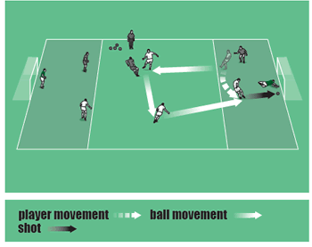

## How to play it

* Set up as shown in the pictures above. You need balls, bibs, cones and goals.
* The game is 4v4 plus two neutral goalkeepers.
* Players are fixed in their zones - 2v2 in the central zone with a player from each team in the end zones.
* Attackers can score in either goal but the shot must be from within the end zone.
* If a defender wins the ball in the end zone, he becomes an attacker, though the ball must go back into the central zone before a shot can be taken.
* After each goal, or should the ball go out of play, the game is restarted by you throwing a ball high into the air in the central zone.
* Rotate players frequently and play for 15 minutes.

## Technique and tactics

* The 2v2 in the centre is the engine room of the game. These players need to be combative, and must link up and communicate well. Play is in both directions, so midfielders must look both ways, receive the ball on the half-turn where necessary and always keep their heads up.
* Attackers and defenders must be ready to alter their mentality quickly - one second defending, the next attacking, they have to be ready to perform very different tasks.
* The game also takes patience and craft. Winning the ball in the final third doesn't present the attacker with an instant opportunity to score, so you're looking for him to problem solve in an attempt to fashion a clear chance.