**50 Ways to Score Goals**

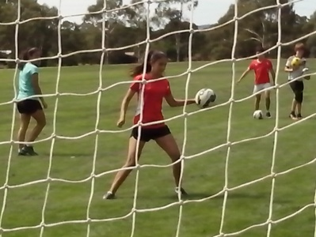

***Any kid who can learn how to shoot can discover how to score goals.***

**THE WORLD OF FREESTYLE SOCCER**

***Imagine a world where kids improve all the time and they know it.***

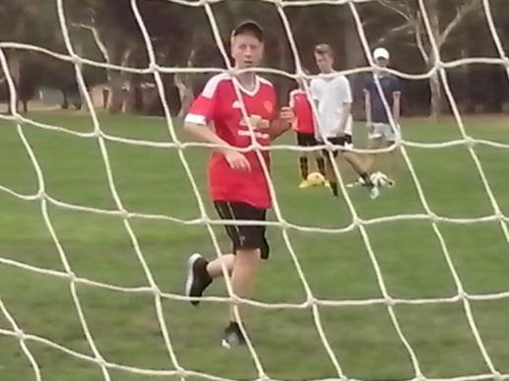

All kids are different. In the world of Freestyle Soccer, the vast majority of kids have the talent to reach the top and the only person who can stop them is themselves. Every Freestyle kid can learn how to shoot and discover how to score because they believe they can.

Freestyle Soccer kids open their eyes, ears, mouths and minds. They look and learn, listen to new ideas, question old ideas and have the confidence to think for themselves. Freestyle kids are open to change.

In the world of Freestyle Soccer, kids practise shooting for 2 hours at a time using up to 100 balls so that control becomes second nature. They know how to score because they learn how to miss. They make as many mistakes as they like, and learn from them, because they’re not scared of failure. Freestyle strikers specialise in all types of goals.

Any Soccer kid can improve in 5 minutes just by getting 200 touches of the ball to achieve an intuitive level of talent. Freestyle Soccer kids develop respect, responsibility, resourcefulness and resilience. Once they discover that they can improve, they will keep on improving.

**TALENT**

***It takes skill to learn how to shoot. It takes talent to discover how to score goals. Skill comes from the coach. Talent comes from the kids.***

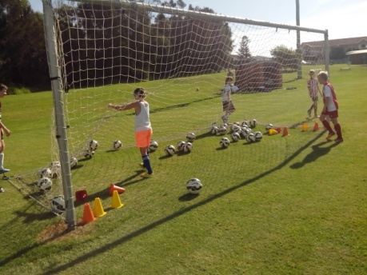

All kids have talent but talent is not always enough. It’s what they do with it that counts. At grading, we pick the kids who impress with their skill and fitness. It’s only later that we realise that the skilful kids may be too selfish to pass the ball or the athletes may be too lazy to run for it. A lot of Soccer talent is hidden, waiting to be discovered.

Australia has the talent to be a Top 20 Football Nation but we lack the confidence to believe it so we teach every kid the same generic skills. If we can search Europe for the best ways to teach Australian Soccer kids, we can search Australia for the best ways to learn about them.

The clues to the future of Australian Soccer are standing right in front of us at every oval. We just need to learn where to look, what to look at and what to look for. We look at the kids who train when they’re told to train and we look for perfect technique so that we can correct their mistakes. We need to look at the Freestyle kids who train when they’re not told to train so that we can discover what motivates them.

**SHOOTING TO THE TOP**

***The quality of a player is not measured by what we teach them but by what they learn. They’re not always the same thing.***

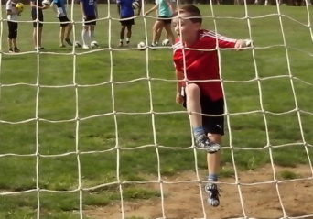

Original talent is not always evident, especially when most kids are only doing what they’re told to do. Talent becomes clearer when the pressure is increased. On a wet day, the talented striker looks more sure footed while the rest of the kids are slipping around the ground.

All kids have external qualities that can be coached (fitness, skill) and internal qualities that can’t be coached (intellect, initiative). A Talent Tenplate is a list of ten indicators that help to identify natural quality.

A Learning Program is designed to observe individual players and identify their character, intelligence, mindset, mobility, self control, understanding, team spirit, drive, creativity and growth.

All players have natural talent but they don’t all make the best of what they have. The Tenplate shows us what qualities to look at and what abilities to look for.

**CHARACTER**

***Character is what kids develop for themselves.***

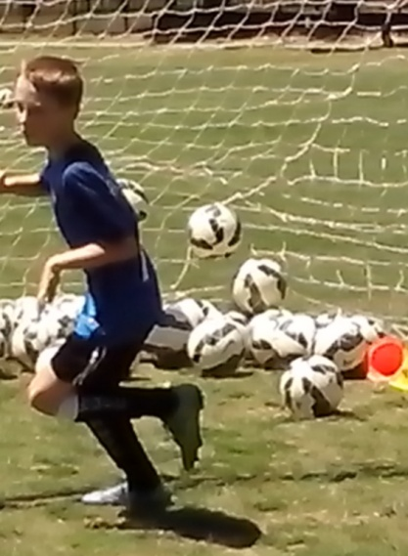

Kids who play individual sport can have a volatile character to drive them without affecting anyone else. Kids who play team sport need a stable character so they can think about other people and support their team mates. Team players have a responsibility to the rest of the team.

Characteristics become noticeable in all situations both on and off the field. Some kids will always help with the team gear while other kids walk off without thinking. Freestyle kids can think without being told. We should never judge kids too early when their parents make all the decisions for them. Things change when kids reach their early teens and they start to think for themselves. We should never ignore the late developers. We overlook too many talented kids by grading too early.

**INTELLIGENCE**

***Motional intelligence means knowing where to move and understanding why.***

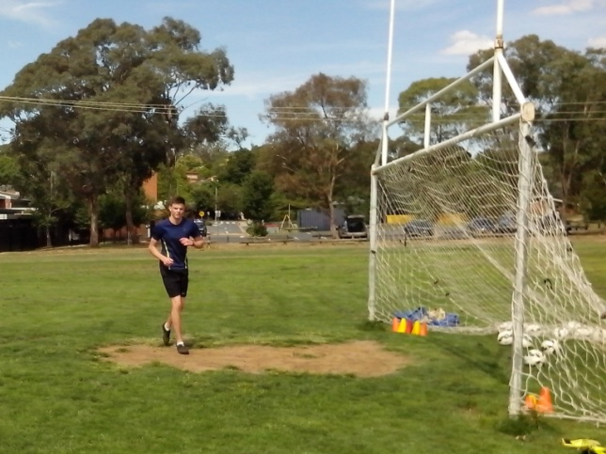

The average Soccer kid spends 5% of their game on the ball and the other 95% off the ball. We teach them all the Soccer skills they need for 5% of the game and overlook the natural skills that they need for the rest of the game. We have no idea what kids are thinking about.

A skilful kid can dominate a game with the ball. A talented kid can dominate the game without the ball. Freestyle kids don’t need a ball to look, listen, run and call. They use their intelligence to save their legs.

Some strikers just ballwatch and keep getting caught offside because all they think about is ‘ball and goal’. Freestyle strikers think about ‘space and possession’. They make the most of their intelligence and are constantly aware of what both teams are doing. A Freestyle striker can disrupt the opposition and draw defenders out of their comfort zone with just a run and a call. Soccer coaching is what we can teach kids. Freestyle Soccer is what we can learn from them.

**MINDSET**

***A lot of Soccer kids don’t know what they’re playing at. Freestyle kids know because they explore everything about their own game.***

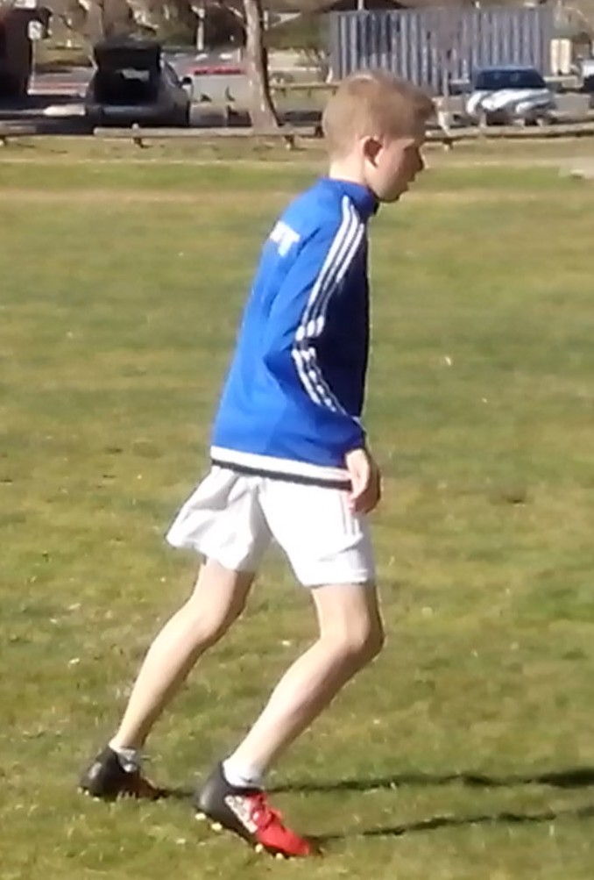

Kids can achieve anything they want if they set their mind to it. When on form, a striker will lock onto the target and take the shot. When in doubt, a striker will hesitate and miss that chance. Strikers need to coordinate mind, body and ball to score goals. They need a clear mind so they can make instant decisions without having to stop and rethink.

Shooting practice is what we put into a game. Goal scoring is what we get out of it. Some strikers take their eyes off the ball when they shoot to check the result. Freestyle strikers stay focused on the ball and the result takes care of itself. They get out of it what they put into it.

**MOBILITY**

***Freestyle strikers use mobility in attack to disrupt stability in defence.***

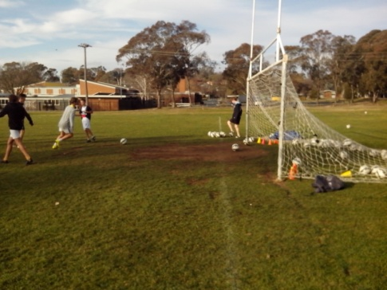

A lot of attackers make life too easy for opposing defenders. They run up the field in straight lines while fullbacks stand and wait for them.

On corners, and free kicks, some forwards stand next to the defenders and become an easy mark. Some of them even follow their markers if they change their position. Freestyle strikers never make it easy for their opponents. They either lead them astray or they get away from them and find space. When the midfielder has the ball, some forwards wait for the pass instead of making a run and call. Freestyle strikers use their intelligence and mobility to maximise their opportunities.

Freestyle players look, think and move 360 degrees. They avoid using the straight through ball that goes straight to the opposition. They can disrupt any stable defence with a square run or a diagonal pass. Lazy defenders will want to stay in their comfort zone and wait to see what happens. Freestyle strikers make their life as difficult as they can.

**CONTROL**

***Any kid can learn to control the ball. Freestyle kids learn to control their power, temperament, options and the game.***

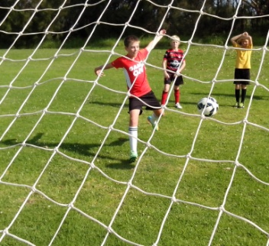

What makes Freestyle kids stand out is a willingness to look at other players, listen to new ideas, ask questions and think for themselves.

Kids who have a strong character are always aware of consequences and easily avoid any situations where less disciplined kids just want to retaliate. Any player, who fouls an opponent, is just admitting that they don’t have the skill to beat them. Force is the default setting for kids who lack confidence in their own ability.

There are plenty of scoring opportunities in a game and plenty of shots but very few are on target because kids tense up, they rush their move and try too hard to kick the ball too hard. Freestyle strikers use target cones to measure their effective range so they automatically know how to control their power and weight the shot. Kids who move can make an opponent move. Kids who stand still will create nothing.

**UNDERSTANDING**

***Certain kids develop eye/foot coordination in minutes because they understand footwork and vision. Uncertain kids just don’t get it.***

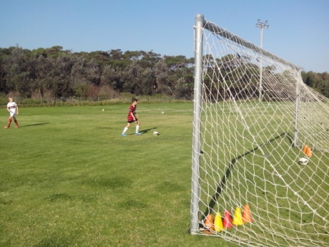

Some kids never learn because they never get the freedom to think for themselves, make their own decisions, make mistakes, understand the causes, learn from them and move on. They just do what they’re told.

Some coaches find it impossible to watch kids make mistakes without stopping to correct their technique. They’re not helping them. They’re just limiting their responsibility, resourcefulness and resilience.

The first thing we learn about Freestyle kids is that they don’t fall apart when adults aren’t there to tell them what to do. They don’t stand in a line waiting to kick a ball every two minutes. They play and learn. That’s their job. Freestyle kids understand more than we think and they think more than we understand. They are the innovation generation. Give them a ball and they’ll develop a skill. Give them a net, and 50 balls, and they’ll develop their own drills. Give them a chance and they’ll show how innovative and talented they really are.

**TEAMWORK**

***Soccer kids learn the importance of depending on each other.***

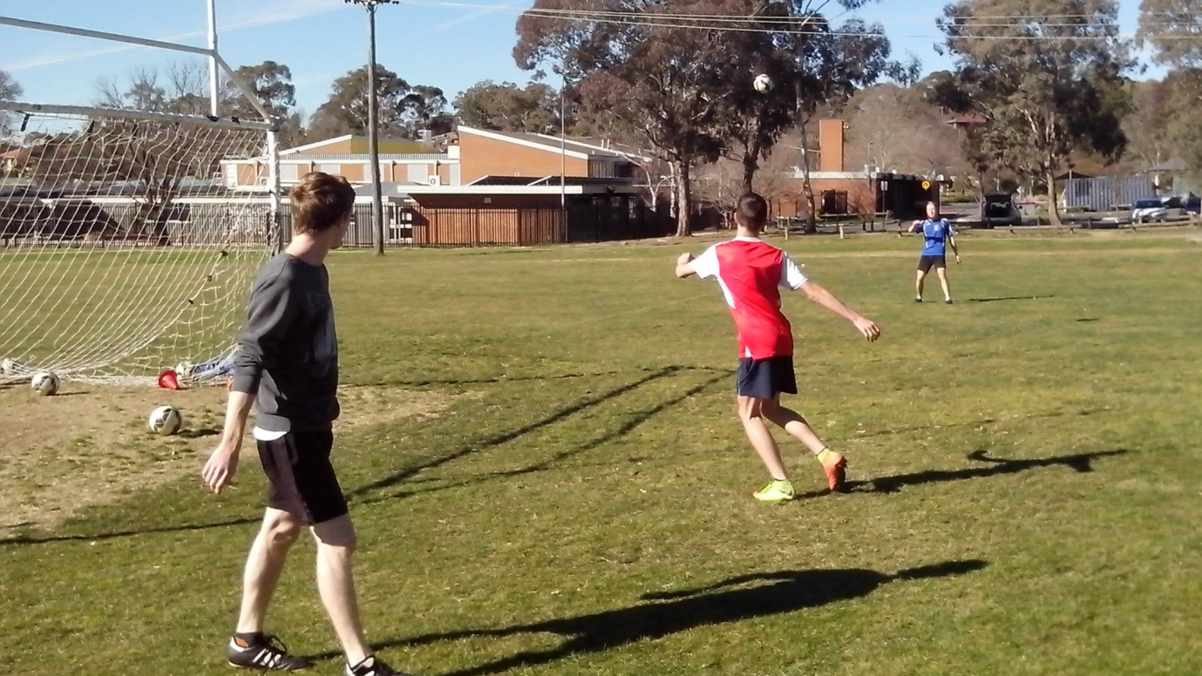

Some kids are more suited to individual sport because they think more about themselves. Soccer kids learn to think about others and discover the importance of team spirit. A team is something that kids want to belong to, like a gang, because it gives them a sense of purpose.

Strikers need to look for support runs, listen for the calls and judge when to play them. Kids treat kids the same way they want to be treated. Kids who ignore a quality call will get ignored when they want the ball. That’s human nature. Soccer kids play team sport so they can learn to trust each other. When a striker misses a shot, it’s essential that they get good support from team mates not criticism.

The most important part of the pass is the receiver. Kids who don’t understand that will focus on accuracy and hit the ball too hard or too soft. An individual player needs to help others and needs other players to help them. An individual striker doesn’t need to play the call but they need to listen for it so they always have an option to fall back on.

**DRIVE**

***A lot of kids are driven by adults. Freestyle kids are self drive.***

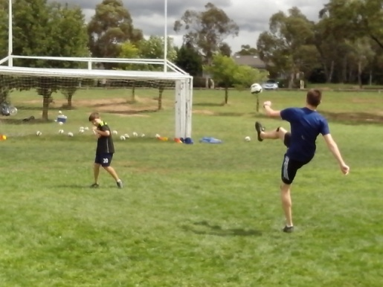

When a healthy wealthy sporting nation, with a high performance coaching system, is ranked number 50 in the Football World, somebody should be jumping up and down and saying or doing something about it. Above all else, sport should be a challenge.

Australia has the talent and resources to be a Top 20 Football Nation but we lack the passion to strive further or drive harder. Nobody in Australian Soccer has the confidence to question the old ideas or challenge the new ideas. We all stand around waiting to be told what to copy next. We need to activate the untapped and hidden talent.

Drive can emerge at any stage and age. We give Soccer kids labels when they turn 11 and expect them to stay at that same level for the next few years but some kids don’t develop their drive until their mid teens when they finally have the freedom to think for themselves and make their own decisions. We give up too early on too many kids.

**CREATIVITY**

***The innovation of the new generation can only be delayed by the hesitation of the old generation.***

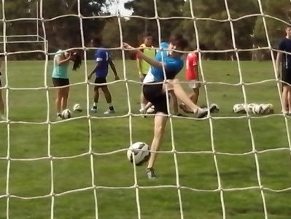

Most Soccer kids learn one way to shoot based on best practice. Freestyle kids learn different ways to shoot based on better practice and hundreds of shots at goal. Talented kids see what we can’t see.

No kid wants to be one dimensional or monocoached. They all have different talent and different character. Any kid has the talent to think for themselves, create their own moves and improvise the old moves.

No kid wants to copy everyone else and become predictable. Each kid is an individual. Freestyle kids juggle a ball so that they can learn to control it at any height, one touch or two touch. There isn’t a perfect way to play Soccer. There are as many ways as there are talented kids.

The only problem with a perfect system is when we believe that it’s perfect and we stop looking for ways to improve. The key to Freestyle Soccer is a willingness to improve no matter how good we might be.

**GROWTH**

***Soccer kids need the freedom to stand on their own two feet.***

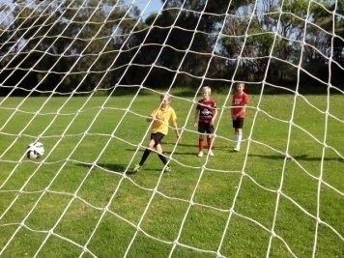

If we keep doing the same, we will always stay the same and get the same results. Kids need to grow and they need to see that they grow. If strikers start with close up shots, they can gradually increase their range, speed, power and degree of difficulty. If they begin with conventional shots they soon develop the confidence to improvise.

When kids juggle a ball, their juggling figures always improve. As they improve, the kids become more confident. Strikers, who can juggle, will attack the high ball in the box. As kids become more confident, they aim higher and keep improving. Kids won’t realise this unless they can keep a written record of their results. Confidence creates goals and goals create confidence. Soccer is not about winning games. It’s about scoring more goals than the other team. Freestyle Soccer is all about improving and growing. The most effective way for kids to grow is to challenge their limits and discover what works.

**340 TARGETS**

***Nobody knows how accurate kids really are because there are no small targets in Soccer.***

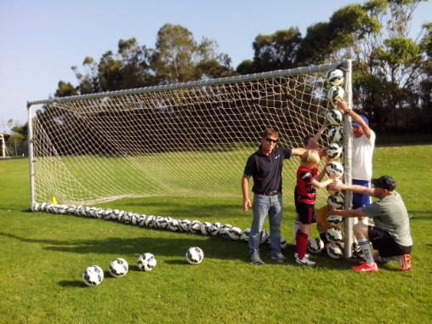

Technique is the key to shooting. Vision is the key to scoring goals. When the average player looks at the opposing goal, they look at the crossbar. When they shoot at goal, they aim for the whole goal. So many shots go straight to the keeper who just happens to be standing right in the middle of that large target. That’s how accurate kids are.

Goals are too big. What players see is what they get. We can place 34 balls on the ground from one post to the other and 10 balls from the ground to the crossbar. That’s 340 different places to kick a ball. The average kid aims for 340 targets while the Freestyle kid aims for one.

Freestyle kids know how to score because they learn how to miss. They understand why so many shots go straight to the keeper or straight over the bar. At shooting practice, they place target cones just inside the posts. In games, they aim for the bottom corners where even agile keepers struggle to reach in a dive.

**OUTTAKES AND MISSTAKES**

***Plenty of kids blast the ball too high. Freestyle kids get over it.***

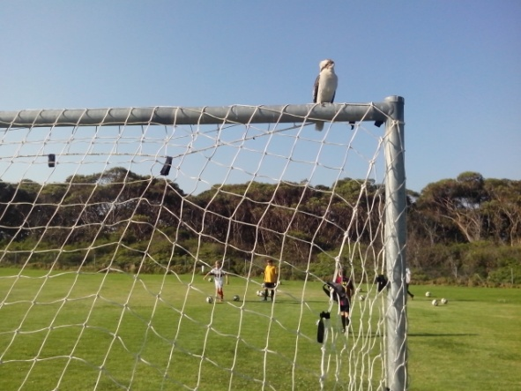

Kids learn fear of failure from adults. Players learn to play non competitive games to avoid the trauma of losing. There are coaches who try not to lose instead of trying to win. There are strikers who never miss much because they never shoot much. They play safe.

Kids make mistakes because they worry about making them. Failure isn’t a problem. Fear of failure is the biggest issue in Australian Soccer. The most effective way to overcome mistakes is to tell kids to make as many mistakes as they like. Players will feel an immediate relief and begin to relax. As soon they stop worrying they will stop making mistakes. Most coaches are too scared to try this.

Every time kids make a mistake, well meaning adults stop the mistake and correct the kid. They need to correct the mistake. If they observed the mistake, they would be able to discover the underlying cause.

**UNDERLYING CAUSE**

***Freestyle kids have got nothing to lose. They win or they learn.***

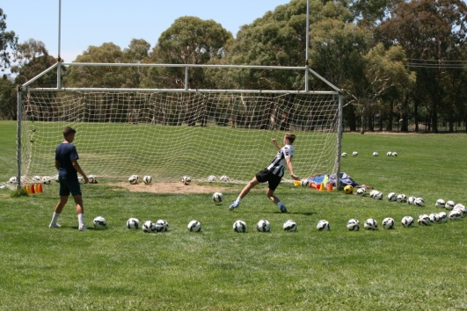

In the 10 years it takes to coach the average Soccer kid, not one person will spare 15 minutes to learn about that player or identify their strengths and weaknesses. Goalscoring is not a matter of luck. There’s a reason for every hit and miss in Soccer. A priority in Australian Soccer is the scarcity of coaches. Every team coach who teaches kids should have an assistant coach who learns about them.

Most Australian Soccer kids spend years repeating the same simple mistakes and coaches spend years correcting the same simple techniques because nobody ever discovers the real reason. There are talented, intelligent 17 year old Soccer players who have been taking their eyes off the ball every time they shoot for the last 10 years and nobody has noticed because they focus on perfect kicking technique.

Soccer coaches honestly believe that they’re helping kids by pointing out every mistake they make. In Freestyle Soccer, we can learn a lot more by looking at the mistakes and discovering the real cause.

**FEETBALL**

***Most little kids are naturally two footed until they start Football training.***

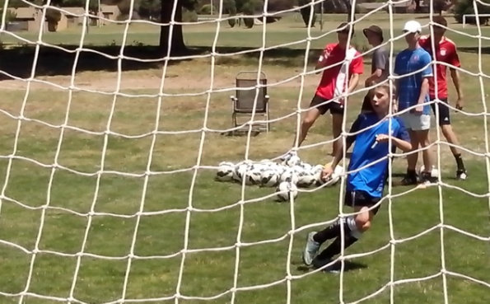

The only reason kids have a weak foot is because they don’t use it. When they run, one foot is just as strong as the other. Freestyle Soccer develops close repetition training drills that develop both feet equally well. Players need to use both feet so they can move more efficiently.

Freestyle Soccer kids use juggling to record their ball control and measure their improvement. The secret to juggling is as simple as walking and running. If kids alternate their feet with every touch of the ball, they will maintain natural balance and coordination. A one footed juggler is limited by the strength in their standing foot. A good juggler should develop their weaker foot to achieve 80% performance of their stronger foot.

In the pressure of a goalmouth, strikers and defenders need to respond intuitively with either foot. They don’t have time to switch the ball to their preferred foot. Freestyle kids keep their composure in the box.

**SHOOT THROUGH**

***The worst pass in Soccer is probably the straight through ball that no striker can catch.***

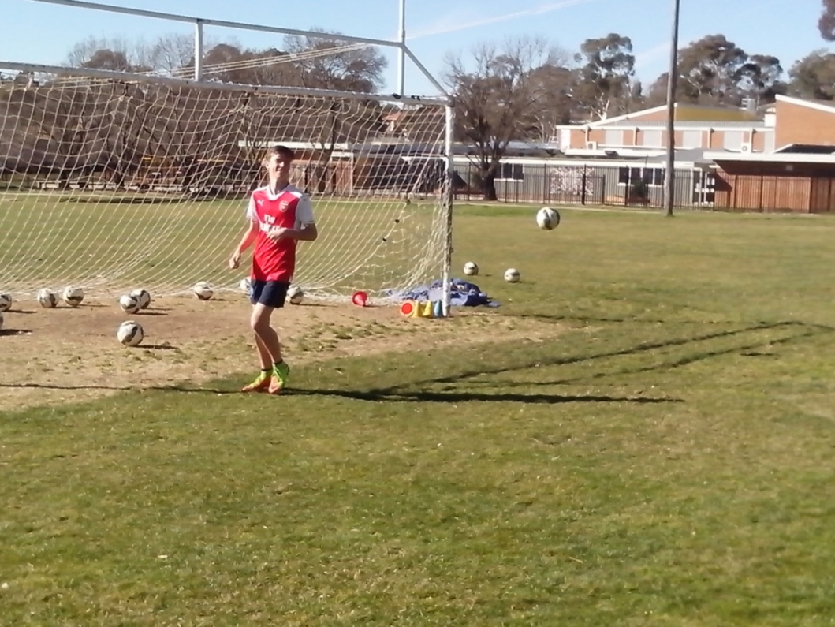

Kids who can only think about winning and scoring goals will always play kick and rush, and they will move forward as quickly as possible. In an average game, only three goals are scored out of 100 attacks but kids still rush forward and lose possession. They play the straight through ball that no striker can outrun. Freestyle kids look for the most penetrating angle because they understand space and possession.

Any kid can kick a ball but they need practice to learn how to pass, distribute, put in a cross or feed a through ball into space. A firm through ball should never be directed too close to the target man because they need to turn blind and catch it before it goes through to the keeper. Freestyle kids learn to run their own drills so they know where to put the ball. Most kids have no idea how to feed the striker because most coaches like to run all the drills at training and during match preparation. We can’t expect kids to dictate the moves in a game if we don’t trust them to practise the same moves at training.

**GROUND CONTROL**

***The low hard ball challenges players to control their power and their enthusiasm.***

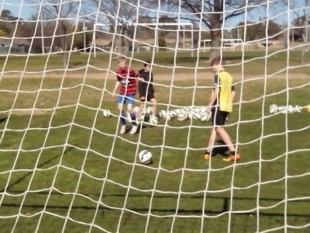

It should be virtually impossible for a player to strike the ball over the crossbar unless they’re trying to chip the keeper. Every kid needs to master the ground ball before they take to the air. Freestyle strikers keep their shots down because they understand the importance of small targets and they aim for the bottom corners.

Too many Soccer kids try too hard to kick the ball too hard at a target that is far too big. They lift their heads so they can look up and see the net bulge. Some kids expect too much too soon. They try to impress their mates with fancy tricks when they just need to keep it simple. Most coaches have no idea what kids should aim for and they expect them to shoot as hard as possible as often as possible in the hope that the goalkeeper will drop the ball or misjudge the flight. At training, Freestyle kids use small target cones to balance precision with power. In games, a crack shot can strike a small target 30 metres away. **AIR CONTROL**

***Juggling gives kids confidence with the difficult high ball.***

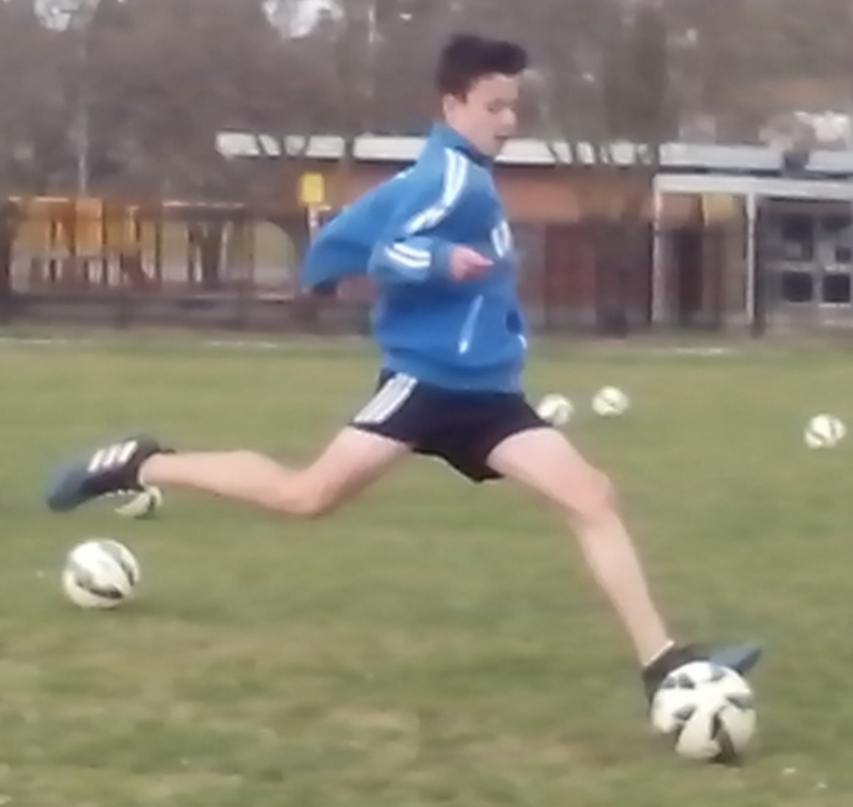

A lot of kids hold back from a high bouncing ball in a game because they’ve been conditioned to keep the ball on the ground at training. When given a choice, Freestyle kids always pick the hard way out so that they can learn more from it. They always look for the challenge.

Any kid can control the simple ball on the ground. Freestyle kids prefer to practice with the difficult high ball so they can learn to receive the ball under pressure and play the most effective option.

When we protect kids from pressure, we’re just delaying the inevitable. At some stage, kids have to face the reality of life. Some kids see a challenge and turn it into a problem. Freestyle kids see a problem and turn it into a challenge. Their confidence drives their respect, responsibility, resourcefulness and resilience. Ordinary kids don’t know what to do with a high ball. Freestyle kids attack the ball.

**MATCH WARMUP**

***We can learn a lot about Australian Soccer by asking every coach how many ball touches players need before they’re ready to play.***

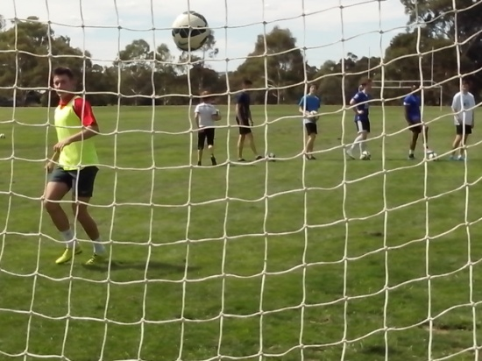

The most important time of the week is the half hour before kickoff. Some kids can lose the game before it even starts. They look at the opposition and start to imagine how strong and skilful they are. Some kids remember the ref who gave them a hard time in the last game. Some kids don’t get enough ball touches before the whistle blows. They use the first 20 minutes of the game to play themselves in. Some kids can’t focus before a game. They disrupt or distract their mates.

Every kid needs at least 200 touches of the ball before their eye/foot coordination kicks in and their ball control becomes second nature. Any coach can discover that quite easily if they think about it. When we get serious about playing games, we can show a lot more respect for kids by telling them their position at training rather than 10 minutes before the game. An intelligent kid will use mental rehearsal to prepare for a game and will benefit from psyching themselves up.

Strikers need to warm up with the keeper so they can get some shots in and get used to the surface. On a wet and windy day, kids should practise corners from each side so they can read the conditions.

**MATCH PLAY**

***Possession is simply the most important key to any game.***

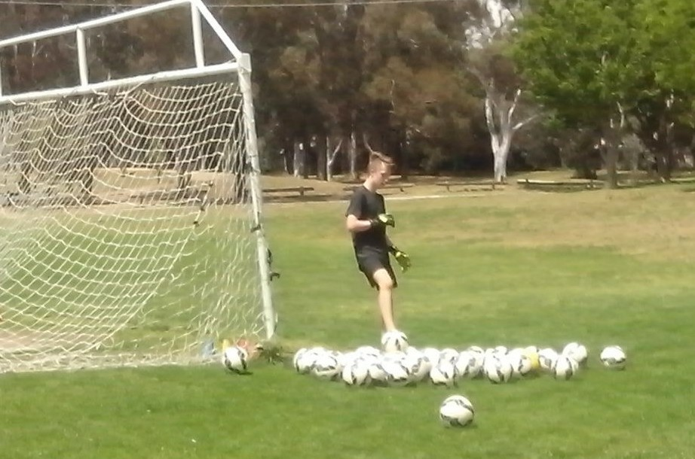

When we tell players to score goals, they rush forward and lose possession. When we tell them to keep possession, they pass the ball around until they can score goals. In a 90 minute game, there’s an average of three goals scored in 100 attacks. That’s a 3% success rate.

Ordinary Soccer is very straightforward. Kids run straight forward and kick straight forward. Freestyle kids have the intelligence and composure to think laterally. They look, think and play, 360 degrees so their team can keep the ball. Possession is gold. They don’t give away corners if they can put the ball out for a throw and they don’t give away throws if they can turn their clearance into a counter attack.

Interchange is important in junior Soccer. Attackers have a different mindset to defenders and their game often reflects an unorthodox nature. No coach should take a forward off the field and then put them back on in defence. A striker is intuitively creative and uses mobility to disrupt stability. A defender uses discipline to resist the mobility of attack. The last thing a coach needs is a striker who stands still and waits to see what happens or a defender who can’t hold their position.

**CALLING THE SHOTS**

***Calling is the most effective way to turn eleven individuals into a cohesive team.***

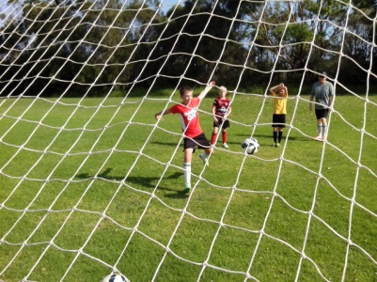

Most Australian Soccer kids have no idea what to call in a game. The most common call on the field is ‘mine’. The most common call off the field is ‘big kick’. Two team mates will clash going for the same ball or same tackle because neither of them bothers to call their name.

Australian Soccer is based on the ball and the ball player. Everybody stands around and ball watches. The ball player has the ball and the strikers just stand there with their markers waiting for the pass before they make a run. The ball player is desperately waiting for someone to make a run and a call. There are plenty of kids who can dominate the game with the ball. If we really want to compete at the top level we need support players who can dominate the game without the ball.

There are so many ways to communicate in a game. Freestyle strikers communicate with team mates by calling where they want the ball, running into position, waving or pointing to the spot. Two smart team mates can coordinate simple moves before a game. When one kid takes a corner the other kid knows where to run. A striker can predict where the throw is going by which hand the thrower holds the ball.

**FORWARD SCOUTS**

***The first attack will light up the target for the rest of the team.***

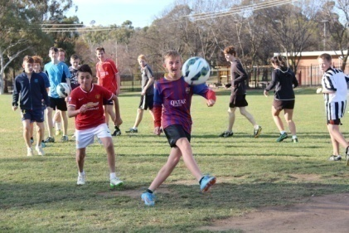

Shrewd coaches never show their hand too early in a game. Unlimited interchange enables an innovative coach to keep the best strikers in reserve for later use as shock tactics. At the start of the game, the elite top gun strikers will stand on the sideline and study the opposing defence to analyse their response to pressure. The first wave of attack tests the strength of the defence. Their role is to disrupt opponents and draw them out of position. If a striker does nothing, nothing happens. But when a striker moves, a defender will either leave their position and follow them or let them go and give them too much space.

For the first 15 minutes of the game, the midfield and defence are instructed to play safe and simple while the tactics are being assessed. After 15 minutes, the coach can send the elite strikers into the game as fresh reserves. The elite strikers go onto the field with a better understanding of their opposition. If they’ve done their job correctly they will have already discovered the chinks in the opposing defence.

In a game, tactics should be fun, original, exciting, entertaining and challenging. In Australian Soccer, we can either follow the rest of the world and copy best practice or create our own moves to reflect the Australian spirit. There’s more to Soccer than winning. Improvement depends on how well we play the game and what we learn from it.

**HOT SHOTS**

***Most Australian Soccer kids don’t miss much because they don’t shoot much.***

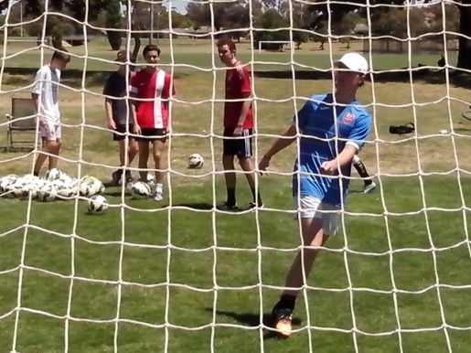

The most effective time to shoot is when the keeper least expects it. A lot of strikers watch the ball and the ball player and they often get caught offside. Freestyle strikers watch everything and they know as soon as a keeper comes off their line. Every good striker has an attack plan in mind but the hot shot is always there as the default option.

The mean average Soccer kid will usually telegraph their shot to the keeper by facing the goal or running towards the goal. Freestyle kids will pull a shot out of thin air while running across the goalmouth or even running away from it. A hot shot occurs when a moving kid hits a moving ball first time combining the momentum of the kid and the energy in the ball. The key to hitting is not being scared of missing.

Most Soccer kids are conditioned to get into position and control the ball first before shooting. Freestyle kids are able to strike a ball when they’re off balance and the ball is out of control. Juggling skills teach Freestyle kids to judge the spin and bounce of any ball at any height or speed and shoot intuitively before the keeper can get into position.

**HOT CHIPS**

***Hot chips require the finest balance of power and precision.***

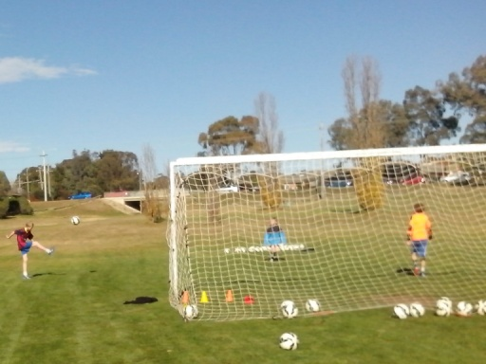

When a firm clearance comes out of defence, the well trained Soccer kid will always control the ball first, check the target and then take a pot shot at goal with a dead ball. They play at the cognitive level.

Freestyle kids learn to play at the intuitive level. They are already moving and checking the target before the ball gets to them. They will chip the ball back over the keeper’s head with one touch to maximise the natural energy in the ball. They will catch the keeper off his line.

Kids need to read the speed of the feed so they can judge how much power and precision they require to get the ball over the keeper but under the bar. There are plenty of talented strikers who never get to practise chipping in a 15 minute shooting session.

Any kid can shoot but the Freestyle kids have an arsenal of different shots and they can use their intelligence to disguise the shot. A smart player can stand side on to the goal as though they’re going to play a square pass and then use a rotational chip to put height and spin on the ball. A rotational chip is easy to hit but hard for a keeper to read.

**MICRO CHIPS**

***A micro chip is the most effective way to put one over an opponent.***

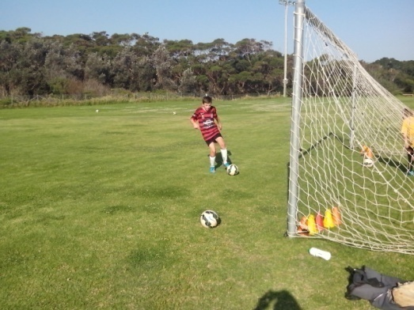

When a striker is in the box and they can’t get the shot through two defenders and a goalkeeper, they can dink the ball over the top.

The micro chip is the dynamic stab under the ball that makes it spin faster, fly higher and drop faster. Freestyle kids practise chipping all the time until the move becomes second nature. They learn to follow through from outside the box or stab the chip from inside the box.

Some kids are so pressured by parents, coaches and teachers, to try their hardest that they always try too hard to kick the ball too hard over the crossbar. The key to chipping the ball is relaxation so that kids can focus on weighting the ball correctly. Freestyle kids relax on the ball because they spend hours at shooting practice with hundreds of Soccer balls. They can put a different spin on any shot.

**DROP SHOTS**

***Ordinary strikers are two dimensional and focus on line and length. Freestyle kids are three dimensional and get the height right.***

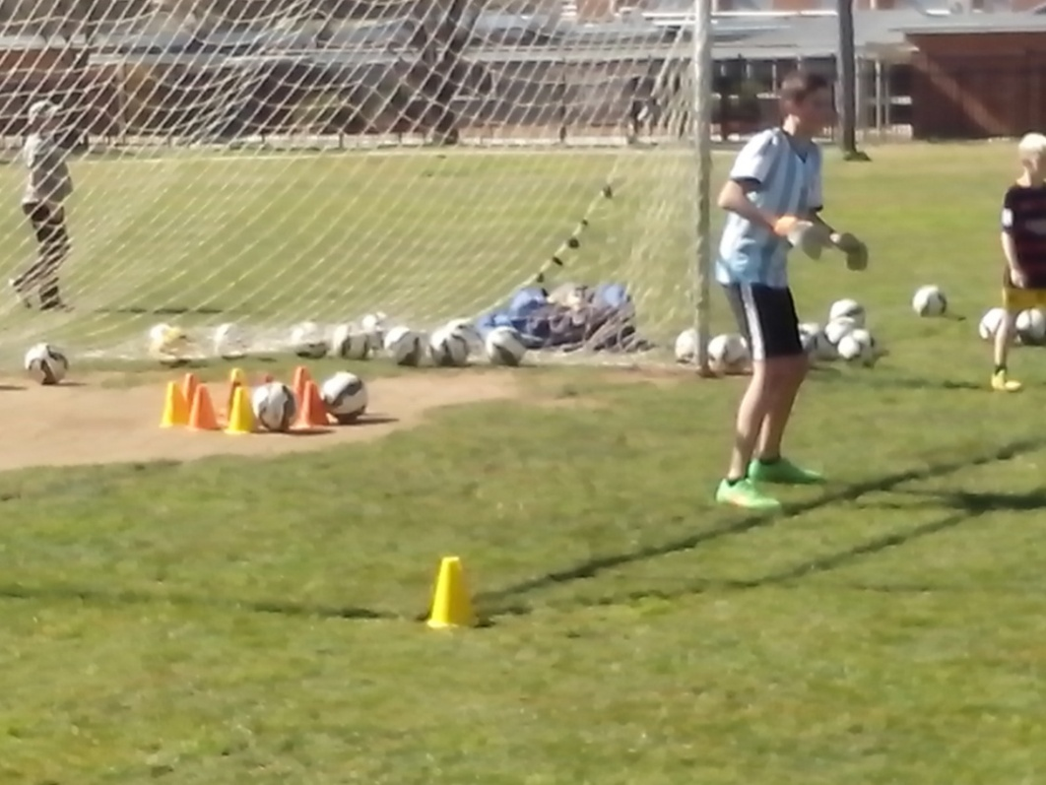

A lob is a specialist strike that becomes useful in a confined space. Anybody can boot a ball towards goal. Freestyle kids have a full collection of hits they can use around the target. Instead of getting behind the shot and driving the ball, the intelligent striker rolls the ball back and lifts it over the defence and the goalkeeper. Freestyle kids understand the importance of human coordination and balance. They can vary the elevation just by leaning forward or leaning back.

The average Australian Soccer kid is conditioned to play it safe and always keep the ball on the ground. In reality, the ball is always bouncing up in the air. A competent juggler will always attack the high ball while other players stand back and wait for the ball to come down to earth. Soccer kids will never achieve their full potential if they always choose the easy way out. A competitive sport depends on how much we’re willing to challenge our limits. On a windy day, the Freestyle kids will lift their game and put the ball up in the air.

**GOAL DIGGERS**

***A Goal Digger can bury the ball from any angle or range.***

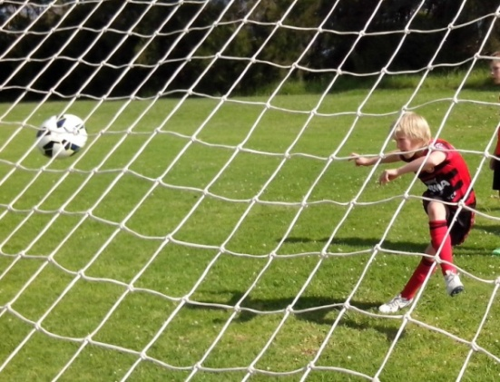

The mean average Soccer kid will always put too much force into a kick. Freestyle kids will always develop timing and rhythm before they add power and mobility. They use a sound check to measure touch and timing. When timing is off, the kick will make a high slapping sound. When timing is perfect, the ball makes a deep sound. Once kids discover the sweet spot, they can hear it. Anyone can kick a ball. When we get serious about Soccer, we need to play with the ball.

The most effective way to learn how to volley a difficult high ball is by practising close up shots in the 6 yard box to develop balance. The side volley depends on total control, using the arms and upper body for counterbalance. It’s easier to train when kids don’t strain. Slow is smooth and smooth is fast. Then kids are ready to shoot further out.

**HEADING FOR GOAL**

***After shooting, heading is the most neglected skill in Soccer. A lot of Australian Soccer kids are scared of heading the high ball.***

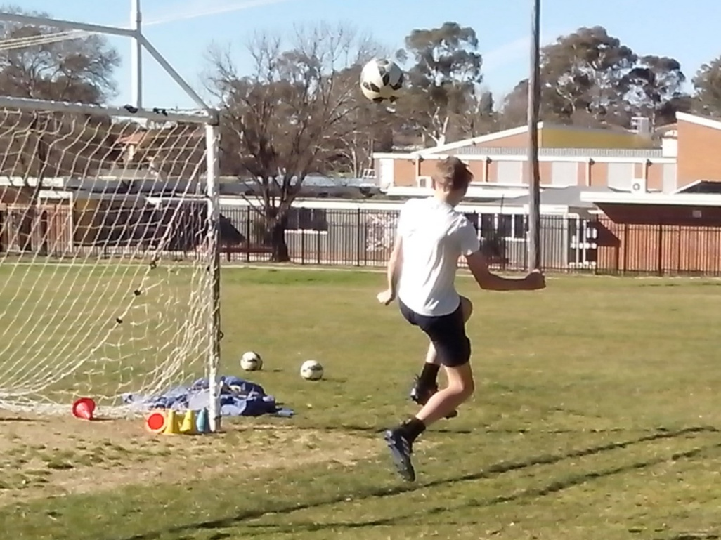

Fear of heading develops in Australian Soccer kids from an early age. Girls are scared of heading the all. Boys are scared of admitting that they’re scared of heading the ball. When kids are conditioned to keep the ball on the ground, they don’t get enough practice with a high ball.

The key to heading a Soccer ball is very simple. Kids need to hit the ball instead of letting the ball hit them. Kids are scared of the ball hurting them so they close their eyes and brace themselves and, sure enough, the ball hits them and hurts them. Anyone can work that out.

We need to stop running away from problems and start facing the challenge if we really want Australian Soccer kids to reach their full potential. We can’t avoid heading and then expect kids to pick it up later. We need to develop a national game that reflects the Australian character. We can teach any Australian Soccer kid a safer way to head the ball in 5 minutes, just by using close repetition training drills.

**EXPRESS DELIVERY**

***If kids never get to shooting practice, they’ll never get to practise shooting. Every club needs training sessions dedicated to scoring.***

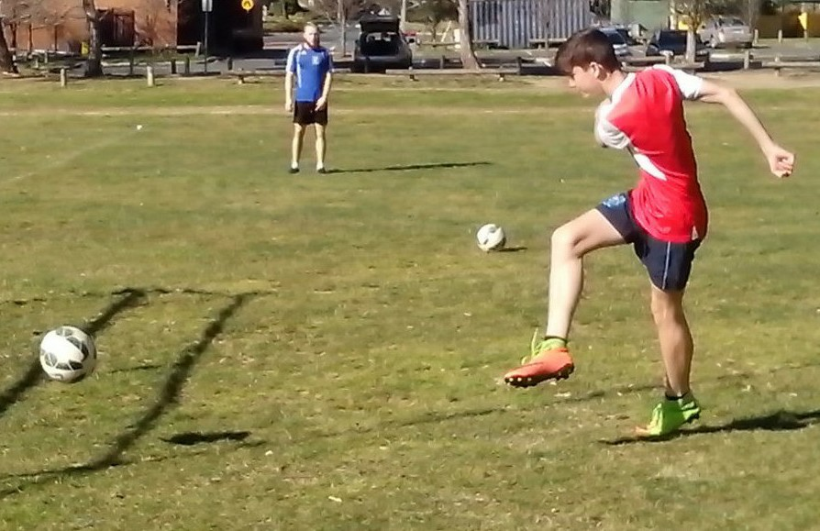

A confident striker will practise shots before a game and then test the keeper early in the match. It takes at least 200 shots on target before a striker is confident about scoring goals. Most Australian Soccer kids never have enough confidence to even think about trying it.

We need to stop believing that Australians lack the talent to reach the top and start believing that we already have the talent to compete with the best Football Nations in the world.

Freestyle strikers develop a hit collection of shots they can use in a game depending on their position, range and opportunity. They might chip a high ball or drive a low shot to identify any weaknesses in the keeper. Once they measure their range, Freestyle kids have the confidence to test any keeper with a hard drive. These are kids who have the commitment and determination to show what they can do.

**GRAVITY**

***What goes up must come down.***

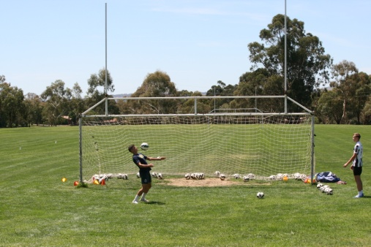

The secret to Freestyle Soccer is fusion. If we’re really serious about competing at the highest level, Australian Soccer kids need to control their human intelligence, human movement and human behaviour to maximise their technical ball control. There are plenty of talented strikers who don’t think, move or make the right decisions in a game. They use their right foot when the ball is on their left or they try to stop a head high pass by stepping aside and lifting their foot in the air.

Kids are not built to be Sumo wrestlers. They’re ergonomically built to play Soccer and control a ball at any height or direction. Gravity drills teach Freestyle kids to look, think and move while they control the ball. They learn to use their body and gravity. They can strike and receive a high ball with their head or shoulders, a medium ball with their chest or thighs and a low hard ball with their feet. They can rotate their body to control the ball at any angle. Freestyle kids can practise head/volley, chest/volley and thigh/volley using gravity to let the ball drop to their feet. They understand the importance of the first touch when setting up a shot and they’re not scared of the high ball.

**TRICKSHOTS**

***In any creative field, kids master the conventional moves first and then they learn how to improvise and impose their own style.***

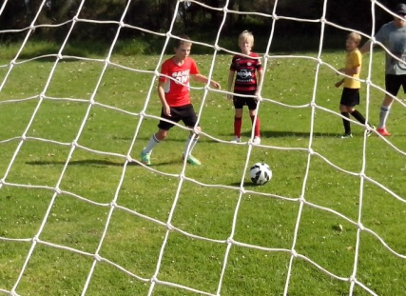

Freestyle kids are unique in Australian sport because they are willing to look at new and different ideas. They’re not limited to using one foot, keeping the ball on the ground or playing non-competitive. Freestyle Soccer kids have the freedom to explore and store a striking range of shots in their subconscious. When a hard ball comes across from the wing, these kids can score with their head, shoulders, chest, thighs, laces, heel or toe. They learn to use whatever comes to mind.

The advantage of close repetition drills is that kids intuitively know what they can use in a game. When a firm clearance comes out from the keeper, the mean average Soccer kid will always stop the ball first and then think too much before they blast the ball over the crossbar.

The Freestyle kid will chip the ball first time over the goalkeeper’s head without even thinking about it because they’ve practised the same move hundreds of times in a Shooting Gallery. Some kids just learn tricks to show off. Freestyle kids learn tricks to beat the keeper. The advantage of juggling practice is quick reaction at any level.

**TURN AND BURN**

***Repetition creates quick thinking, fast moving and sharp shooting.***

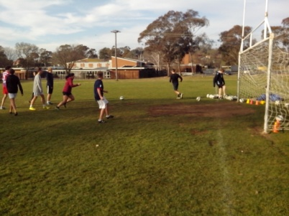

Not every shot is designed to score a goal. A certain striker will test the keeper early in the game with a hot shot. An uncertain striker will wait until everything lines up and then it’s too late. A hot shot is a sudden and speculative snapshot where the striker may be unsighted. It’s a power shot that tests the reaction of the keeper under pressure.

When an experienced target man receives the ball with their back to goal, they can turn and shoot without checking the target first because they have an intuitive feel for the goal. An intelligent striker will use their peripheral vision to read the play and they can estimate the target by the position of their own goal at the opposite end of the pitch.

An extrovert striker is happy to attract attention early in the game to put pressure on the opposition. It’s a compliment to any striker when defenders try to man mark them. Similarly, a foul indicates that the defender lacks the skill to beat them. Force is the default option when skill is lacking. Smart strikers draw attention away from their mates.

**CHILL AND DRILL**

***Freestyle kids go as far as they can, aim as high as they can and keep their shots as low as they can.***

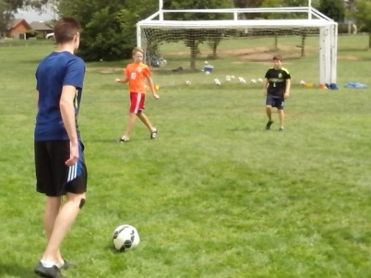

The mean average Soccer kids always expect too much too soon and they try too hard to kick the ball too hard while aiming for the largest target. Freestyle Soccer kids spend so much time networking that they learn to relax in the pressure of the goalmouth and they have the composure to place the ball out of reach of the keeper.

When players practise shooting hundreds of times, pressure becomes their comfort zone and they don’t need to use the same brain activity as others. They play at the intuitive level where they can do the right thing without stopping to think. The firing sequence is second nature.

There are talented strikers who panic in front of an open goal and go off half cocked because they only practise for 15 minutes a week. Kids familiar with goalscoring know how to get ready, aim and fire.

**SHOOTING ON THE RUN**

***A coaching system gives kids the skills to develop their confidence. A learning program gives kids the confidence to develop their skills.***

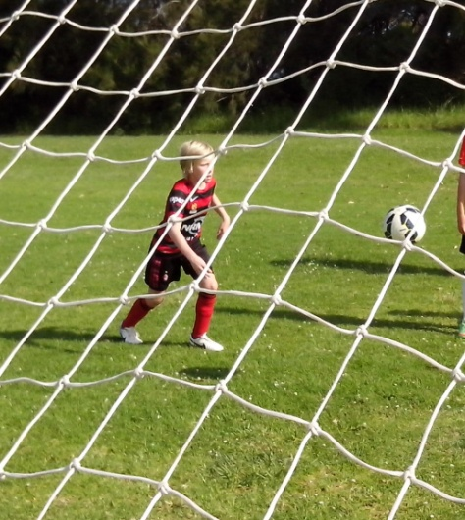

A lot of Soccer kids are conditioned to develop perfect control. They will often stop the ball, think of the right shot, and then kick a dead ball. Kids who take hundreds of shots every week will kick a moving ball because they already know what to do without stopping it. Intuitive players learn to think and shoot on the run. A dead ball is a dead giveaway to a keeper. A live ball keeps them on their toes.

Soccer is all about a kid and a ball. Freestyle Soccer is all about a moving kid and a moving ball. Fusion training enables kids to combine human intelligence, human movement and human nature. They learn to shoot on the run while other kids stand still and wait. The average Soccer kid only trains between 50 and 100 hours each year so they need to maximise their time. They don’t have the time to practise close control while standing still or to run laps without a ball. Freestyle kids practise 300 hours each year so they can synchronise mind, body and ball to make the right decisions and the right moves.

**WINGING IT**

***While most Australian Soccer kids have no idea how to cross a ball, Freestyle kids are busy mastering the inswingers and outswingers.***

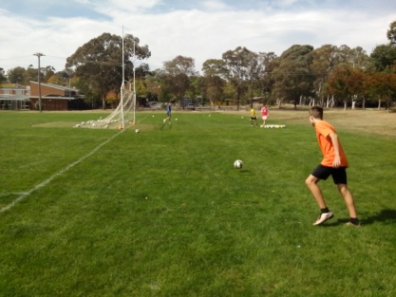

Any kid can learn to kick a ball. They need skill if they want to pass it and they need practice if they want to understand how to cross it. The most common cross in Soccer goes behind the goal line because kids are used to playing the way they face. The second most common cross goes straight to the goalkeeper because strikers stray into the 6 yard box. Kids need to learn the third most common cross in Soccer. The ideal cross is cut back from the goal line so the striker isn’t offside.

A good cross depends on a good pass to the wing, preferably on the ground and in front of the winger so they can run onto the ball. If the winger lacks confidence, they will stop the ball first and then try to cross a dead ball. A confident crosser can take the ball in their stride and convert the momentum into a high floater or low hard cross. The most important part of any pass is the receiver. Freestyle kids rotate responsibilities at shooting practice so that every kid learns how to pass, knows how to shoot and understands how to cross. There’s no point in coaches crossing the ball because they don’t play in the game.

**DEFLECTION**

***It’s amazing how often a low hard drive can cross the goalmouth without anybody getting a foot to it.***

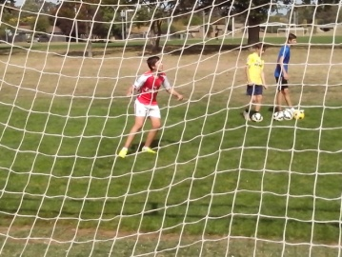

Ordinary kids will always shoot with 100% power so they can force the ball into the net. There are little kids who can blast the ball over the bar from inside the 6 yard box. They never get enough shooting practice to reach an intuitive skill level so they’re happy just to kick the ball. A goal can be good, bad or ugly. The ball doesn’t need to be controlled to go into the net. Some kids are proactive and others are reactive. A lot of kids will just miss making contact with a low hard cross because they stand flat footed and wait to see what happens.

Freestyle kids are masters of footwork and vision so they’re always looking, thinking and making decisions on the move. High level shooting enables players to read the speed of the feed so they know exactly how much force to put on the ball. They can deflect a ball into the net just by taking the sting out of it. A sharpshooter will use head, shoulders, chest, thighs, inside foot, sole or backheel to deflect a ball at any height or angle because they’re always on their toes and ready.

**CORNERS**

***Every corner should provide a scoring opportunity.***

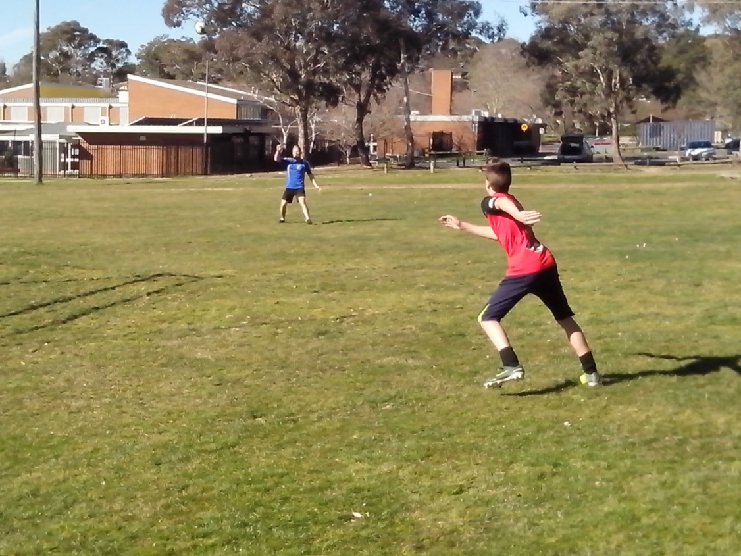

Most corners are just as much surprise to the attacking team as to the defence. The forwards go and stand with their markers and wait to see what happens. Very few strikers have the confidence to dictate the play. Freestyle kids will always move and make something happen. Every move will either put them in space and provide a scoring option or take an opponent out of position and create space for someone else.

Freestyle Soccer kids will never stand in the box waiting for the cross. They will position themselves outside the box on the opposite side of the corner so that defenders can either see them or the ball but not both of them at the same time. At a signal from the corner taker, the Freestyle kids will make their run into or across the box. With a run and a call, a smart player can draw two defenders to the near post and leave a team mate unmarked on the far post. Kids need the freedom to be innovative or they will always stand still and wait for instructions. Intelligence and initiative are key elements of Freestyle Soccer talent.

**FREE KICKS**

***Shooting is easy. Any kid can kick. Scoring is simple. Any kid can practise.***

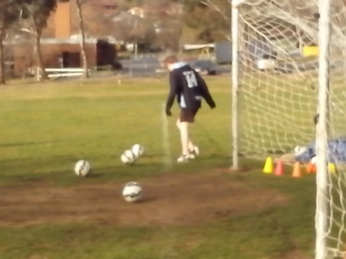

The first thing we learn about free kicks is that the opposition will never stand where they’re supposed to stand. We choreograph free kicks at training and then the other team never do the right thing.

Some teams can’t help losing games because they’re out of their depth. Most Soccer teams who lose a game get enough opportunities to win but they don’t take them. After the game, kids will remember when they couldn’t shoot, wouldn’t shoot or didn’t shoot. Some kids will remember when they did shoot but rushed and missed the target.

Free kicks give kids a better chance of scoring. In dead ball moves, the ball is supposed to be dead not the kids. The kids are supposed to move not the ball. In Australian Soccer, a lack of moving and calling is becoming more common. In a prescriptive system, kids are scared of getting it wrong so they try to second guess what the coach would do. Freestyle kids don’t need to choreograph free kicks. They have the confidence to act spontaneously and improvise under pressure.

**THROWS**

***Kids can’t be offside from a throw, so they use that advantage.***

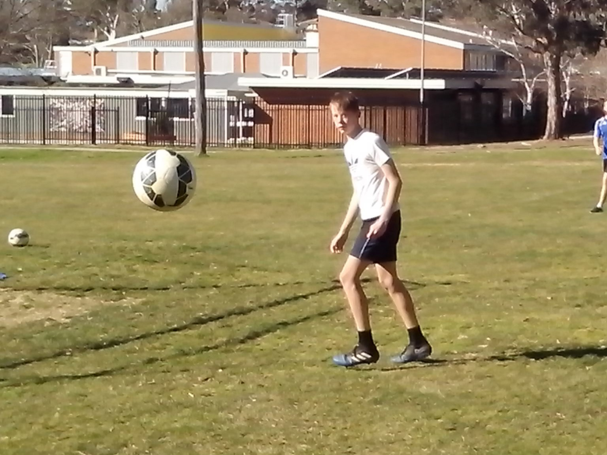

Throws are another neglected part of the game like heading and shooting. Throwers make the mistake of lifting their foot when they throw. Attackers stand still and wait to see where the ball is thrown before they move and defenders give their opponents too much space.

Freestyle kids play percentage Soccer so they will use anything they can to gain an edge. A loud call, a smart run, a quick throw down the line and a first time cross can set up the striker inside the box. A long throw can enable a striker to shoot first time before the keeper is able to move into position.

It’s impossible for a Soccer kid to be untalented because there are so many talents in Soccer and every kid is different. There’s always one kid who can throw the ball further than the rest of the team and that’s the kid who can use his hands to play the final pass before the shot.

**PENALTIES**

***Target cones are a great way to teach kids how to take penalties.***

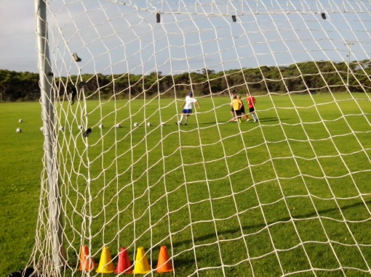

A penalty should provide a definite advantage for the attacking team but it’s amazing how many kids miss the goal completely because they allow the keeper to psyche them out or the penalty taker takes too long and they think about it too much. There are so many teams who go into competitions without bothering to practise penalties. Freestyle kids don’t let any part of the game go untried or untested.

Certain penalty takers will pick their spot and go for it even if the keeper dives that way. Uncertain penalty takers will take an extra look and then hesitate. Penalties should be intuitive. Once kids become cognitive, and worry too much, they give the advantage to the keeper.

Freestyle kids are always the first to get to training and the last to leave. Penalty practice is always better after training when the more motivated kids stay back to do extra practice. The Game of Cones is ideal for penalty practice. Freestyle kids will always develop their precision first before they extend their range and increase their power. Small target practice enables kids to develop the low hard penalty.

**BLIND SIDE**

***A lot of kids go through the motions without actually moving. The game needs perpetual motion if we want to challenge the best.***

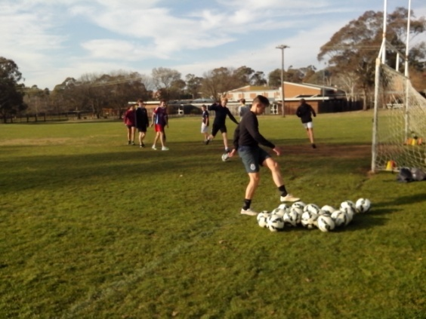

When they win a corner, or a free kick, most attackers automatically go and stand with the defenders so that every kick becomes a 50-50 ball. Freestyle attackers will always position themselves on the blind side so that the defenders will either keep their eyes focused on the ball player or get distracted by the support player. In either case, the defender is at a disadvantage because they can’t get the full picture.

Strength plus speed plus timing equals power. The player who runs onto a ball will always have more momentum than the kid who stands still and waits to see what happens. Freestyle kids make it happen. So many defenders follow the bouncing ball and they never notice the innovative players who can run silent and run deep. Smooth becomes fast. Freestyle players stay outside the box and delay their run so they don’t get picked up till the last second when it’s too late. They use simple but effective ideas to outmanoeuvre their opponents.

**DUMMY RUNS**

***When certain players lead the way, uncertain players follow them.***

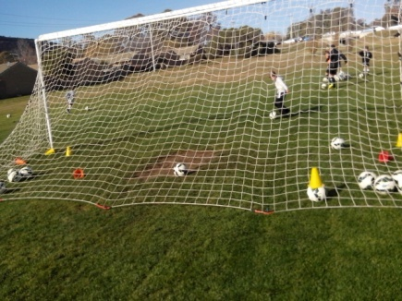

Match performance is generally a reflection of personal character. Attackers are creative and defenders are disciplined. Confidence can make all the difference. Skilful players can dominate a game with the ball but talented players can dominate a game without the ball.

Strikers who only train when they’re told to train can be relied on to do just enough in a game. They will make runs if they can see a reason or result for their efforts. The Freestyle kids who train without being told to train can always be expected to do more than they’re asked. They will chase a ball even if it’s likely to go out of play. They will chase the straight through ball in case the keeper drops it. These kids send a clear message to the other teams that they never give up.

When Freestyle strikers make a run and a call in a game, they don’t necessarily want the ball. Just by doing something, they will create something. The kids who stand still and do nothing, create nothing. If we aim Australian Soccer at the mean average, so that everybody can follow the same system, we will create a lot of mean average kids.

**THE DOG AND THE FRISBEE**

***A moving dog can assess the point of intersect, judge the point of intercept and establish the point of impact of a moving object.***

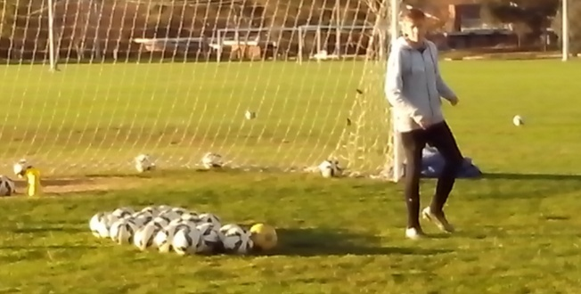

Dogs learn from experience. They don’t learn that they’re learning. They just do what comes natural. When a Frisbee is in flight, a dog doesn’t move to the where the Frisbee is. They move to where the Frisbee will be. Familiarity with shooting drills enables certain Soccer players to develop the same skills. Constant cross training, with the difficult high ball, gives players confidence to challenge in the air.

Ordinary training produces ordinary players. Extra training produces extraordinary players. Soccer is about ball control. Freestyle Soccer is about coordinating motor skills, mind skills and Soccer skills. Any kid can kick a ball. The fusion of mind, body and ball allows kids to look, listen, learn, move and control the ball without pausing to think.

Anybody can learn to play the simple ball on the ground. Freestyle kids like the challenge of reading the spin, bounce, height and flight of the difficult high ball or the low hard ball. It’s too easy to practise what we can do. The challenge for Australian Soccer is to practise what we can’t do. We can all become ordinary or make a difference.

**FEAR OF FAILURE**

***Some strikers hesitate and question their ability to shoot. Freestyle kids are more likely to shoot first and ask questions later.***

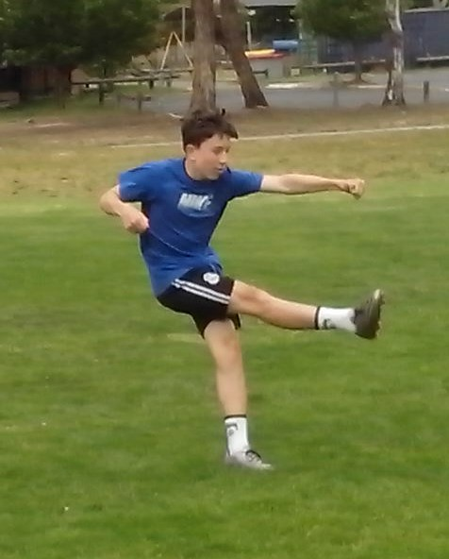

There are so many talented strikers who lack the confidence to shoot in case their coach shouts at them or their team mates laugh at them. They hesitate in front of an open goal while they try to second guess what the coach wants them to do. Fear of failure is the greatest obstacle in Australian Soccer. It makes talented strikers take the easy way out and pass the problem to the next kid instead of having a go.

There are plenty of talented kids who make mistakes because they worry about making mistakes. These are intuitive players who revert to the cognitive level so they can stop and think before every move. Freestyle kids make more mistakes and they learn a lot more. Failure is not a problem for Soccer kids. Fear of failure is the real issue.

**PRESSURE**

***We won’t score goals if we can’t shoot or don’t shoot.***

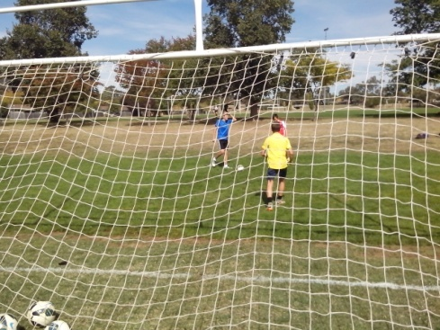

Pressure comes from within us not without us. Some kids avoid pressure and look for the easy way out. Other kids chase pressure and look for the hard way out. The most effective way to overcome pressure is to face it and get over it. Failure isn’t a problem. Fear of failure encourages us to be non-competitive so we don’t get upset.

Freestyle kids do more than expected. The fullback is the first man in attack. The striker is the first man in defence. They pressure fullbacks to give away a corner instead of a throw or force them to kick the ball out instead of passing forward. An effective striker can pressure the keeper into error. They can disrupt a defence by running and calling. Any Australian Soccer kid can adapt to pressure and lift their game.

Rapid response strikers practise shooting under pressure to speed up their reflexes. They will sprint onto a moving ball to maximise the energy in their shot. Kids who lack confidence will always back away to give themselves more time and space to make a decision. Freestyle strikers learn to react intuitively without time or space or hesitation.

**DECISION MAKING**

***All Australian Soccer kids need the freedom to drive, strive, thrive and come alive.***

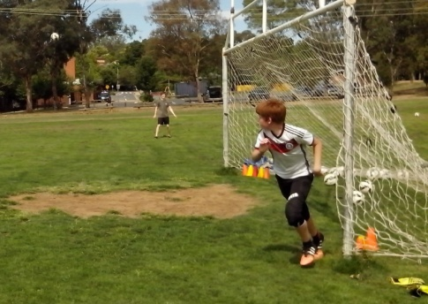

Any kid can learn how to trap, pass, dribble, head, screen the ball and shoot. The most difficult skill in Soccer is knowing when to choose the right one. There are kids who pass the ball in front of an open goal when they could shoot and there are kids who shoot when they should pass the ball. The key is to trust kids to think for themselves.

There are Freestyle kids all over Australia who learn to make their own decisions at skate parks, basketball courts and BMX tracks without direction, protection or correction from well meaning adults. These kids become confident because they learn from their mistakes.

Freestyle strikers are the kids who get together at a Shooting Gallery and practise their own shooting drills so that they learn what to do, know how, understand why, discover where and decide when. These kids develop a positive mindset. They achieve what they believe because they can put their mind to it. Ordinary kids hesitate before they shoot and are in two minds because they don’t want to make the wrong decision and get into trouble. Strikers can’t achieve their full potential if they’re scared that being different means being wrong.

**VIDEO REPLAY**

***We keep correcting what kids do wrong without discovering how they get it wrong or understanding why they get it wrong.***

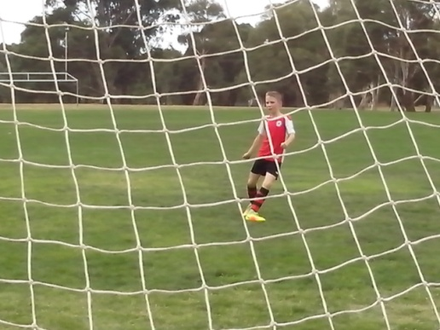

Shooting isn’t a matter of luck. There’s a reason for every goal and every near miss. A video camera set up behind the net can monitor every striker, assess every shot and evaluate every result. We can’t keep teaching the same without learning something different.

Rainbow is a rapid fire drill that enables 8 players to take 64 shots in 60 seconds. A video camera analyses footwork and vision, power and precision, movement and decision, belief and repetition, challenge and intuition. It identifies the effects of natural skills on Soccer skills.

We can’t improve kids till we know what each kid needs to improve. We can’t teach kids to hit a target till we know what they’re missing. Kids can’t learn to score if they don’t know how to shoot. They can’t learn to shoot if they only practise for 15 minutes every week.

With video replay, we can identify the strengths and weaknesses of every Soccer striker and find the key to their shooting ability.

**TACKLING ISSUES**

***The only problem with winning is the fear of losing. For every winner, we create a loser.***

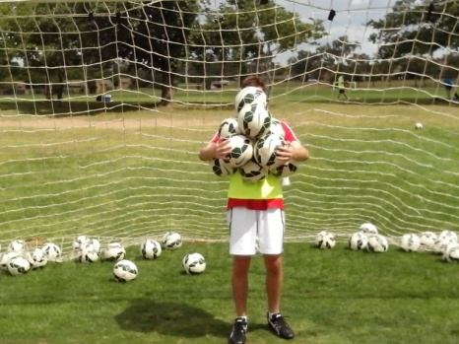

Kids achieve because they don’t know what they can’t do. Adults give up too easily because they know what they can’t do. It’s amazing how far kids can go if we don’t keep telling them how bad they are. The vast majority of Australian Soccer kids don’t know that they lack the talent to reach the top so they keep going and keep improving.

Some of us look at a challenge and can only see a problem. Others look at a problem and can only see a challenge. Freestyle strikers aren’t tied down to a set program. They persevere with a challenge until they overcome it. If they miss their shots, they discover the underlying cause and do something about it. There’s a key to every kid, a drill for every skill and a solution to every problem. If we’re really serious about becoming a Top 20 Football Nation, we need to start looking for new and different ways to tackle the basic issues.

**CERTAINTY**

***A dead ball should be is a dead certain way of scoring goals.***

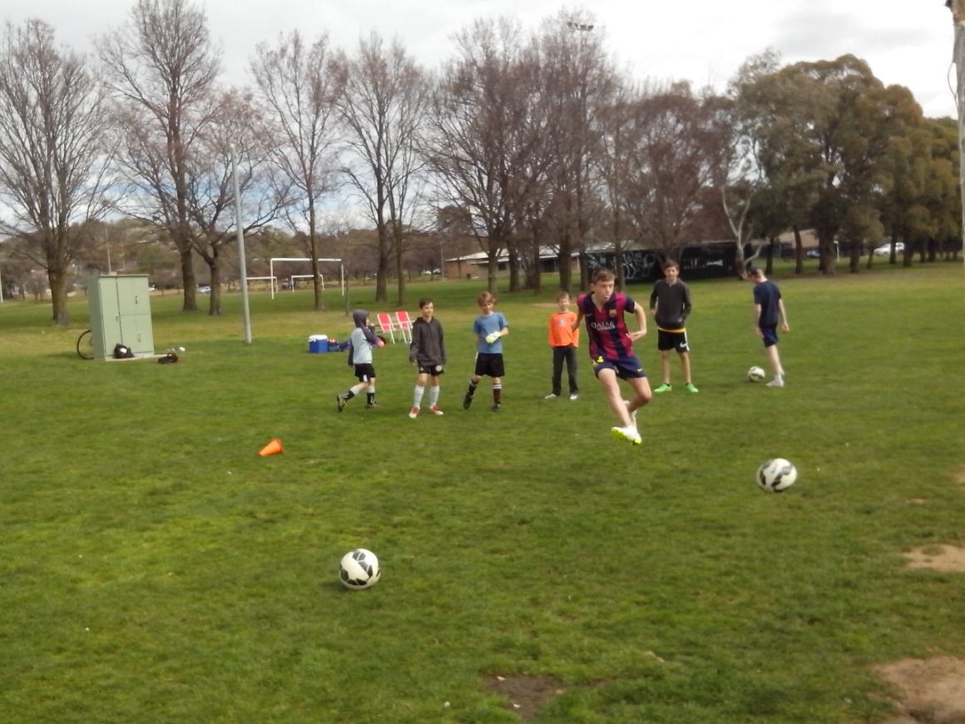

Freestyle Soccer is based on the Certainty Principle. Certain coaches make certain players. Uncertain coaches make uncertain players.

The aim of Freestyle Soccer is to make certain that we improve every Australian Soccer kid, not just the elite players who are easy to coach. There is so much untapped or hidden Soccer talent in Australia and we need to discover the coaches who are willing to believe in it.

When they get serious about playing games, Freestyle kids make certain that they improve by looking for better ways to shoot, safer ways to head the ball, smarter ways to outmanoeuvre their opponents, different ways to become unpredictable and more ways to win..

Freestyle kids make certain of scoring goals because they practise shooting for two hours with 100 balls from every angle and range and they research every way that they can hit or miss their shots.

**SHOOTING STARS**

***Who taught Ronaldo how to play Soccer? Ronaldo taught himself.***

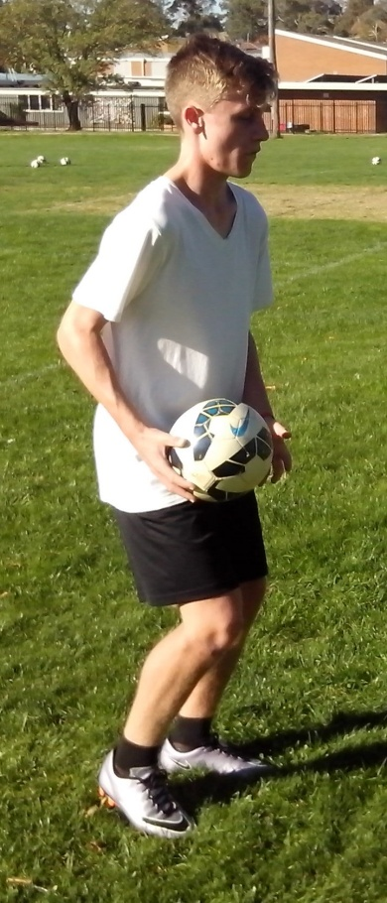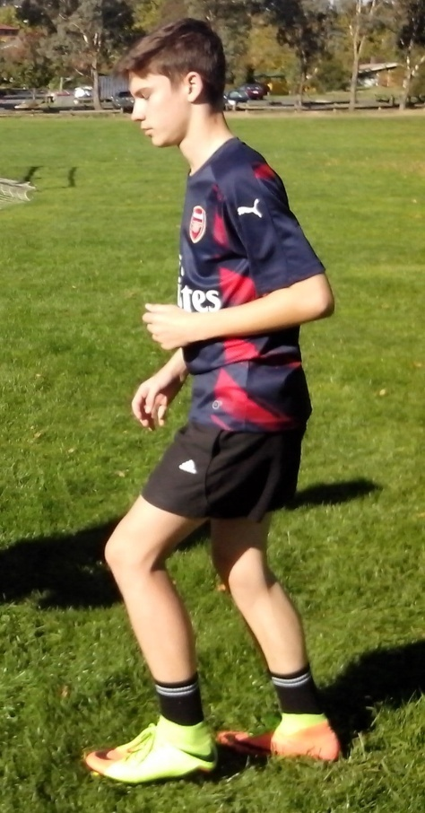

Every Australian Soccer kid should have a hero they can emulate. The top Soccer players can motivate and inspire kids to train a lot harder.

We always look for the easy way out in Australian Soccer. We look for the docile players who train when they’re told and do what they’re told because they’re a lot easier to coach. We try to avoid any kids who use their initiative and do things differently. We overlook too much original talent just so we can develop players to suit a system. If we can inspire talent, we can develop a system to suit our players.

A Freestyle mentor, who believes that kids have the talent to reach the top, can inspire Soccer kids to train for the love of the game. Ronaldo and Messi do more to inspire Australian Soccer kids than any Soccer coach because they encourage these kids to dream that they can reach the highest level of skill, not just make up the numbers. The clue is the name written on the back of the shirts that all these kids wear.**TARGET MAN**

***Strikers need to read the speed of the feed.***

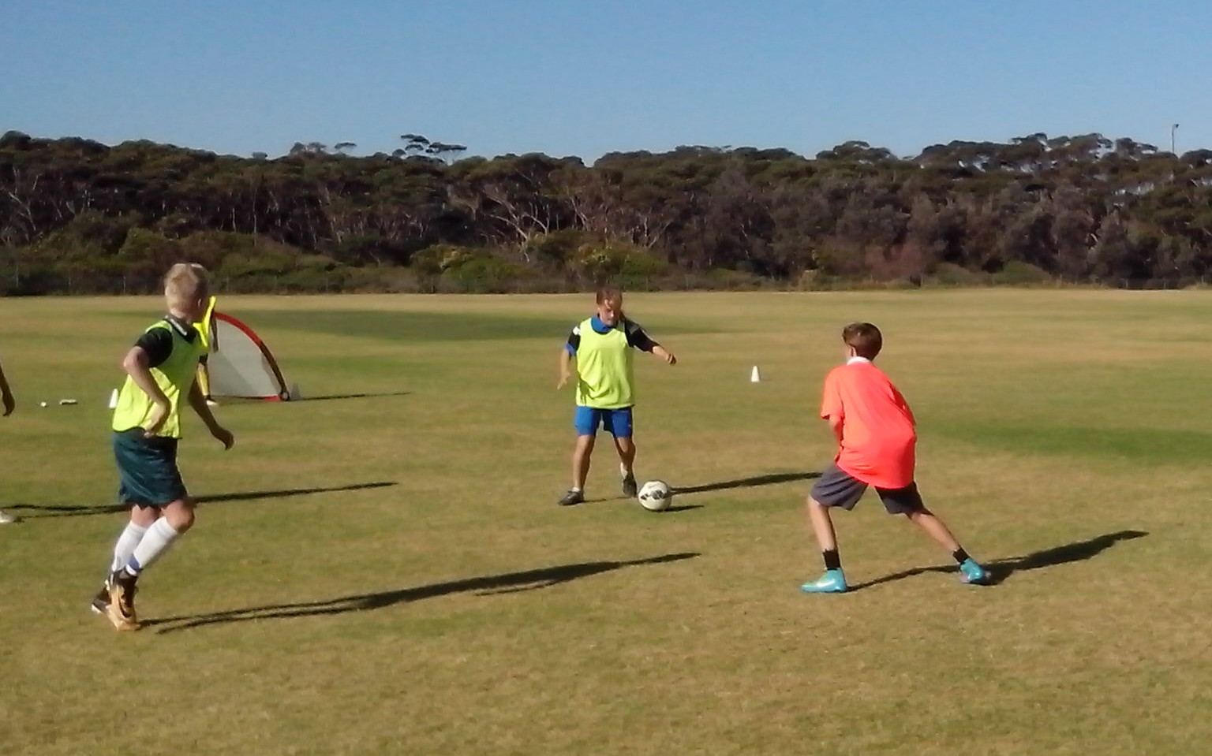

There’s a lot more to playing Soccer than kicking a ball. A successful hit man will never make things easy for their opponents by standing still with their markers. They will either pressure them or give them the runaround. A talented target man will easily lose their marker or take them where they don’t want to be.

Freestyle strikers never make it easy for the other team. In the first few minutes of every game, the Freestyle striker will evaluate the strengths of the defence and identify the weaknesses. It doesn’t take long to discover which players hold their position and which players follow the ball or the attacker. Space is the final frontier in Soccer.

A Target Man is a Spaceman. They explore space so that they can discover and create more space for their team mates. No Freestyle Soccer kid will ever stand still for long enough to be ineffective. They will always look and think, move and improve, believe and achieve.

**10 MOST POPULAR WAYS TO MISS**

***If we can’t learn from our mistakes, we will keep repeating them.***

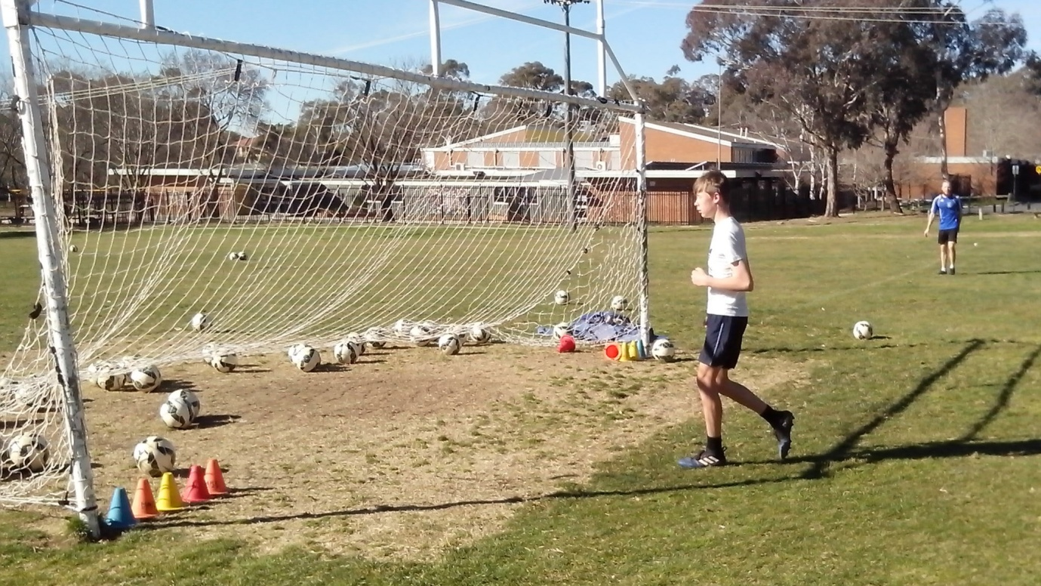

**Freestyle kids know how to score because they learn how to miss. A crack shot knows the underlying cause of every shooting error.**

Aim big and miss big.

Try too hard to kick the ball too hard.

Don’t check the target before shooting.

Stab **at** the ball instead of striking **through** it.

Take your eyes off the ball when you strike it.

Pass the ball instead of shooting (fear of failure).

Panic under pressure, tense up and rush your shot.

Look at the keeper so you can kick the ball straight at them.

Practise blasting the ball over the bar for 15 minutes every week.

Worry about making mistakes and getting corrected or laughed at.