# 4v4 dribble or pass

## By Michael Beale

Using games to teach players how to become used to tactical moves is a great way to help them understand attacking and defending as a unit.

When defending in groups, it is important players work together to stop the opponent. Players must support each other and communicate with each other to press the team with the ball.

This game is designed to develop a deep defence that invites attacks in order to quickly counter attack.

In a 30x25 yards area, you need six small goals marked out by cones, and a ball.

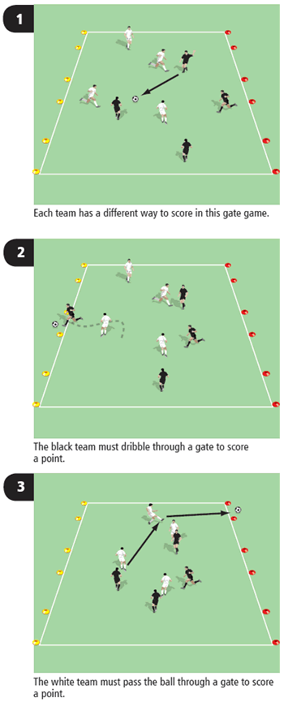

http://www.bettersoccercoaching.com/images/BSC363b.gif

## How to play it

1. Two teams of four players play a game and both teams have a different way of scoring.
2. The white team drops back to defend its three yellow goals. The black team is aiming to dribble through the gates in order to score.
3. If the white team wins possession, its objective is to make a pass forward and through one of the black team's goals. This represents winning the ball in a game and then making a good pass to a midfielder or forward's feet.

## This session is from [*Perfect Defending*](http://www.coach-soccer.com/defending/indexusd.asp?sReferrer=bsc623a) by Michael Beale, designed to help coach players in every aspect of the game, from individual core skills to team-based defending strategies