Basketball in the NT | Strategic Collaboration 2011 - 2013

Our Sport  Basketball is:  - An international game (213 countries)  - A sport Australia is good at (ranked 3rd in the world)  - In your community  - A popular sport in Australia and in the NT  - For men and women  - Suitable for all ages and abilities  - Accessible to all  - An opportunity to play, officiate or coach from grass roots to elite  - An opportunity to connect with friends |  | Our Collaborative Relationship  Basketball NT is basketball’s governing body in the NT and is affiliated with Basketball Australia. Darwin Basketball Association and Alice Springs Basketball Association are members of BNT and provide weekly competitions for 2,200 registered participants. Together we are responsible for the growth and development of the sport in the NT.  To achieve growth and development of our sport, we are committed to working collaboratively. This is characterised by:  - Transparent Decision Making  - Active Support  - Open and Honest Communication  We are committed to:  - Being Solution Focussed  - Making decisions based upon what is best for basketball in the NT

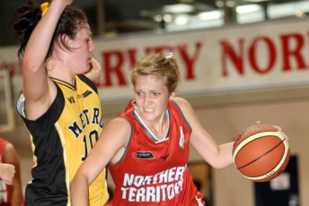 |  | 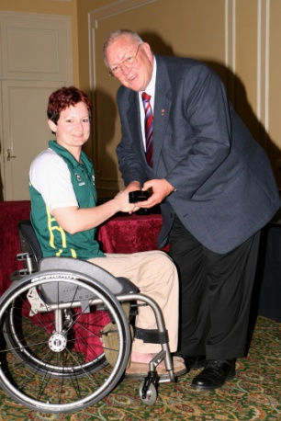 | 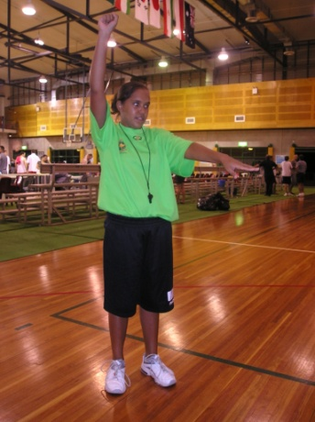 | 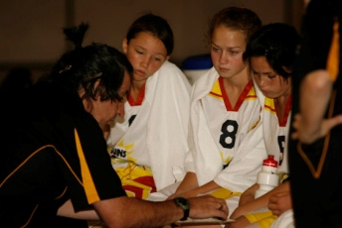 | 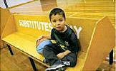
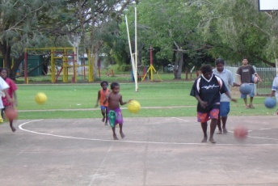 | 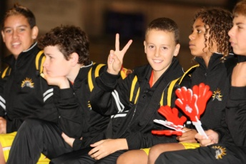 |  |  | 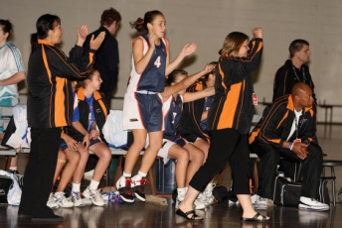 | 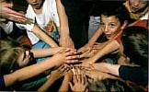

Introduction
The Northern Territory has a proud history of achievement and involvement in basketball. It is one of the most popular games in the Northern Territory. Michael Ah Mat was the first Indigenous Australian to play basketball in the Olympics (1964) and he was a proud Territorian. Other Territorians who have progressed to international level include Benny Lewfatt (1961), Toni Gabliesh (first NT AIS Athlete and U20 National Representative 1989), Travis Haslem (FIBA badged referee), Kia Dowell (bronze medal, 2005 World University Games), Melanie Hall (bronze medal, 2008 Paralympics) and Brad Newley (Olympics, 2008).

Basketball is one of the most popular sports in the NT, with almost every community having a basketball court. However much of this participation is unstructured with the Darwin Basketball Association (DBA) and the Alice Springs Basketball Association (ASBA) representing only 17% of the overall number of people playing basketball in the NT. Many people play at community festivals, at school, at the YMCA or on a bitumen court at communities as diverse as Gapuwiyak, Daly River, Ngukurr or Yuendumu. The NT Championships formerly brought together many of the communities, however in recent years attendance at the championships has dwindled. It is a key challenge for us to engage these communities again.

The Darwin and Alice Springs Associations have a long history and provide the cornerstone of basketball competitions and development in the NT; however, for the continued growth of the sport, we need to have sustainable options for the other major demographic areas of the NT. Palmerston, Katherine, Tennant Creek and Nhulunbuy, are areas that must have more input to, and receive more support from, the NT Basketball community with the view to nurturing and establishing new Associations. The reality is that the total registration numbers in the NT are the equivalent of a small to medium sized association elsewhere in Australia. We need to act, off court, as one association, one territory, rather than separate entities. On the court, the rivalry particularly between Darwin and Alice Springs will remain as strong as ever and this is great for the game.

There are obvious gaps in our sport at the moment, such as the lack of a full time resource for the development of officials, opportunities for senior basketballers to have a regular program (apart from the biennial Arafura Games and Masters Games) and the engagement of the significant number of people playing our game, but not as registered members. These cannot be addressed effectively by one organisation – it requires the collaboration of all.

Perhaps the most pressing issue, and the one that can most hamper our collective achievements unless we get it right, is the governance of the sport.
The NT Department of Sport & Recreation has undertaken a review into the governance of the sport and we are firmly committed to the implementation of the findings of that review.

It is an exciting time for basketball and the level of interest in the game is strong. Through the support of the NT government, we are able to welcome both NBL (pre-season tournament) and WNBL teams to the Territory, which provides a tangible connection to the elite level of the sport. This collaborative agreement sets the platform for the continued growth of the sport.

Values that Underpin Our Collaborative Relationship

In the past, the sport of basketball has been fractured in the NT and we have operated largely in isolation and sometimes in direct conflict with each other. Our engagement with others actively involved in basketball (YMCA, School Sport NT) has been limited and inconsistent.

Our ability to grow and develop the sport requires us to work collaboratively. Underpinning this behaviour are three keys values, which will guide our future working relationships:

Transparent Decision Making
- We have clear policies in place that identify the extent of any authority delegated to management.
- We support and respect the extent of those delegated with authority from board to management and from one organisation to another.
- We respect the “umpire’s” decision – decisions are made based on the clear policies and are respected and enforced by all.
- We have clearly identified channels for raising issues.
- We ensure that everyone is treated and heard equally when issues are raised.

Active Support
- We actively support each other – and we encourage others to model that support.
- We do not tolerate behaviour that is disruptive and goes outside Transparent Decision Making.
- We support all decisions and NT programs.

Open and Honest Communication
- We air our grievances in appropriate forums and in an appropriate manner.
- We put our considered views and respect decisions that are made in good faith, even if they differ from our own views.
- We do not criticise without offering an alternative.

Values that Underpin Our Operation

The following values will underpin the manner in which all levels of the operation of, and participation in, basketball in the NT are implemented and administered.

Decisions and programs will have to be tested by asking the following questions:
- Does this program / decision have integrity?
- Does this program / decision provide opportunity?
- Does this program provide fun/enjoyment?
- Are our employees and volunteers enjoying this?

Integrity
- Incorporates honesty, transparency, fairness, respect, responsibility and sincerity.
- If facts indicate that we made a poor decision or took an improper action, then we must admit that we are wrong and put in place processes to minimise the chance that such decisions/actions would occur again.
- If evidence based on facts show we are correct, we must stand firmly and fairly to what we know is right.

Opportunity
- Provides equal opportunities for participation and competition at all levels and locations.
- Is inclusive of all stakeholders.

Enjoyment
- Ensures safety of all participants.
- Provides fun for all participants.
- Provides a level of satisfaction at all levels – for players, officials, administrators, spectators, sponsors and volunteers.
Our Strategic Vision for Basketball in the NT 2011-2013 - A United Sport Played Throughout the Territory

Our Mission
To make basketball a top three sport in the Northern Territory in performance, participation and public interest.

Our Competitive Differentiation
The sporting landscape is increasingly under pressure from many influences ranging from changing family structures to a financial environment where “discretionary” spend is falling. As society becomes increasingly health conscious, the “natural” choice of playing a team sport is giving way to individual pursuits such as gymnasiums or simply going for a walk. Whilst lengthy seasons with strict finals eligibility and other guidelines remain attractive for the “serious” player, sports with more flexible structures are gaining in popularity. Indeed, there are many instances where non-affiliated providers deliver a basketball “product” that better suits these players seeking their sport “on demand”.

In this landscape, basketball’s competitive differentiation is:

- A sport for everyone
Basketball in Australia has programs that cater for anybody interested in the sport – playing, officiating, coaching and administration. Basketball is accessible to Persons with a Disability, wheelchair athletes, Indigenous, juniors, masters and deaf athletes – men and women.

- Popular Throughout the NT
Research indicates that 13,400 people play basketball in the Northern Territory, with 2,310 registered with affiliated associations. Around 80% of remote communities have access to a basketball court and 650 children participated in basketball in the Active After School Communities Program in 2009.

- Play it anywhere – all weather
Whether in a large stadium, an association venue, a school gymnasium, an outdoor court at the local council park or in your backyard - basketball can be played anywhere.

- Olympic and Paralympic Pathway
Australia is ranked by FIBA as the 3rd nation in the world and the NT has been well represented in this pathway. Currently three Territorian athletes are in national squads (Junior Women, Men’s Wheelchair and Woman’s Wheelchair) and Brad Newley, who first bounced a basketball in Alice Springs is on the Senior Men’s Team.

Our Strategic Vision for Basketball in the NT 2011-2013: A United Sport Played Throughout the Territory - Snapshot of Basketball in the NT

 | Actual – 2010 | Potential – 2013 | Partners to assist the transformation
Organisational Capacity | Affiliated Associations  - 2 (Darwin, Alice Springs) | Affiliated Associations  5 (Darwin, Alice Springs, Palmerston, Katherine, Nhulunbuy, Tennant Creek) | DBA / ASBA / Basketball Australia  NT Sport & Recreation  Clubs/ communities  Players & officials
Staffing
Full time (BNT – 2, DBA – 3.5, ASBA - .5)
Participation | Registered Players: 2,610  AASC: 650 | Registered players: 5,000  AASC: 800 | DBA / ASBA  NT School Sports  Clubs/communities  All players & officials
 | ERASS : 11000 | ERASS: 15000 | Australian Sports Commission  NT School Sports
 | Formal Wheelchair Basketball: 80 | Formal Wheelchair Basketball 200
 | School Sport:  - # of schools  - Primary and Secondary school teams | School sports  - Increased numbers of schools  - Increased numbers of school teams | Australian Sports Commission  NT School Sports
Competitions | NT Championships  - Participating Associations – 1  - Participating Communities -  - Number of Junior Teams –  - Number of Senior Teams - | NT Championships  - Participating Associations – 5  - Participating Communities - 5  - Number of Junior Teams – 36  - Number of Senior Teams – 12 | DBA / ASBA / Basketball Australia  NT Sport & Recreation  Clubs / Communities  Players & officials
 | NT Senior  - Arafura – every 2 years | NT Senior  - Arafura – 2011/2013  - Asia tour 2012 | DBA / ASBA  NT Sport & Recreation  All players
 | Masters  - Alice Springs - | Masters  - Alice Springs October 2012/2014 | ASBA/ Basketball Australia  NT Sport & Recreation  All players & officials
Performance | National Squad Players  - Australian Development Camps – 1  - Gliders/Rollers – 1 | Australian Development Camps – 3  Gliders/Rollers - 3 | DBA/ ASBA/ Basketball Australia  NT Sport & Recreation  Players and officials
 | National Officials  - FIBA Referee - 1 | National Officials –  FIBA Referees - 3 | DBA/ ASBA / Basketball Australia  NT Sport & Recreation

Our Strategic Vision for Basketball in the NT 2011-2013: A United Sport Played Throughout the Territory

Our First Steps
We will establish three joint Commissions, to address key challenges in basketball in the NT at this time:

Governance Review
The NT Department of Sport and Recreation has received an independent report into the governance of basketball in the NT. A joint Governance Commission will be appointed to drive the implementation of this report. The Commission shall comprise a representative of each of the following:
- Basketball NT
- Alice Springs Basketball
- Darwin Basketball
- NT Sport & Recreation
- Basketball Australia

Officiating Development
The development of officials in the NT is largely driven by volunteers – there is no full time person who has responsibility for the development of officials. Each separate organisation has devoted funds to the development of officials but as three separate pools, the impact has been minimal.
A Commission will be appointed to recommend how the development of officials can be achieved and sustained. This may include sourcing funds for a full time person to oversight this activity across the NT. The Commission shall comprise a representative of:
- Basketball NT
- Alice Springs Basketball
- Darwin Basketball
- NT Sport & Recreation
- Basketball Australia
- Co-opted member (appointed by the above representatives) based upon relevant high level officiating experience.

Growing Communities
Increasing the number of affiliated associations and communities participating in NT Championships and with players at the NT representative level is important. A Commission to make recommendations on growing communities will comprise:
- Basketball NT  - NT Sport & Recreation  - School Sport NT  - ISDO Network (Indigenous Sports Development Officers) | - YMCA  - Darwin Basketball  - Alice Springs Basketball

Our Strategic Vision for Basketball in the NT 2011-2013: A United Sport Played Throughout the Territory

Basketball’s National Programs
Basketball in Australia has a number of national programs and our goal is to maximise the NT’s involvement in those programs.

- Aussie Hoops
Is a nationally branded program which offers an introduction to basketball suitable for primary school aged children and their parents and teachers. The defining features of the brand are being ACTIVE, having FUN and learning BASKETBALL skills.

- The Basketball Network (TBN)
TBN provides affiliated associations with a website, registration system and competition module and is used by both Darwin and Alice Springs.

- Australian Junior Championships
The National Junior Championships bring all States and Territories together for competitions from U14 to U20. Teams representing NT North and NT South participate in U14; teams representing the NT participate in U16 and U18. The NT has not had representation at U20 since 2003. The Ivor Burge Championships (hosted with the U20 Nationals) was introduced in 1995 however NT athletes have not participated since 2005. The National Schools Championship determines the champion secondary school in Australia and although the NT champion is entitled to participate, no team has. School Sport Australia, in partnership with Basketball Australia, conduct the Primary and Secondary Schools tournament, which is for state school teams and School Sport NT participate at this tournament.

- National Intensive Training Program (NITP)
The NITP was introduced in 1992 to develop both athletes (aged 14 – 17) and coaches throughout Australia to national and international standards. BNT employs a head coach as part of this program in the NT who works with a network of volunteer coaches in both Darwin and Alice Springs.

- National Officials Development Program (NODP)
Our development programs for referees, scoretable officials and statisticians are amongst the best in the world. The NODP programs provide additional training and mentoring to accelerate development. The NT has had referees participate in the program from time to time however does not have systemised involvement.

- National Insurance Scheme
Basketball Australia’s National Insurance Scheme is available to all affiliated associations and provides public liability, professional indemnity, player injury as well as Directors and Officers insurance.

- Women’s National Basketball League (WNBL) and National Basketball League (NBL)
The WNBL (since 1981) and NBL (since 1979) are world standard leagues with teams throughout Australia. The NBL pre-season competition (involving all teams) is played in Darwin in September and a WNBL game (involving the West Coast Waves – formerly Perth Lynx) and has been played in the NT since 2006. This followed the successful staging of NBL games (involving the Perth Wildcats) in Darwin between 2003 and 2007.

- National Teams
Basketball Australia has 14 national teams and Australia is currently ranked 3rd in the world by FIBA. We have won 32 medals at world level.

Basketball in the NT | Strategic Collaboration 2011 – 2013
Our Collaborative Charter

This Collaborative Charter is signed by all supporters of Basketball in the NT to demonstrate our commitment to the growth and direction of this sport. The more people, clubs, associations and other organisations that are prepared to work collaboratively the better the outcome for basketball in the NT.

WE:
- Support basketball in the NT;
- Are committed to the growth of basketball in the NT;
- Will not denigrate any other person or organisation involved in basketball;
- Are prepared to make constructive comments through appropriate forums and will respect and support the ultimate decision, even if contrary to our own; and
- Believe that people are the development of the basketball community.

In signing this Collaborative Charter, I will:
- Respect the “umpire’s” decision – and ensure that changes made to policy are respected and enforced by all;
- Actively support basketball in the NT – and will encourage others to support it;
- Not tolerate behaviour that is disruptive and non-collaborative; and
- Not criticise without offering an alternative.

Signed:

Steve McGugan Jill Mills Paul Feeney
President President President
Basketball NT Alice Springs Basketball Association Darwin Basketball Association

